Maximo API Interaction & AI Workflow Guide
Author: Markus van Kempen
Date: 3 Feb 2026

Introduction
This document is a comprehensive guide for developers, integrators, and Maximo administrators who want to leverage AI-assisted development to interact with the Maximo REST API. It covers: * Locating and understanding API documentation * Generating code (API calls, scripts, SQL) from natural language * Testing, simulating, and refining code through conversational AI * Building custom UI applications
Target Audience: Maximo Developers, Integration Specialists, and anyone working with the Maximo OSLC REST API.

1. Prerequisites
Before using this guide, ensure you have: * Maximo Instance Access: A running Maximo instance with the REST API enabled. * API Key: A valid Maximo API Key with appropriate permissions. Create this via Security > API Keys in Maximo. * Node.js (v18+): Required for running the local proxy server. * AI IDE (Optional but Recommended): Cursor, Windsurf, Antigravity, or VS Code with Copilot.

2. Documentation & Resources
To effectively interact with Maximo, we use the following key resources:

A. Swagger/OpenAPI Documentation
The Swagger UI provides interactive API documentation.
- URL Pattern: https://[YOUR_MAXIMO_HOST]/maximo/oslc/oas/api.html
- Usage: Browse Object Structures, try out queries, and view response schemas.

B. Schema Retrieval Commands
Automate retrieval of the full OpenAPI definition for offline analysis or AI context.
curl -X GET "https://[YOUR_MAXIMO_HOST]/maximo/api/oas/api.json" \
-H "apikey: [YOUR_API_KEY]" \
-H "Content-Type: application/json" \
-o maximo_openapi.json

C. API Request Examples
Standard template for authenticated API requests.
curl -X GET "https://[YOUR_MAXIMO_HOST]/maximo/api/os/mxwo?oslc.pageSize=10&lean=1" \
-H "apikey: [YOUR_API_KEY]" \
-H "Content-Type: application/json"

D. External References
- IBM Maximo Manage REST API — Official IBM documentation.

3. OSLC Query Syntax Reference
The Maximo API uses OSLC (Open Services for Lifecycle Collaboration) query parameters. Understanding these is critical.
Parameter | Description | Example
oslc.where | Filter records using a condition | status="APPR"
oslc.select | Specify which fields to return | wonum,description,status
oslc.orderBy | Sort results; - prefix for descending | -reportdate
oslc.pageSize | Limit number of records returned | 10
lean | Return simplified JSON (no metadata) | 1
Combining Conditions (oslc.where): * AND: status="APPR" and siteid="BEDFORD" * OR: status="APPR" or status="INPRG" * Comparison: wopriority<=2 or reportdate>="2026-01-01" * LIKE: description like "%pump%" (wildcard search)

4. Demonstrating Code Generation from Natural Language & AI Interface
This section explains how the AI Editor demonstrates code generation from simple text instructions.

4.1 The Workflow
The AI bridges business requirements and technical implementation:
- Natural Language Processing: The Editor interprets high-level instructions (e.g., “Find all pumps that failed last month”) and maps them to specific Maximo artifacts.
- Context-Aware Interface: By referencing the Swagger API Definition, the AI maintains “schema awareness.” It knows that a “Work Order” corresponds to MXWO and that “Priority 1” maps to wopriority=1.
- Benefits: This eliminates manual lookup of column names and API endpoints.
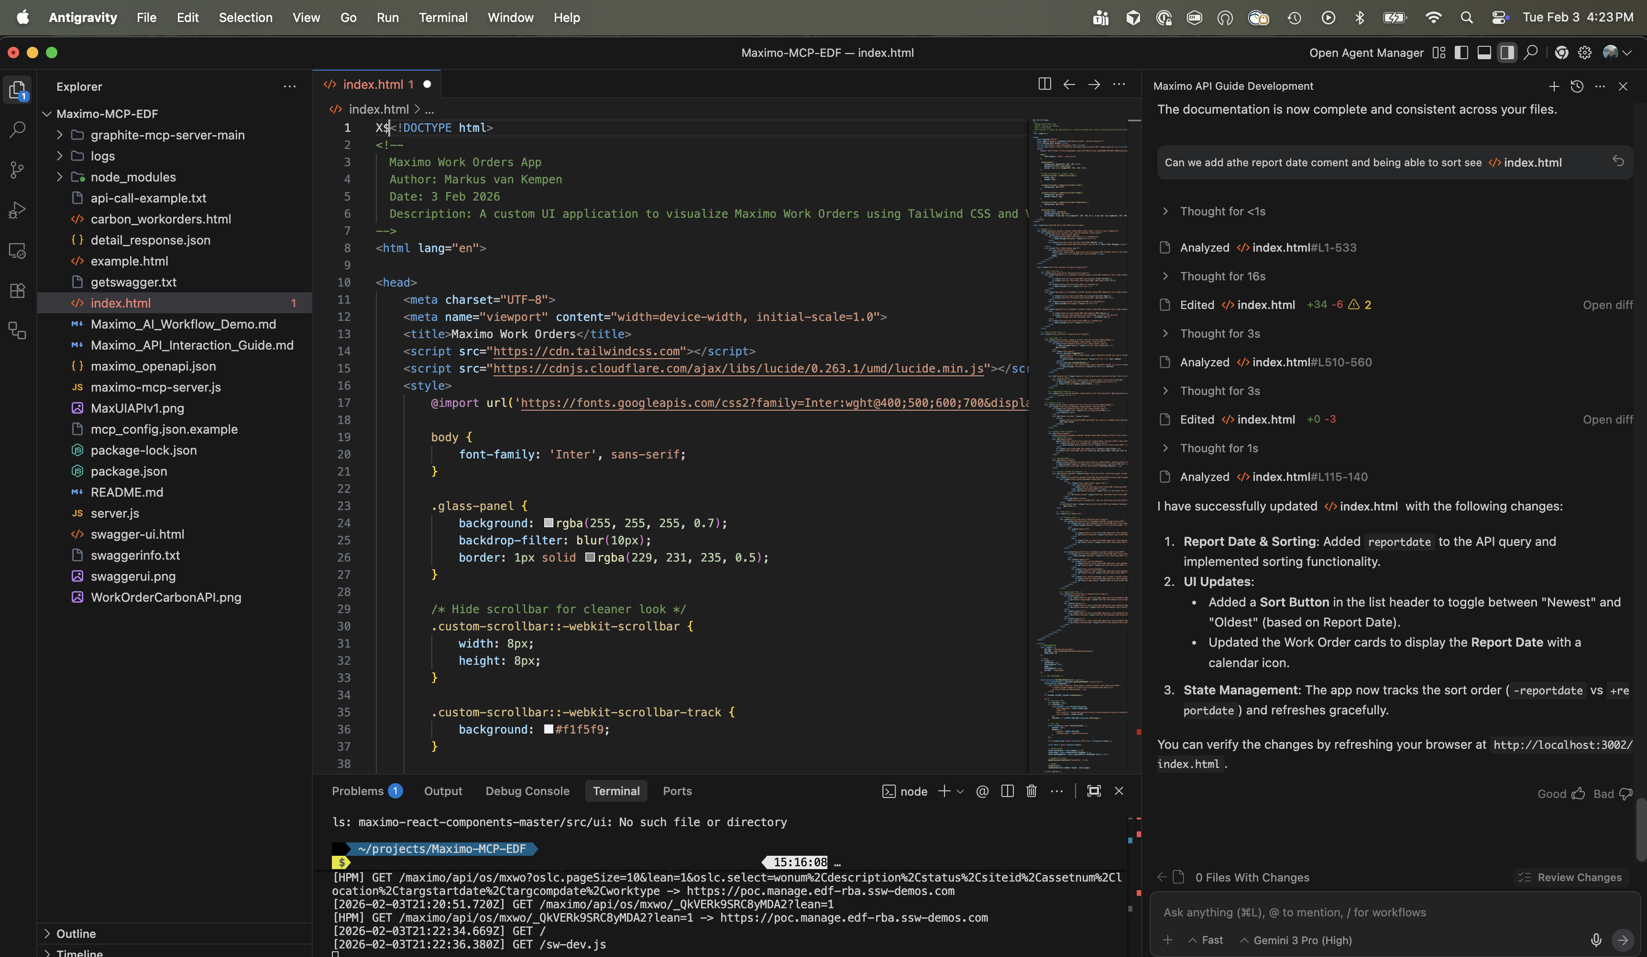
AI IDE Interface

4.2 Universal Applicability
While this guide references specific tools, the core workflow is generic and platform-agnostic: * AI Assistants: Antigravity, Cursor, Windsurf, VS Code Copilot, or any LLM-driven coding environment. * Languages: Python, JavaScript, Java, Go, or any language with HTTP support.

5. Generating Different Code Types (Scripts, SQL, API) by Business Context
The AI generates various code artifacts depending on the user’s context.

A. OSLC REST API Calls
- Context: Web Apps, Integrations, Testing (Postman/Curl).
- AI Process: Maps business rules to OSLC query parameters.
- Example Prompt: “Get approved work orders from BEDFORD site”
- Example Output:
- GET /maximo/api/os/mxwo?oslc.where=status="APPR" and siteid="BEDFORD"&oslc.select=wonum,description&lean=1

B. Python/Node.js Scripts
- Context: Backend automation, data migration, batch processing.
- AI Process: Generates full scripts with authentication, error handling, and iteration logic.
- Example Prompt: “Write a script to fetch all priority 1 work orders and print their descriptions”
- Example Output:
- import requests
url = "https://[YOUR_MAXIMO_HOST]/maximo/api/os/mxwo"
headers = {"apikey": "[YOUR_API_KEY]"}
params = {"oslc.where": "wopriority=1", "oslc.select": "wonum,description", "lean": 1}
response = requests.get(url, headers=headers, params=params)
for wo in response.json().get('member', []):
print(f"{wo['wonum']}: {wo.get('description', 'N/A')}")

C. SQL Queries
- Context: Direct database inspection, BIRT/Cognos reports, performance tuning.
- AI Process: Translates the logical request into ANSI SQL.
- Example Prompt: “Get overdue work orders”
- Example Output:
- SELECT wonum, description, status, targcompdate
FROM workorder
WHERE status NOT IN ('COMP', 'CLOSE', 'CAN')
AND targcompdate < CURRENT_DATE;

6. Executing Tests, Simulations, & Refinement via AI Interaction
The workflow extends beyond generation to include validation and refinement.

6.1 Execution & Test
- Immediate Validation: The AI can execute “Safe” operations (GET requests, SELECT queries) immediately.
- Error Correction: If an API call fails (e.g., 400 Bad Request), the AI analyzes the error and auto-corrects the query.

6.2 UI Simulation
- Visual Verification: Instead of viewing raw JSON, the AI can render the data into a Carbon Design System table.
- Benefit: Stakeholders can “see” the result of the API call in a user-friendly format.

6.3 Conversational Refinement
Users can refine output with follow-up prompts:
Turn | User Prompt | AI Action
1 | “Get work orders” | Generates basic query
2 | “Add the reported date” | Adds reportdate to oslc.select
3 | “Sort by newest first” | Adds oslc.orderBy="-reportdate"
4 | “Only show priority 1” | Adds wopriority=1 to oslc.where

7. Detailed Task Example

Task: “Show the last 5 work orders with status In Progress”

Step 1: User Request
“Connect to Maximo and show me the last 5 work orders that are currently In Progress.”

Step 2: Context Analysis (AI)
- Target Object: MXWO (Work Order)
- Condition: status = ‘INPRG’
- Sorting: By statusdate descending
- Pagination: Limit to 5 records

Step 3: Generated Artifacts
A. OSLC REST API Call
curl -X GET "https://[YOUR_MAXIMO_HOST]/maximo/api/os/mxwo?oslc.where=status=%22INPRG%22&oslc.orderBy=-statusdate&oslc.pageSize=5&lean=1" \
-H "apikey: [YOUR_API_KEY]" \
-H "Content-Type: application/json"
B. SQL Query
SELECT wonum, description, status, statusdate
FROM workorder
WHERE status = 'INPRG'
ORDER BY statusdate DESC
FETCH FIRST 5 ROWS ONLY;
C. Python Script
import requests
url = "https://[YOUR_MAXIMO_HOST]/maximo/api/os/mxwo"
headers = {"apikey": "[YOUR_API_KEY]", "Content-Type": "application/json"}
params = {
"oslc.where": 'status="INPRG"',
"oslc.orderBy": "-statusdate",
"oslc.pageSize": "5",
"lean": "1"
}
response = requests.get(url, headers=headers, params=params)
if response.status_code == 200:
for wo in response.json().get('member', []):
print(f"WO: {wo.get('wonum')} - {wo.get('description')}")
else:
print(f"Error: {response.status_code} - {response.text}")

Step 4: Execution & Verification
The AI executes the command and can render the JSON result into a visual table.

8. Common Errors & Troubleshooting
Error | Cause | Solution
400 Bad Request | Invalid field name or syntax error in oslc.where | Verify field names against the schema. Check for unescaped quotes.
401 Unauthorized | Invalid or missing API Key | Ensure apikey header is correct and has appropriate permissions.
403 Forbidden | API Key lacks permission for the Object Structure | Request access from your Maximo administrator.
404 Not Found | Incorrect Object Structure name (e.g., mxwr instead of mxwo) | Verify the Object Structure name in Swagger.
500 Internal Server Error | Server-side issue | Check Maximo logs; may indicate a timeout or configuration problem.
CORS Error (Browser) | Browser blocking cross-origin requests | Use a local proxy server (see Section 10).

9. Building a Custom UI Application
We can go beyond scripts by creating full-featured frontend applications.

Overview
The file index.html serves as a template for turning raw JSON API responses into interactive dashboards.

AI Prompts for UI Generation
Prompt 1: Basic Structure > “Create a single-file HTML application to visualize Maximo Work Order data. Use Tailwind CSS via CDN for styling and Vanilla JavaScript for logic.”
Prompt 2: Advanced Design > “Enhance the design using a dark theme with glassmorphism effects. Implement a Master-Detail view where clicking a work order card on the left updates a detailed view panel on the right.”
Prompt 3: Refining Details > “Add Lucide Icons for visual indicators. Include a search/filter input and pagination controls.”

Carbon Design System Example
For a native Maximo look and feel, use the IBM Carbon Design System.
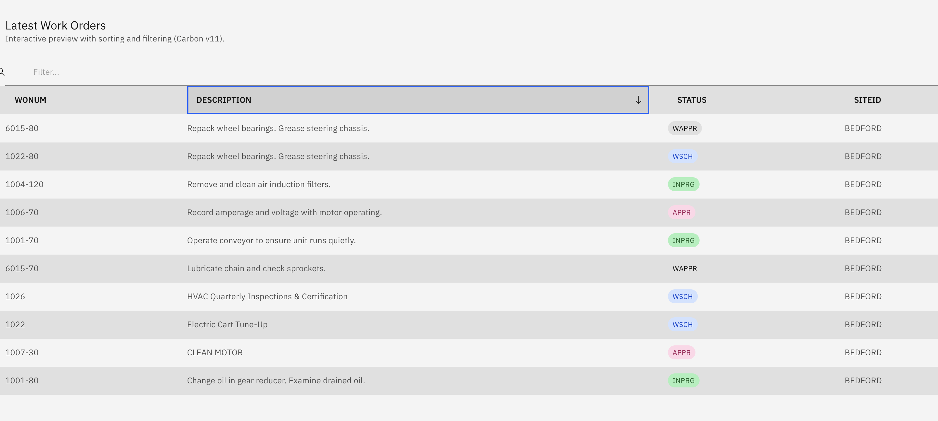
Carbon UI Example

10. Local Proxy Server Implementation
To bypass CORS restrictions when connecting to the Maximo API from a browser, use a Node.js proxy server.

Application Architecture
- server.js: Express.js server that proxies /maximo/* to the actual Maximo host.
- index.html: Frontend application fetching live data via the local proxy.

Running the Application
# Install dependencies
npm install
# Start the server
node server.js
Open your browser to: http://localhost:3002/

Interface Preview
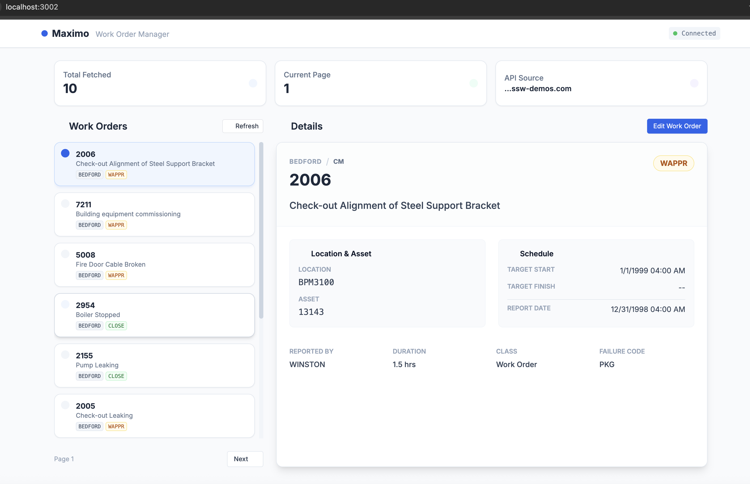
Localhost Maximo App

11. Security Best Practices
- Never hardcode API Keys in client-side JavaScript. Use environment variables or server-side proxies.
- Use Read-Only Keys for development to prevent accidental data modification.
- HTTPS Only: Always use HTTPS when communicating with the Maximo API.
- Limit Scope: Request API Keys with access only to the Object Structures you need.
- Rotate Keys: Periodically rotate API Keys and revoke unused ones.

12. Archive & Knowledge Retention
To ensure these workflows are reusable: 1. Save Successful Queries: Store working OSLC query strings in project documentation. 2. Update Examples: Add new use cases to your API Examples library. 3. Schema Cache: Keep a local copy of the OpenAPI definition for faster AI context loading.

