Maximo MCP Comprehensive Guide: AI-Driven Development
Author: Markus van Kempen
Date: 3 Feb 2026

1. Introduction
This comprehensive guide details how to leverage the Maximo Model Context Protocol (MCP) Server to transform Maximo development. Unlike traditional methods that rely on static documentation, the MCP server empowers AI Assistants to actively interact with your Maximo environment, enabling schema introspection, live data querying, and intelligent code generation.

1.1 What is the Model Context Protocol (MCP)?
MCP is an open standard that allows AI models to communicate with external systems via a defined set of “tools.” In this context, the maximo-mcp-server.js acts as a bridge, exposing Maximo capabilities to any MCP-compatible AI IDE.

1.2 Key Benefits
- Automated Schema Knowledge: The AI no longer relies on generic training data. It introspects your specific Maximo configuration to understand available Object Structures and their fields.
- Live Data Validation: Queries can be executed immediately to verify correctness, eliminating the “code-deploy-debug” cycle.
- Multi-Format Code Generation: Generate OSLC API calls, Python scripts, or SQL queries from the same natural language request.

1.3 Why Use an MCP Server vs. Direct Approach?
You might wonder: “Why not just paste the Swagger documentation into the chat, or provide API examples directly?” Here’s why the MCP approach is superior:
Aspect | Direct Approach (Manual Context) | MCP Server Approach
Context Size | Limited by token window; large schemas get truncated | Schema loaded server-side; AI queries specific parts on demand
Data Freshness | Static; copy-pasted docs become stale | Dynamic; always reflects current Maximo configuration
Validation | AI guesses; errors found at runtime | AI can test queries live and auto-correct before you see them
Security | API keys may be pasted into chat (risky) | Keys stored in local config; never sent to LLM provider
Effort | Manual copy/paste for every session | Zero effort after initial setup; context is automatic
Consistency | Varies by what you remember to include | Standardized tool interface; same capabilities every time
Example: Finding the right field name
- Direct Approach: You paste a 500-line schema excerpt and ask “What’s the field for work order priority?” The AI scans the text and hopes it’s complete.
- MCP Approach: The AI calls get_schema_details(objectStructure: "MXWO"), receives the authoritative field list directly from the OpenAPI spec, and responds with wopriority — guaranteed correct.
Bottom Line: The MCP server transforms the AI from a “smart guesser” into a “connected assistant” with direct access to your Maximo environment.

2. Prerequisites & Installation

2.1 Prerequisites
Before configuring the MCP server, ensure the following are in place: * Node.js: Version 18 or higher installed locally (node --version). * Maximo API Key: A valid API key with at least read-only access to the desired Object Structures (e.g., MXWO, MXASSET). * OpenAPI Schema (Recommended): A local maximo_openapi.json file for faster schema lookups.

2.2 Installing Dependencies
Navigate to the project directory and install the required Node.js packages:
cd /path/to/Maximo-MCP-EDF
# Install dependencies
npm install
The maximo-mcp-server.js requires the following packages (defined in package.json): * @modelcontextprotocol/sdk — The MCP SDK for Node.js * zod — Schema validation library

3. Configuring the MCP Server in Your IDE

3.1 Configuration for Antigravity (Google)
Antigravity uses a settings file located in your project’s .gemini directory.
Step 1: Create the settings file
mkdir -p .gemini
touch .gemini/settings.json
Step 2: Add the MCP configuration
Edit .gemini/settings.json and add:
{
"mcpServers": {
"maximo": {
"command": "node",
"args": [
"/Users/markusvankempen/projects/Maximo-MCP-EDF/maximo-mcp-server.js"
],
"env": {
"MAXIMO_URL": "https://[YOUR_MAXIMO_HOST]/maximo/api",
"MAXIMO_API_KEY": "[YOUR_API_KEY]",
"MAXIMO_OPENAPI_PATH": "/Users/markusvankempen/projects/Maximo-MCP-EDF/maximo_openapi.json"
}
}
}
}
Step 3: Restart Antigravity
Close and reopen your Antigravity session. The MCP server will be available as “maximo” in your tools list.

3.2 Configuration for Cursor
Cursor uses a global MCP configuration file.
Step 1: Locate the settings file * macOS: ~/.cursor/mcp.json * Windows: %USERPROFILE%\.cursor\mcp.json * Linux: ~/.cursor/mcp.json
Step 2: Create or edit the file
# macOS/Linux
mkdir -p ~/.cursor
nano ~/.cursor/mcp.json
Step 3: Add the MCP configuration
{
"mcpServers": {
"maximo": {
"command": "node",
"args": [
"/Users/markusvankempen/projects/Maximo-MCP-EDF/maximo-mcp-server.js"
],
"env": {
"MAXIMO_URL": "https://[YOUR_MAXIMO_HOST]/maximo/api",
"MAXIMO_API_KEY": "[YOUR_API_KEY]",
"MAXIMO_OPENAPI_PATH": "/Users/markusvankempen/projects/Maximo-MCP-EDF/maximo_openapi.json"
}
}
}
}
Step 4: Restart Cursor
Restart Cursor for the changes to take effect.

3.3 Configuration for VS Code (with Copilot/Continue)
For VS Code with MCP-compatible extensions like Continue, use the extension’s settings.
Step 1: Open VS Code Settings
Press Cmd+Shift+P (macOS) or Ctrl+Shift+P (Windows/Linux) and search for “Continue: Open Settings”.
Step 2: Add MCP Server Configuration
In the Continue configuration file (~/.continue/config.json), add:
{
"mcpServers": [
{
"name": "maximo",
"command": "node",
"args": ["/Users/markusvankempen/projects/Maximo-MCP-EDF/maximo-mcp-server.js"],
"env": {
"MAXIMO_URL": "https://[YOUR_MAXIMO_HOST]/maximo/api",
"MAXIMO_API_KEY": "[YOUR_API_KEY]",
"MAXIMO_OPENAPI_PATH": "/Users/markusvankempen/projects/Maximo-MCP-EDF/maximo_openapi.json"
}
}
]
}

3.4 Environment Variables Reference
The maximo-mcp-server.js reads the following environment variables:
Variable | Required | Description | Default
MAXIMO_URL | Yes | Base URL for the Maximo REST API | (none - must be set)
MAXIMO_API_KEY | Yes | API Key for authentication | (none - must be set)
MAXIMO_OPENAPI_PATH | No | Path to local OpenAPI schema file | ./maximo_openapi.json

3.5 Verifying the Setup
After configuration, verify the MCP server is working:
Method 1: Ask the AI > “Is the Maximo MCP server connected?”
The AI should respond by calling get_instance_details and confirming connectivity.
Method 2: Run Manually
Test the server directly from the command line:
node /path/to/Maximo-MCP-EDF/maximo-mcp-server.js
You should see output like:
Loading OpenAPI spec from /path/to/maximo_openapi.json...
Loaded OpenAPI spec. Components: 1247
Maximo MCP Server running on stdio
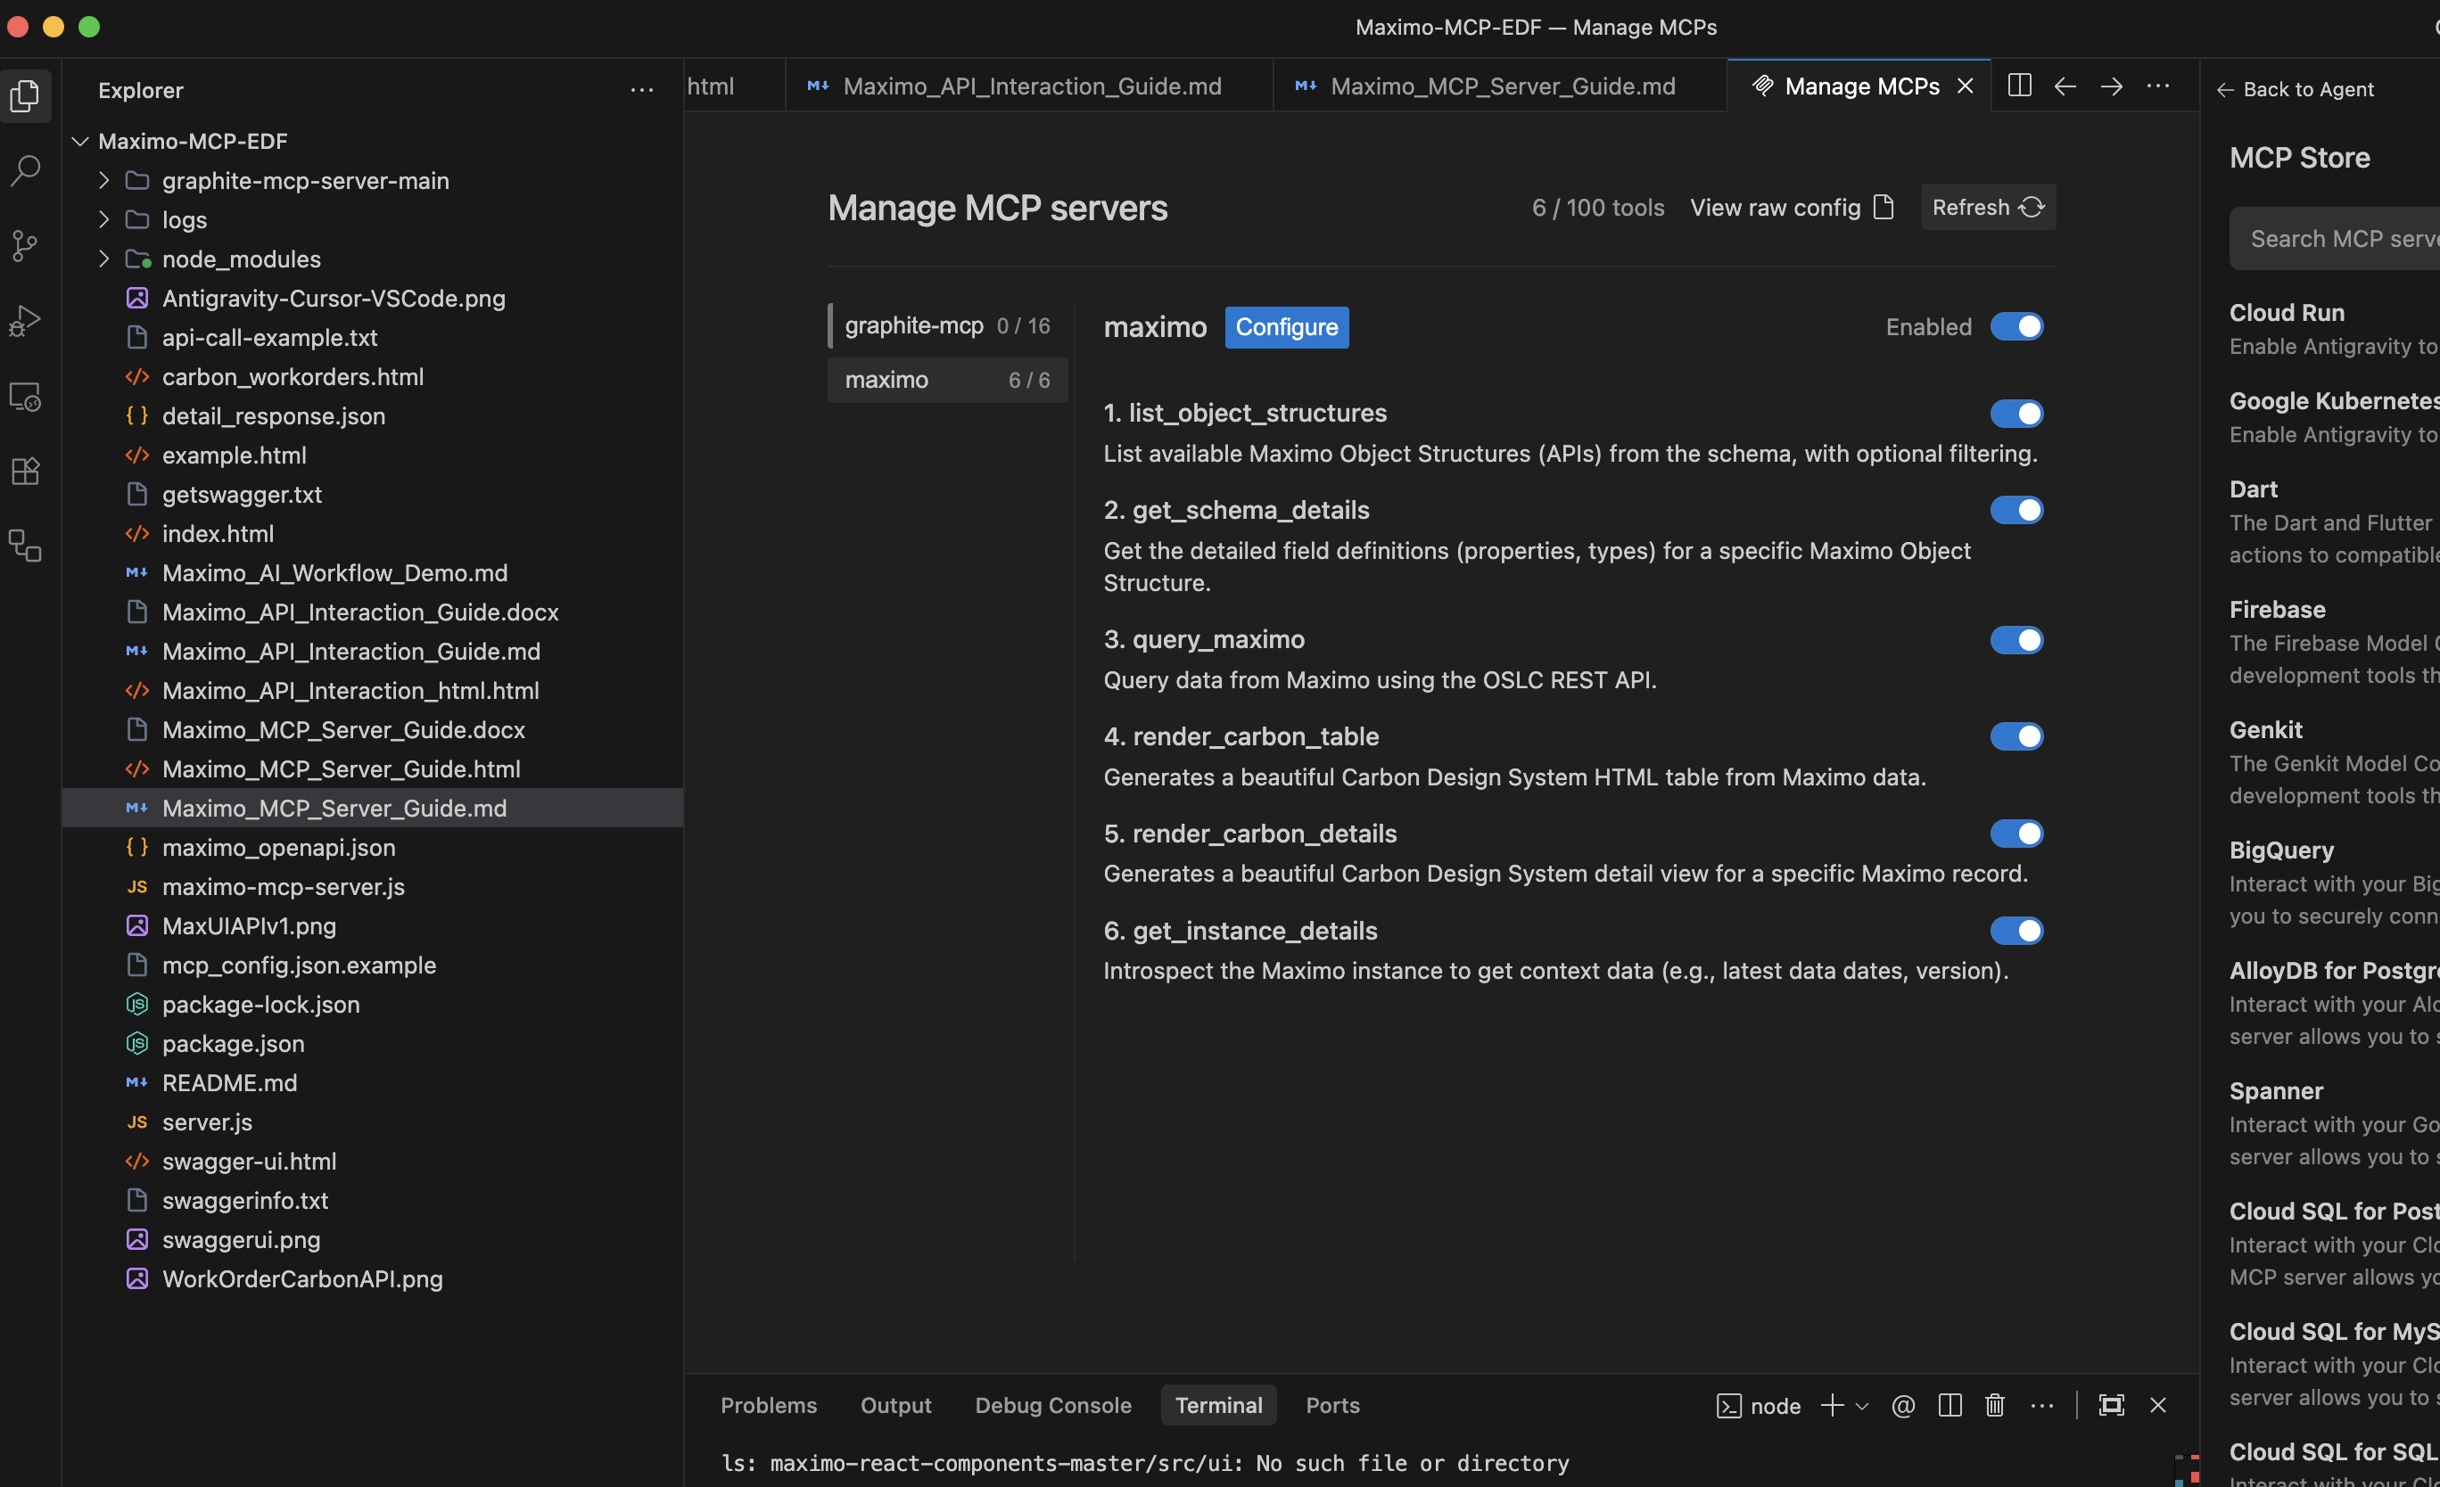
MCP Configuration
Key Benefit: Once configured, the MCP setup automatically handles Schema Knowledge and API Connectivity. You do not need to manually feed the AI Swagger files or API documentation; the MCP server proactively retrieves this context for every request.

4. Available MCP Tools
The Maximo MCP Server exposes the following tools to the AI agent:
Tool Name | Description | Example Use Case
list_object_structures | Searches the available Maximo APIs by name or description. | “What APIs are available for Assets?”
get_schema_details | Retrieves detailed field definitions (type, length, title) for a specific Object Structure. | “What fields are on the MXWO object?”
query_maximo | Executes a live OSLC REST query against the Maximo instance. | “Get the last 5 approved work orders.”
get_instance_details | Checks server connectivity and retrieves meta-information like latest work order date. | “Is the Maximo server reachable?”
render_carbon_table | Generates an interactive HTML table (Carbon Design System) from query results. | “Show me a table of open work orders.”
render_carbon_details | Generates a detailed HTML view for a single record. | “Show me the details for work order 1001.”

5. Code Generation from Natural Language
The MCP server acts as the “eyes and ears” of the AI, allowing it to translate vague natural language into precise technical operations by inspecting the actual Maximo configuration.

4.1 The Workflow
- User Request: “Find all pumps that failed last month.”
- Schema Discovery: The AI calls list_object_structures to find relevant APIs (e.g., MXASSET, MXWO).
- Field Mapping: It calls get_schema_details to understand the data structure (e.g., confirming assetnum, description, failurecode).
- Code Generation: It generates the correct query or code block.

4.2 The AI-Assisted Interface
The AI doesn’t just guess; it verifies. By having access to the live schema, the AI Interface can: * Autocomplete field names based on the actual object structure. * Validate that a specific relationship exists before suggesting it. * Contextualize answers, distinguishing between a “Work Order” (MXWO) and a “Service Request” (MXSR).
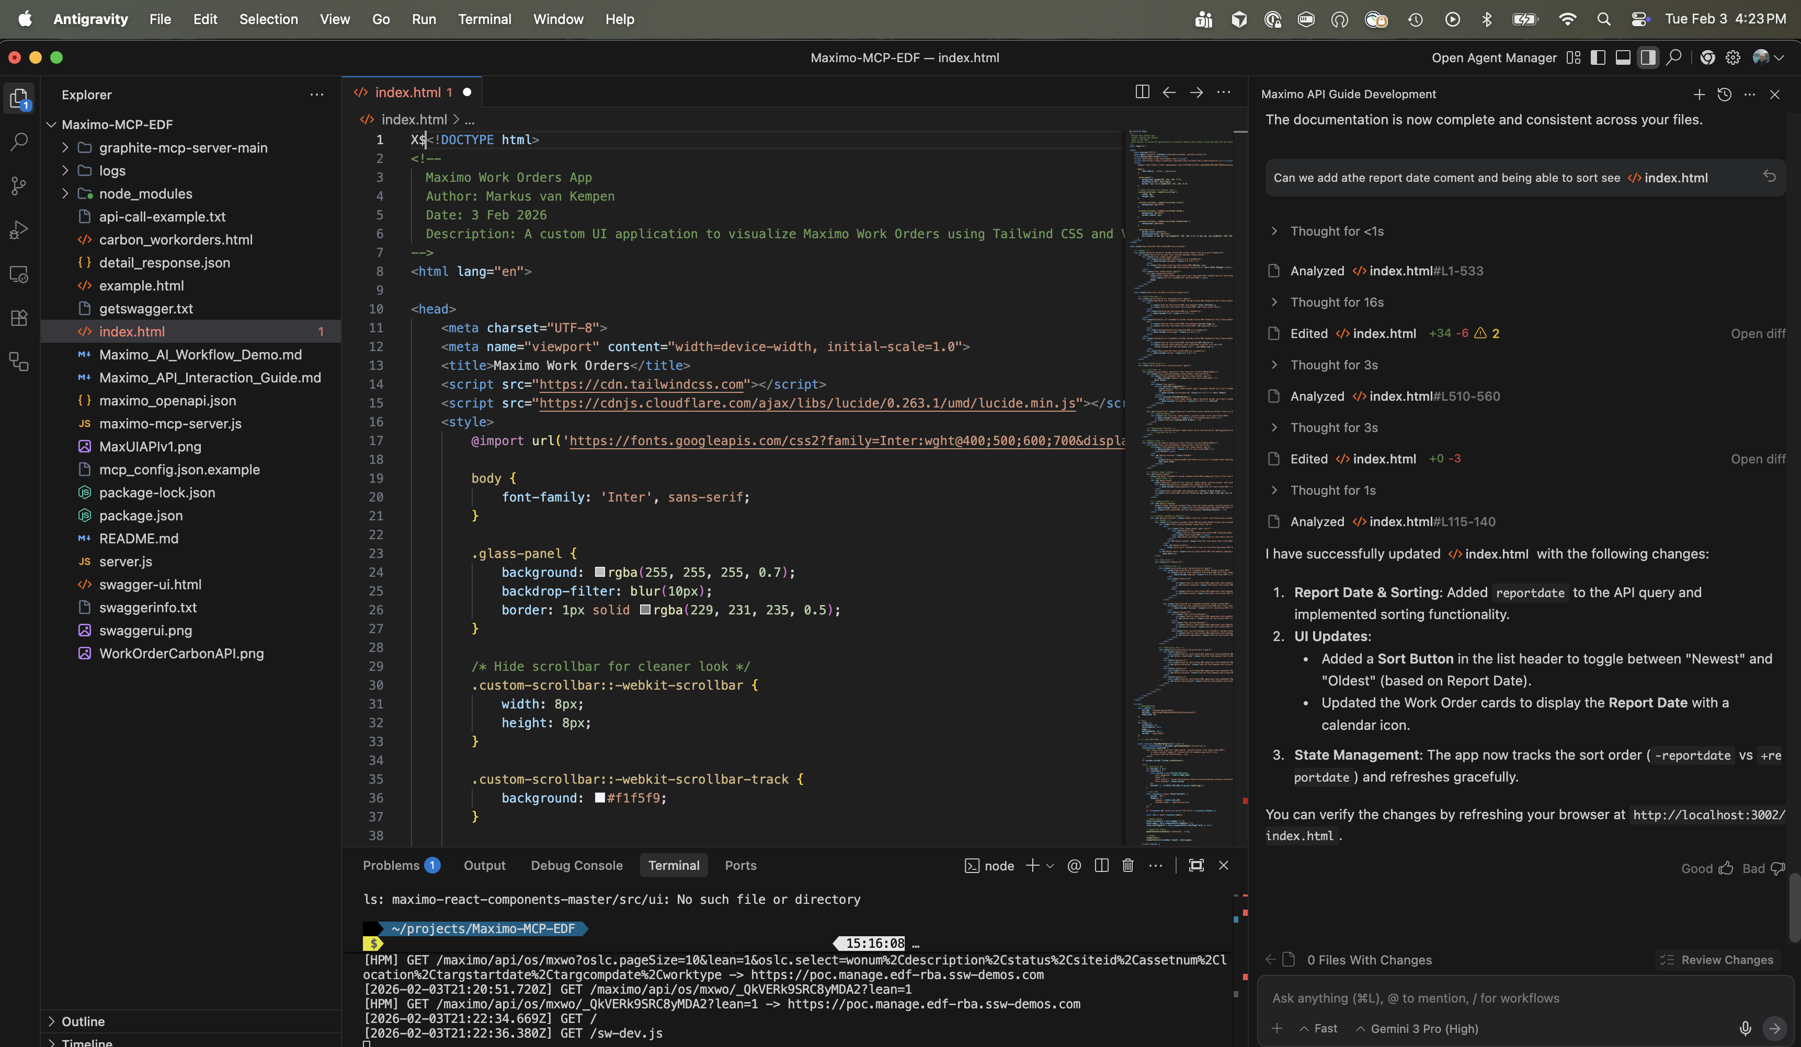
AI IDE Interface

6. Generating Multi-Format Code (Scripts, SQL, API)
One of the most powerful features of the MCP integration is the ability to generate context-aware code in multiple formats, ensuring alignment with the Target Data Structure.

A. OSLC REST API Calls
- Context: Web Apps, Integrations (Postman/Curl).
- Process: The AI checks get_schema_details to identify the correct OSLC query parameters.
- Example Prompt: “Get approved work orders with their asset numbers.”
- Example Output:
- GET /maximo/api/os/mxwo?oslc.where=status="APPR"&oslc.select=wonum,description,assetnum,reportdate&lean=1

B. Python/Node.js Scripts
- Context: Automation, Data Migration, Batch Processing.
- Process: The AI constructs robust scripts using libraries like requests or axios, injecting the correct field names and error handling logic derived from the schema.
- Example Prompt: “Write a Python script to fetch all work orders from this year and export them to CSV.”
- Example Output (Python):
- import requests
import csv
MAXIMO_URL = "https://your-host/maximo/api/os/mxwo"
headers = {"apikey": "YOUR_API_KEY"}
# AI knows 'reportdate' is the correct field from schema introspection
params = {
'oslc.where': 'reportdate>="2026-01-01"',
'oslc.select': 'wonum,description,status,reportdate',
'lean': 1
}
response = requests.get(MAXIMO_URL, params=params, headers=headers)
data = response.json().get('member', [])
with open('work_orders.csv', 'w', newline='') as f:
writer = csv.DictWriter(f, fieldnames=['wonum', 'description', 'status', 'reportdate'])
writer.writeheader()
writer.writerows(data)
print(f"Exported {len(data)} work orders.")

C. SQL Queries
- Context: Analytics, BIRT Reports, Database Administration.
- Process: By understanding the underlying Object Structure capabilities, the AI can infer the database schema and generate ANSI SQL.
- Example Prompt: “Write SQL to find overdue work orders.”
- Example Output:
- -- AI infers table names from Object Structure backing tables
SELECT wonum, description, status, targcompdate
FROM workorder
WHERE status NOT IN ('COMP', 'CLOSE', 'CAN')
AND targcompdate < CURRENT_DATE;

7. Execution, Simulation, & Refinement
The MCP server bridges the gap between writing code and running it. It allows for an interactive loop of execution, visualization, and refinement.

6.1 Execution & Test
- Tool: query_maximo
- Action: The AI can execute the generated query immediately to verify it returns results.
- Benefit: “Fail Fast.” If the query returns a 400 error (e.g., invalid field), the AI sees the error message and auto-corrects the code before showing it to you.

6.2 Simulation (UI Generation)
- Tool: render_carbon_table / render_carbon_details
- Action: Instead of showing raw JSON, the AI renders the data into a Carbon Design System HTML table with sorting and filtering.
- Benefit: Stakeholders can visually inspect the data structure and content quality (e.g., “Oh, the description field is empty for these records”) without needing a deployed frontend.
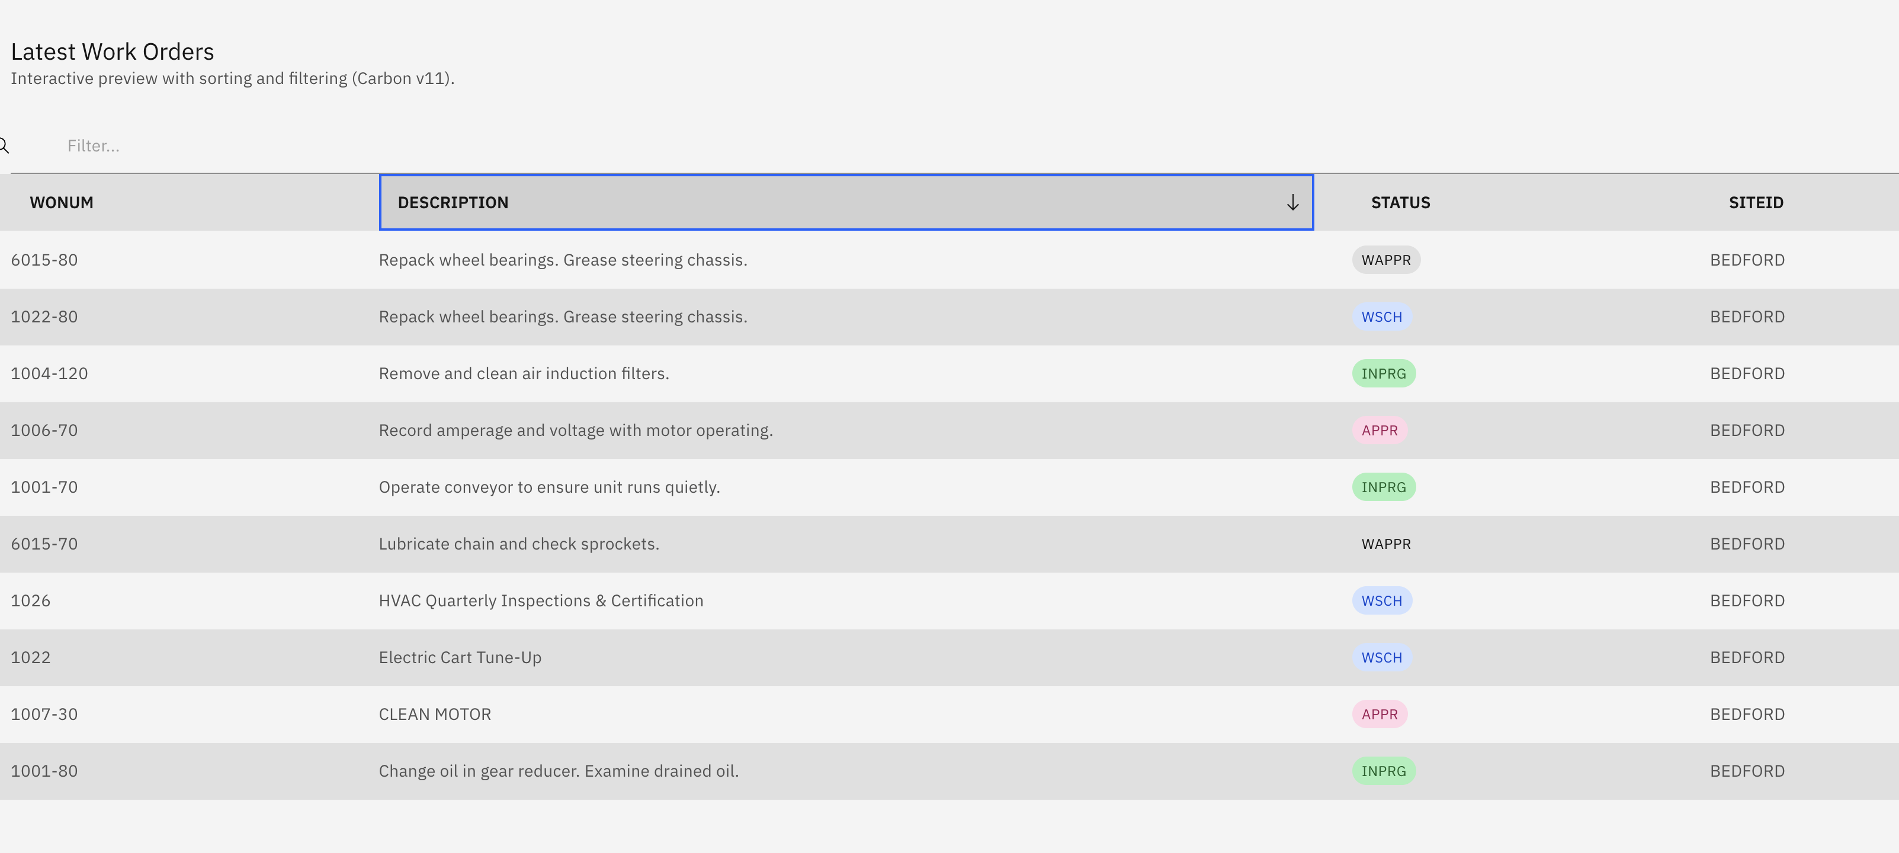
Carbon UI Example

6.3 Conversational Refinement
Because the AI has context, you can refine the output conversationally:
Turn | User Prompt | AI Response
1 | “Get me the work orders.” | Calls query_maximo and shows a list.
2 | “It’s too messy. Sort by newest first.” | Adds oslc.orderBy="-reportdate". Re-runs query.
3 | “Add the site ID column.” | Checks schema, finds siteid, adds to oslc.select. Updates table.
4 | “Filter only for BEDFORD site.” | Adds siteid="BEDFORD" to oslc.where. Re-runs.

8. Real-World Walkthrough: Creating a Custom Dashboard
Let’s walk through a typical use case from start to finish.
Goal: Build a simple HTML dashboard showing the last 10 high-priority work orders.

Step 1: Discover the API
User: “What’s the API for work orders?”
AI: Calls list_object_structures(filter: "work order") and responds: > “The primary Object Structure for Work Orders is MXWO.”

Step 2: Understand the Schema
User: “What fields are available on MXWO for priority and dates?”
AI: Calls get_schema_details(objectStructure: "MXWO") and responds: > “Key fields include: wopriority (integer), reportdate (datetime), targstartdate (datetime), status (string).”

Step 3: Query Live Data
User: “Show me the top 10 priority 1 work orders, sorted by report date.”
AI: Calls query_maximo with the constructed query and displays the results.

Step 4: Generate the UI
User: “Now build me a dark-themed HTML page to display this data.”
AI: Generates a complete index.html file using Tailwind CSS with dark mode, fetching from the Maximo API via the local proxy server.

9. Security & Best Practices
- Local Execution: The MCP server runs locally on your machine. Your API Key is stored in your local configuration and is not sent to the LLM provider’s servers; only the results of the queries are.
- Read-Only Access: For development, it is recommended to use an API Key with limited permissions (e.g., Read-Only) to prevent accidental data modification during AI experimentation.
- Schema Caching: The server uses a local maximo_openapi.json to speed up schema lookups and reduce load on the Maximo server.
- Environment Variables: Never hardcode API keys. Use environment variables in the MCP config as shown.

10. Summary
Feature | Without MCP | With Maximo MCP
Knowledge | Static (Training Data cut-off) | Dynamic (Live Schema Access)
Validation | Guess & Check | Introspect & Verify
Output | Code Snippets | Executed Queries & Visual UIs
Refinement | Manual debugging | Conversational Auto-correction
This workflow transforms the IDE from a text editor into a Maximo command center, reducing development time and errors significantly.

