

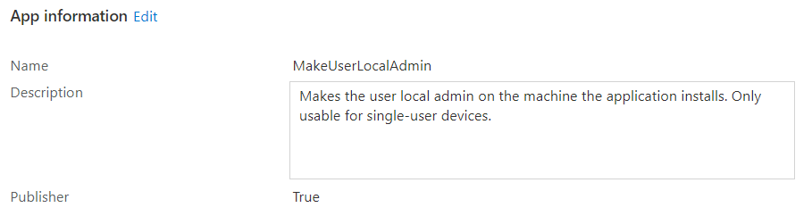

MakeUserLocalAdmin

Makes the user local admin on the machine the application installs. Only usable for single-user devices.

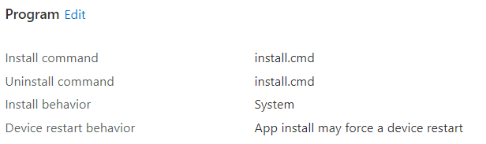  
  
install.cmd

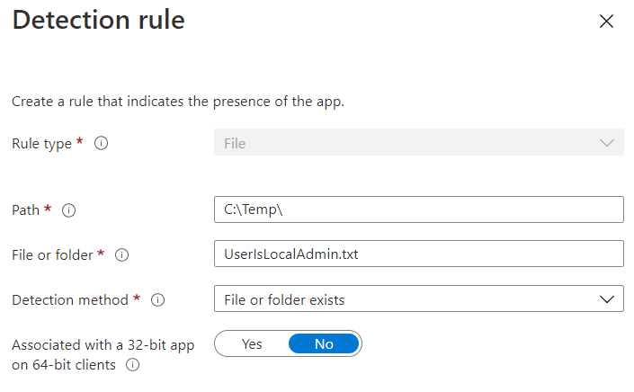

C:\Temp\

UserIsLocalAdmin.txt