Chad Markwell

Phase 4

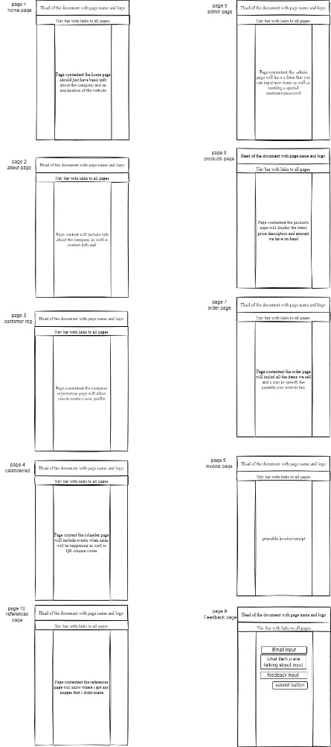 The purpose of this project is to be the site for a fake tech company called Markwell Industries. This image is what was used as the first design to help me figure out what exactly I wanted to be included in each page and how I wanted the site to be structured. Just after the references there are screenshots of the site as well as a couple of code snippets that show off some of the interesting bits that went to making this site possible. There is also a link to my github repo containing all my code if you are interested.

This project used a lot of different kinds of technology and different tools that I needed to create this website. Visual Studio Code is was what I used to code the entirety of my project. It is a very useful IDE and it helps me view all my files at once with good structure. I used a great website called draw.io to create the design image, it is verry useful to create things like this as well as stuff like flowcharts. Gimp is another great tool that I used to create my logo, it is a great free image editor. The Chrome Browser was used to test out my code and see it visually to make sure everything looked well. I also used F12 within it to enter inspector mode so that I could see the errors that occasionally popped up.

My test plan was to look at a page identify any problems, evaluate them, and then work to solve them. The test plan for my website is very simple as it consisted of doing checks of each webpage making sure they were all consistent with their designs site headers. I also made sure to check everything worked well at different scaling. I used F12 mode in the chrome browser often to look at what my exact problem was that my page was facing. Within the inspect mode you can see the errors and track them down to the line of code where they originated and then I can work it out from there.

References:

GIMP: <https://www.gimp.org/>

Chrome Browser: <https://www.google.com/chrome/>

Visual Studio Code: <https://code.visualstudio.com/>

draw.io: draw.io

W3 schools: <https://www.w3schools.com/>

Github Repo:<https://github.com/markw1ce/ITC320Project/tree/main/TermProject>

Code from product.js :

Example code from admin.html



