Ford GoBike Analysis Report

Executive Summary

This report analyzes a dataset of 183,416 bike trips. The primary objective is to identify user behavior patterns, demographic trends, and high-traffic locations to provide data-driven recommendations for operational growth and marketing efficiency.

Data Specifications (Data Space)

- Total Records: 183,416 bike trips.
- Timeframe: The data tracks trip starts and end times.
- Key Columns: User type, gender, birth year, station names, and geographic coordinates (Latitude/Longitude).

Problem Statement

Understanding who uses the bikes, how long they ride, and where the most popular hubs are located to improve business operations.

Data Cleaning (Pre-processing)

- Time Correction: Handled errors in time formats by splitting strings and calculating accurate durations.
- Age Calculation: Calculated user age from member_birth_year and filtered out unrealistic values to ensure data accuracy.

Key Findings & Visualization Analysis

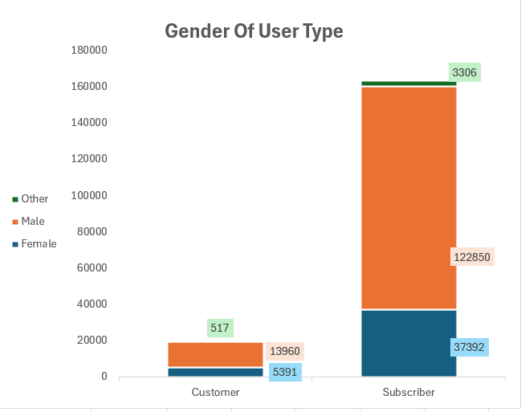

Chart 1: Gender of User Type
- Description: A stacked column chart showing that Males make up the vast majority of the user base, particularly among Subscribers (122,850 users).
- Key Insight: There is a significant gender gap; the service is heavily male dominated, especially for long-term members. Subscribers are the primary revenue driver, but Females are underrepresented.
- Recommendation: Target the 5,391 female Customers with "Trial Subscriptions" to convert them into long-term members and close the gender gap.

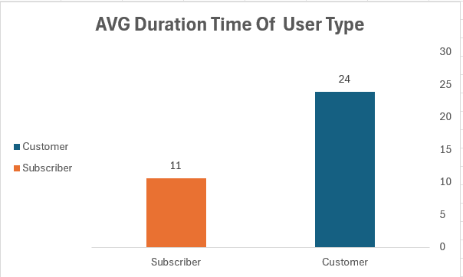

Chart 2: AVG Duration Time of User Type
- Description: A column chart comparing how long different users keep their bikes. Customers average 24 minutes, while Subscribers average only 11 minutes.
- Key Insight: Customers (casual riders) ride for much longer periods, likely for leisure or tourism. Subscribers ride for shorter bursts, suggesting they use the bikes for quick daily commutes.
- Recommendation: Introduce a "Weekend Leisure Pass" for Customers to capitalize on their longer riding habits and ensure bike stations near parks or scenic routes are fully stocked.
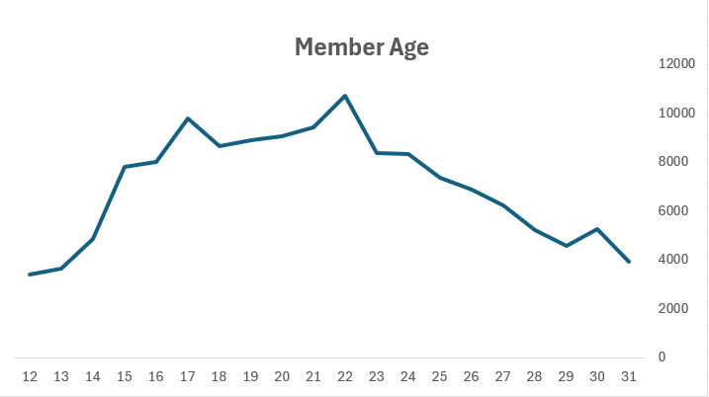

Chart 3: Member Age
- Description: A line chart showing that bike usage is highest among users in their early 20s, peaking specifically around age 22.
- Key Insight: Engagement is strongest among young adults (20-30), likely students or early-career professionals, and declines steadily after age 35.
- Recommendation: Direct social media advertising and "Back to School" promotions toward the 20-25 age demographic to capitalize on their high activity levels.
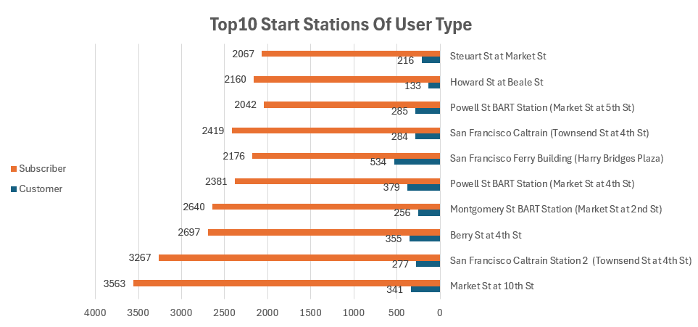

Chart 4: Top 10 Start Stations of User Type
- Description: A horizontal bar chart showing the most popular starting locations, led by Market St at 10th St with over 3,500 trips.
- Key Insight: Usage is highly concentrated in specific hubs; Subscribers (orange bars) represent most of the traffic at these top locations.
- Recommendation: Prioritize these 10 stations for preventative maintenance and ensure high bike "rebalancing" (moving bikes back to these docks) during morning rush hours to meet the high demand.
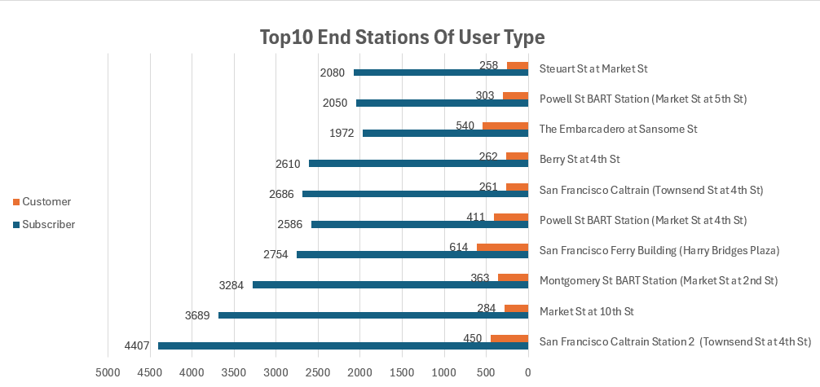

Chart 5: Top 10 End Stations of User Type
- Description: A horizontal bar chart identifying the most frequent destination stations, led by Berry St at 4th St.
- Key Insight: Many of these stations overlap with the top "Start Stations," confirming they are major transit hubs for two-way commuting.
- Recommendation: Monitor these stations for "full dock" alerts to ensure users can always find a place to park their bikes at the end of their trip.

