Cem Albal, Chris Dittinger, Ikram Uygur

Hand Gesture Music Player

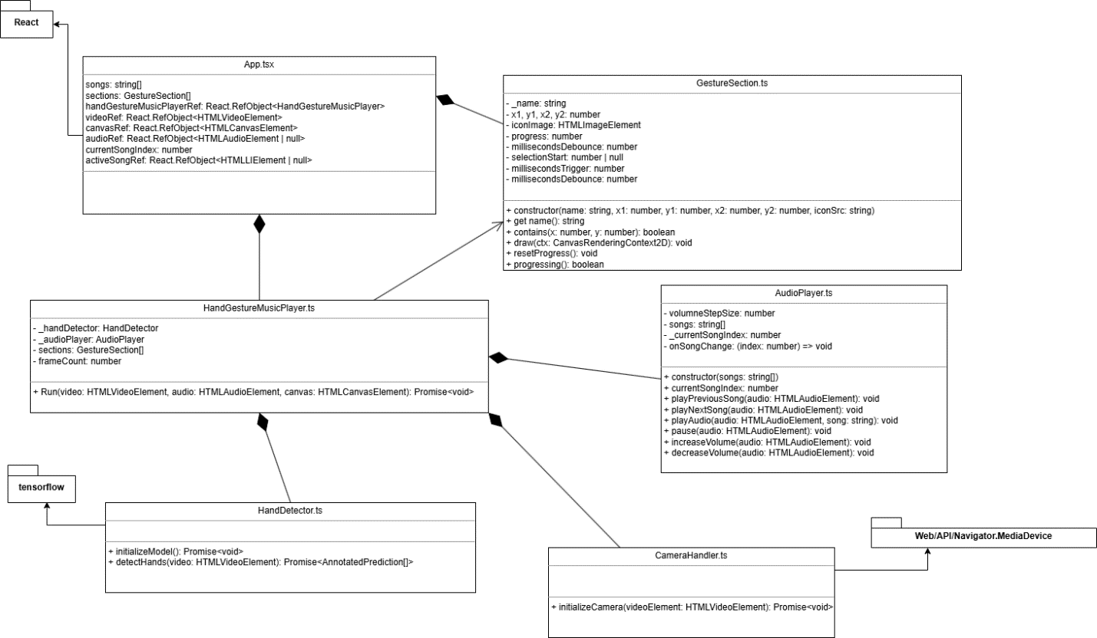

* Starting and Stopping the Music
* Changing the Song
* Adjusting the Volume
* Progress Cycle for User feedback

Architecture

UseCase

Technologies/ Dependencies

### MediaDevices API