Project – (250 Points Total):

This is an extremely detail oriented assignment! Please spend the time necessary to complete this assignment as thoroughly as you possibly can since it will be most beneficial to you in the long run!

There are a ten topics here. Each topic is worth twenty (25) points and may include multiple technologies within the topic. You may need to research certain topics and others you may have within your class notes from the labs and lectures. For each topic you should:

1. Provide a detailed description and/or explanation of what the topic is (in your own words). If there are multiple technologies in use, make sure you describe each one individually.
2. Following the description/explanation you will create an example topology that will be used for this question. (Yes, you may utilize this same topology on other questions – only if it directly relates to other questions.) Make sure you specify interfaces in use, ip addresses and subnet masks within your topology. Your topology should pertain to the topic and should not have more technologies
3. configured within the topology than is necessary to demonstrate your mastery of the topic discussed.
4. Next, you will provide a configuration for the topic listed based upon your example topology.
   1. For the first few questions, you should provide detailed steps as to where you are within the router or switch when issuing a specific command so you demonstrate basic knowledge and manipulation of the Cisco IOS. Throughout all of the topics you should specify what each command does. (A brief example is listed below.)
5. Provide show commands for each topic. What are you looking for in order to verify this technology is working properly?
6. Provide debug commands for each topic. And, explain how you would go about troubleshooting this technology if something is not working correctly.

Please keep in mind… No assumptions are made! Some of the items have multiple steps so be sure to include **all** the steps in the configuration, etc...

**For example** *(please keep in mind this is abbreviated example):*

If you are asked to ***assign an IP Address to a router interface***, you may want to specify the following:

Create a sample topology, then write…

An IP Address is a Layer 3 logical address that is assigned to each host within a TCP/IP network. The IP Address assigned to the host is determined by the network administrator and is dependent upon the network it is directly connected to. An IP Address is a hierarchical address that consists of 4 octets, 8 bits each, 32 bits in total. An IP Address is typically written in dotted decimal notation:

* + - 1. is an example of a Class A IP Address

To assign an IP Address to a router interface you would proceed in the following manner:

|  |  |
| --- | --- |
| Router> | This prompt specifies the router is in USER mode |
| Router>***enable*** | this command is entered to go from USER mode to PRIVILEGE mode |
| Router# | You are now in PRIVILEGE mode |
| Router# ***configure terminal*** | used to enter GLOBAL CONFIGURATION mode from PRIVILEGE mode. This is needed to configure all parameters within the router |
| Router(config)# | You are now in GLOBAL CONFIGURATION mode |
| Router(config)#***interface fastethernet0/0*** | This is entered to go into INTERFACE CONFIGURATION mode to configure the fastethernet0/0 interface within the router |
| Router(config-if)# | You are now in INTERFACE CONFIGURATION mode |
| Router(config-if)#***ip address 1.1.1.1 255.0.0.0*** | This sets the IP Address to 1.1.1.1 with a subnet mask of 255.0.0.0 which is the default subnet mask for a Class A IP Address |
| Router(config-if)#***no shutdown*** | After the IP Address is set on the interface, it’s always a good idea to enable the interface and test connectivity. |

Specify the show commands, test commands to verify the configuration is working properly and move onto the next topic.

This assignment should be **printed and turned in by 9:00am, Saturday, April 29, 2017.** **In addition to your printed copy, please submit a softcopy in Microsoft Word (.docx or .doc) format via email to robert.cannistra@marist.edu.** Make sure you cite your resources and do not plagiarize! Your citations should be placed at the end of each question, not at the end of the project. **All work should be completed individually!!!** **There will not be any extensions given for this assignment**, so make sure you **SUBMIT IT ON TIME otherwise you will receive a grade of ZERO!!!**

If you have any questions or concerns, please let me know!

Topics to research, explain, provide detail and provide examples for: (make sure you provide as much detail as possible in a concise manner and make it as legible as possible! Once this is graded and turned back to you, it will provide you with a detailed study guide for your final practical.) Please feel free to copy and paste the table from above and use it as a template for each question. Please do not remove the numbers or questions/statements below. Use this as a template and add your answers under each numbered question/statement on each page.

# Project – (250 Points Total)

1. VLANs, VTP, and IEEE 802.1q (NOTE: Make sure you accomplish this ***without*** going into VLAN Database mode and show the syntax for both 2960 and 3560 switches!)

VLANs are a group of devices that one or more LANs are connected that is defined on the layer 2 network. VLANS are used on a router so we can split up the many broadcast addresses and can assign different interfaces to these set VLANS. VLANs take these broadcast addresses and divide them up so we can route between another vlan(s). VTP is a trunking protocol that is meant for VLANs so we can distribute VLANS through all switches instead of having to configure the VLAN on each switch. Finally we have IEEE 802.1q, which is the standard that is used for VLANs. All of these components allows a group of VLANs to communicate together even though they are found on different LANs.

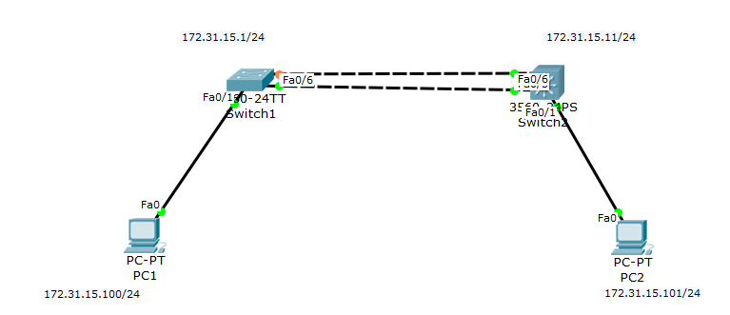

Switch1

|  |  |
| --- | --- |
| **Command** | **Description** |
| Router> | Enters privilege mode |
| Router#config t | Enters configuration mode |
| Router(config)#Int vlan 1 | Entering admin vlan 1 |
| Router(config-if)#Ip address 172.31.15.1 255.255.255.0 | Sets the IP address and Subnet Mask |
| Router(config)#Vtp mode server | Setting the switch to server mode |
| Router(config)#Vtp domain inetlab | Setting the domain to inetlab |
| Router(config)#Vtp password cisco | Setting the vtp password to cisco |
| Router(config)#Vlan 10 | Creates vlan 10 |
| Router(config-vlan)#Name S1S2 | Names vlan 10 S1S2 |
| Router(config)#Int range f0/5-6 | Entering interface f0/1 |
| Router(config-if)#Switchport mode trunk | Trunks the f0/1 interface |
| Router(config)#Int f0/1 | Entering f0/5 interface |
| Router(config-if)#Switchport mode access | Enters access command line |
| Router(config-if)#Switchport access vlan 10 | Giving int f0/5 access to vlan 10 |

Switch2

|  |  |
| --- | --- |
| **Command** | **Description** |
| Switch(config)#Int vlan 1 | Entering admin vlan 1 |
| Switch(config-if)#Ip address 172.31.15.11 255.255.255.0 | Sets the IP address and Subnet Mask |
| Switch(config)#Vtp mode server | Setting the switch to server mode |
| Switch(config)#Vtp domain inetlab | Setting the domain to inetlab |
| Switch(config)#Vtp password cisco | Setting the vtp password to cisco |
| Switch(config)#Vlan 10 | Creates vlan 10 |
| Switch(config-vlan)#Name S1S2 | Names vlan 10 S1S2 |
| Switch(config)#Int f0/5 and f0/6 | Entering interface f0/1 |
| Switch(config-if)#Switch trunk encapsulation dot1q | Command needed for 3560 switches |
| Switch(config-if)#Switchport mode trunk | Trunks the f0/1 interface |
| Switch(config)#Int f0/1 | Entering f0/5 interface |
| Switch(config-if)#Switchport mode access | Enters access command line |
| Switch(config-if)#Switchport access vlan 10 | Giving int f0/5 access to vlan 10 |

Troubleshooting and De-bugging:

* Ping command: ping 172.31.15.101 --- this command is used to test for connectivity across your network.
* Show vlan: show vlan--- shows all of the vlans that are in use, shows the name of the vlan, and shows what ports the interface the vlan is attached to.
* Show interface trunk: show interface trunk--- shows what vlans are allowed on trunk, tells us the native vlan and gives us general info about what vlans have trunk and what interfaces are allowing trunking to pass.
* Show vtp status: show vtp status--- gives us general info about the vtp and all of its information (ex. Domain name, operating mode, number of exisiting vlans)
* Show vtp password: shows the password of the vtp

1. InterVLAN Routing with a Router-on-a-stick and SVIs

InterVLAN routing divides a single physical network into multiple broadcast domains. Since we have no layer 3 switch in this case we use a router on a stick. We put multiple vlans on the switch and then the router takes those vlans and uses these for its routing. This is where interVLAN comes into play. InterVLAN routing creates a communication across all VLANS.

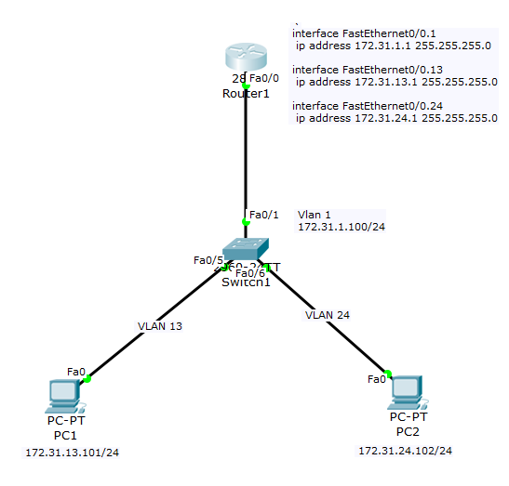

Router1

|  |  |
| --- | --- |
| **Command** | **Description** |
| Router> Enable | Enters privilege mode |
| Router# config t | Enters configuration mode |
| Router(config)#int f0/0 | Enters the f0/0 interface |
| Router(config-if)#no ip address | Gives the f0/0 interface no ip address |
| Router(config)# Int f0/0.1 | Enters f0/0.1 sub interface for vlan 1 |
| Router(config-subif)#ip address 172.31.1.1 255.255.255.0 | Sets the ip address and subnet mask of the sub interface f0/0.1 |
| Router(config-subif)#encapsulation dot1q 1 |  |
| Router(config)#int f0/0.13 | Enters f0/0.13 sub interface for vlan 13 |
| Router(config-subif)#ip address 172.31.13.1 255.255.255.0 | Sets the ip address and subnet mask of the sub interface f0/0.13 |
| Router(config-subif)#encapsulation dot1q 13 | Applys a vlan id to the subinterface |
| Router(config)#Int f0/0.24 | Enters f0/0.24 interface for vlan 24 |
| Router(config-subif)#ip address 172.31.24.1 255.255.255.0 | Sets the ip address and subnet mask of the sub interface f0/0.24 |
| Router(config-subif)#encapsulation dot1q 24 | Applys a vlan id to the subinterface |
| Router(config)# int f0/0 | Enters f0/0 interface |
| Router(config-if)#no shutdown | Enables the f0/0 interface |

Switch1

|  |  |
| --- | --- |
| **Command** | **Description** |
| Switch> Enable | Enters privilege mode |
| Switch#config t | Enters configuration mode |
| Switch(config)#int vlan 1 | Enters interface vlan 1 |
| Switch (config-if)#ip address 172.31.1.100 255.255.255.0 | Sets ip address and subnet mask for vlan 1 |
| Switch (config)# vtp mode server | Sets the switch mode to server |
| Switch (config)# vtp domain INETLAB | Names the domain INETLAB |
| Switch (config)#vtp password cisco | Gives the vtp a password of cisco |
| Switch (config)#Vlan 13 | Creates interface vlan 13 |
| Switch (config-if)# name PC1 | Names vlan 13 PC1 |
| Switch (config)#Vlan 24 | Creates interface vlan 24 |
| Switch (config-if)# name PC2 | Names vlan 24 PC2 |
| Switch (config)# int f0/1 | Enters interface f0/1 |
| Switch (config-if)#switchport mode trunk | Enables trunking on the given interface |
| Switch (config)# int f0/5 | Enters interface f0/5 |
| Switch (config-if)#switchport mode access | Sets the switchport mode to access |
| Switch (config-if)#switchport access vlan 13 | Tells us vlan 13 will be carried on this access port |
| Switch (config)# int f0/6 | Enters interface f0/6 |
| Switch (config-if)#switchport mode access | Sets the switchport mode to access |
| Switch (config-if)#switchport access vlan 24 | Tells us vlan 24 will be carried on this access port |

Troubleshooting and De-bugging:

* Ping command: ping 172.31.1.100 --- this command is used to test for connectivity across your network.
* Show vlan: show vlan--- shows all of the vlans that are in use, shows the name of the vlan, and shows what ports the interface the vlan is attached to.

1. First Hop Redundancy Protocol with HSRP using Link Aggregation between two 3560 multilayer switches. Demonstrate your knowledge of LACP and PAgP.

First hop redundancy is a protocol that has two routers provide backup for the default gateway addresses. So in the event of a failure the backup router will take over the router that has failed. HSRP provides redundancy and allows a computer to use multiple routers that act as one router. We have two types of link aggregation; Lacp and pagp. Lacp which allows us to put more than one port together to form a single channel. We then give that channel a number and give it an active mode. Pagp acts the same but instead we give it a desirable mode. Both of these protocols allow us to combine multiple networks connections together.

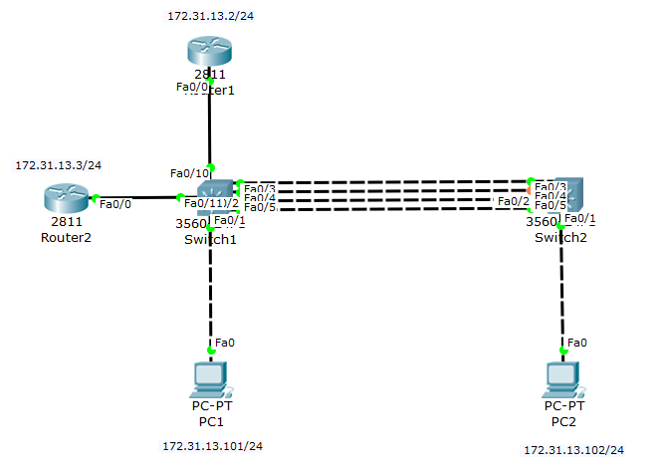

*3560 Swtich 1:*

|  |  |
| --- | --- |
| **Command** | **Description** |
| Switch> Enable | Enters privilege mode |
| Switch# config t | Enters configuration mode |
| Switch(config)#int range f0/2-3 | Enters range of interfaces of f0/2 and f0/3 |
| Switch (config-if)#channel-protocol lacp | Sets the link aggregation channel protocol to lacp on the designated interfaces |
| Switch (config-if)# channel-group 1 mode active | Sets the designated interfaces to channel group 1 and lacp is enabled |
| Switch (config)#int range f0/4-5 | Enters range of interfaces of f0/4 and f0/5 |
| Switch (config-if)#channel-protocol pagp | Sets the link aggregation channel protocol to pagp on the designated interfaces |
| Switch (config-if)# channel-group 2 mode desirable | Sets the designated interfaces to channel group 2 and pagp is enabled |

*3560 Switch 2:*

|  |  |
| --- | --- |
| **Command** | **Description** |
| Switch> Enable | Enters privilege mode |
| Switch# config t | Enters configuration mode |
| Switch(config)#int range f0/2-3 | Enters range of interfaces of f0/2 and f0/3 |
| Switch (config-if)#channel-protocol lacp | Sets the link aggregation channel protocol to lacp on the designated interfaces |
| Switch (config-if)# channel-group 1 mode active | Sets the designated interfaces to channel group 1 and lacp is enabled |
| Switch (config)#int range f0/4-5 | Enters range of interfaces of f0/4 and f0/5 |
| Switch (config-if)#channel-protocol pagp | Sets the link aggregation channel protocol to pagp on the designated interfaces |
| Switch (config-if)# channel-group 2 mode desirable | Sets the designated interfaces to channel group 2 and pagp is enabled |

*Router 1:*

|  |  |
| --- | --- |
| **Command** | **Description** |
| Router> Enable | Enters privilege mode |
| Router# config t | Enters configuration mode |
| Router(config)#int f0/0 | Enters the interface f0/0 |
| Router(config-if)#ip address 172.31.13.2 255.255.255.0 | Sets the ip address and subnet mask to that interface |
| Router(config-if)#standby 1 ip 172.31.13.1 | Sets the virtual ip address for standby group 1 |
| Router(config-if)#standby 1 priority 110 | Sets priority value for the router, lowest value in order to be an active router |
| Router(config-if)#standby 1 preempt | Enables HSRP. Sends out a message to any other router within that standby group preempting the state it is in depending on what the priority values of each router are |
| Router(config-if)#no shutdown | Enables the interface |

*Router 2:*

|  |  |
| --- | --- |
| **Command** | **Description** |
| Router> Enable | Enters privilege mode |
| Router# config t | Enters configuration mode |
| Router(config)#int f0/0 | Enters the interface f0/0 |
| Router(config-if)#ip address 172.31.13.3 255.255.255.0 | Sets the ip address and subnet mask to that interface |
| Router(config-if)#standby 1 ip 172.31.13.1 | Sets the virtual ip address for standby group 1 |
| Router(config-if)#standby 1 priority 115 | Sets priority value for the router, higher value than R1 to set as standby router |
| Router(config-if)#standby 1 preempt | Enables HSRP. Sends out a message to any other router within that standby group preempting the state it is in depending on what the priority values of each router are |
| Router(config-if)#no shutdown | Enables the interface |

Troubleshooting and De-bugging:

* Ping command: ping 172.31.13.1 --- this command is used to test for connectivity across your network.
* Ether channel summary: show etherchannel summary--- shows what channel-groups are being used, what protocol they have, and what ports they are used on.

1. IPv4 and IPv6 Static routing (NOTE: With AND Without the use of a default static route.)

Static routing is just one way of routing between more than one routers in order for them to communicate with one another. The problem with static routing is you must statically input each route on both routers. This works well for ipv6 too. A default static route is simply a static route with a 0.0.0.0/0 destination ip address. We then supply a next hope router address. Again this can work for ipv6 we just have to supply a ::0/0 destination ipv6 address.

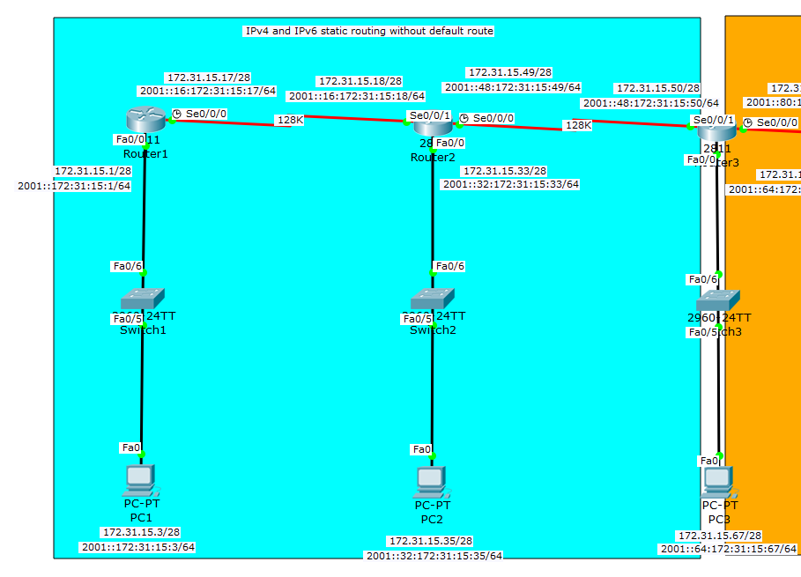

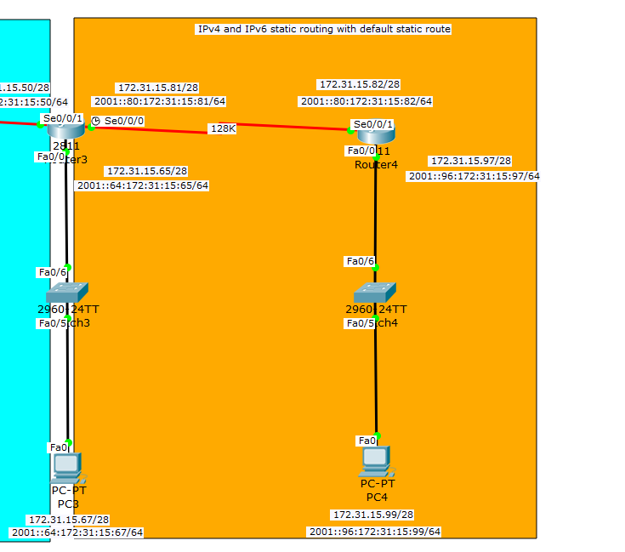

Router1 – Router3 (without default route)

|  |  |
| --- | --- |
| **Command** | **Description** |
| Router> Enable | Enters privilege mode |
| Router# config t | Enters configuration mode |
| Router(config)# ipv6 unicast-routing | Enables ipv6 unicast routing |
| Router(config)# Int f0/0 | Enters f0/0 interface |
| Router(config-if)# Ip address 172.31.15.1 255.255.255.240 | Sets the ip address and subnet mask |
| Router(config-if)# ipv6 address 2001::172:31:15:1/64 | Sets the ipv6 address and subnet mask |
| Router(config)#no shutdown | Enables f0/0 interface |
| Router(config)#Int s0/0/0 | Enters serial 0/0/0 interface |
| Router(config-if)#ip address 172.31.15.1 7255.255.255.240 | Sets the ip address and subnet mask |
| Router(config-if)# ipv6 address 2002::16:172:31:15:17/64 | Sets the ipv6 address and subnet mask |
| Router(config-if)# clock rate 128000 | Sets the clock rate to 128000 |
| Router(config-if)#no shutdown | Enables int s0/0/0 |
| Router(config)#Int s0/0/1 | Enters serial 0/0/1 interface |
| Router(config-if)#ip address 172.31.15.18 255.255.255.240 | Sets the ip address and subnet mask |
| Router(config-if)# ipv6 address 2002::16:172:31:15:18/64 | Sets the ipv6 address and subnet mask |
| Router(config)# ip route 172.31.15.32 255.255.255.240 172.31.15.18 | Sets an static ip route with a .18 next hop destination |
| Router(config)# ip route 172.31.15.48 255.255.255.240 172.31.15.18 | Sets an static ip route with a .18 next hop destination |
| Router(config)# ip route 172.31.15.64 255.255.255.240 172.31.15.49 | Sets an static ip route with a .49 next hop destination |
| Router(config)# ipv6 route 2001:0:0:32::/64 2001::16:172:31:15:18 | Sets an static ipv6 route with a .18 next hop destination |
| Router(config)# ipv6 route 2001:0:0:48::/64 2001::16:172:31:15:18 | Sets an static ipv6 route with a .18 next hop destination |
| Router(config)# ipv6 route 2001:0:0:64::/64 2001::48:172:31:15:49 | Sets an static ipv6 route with a .49 next hop destination |
| On router 2 which corresponds with router 1 in default static routing | |
| Router(config)# ip route 172.31.15.0 255.255.255.240 172.31.15.17 | Sets an static ip route with a .17 next hop destination |
| Router(config)# ip route 172.31.15.64 255.255.255.240 172.31.15.50 | Sets an static ip route with a .50 next hop destination |
| Router(config)# ipv6 route 2001::/64 2001::16:172:31:15:17 | Sets an static ipv6 route with a .17 next hop destination |
| Router(config)# ipv6 route 2001:0:0:64::/64 2001::48:172:31:15:50 | Sets an static ipv6 route with a .50 next hop destination |

On router3 and 4 which hare with default static route

|  |  |
| --- | --- |
| **Command** | **Description** |
| Router> Enable | Enters privilege mode |
| Router# config t | Enters configuration mode |
| Router(config)# ipv6 unicast-routing | Enables ipv6 unicast routing |
| Router(config)# Int f0/0 | Enters f0/0 interface |
| Router(config-if)# Ip address 172.31.15.65 255.255.255.240 | Sets the ip address and subnet mask |
| Router(config-if)# ipv6 address 2001::64:172:31:15:65/64 | Sets the ipv6 address and subnet mask |
| Router(config)#no shutdown | Enables f0/0 interface |
| Router(config)#Int s0/0/0 | Enters serial 0/0/0 interface |
| Router(config-if)#ip address 172.31.15.81 7255.255.255.240 | Sets the ip address and subnet mask |
| Router(config-if)# ipv6 address 2002::80:172:31:15:81/64 | Sets the ipv6 address and subnet mask |
| Router(config-if)# clock rate 128000 | Sets the clock rate to 128000 |
| Router(config-if)#no shutdown | Enables int s0/0/0 |
| Router(config)#Int s0/0/1 | Enters serial 0/0/1 interface |
| Router(config-if)#ip address 172.31.15.50 255.255.255.240 | Sets the ip address and subnet mask |
| Router(config-if)# ipv6 address 2002::48:172:31:15:50/64 | Sets the ipv6 address and subnet mask |
| Router(config)# ip route 0.0.0.0 0.0.0.0 172.31.15.82 | Sets an default static ip route with a .82 next hop destination |
| Router(config)# ipv6 route ::/0 2001::80:172:31:15:82 | Sets a ipv6 default static route with a .82 next hop destination |
| On router 4 which corresponds to router 3 for default static routing | |
| Router(config)# ip route 0.0.0.0 0.0.0.0 172.31.15.81 | Sets an default static ip route with a .81 next hop destination |
| Router(config)# ipv6 route ::/0 2001::80:172:31:15:81 | Sets a ipv6 default static route with a .81 next hop destination |

Troubleshooting and debugging:

* ping command: ping 172.31.15.81--- this command is used to test for connectivity across your network.
* Show ip route: show ip route --- shows the route, what type of protocol is being used, and what port or ip it is connected to.
* Show ipv6 route: show ipv6 route --- does the same thing as the ‘show ip route’ but shows the ipv6 version.
* Show ip interface brief: show ip int brief --- show ip int brief: show ip int brief --- tells us what interface is being used and what ip-address it is connected to.
* Show ipv6 interface brief: show ipv6 int brief: show ip int brief --- tells us what interface is being used and what ip-address it is connected to but in the ipv6

1. EIGRP and EIGRP for IPv6 (NOTE: Make sure you utilize VLSM in your topology and configuration without the use of automatic summarization.)

EIGRP is yet another routing protocol that we use to route between more than one router. EIGRP sends out updates everyone time a network changes. EIGRP stores all neighboring routing tables so it can adapt to alternative routes. EIGRP has a composite metric, which includes five different values. Bandwidth, Reliability, Load, MTU, and Delay. Another key thing about EIGRP is that it has an administrative distance value of 90.

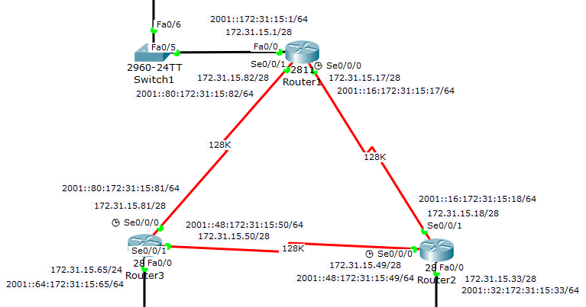

*Router 1*

|  |  |
| --- | --- |
| **Command** | **Description** |
| Router> Enable | Enters privilege mode |
| Router# config t | Enters configuration mode |
| Router(config)# ipv6 unicast-routing | Enables ipv6 unicast routing |
| Router(config)# Int f0/0 | Enters f0/0 interface |
| Router(config-if)# Ip address 172.31.15.1 255.255.255.240 | Sets the ip address and subnet mask |
| Router(config-if)# ipv6 address 2001::172:31:15:1/64 | Sets the ipv6 address and subnet mask |
| Router(config-if)# ipv6 eigrp 307 | Sets up ipv6 eigrp |
| Router(config)#no shutdown | Enables f0/0 interface |
| Router(config)#Int s0/0/0 | Enters serial 0/0/0 interface |
| Router(config-if)#ip address 172.31.15.17 255.255.255.240 | Sets the ip address and subnet mask |
| Router(config-if)# ipv6 address 2002::16:172:31:15:17/64 | Sets the ipv6 address and subnet mask |
| Router(config-if)# clock rate 128000 | Sets the clock rate to 128000 |
| Router(config-if)#ipv6 eigrp 307 | Sets up ipv6 eigrp |
| Router(config-if)#no shutdown | Enables int s0/0/0 |
| Router(config)#Int s0/0/1 | Enters serial 0/0/1 interface |
| Router(config-if)#ip address 172.31.15.82 255.255.255.240 | Sets the ip address and subnet mask |
| Router(config-if)# ipv6 address 2002::80:172:31:15:82/64 | Sets the ipv6 address and subnet mask |
| Router(config-if)# ipv6 eigrp 307 | Sets up ipv6 eigrp |
| Router(config)#router eigrp 307 | Enables and enters eigrp named 307 |
| Router(config-router)#No auto-summary | Disables auto-summary for eigrp |
| Router(config-router)#router-id 172.31.16.200 | Sets the router id to the specified address |
| Router(config-router)#network 172.31.15.0 0.0.0.15 | Sets up a specified network on ospf. In this case .0 network |
| Router(config-router)#network 172.31.15.16 0.0.0.15 | Sets up a specified network on ospf. In this case .16 network |
| Router(config-router)#network 172.31.15.80 0.0.0.15 | Sets up a specified network on ospf. In this case .80 network |
| Router(config-router)#network 172.31.16.200 0.0.0.0 | Sets up a specified network on ospf In this case .200 network |
| Router(config)#ipv6 router eigrp 307 | Sets up ipv6 eigrp |
| Router(config-router)# no shutdown | Enables ipv6 eigrp |

Troubleshooting and debugging:

* ping command: ping 172.31.15.67 --- this command is used to test for connectivity across your network.
* Show ip route: show ip route --- shows the route, what type of protocol is being used, and what port or ip it is connected to.
* Show ipv6 route: show ipv6 route --- does the same thing as the ‘show ip route’ but shows the ipv6 version.
* Show ip interface brief: show ip int brief --- show ip int brief: show ip int brief --- tells us what interface is being used and what ip-address it is connected to.
* Show ipv6 interface brief: show ipv6 int brief: show ip int brief --- tells us what interface is being used and what ip-address it is connected to but in the ipv6
* Show ip protocol: show ip protocol --- shows the protocol that is currently in use along with its networks and gateways.

1. OSPFv2 and OSPFv3 (NOTE: Make sure you utilize loopback interfaces within your topology and configuration…and make sure you specify why you are utilizing them.)

OSPF or open shortest path first is another routing protocol used for routing, and uses a link state routing algorithm. OSPF allows all routers to learn all possible routes throughout all of the subnets that are in the network. OSPF is consider a dynamic routing protocol. OSPF is utilizes the ‘area’ which is the collection of all OSPF configured routers and in order for OSPF to be invoked the area must stay constant throughout the entire network.

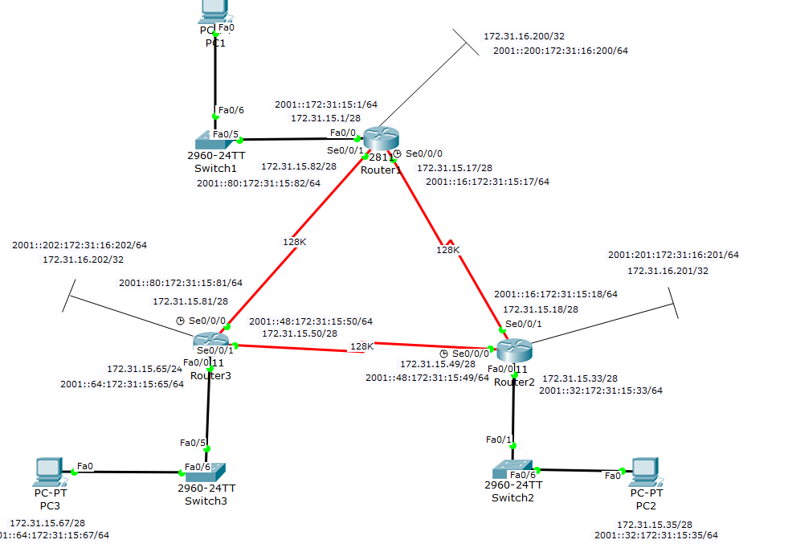

*Router 1*

|  |  |
| --- | --- |
| **Command** | **Description** |
| Router> Enable | Enters privilege mode |
| Router# config t | Enters configuration mode |
| Router(config)# ipv6 unicast-routing | Enables ipv6 unicast routing |
| Router(config)# Int f0/0 | Enters f0/0 interface |
| Router(config-if)# Ip address 172.31.15.1 255.255.255.240 | Sets the ip address and subnet mask |
| Router(config-if)# ipv6 address 2001::172:31:15:1/64 | Sets the ipv6 address and subnet mask |
| Router(config-if)#ipv6 ospf 1 area 0 | Sets up ipv6 ospf in area 0 |
| Router(config)#no shutdown | Enables f0/0 interface |
| Router(config)#Int s0/0/0 | Enters serial 0/0/0 interface |
| Router(config-if)#ip address 172.31.15.17 255.255.255.240 | Sets the ip address and subnet mask |
| Router(config-if)# ipv6 address 2002::16:172:31:15:17/64 | Sets the ipv6 address and subnet mask |
| Router(config-if)# clock rate 128000 | Sets the clock rate to 128000 |
| Router(config-if)#ipv6 ospf 1 area 0 | Sets up ipv6 ospf 1 |
| Router(config-if)#no shutdown | Enables int s0/0/0 |
| Router(config)#Int s0/0/1 | Enters serial 0/0/1 interface |
| Router(config-if)#ip address 172.31.15.82 255.255.255.240 | Sets the ip address and subnet mask |
| Router(config-if)# ipv6 address 2002::80:172:31:15:82/64 | Sets the ipv6 address and subnet mask |
| Router(config-if)#ipv6 ospf 1 area 0 | Sets up ipv6 ospf in area 0 |
| Router(config)# int loopback 0 | Enters the loopback 0 interface |
| Router(config-if)# ip address 172.31.16.200 255.255.255.255 | Sets the ip address and subnet mask |
| Router(config-if)# ipv6 address 2001::200:172:31:15:200/64 | Sets the ipv6 address and subnet mask |
| Router(config-if)#ipv6 ospf 1 area 0 | Sets up ipv6 ospf in area 0 |
| Router(config)#router opsf 1 | Enables and enters ospf 1 |
| Router(config-router)#router-id 172.31.16.200 | Sets the router id to the specified address |
| Router(config-router)#network 172.31.15.0 0.0.0.15 area 0 | Sets up a specified network on ospf. In this case .0 network |
| Router(config-router)#network 172.31.15.16 0.0.0.15 area 0 | Sets up a specified network on ospf. In this case .16 network |
| Router(config-router)#network 172.31.15.80 0.0.0.15 area 0 | Sets up a specified network on ospf. In this case .80 network |
| Router(config-router)#network 172.31.16.200 0.0.0.0 area 0 | Sets up a specified network on ospf In this case .200 network |
| Router(config)#ipv6 router ospf 1 | Enables ipv6 ospf 1 |

Troubleshooting and debugging:

* ping command: ping 172.31.15.67 --- this command is used to test for connectivity across your network.
* Show ip route: show ip route --- shows the route, what type of protocol is being used, and what port or ip it is connected to.
* Show ipv6 route: show ipv6 route --- does the same thing as the ‘show ip route’ but shows the ipv6 version.
* Show ip interface brief: show ip int brief --- show ip int brief: show ip int brief --- tells us what interface is being used and what ip-address it is connected to.
* Show ipv6 interface brief: show ipv6 int brief: show ip int brief --- tells us what interface is being used and what ip-address it is connected to but in the ipv6
* Show ip protocol: show ip protocol --- shows the protocol that is currently in use along with its networks and gateways.

1. Extended ACLs and Extended Named ACLs for IPv4 and IPv6 (NOTE: how, where and why you applying these…)

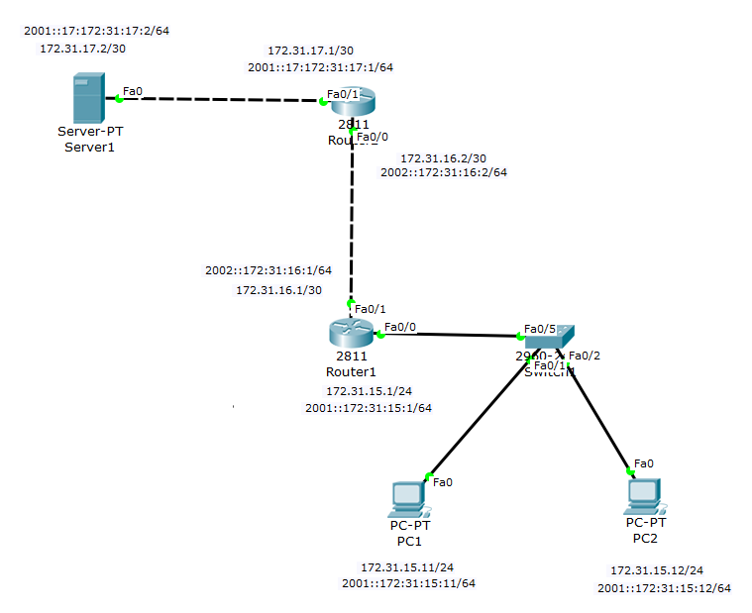

Router 1:

|  |  |
| --- | --- |
| **Command** | **Description** |
| Router> Enable | Enters privilege mode |
| Router# config t | Enters configuration mode |
| Router(config)# ipv6 unicast-routing | Enables ipv6 unicast routing |
| Router(config)# Int f0/0 | Enters f0/0 interface |
| Router(config-if)# Ip address 172.31.15.1 255.255.255.252 | Sets the ip address and subnet mask |
| Router(config-if)# ipv6 address 2001::172:31:15:1/64 | Sets the ipv6 address and subnet mask |
| Router(config)#no shutdown | Enables the f0/0 interface |
| Router(config)#Int f0/1 | Enters f0/1 interface |
| Router(config-if)#ip address 172.31.16.1 255.255.255.252 | Sets the ip address and subnet mask |
| Router(config-if)# ipv6 address 2002::172:31:16:1/64 | Sets the ipv6 address and subnet mask |
| Router(config-if)#no shutdown | Enables int f0/1 |
| Router(config)#ip access-list extended ACCESS | Creates and access the ACCESS(name) extended access list |
| Router(config-ext-nacl)#deny ip 172.31.15.12 0.0.0.0 172.31.17.2 0.0.0.0 | Denys the source ip address and the destination ip address |
| Router(config-ext-nacl)permit ip any any | Permits all other ip address |
| Router(config)#Int f0/1 | Enters f0/1 interface |
| Router(config)#ipv6 access-list ACCESS2 | Creates and access the ACCESS2 extended access list |
| Router(config-ext-nacl)#deny ipv6 2001::172:31:15:12/128 2001::172:31:17:2/128 | Denys the source ip address and the destination ip address |
| Router(config-ext-nacl)# permit ipv6 any any | Permits all other ip addresss |
| Router(config)# int f0/1 | Enters interface f0/1 |
| Router(config-if)#ip access-group ACCESS out | Implements and sets the ACL outward |
| Router(config-if)#ipv6 traffic-filter ACCESS2 out | Implements Ipv6and sets the ACL outbound |
| Router(config-if)#ip route 0.0.0.0 0.0.0.0 172.31.16.2 | Creates a default static route with specified destination host |
| Router(config-if)#ipv6 route ::/0 2002::172:31:16:2 | Creates a ipv6 default static route with the specified destination host |

Router 2:

|  |  |
| --- | --- |
| **Command** | **Description** |
| Router> Enable | Enters privilege mode |
| Router# config t | Enters configuration mode |
| Router(config)# ipv6 unicast-routing | Enables ipv6 unicast routing |
| Router(config)# Int f0/0 | Enters f0/0 interface |
| Router(config-if)# Ip address 172.31.16.2 255.255.255.252 | Sets the ip address and subnet mask |
| Router(config-if)#ip route 0.0.0.0 0.0.0.0 172.31.16.1 | Creates a default static route with the designated destination host |
| Router(config-if)#ipv6 address 2001::172:31:16:2/64 | Sets the ipv6 address and subnet mask |
| Router(config-if)#no shutdown | Enables the int f0/0 interface |
| Router(config)#Int f0/1 | Enters f0/1 interface |
| Router(config-if)#ip address 172.31.17.1 255.255.255.252 | Sets the ip address and subnet mask |
| Router(config-if)#ipv6 address 2001::172:31:17:1/64 | Sets the ipv6 address and subnet mask |
| Router(config-if)#ipv6 route ::/0 2002::172:31:16:1 | Creates a default ipv6 static route with designated destination host |
| Router(config-if)#no shutdown | Enables f0/1 interface |

Troubleshooting and debugging:

* ping command: ping 172.31..17.2 --- this command is used to test for connectivity across your network.

1. Static NAT and Dynamic NAT/PAT for IPv4 (NOTE: Make sure you show a configuration with static NAT for a web server in the DMZ, then PAT using a pool of multiple addresses for internal hosts connecting to the Internet. You should also demonstrate your knowledge of using just the interface IP Address when this is the only available address presented to you.)

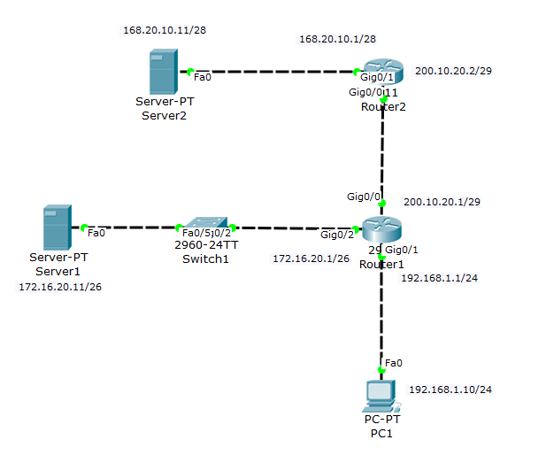

*Router 1:*

|  |  |
| --- | --- |
| **Command** | **Description** |
| Router> Enable |  |
| Router# config t |  |
| Router(config)#int g0/0 | Enters us into gigabitEthernet 0/0 |
| Router(config-if)#ip address 200.10.20.1 255.255.255.248 | Sets the ip address and subnet mask |
| Ip nat outside |  |
| Router(config-if)#no shut | Enables int g0/0 |
| Router(config)#int g0/1 | Takes us into g0/1 interface |
| Router(config-if)#ip address 192.168.1.1 255.255.255.0 | Sets the ip address and subnet mask |
| Ip nat inside |  |
| Router(config-if)#no shut | Enables int s0/0/0 |
| Router(config)#int g0/2 |  |
| Ip |  |
| Router(config-if)#ip address 172.16.20.1 255.255.255.192 | Sets the ip address and subnet mask |
| Router(config)#ip route 0.0.0.0 0.0.0.0 200.10.20.2 | Gives the router a default static route |
| Router(config)#ip ip nat pool PUBLIC 200.10.20.3 200.10.20.4 netmask 255.255.255.248 |  |
| Router(config)# ip nat inside source list PRIVATE pool PUBLIC overload |  |
| Router(config)#ip nat inside source static 172.16.20.1 200.10.20.1 |  |
| Router(config)#ip access-list standard PRIVATE |  |
| Router(config-std-nacl)#permit 192.168.1.0 0.0.0.255 |  |
| Router(config-std-nacl)#deny any |  |

Troubleshooting and debugging:

* ping command:

1. DHCP Server on the Router and a local DHCP client and a remote DHCP client (ie: using DHCP Relay.)

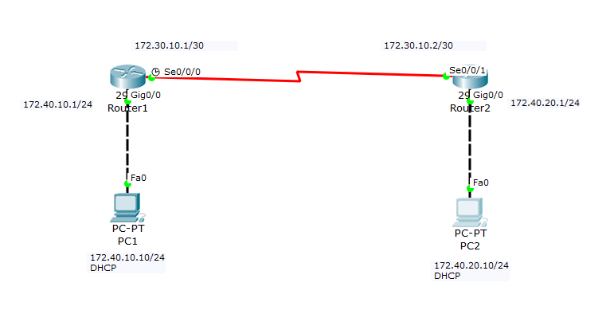

*Router 1:*

|  |  |
| --- | --- |
| **Command** | **Description** |
| Router> Enable |  |
| Router# config t |  |
| Router(config)#int g0/0 | Enters us into gigabitEthernet 0/0 |
| Router(config-if)#ip address 172.40.10.1 255.255.255.0 | Sets the ip address and subnet mask |
| Router(config-if)#no shut | Enables int g0/0 |
| Router(config)#int s0/0/0 | Takes us into s0/0/0 interface |
| Router(config-if)#ip address 172.30.10.1 255.255.255.252 | Sets the ip address and subnet mask |
| Router(config-if)#no shut | Enables int s0/0/0 |
| Router(config)#ip route 0.0.0.0 0.0.0.0 172.30.10.2 | Gives the router a default static route |
| Router(config)#ip dhcp excluded-address 172.40.10.1 172.40.10.5 | Sets the excluded address of the dhcp between .1 and .5 |
| Router(config)#ip dhcp pool INET | Names the dhcp pool INET |
| Router(dhcp-config)#network 172.40.10.0 255.255.255.0 | Gives the dhcp a network address |
| Router(dhcp-config)#default-router 172.40.10.1 | Sets the default router to specified address |

*Router 2:*

|  |  |
| --- | --- |
| **Command** | **Description** |
| Router> Enable |  |
| Router# config t |  |
| Router(config)#int g0/0 |  |
| Router(config-if)#ip address 172.40.20.1 255.255.255.0 |  |
| Router(config-if)#no shut |  |
| Router(config-if)#ip helper 172.30.10.1 | Relays dhcp from remote to the dhcp server |
| Router(config)#int s0/0/1 |  |
| Router(config-if)#ip address 172.30.10.2 255.255.255.252 |  |
| Router(config-if)#no shut |  |
| Router(config)#ip route 0.0.0.0 0.0.0.0 172.30.10.1 |  |

Troubleshooting and debugging:

* ping command:

1. PPP using PPP CHAP

|  |  |
| --- | --- |
| **Command** | **Description** |
| Router> Enable |  |
| Router# config t |  |
| Router(config)#hostname CHAP1 |  |
| Router(config)#username CHAP2 password cisco |  |
| Router(config)#int g0/0 |  |
| Router(config-if)#ip address 172.31.9.1 255.255.255.0 |  |
| Router(config-if)#no shut |  |
| Router(config)#int s0/0/0 |  |
| Router(config-if)#ip address 172.31.10.1 255.255.255.252 |  |
| Router(config)#encapsulation ppp |  |
| Router(config)#ppp authentication chap |  |
| Router(config-if)#no shut |  |
| Router(config)#ip route 0.0.0.0 0.0.0.0 172.31.10.2 |  |

|  |  |
| --- | --- |
| **Command** | **Description** |
| Router> Enable |  |
| Router# config t |  |
| Router(config)#hostname CHAP2 |  |
| Router(config)#username CHAP1 password cisco |  |
| Router(config)#int g0/0 |  |
| Router(config-if)#ip address 172.31.11.1 255.255.255.0 |  |
| Router(config-if)#no shut |  |
| Router(config)#int s0/0/0 |  |
| Router(config-if)# ip address 172.31.10.2 255.255.255.252 |  |
| Router(config-if)#encapsulation ppp |  |
| Router(config-if)#ppp authentication chap |  |
| Router(config-if)#no shut |  |
| Router(config)#ip route 0.0.0.0 0.0.0.0 172.31.10.1 |  |