Mark Miller Lab 8 Normalization March 25, 2017

Part 1: Er Diagram

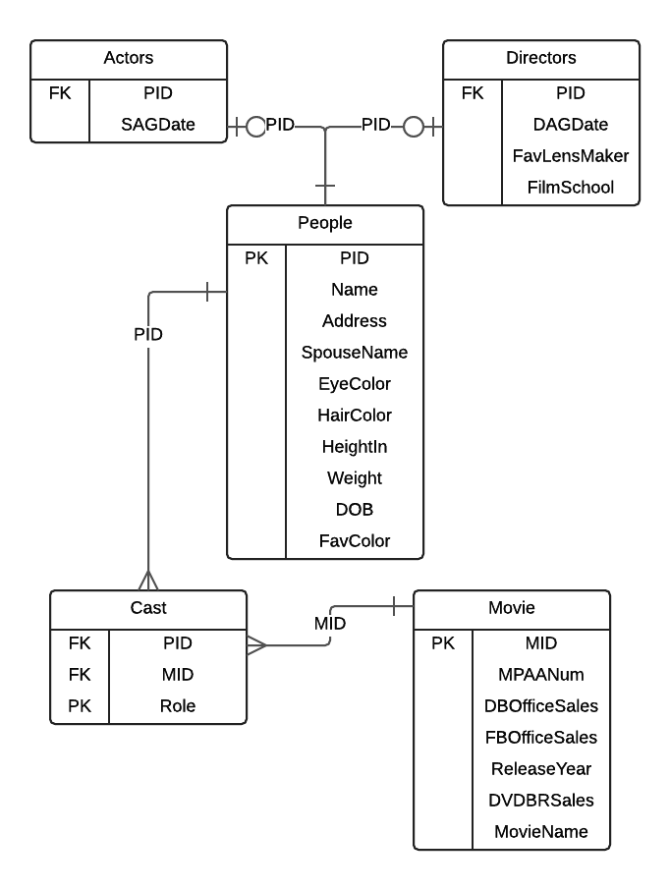

Part 2: Functional Dependencies

1. Actors Table:

PID 🡪 SAGDate

1. Directors Table:

PID 🡪 DAGDate, FavLensMaker, FilmSchool

1. People Table:

PID 🡪 Name, Address, SpouseName, EyeColor, HairColor, HeightIn, Weight, DOB, FavColor

1. Crew Table:

PID, MID, Role (no dependency)

1. Movies Table:

MID 🡪 MPAANum, DBOfficeSales, FBOfficeSales, ReleaseYear, DVDBRSales, MovieName

-

Part 2: SQL Code