 | The Royal British Legion  PARIS BRANCH  MINI-NEWSLETTER  JANUARY 2010

Chairman’s Report

Your Committee wishes you a very Happy and Prosperous New Year.

Since we last reported the 2009 AGM had to be postponed because of the RER Ligne A strike in December. At the postponed meeting which took place on 7th January 2010 we elected and welcomed to the Committee two new members, Vicky Millett and Edwin Gould. We thank them for agreeing to stand and we look forward to working with them..

Now that the move to rue des Acacias is complete the regular programme of Social Events can recommence, and you will find attached the proposed lunch dates. Our new House Manager Tony Bennett has kindly undertaken to open the Clubhouse every Wednesday lunch-time, starting on 3rd February, and providing lunch and the bar facilities. For this no prior booking is required. In addition there will be a monthly Club Lunch for which prior booking will be required however. The dates for these lunches are listed on Page 2 below in “For Your Diary”. Details of the Club Lunches are shown on Page 3. In addition to the lunches we are considering restarting the Film evenings in the Clubhouse when a light supper would be served. Details of these will follow.

Attached you will also find the List of the Christmas Tombola prize-winners. Your Committee thanks all those who took part, and so supporting our General Fund.

« We will remember them »

Contents
Chairman’s Report Page One
For Your Diary Page Two
Club Lunch dates Page Three
Christmas Tombola Winners Page Four
Have you paid your sub? Page Five & Six
_________________________________________________

FOR YOUR DIARY

Club Lunches.

January Wednesday 27th

February Thursday 18th .

March Thursday 25th

Please see enclosed notice and contact Joan Hicks if you would like to attend.

Wednesday opening:
3 Feb Wed 12h00 - 14h00 - The old club tradition of providing bar service and simple weekly lunches, (on Wednesdays) will start as from this date under the auspices of Tony Bennet - and those of you who recall the days when he and his wife Dorothy fed ravening crowds of members at rue Boudreau, largely on their delicious curries and chili will be anxious to drop in and try one for old times sake.
There will be (initially) one spicy dish and one non-spicy dish available. Prices have not been decided but will be very reasonable.
You can, of course, just drop in for a drink too.
In order to help Tony calculate how many people are likely to come to this first Wednesday, if you think you are likely to come (and of course if you have e-mail), could you drop him an line at benland@orange.fr,
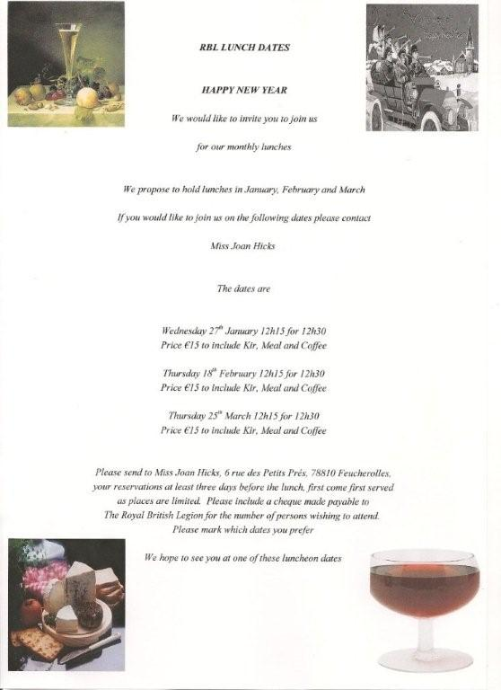

 | The Royal British Legion  Paris Branch: 8 rue Boudreau, 75009 Paris. Telephone 01 47 42 19 26  http://www.rblfrance.org paris@rblfrance.org | Patron: Her Majesty The Queen  Hon. President: H.B.M. Ambassador  Incorporated by Royal Charter  All communications should be addressed to the Secretary

19 Jan 2010

Dear Member,

Annual Subscription

May I add my best wishes to those which I am sure our Chairman has expressed elsewhere in this Newsletter.

Should you have paid your subscription, please ignore this and move on to the next page. If not, may I remind you that we are obliged to return all non-issued cards by the end of January. Thus I should really be grateful if you would let us have your sub without delay.

Your membership and your continued support are both exceedingly valuable to us and we very much hope that we can count on you for 2010 which, with our new premises up and running, promises to be a particularly interesting year.

On the back of this letter you will find a subscription form indicating amounts, address, etc.

We look forward to hearing from you,

Yours very sincerely,

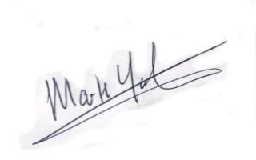

Mark Yates
Membership secretary.
The Royal British Legion Paris Branch

Poppy Appeal et Cotisations 2009/10
Poppy Appeal & Subscriptions 2009/10

    - Normal / Normale 46 Euros
    - Reduced / Réduite (65 and + / 65 ans et +) 37 Euros
    - 25 years and under / 25 ans ou moins 21 Euros

Poppy Appeal contribution
Don au "Poppy Appeal" .........................

Annual subscription
Cotisation annuelle .........................

Administrative Fund donation
Don aux fonds administratifs .........................

TOTAL .........................

Name / Nom .............................................................................................

Address / Adresse ...................................................................................

.............................................................................................

e-mail ……………………………………………………..……...

Please tick the box below if you require a fiscal receipt and, if so,
enclose a stamped addressed envelope.

Veuillez cocher la case si vous désirer un récépissé fiscal et, dans ce cas,
joindre une enveloppe timbrée à votre attention.

Please make your cheque payable to the "Royal British Legion".
Veuillez établir votre cheque à l’ordre de "Royal British Legion"

Royal British Legion. 28 rue des Acacias 75017 PARIS . Tel 01 47 42 19 26
Website : http://www.rblfrance.org/ e-mail : paris@rblfrance.org

