 | The Royal British Legion  Paris Branch: 28 rue des Acacias 75017 PARIS  Tel 01 47 42 19 26  Website: http://www.rblfrance.org/ e-mail: mfyates@gmail.com | Patron:  Her Majesty The Queen  Hon. President:  H.B.M. Ambassador  Incorporated by Royal Charter
FEBRUARY 2013 NEWSLETTER - Chairman’s Report

As we go to press it is still January, time enough to wish you and your families a very Happy and Peaceful New Year. This year sees the 60th Anniversary of H.M. The Queen’s Coronation, and your Committee has planned a British and Commonweath event at the Ecole Militaire to celebrate this very special landmark. The British Ambassador, our Patron in France, has accepted our invitation to be our guest-of-honour. You will find details on Page Six below to enable you to book your tickets well in advance. Janet Warby and Joan Hicks are working hard on this project, and we hope you will give their event the support it deserves.

Let us welcome our new Committee members who were elected at our A.G.M. Peter Huggins, James Weatherlake, Stephen Parry and Jon Copper agreed to stand and we are sure they will enjoy the comradeship which the members of the Committee generate. We salute David Edwards who stands down. We thank him for his ready support in the past and we are certain that we shall continue to have the benefit of his counsels when he comes back to Paris in June.

Joyce Gilhooley has just stood down as our Poppy Appeal Organizer, and we thank her for the dedication she has shown which resulted in a constantly rising campaign total on her watch. In 2012 we reached a record 14,373€, thanks to a great extent to the donation made by our President Gyles Longley from the sales of his autobiography, and we thank him very warmly for his outstanding generosity. The campaign included a very successful Ceilidh, and we would hope to repeat the event in 2013.

We thank Beatrix de Montgermont-Keil for her gripping account on Pages 3-4 below of the moment when her parents’ property in Normandy was liberated by American troops shortly after the Allied landing. We do encourage members who may have a wartime story to tell to dig deep in their memories and record those events for us, as Beatrix has kindly done.

Included here you will find the list of the prizewinners in the Christmas Tombola Draw. A number of prizes have not yet been claimed, so if you have kept your stubs do please check to see if you have won a prize. Finally Joan Hicks and Tony Bennett have now firmed up on the dates of our Club Lunches from April onwards. The February and March dates have already been announced. We thank Tony for the excellent Christmas lunches which he prepared for us, and we also thank Ben for the help given to Tony and for keeping our Clubhouse so clean.

“We will remember them”

CONTENTS

Page One: Chairman’s Report
Page Two : Christmas Tombola Draw Results
Page Three: “Libération de la Propriété de mes Parents” by Beatrix Montgermont-Keil.
Page Five: Club Lunches
Page Six: 60th Anniversary of H.M. The Queen’s Coronation

THE ROYAL BRITISH LEGION
CHRISTMAS DRAW WINNERS, PRIZES AND TICKET NUMBERS
DECEMBER 2012

NAME PRIZE TICKET NUMBER TAKEN/NOT TAKEN

O.G. Longley Bottle of Gin 3383 Not taken
Mitchell Roy & Jan Bottle of Whisky 3308 Not taken
Hopkin Midge Foie Gras Basket 7633 Not taken
Peron Mariette Mini Xmas Tree 2297 Taken
Hicks Joan Chocolates 0800 Taken
Peridi Cups and Saucers 2692 Taken by J. Hicks
Leck C. Glasses 3118 Not Taken
Liberman, Dr. J-P Book on London 1031 Taken
Camus Book 2767 Not Taken
Riaz Pascal Book 0605 Taken
Davey Ken Mini Santa 2149 Not Taken
De Saint Jean Marcelle Diary 1604 Not Taken
Levalleur Bottle of Whisky 1012 Taken
Wilbrenninck Noel Bottle of Whisky 0609 Taken
Gautier Lynham Disney DVD 0974 Not Taken
Blanchard Bottle of Gin 2778 Not Taken
Roux Disney DVD 3272 Not Taken
Spencer-Bernard Lindy Foie Gras plate
and slice 2465 Taken
Huggins Peter Disney Dress 3471 Not Taken
Wells David DFDS Boat Trip 0452 Taken sent by Secretary
Warby Roger RBL Engraved
Glasses 1026 Taken
Renouard Photo Frame 2358 Not Taken
Gould Edwin Photo Frame 0868 Taken
Auduc Jean-Jacque Disney Dress
& Box 2529 Taken sent by Secretary
Barbot Disney lampshade 0944 Not Taken
McDonald Photo Frame 0559 Taken

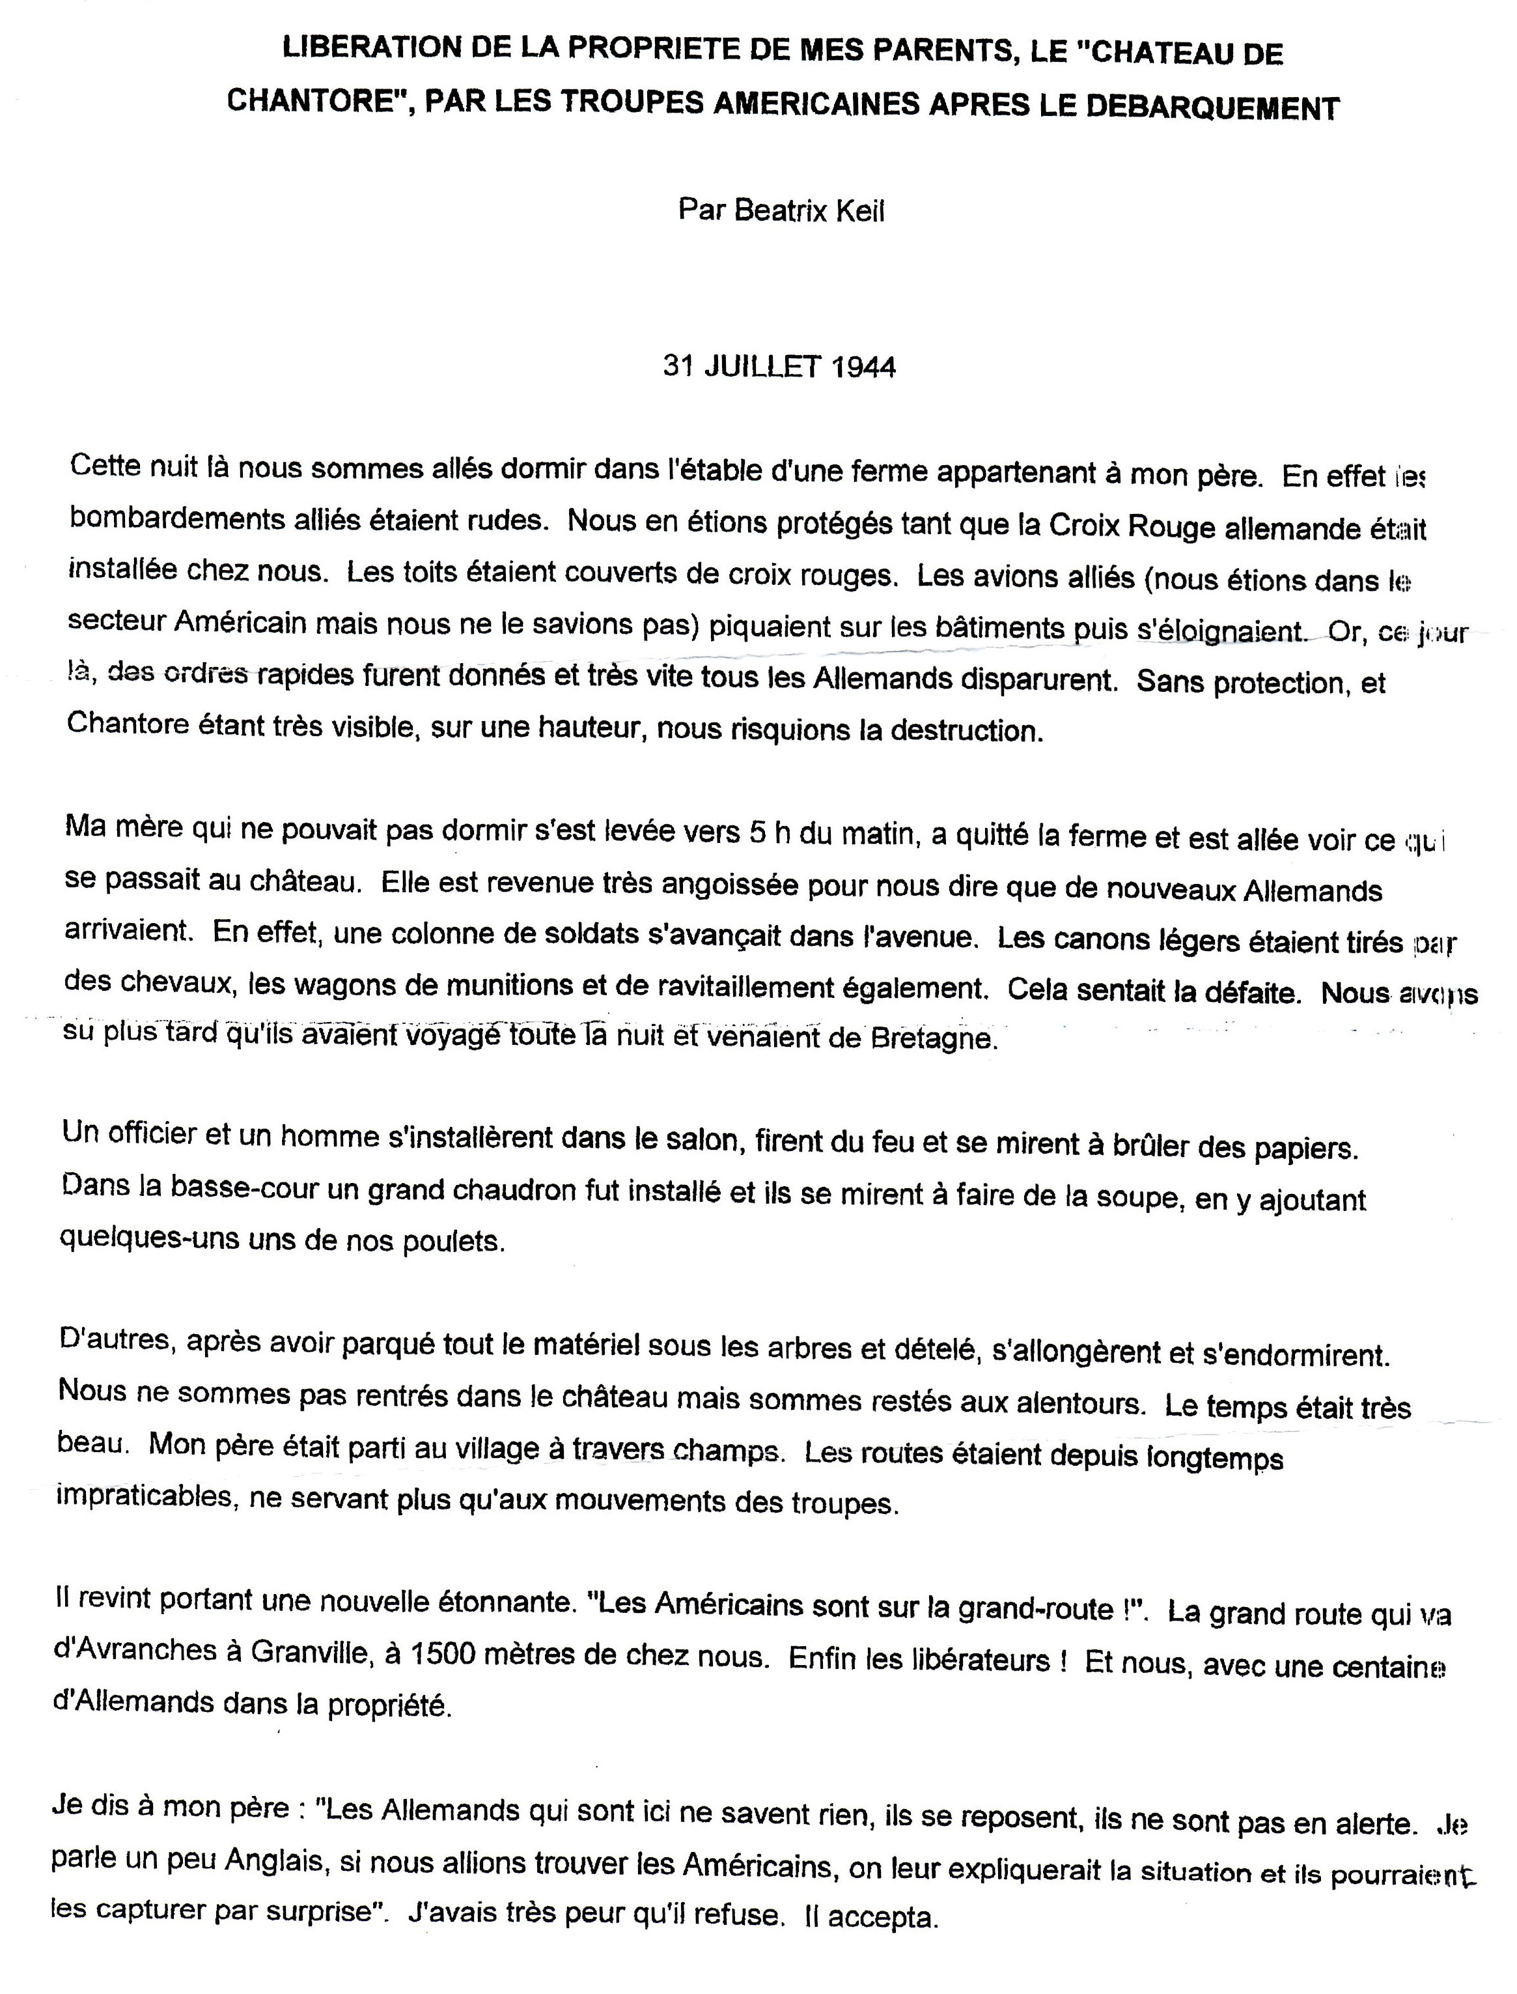
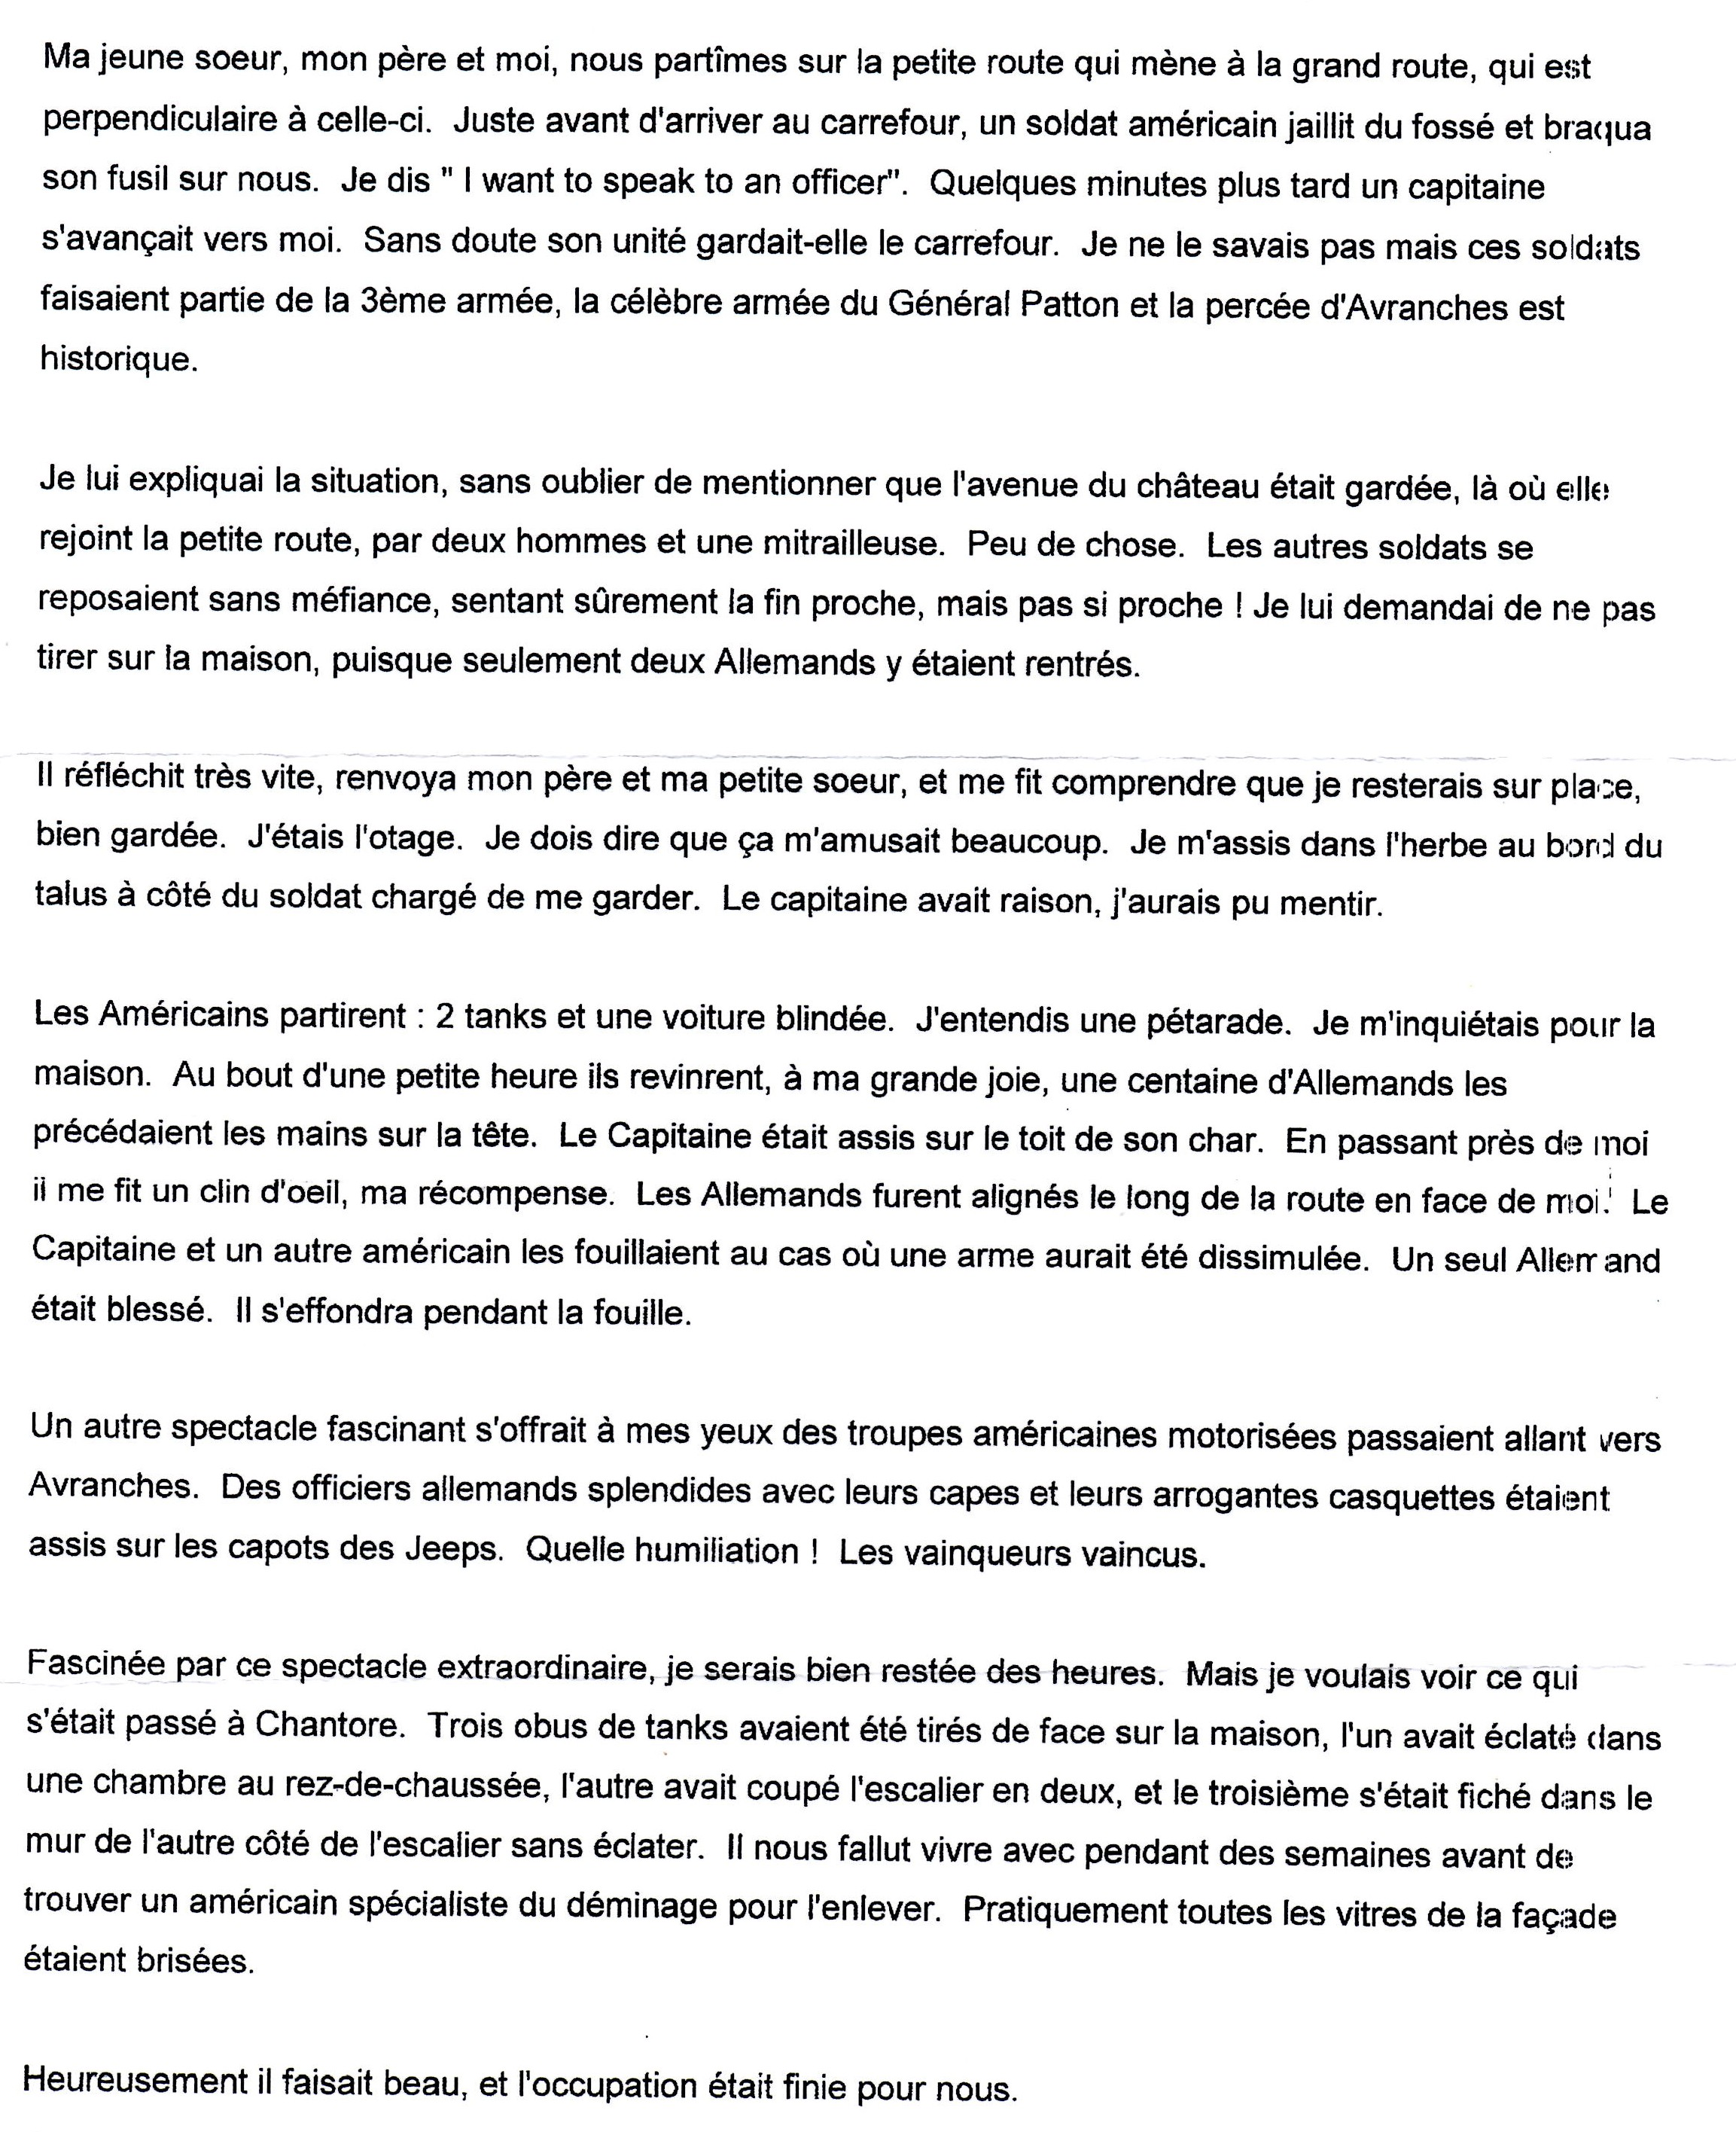

THE ROYAL BRITISH LEGION
PARIS BRANCH

CLUB LUNCHES

Dear Members,

Please find below the dates of the lunches proposed from now until October.

All lunches include welcome Kir, Coffee/Tea and a three course meal.
The price is €16 per person and the time is 12h15 for 12h45.

Please indicate on the reply slip below your preferred dates. Could we ask that you send us one cheque per lunch; this makes life a lot easier for accounting purposes. Should you need to cancel your attendance, please inform Miss Hicks no later than 48 hours before the lunch. We cannot reimburse your cheque after that time.

Hope to see you at one of the lunches.

Joan Hicks
Social Secretary

THE ROYAL BRITISH LEGION
PARIS BRANCH

CLUB LUNCHES REPLY SLIP

I ______________________________________ Telephone number _________________________________

Would like to reserve _________________ place(s) for the following lunch(es)

Wednesday 13th Feb ___________ Thursday 14th March ______________________

Thursday 25th April _____________ Thursday 23rd May _____________________

Wednesday 19th June ___________ Thursday 25th July ______________________

Wednesday 25th September _______ Thursday 24th October ___________________

I enclose one cheque for each lunch mentioned above, made payable to The Royal British Legion for €__________________

I will be accompanied by ______________________________________________________________________

Signed ________________________________________ Dated ______________________________

Please send your reply slip to : Miss Joan Hicks, 6 rue des Petits Prés, 78810 Feucherolles, telephone number 01 30 54 33 06
Or contact joan.hicks@orange.fr

60th Anniversary of H.M The Queen’s Coronation
Dear Members,
Last year was the 60th Anniversary of Her Majesty The Queen’s Accession to the Throne. We had intended to hold an event, but due to many British Community activities around the same time, it was decided by your Committee to put our plans on hold and to stage a Cocktail Dînatoire to celebrate the 60th Anniversary of Her Majesty’s Coronation this year. The date has been set and our Ambassador has kindly agreed to be our principal guest. We intend to extend the invitation not only to you our members, but also to Commonwealth Ambassadors, British and Commonwealth Defence and Military Attachés, members of their staff, French Military VIP’s and the British Community in Paris. Friends and family are also welcome.

The date : Friday 14th June, 2013
The venue : Ècole Militaire
The time : 19h00 until 22h00
The price : 38€ per person.
Free car park in the grounds of the Ecole Militaire.

To reserve your place(s) for this event please send your cheque payable to ‘The Royal British Legion’ for the full amount to Miss Joan Hicks, 6 rue des Petits Prés, 78810 Feucherolles, before Friday 31st May, 2013. Please name all members of your party for security reasons. Proof of I.D. will be required.

Please send your reply slip to : Miss Joan Hicks, 6 rue des Petits Prés, 78810 Feucherolles, telephone number 01 30 54 33 06
Or contact joan.hicks@orange.fr

If you would like to attend this event and park your car at the Ecole Militaire, please fill out the slip below and send it to Miss Joan Hicks at the address above.

CORONATION CELEBRATIONS
AT ÈCOLE MILITAIRE
FRIDAY 14th JUNE 2013

I ______________________________ would like to reserve ____________________ place(s)

for ________________ persons

Names of Guests______________________________________________________________

I enclose my cheque made payable to ‘The Royal British Legion’ for _________________€

I would like to bring my car in the car park within the Ecole Militaire grounds.

The Registration N° of my car is ______________________ The colour is ______________

The make of my car is ____________________________________________________

Signed ___________________________ Dated ____________________________

