
THE BEGINNING OF THE END

The latest in the series of battlefield visits led by Colonel Oliver Warman (Balliol; late Welsh Guards) will take us to the northern Ardennes, and to the site of the allied crossing of the Rhine at Remagen Bridge. Oliver gives us as the theme of this visit « The Beginning of the End ». Interestingly, for those fascinated by the Appeasement movement, Oliver also plans to take us also to Bad Godesburg in the footsteps of Neville Chamberlain, a site symbolic of a period which might be tagged the Beginning of the Beginning.

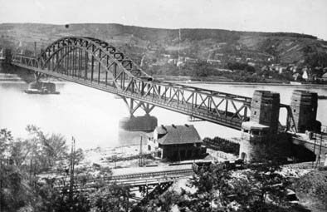 | 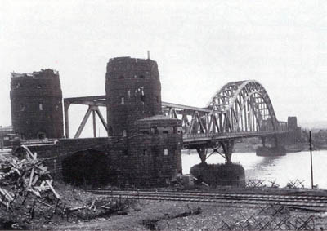  The Remagen Bridge at various stages  in its history | 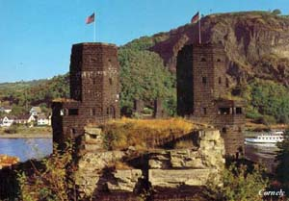

Our visit will take place on Friday 16th-Sunday 18th October. The party will leave the Gare du Nord at 8.25 a.m. on the Friday, arriving at Köln at 12.15 p.m. The party will be met by a private transfer bus to our hotel in the centre of the Old Town, the Maritim Hotel. At 2 p.m. our Coach leaves the hotel for the first part of the tour, returning that evening. Then the Saturday part of the tour will be an all-day affair, finishing with a Rhine Steamer cruise in the late afternoon, hopefully before Götterdämmerung sets in.

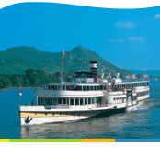
The party return to Paris by the 3.44 p.m. train on Sunday 18th October, arriving at the Gare du Nord at 7.35 p.m.

The cost of the visit breaks down as follows:

- Return train journey, in Thalys 2nd Class, at today’s group price of 130 euros per seat (later bookings by our facilitator would lead to a higher price).

- Hotel (2 nights), including breakfast, transfer bus to/from the station, air-conditioned coach for the tour, Rhine cruise and local taxes: Prices depend on the size of our party, ranging from 218 euros each for a group of 21-22, to 237 euros each for a group of 15-16 only. There would be a 50 euro supplement for a single room.

Although Oliver makes no charge to us for his services we must offer to contribute to his travel and hotel expenses, which should not exceed 50 euros per person, depending on how many we are. Apart from that the only important extras will be the cost of lunch and dinner on Friday and Saturday, and of lunch on Sunday..

If you wish to come on this tour please let Roger Thorn know as soon as possible on: roger.thorn@wanadoo.fr. As always guests are most welcome to join us. Provisional bookings have been made for the train and hotel, and further details will be released as soon as these bookings have been confirmed.

