 | The Royal British Legion  Paris Branch: 28 rue des Acacias 75017 PARIS  Tel 01 47 42 19 26  Website: http://www.rblfrance.org/ e-mail: paris@rblfrance.org | Patron:  Her Majesty The Queen  Hon. President:  H.B.M. Ambassador  Incorporated by Royal Charter
MINI-NEWSLETTER

JANUARY 2015
____________________________________________________________________
Chairman’s Report

La France est actuellement en deuil pour les victimes des attentats terroristes de cette semaine. Nous les britanniques avons envie d’assurer nos amis français que nous partageons votre douleur et nous exprimons nos sincères condoléances aux familles des victimes. Nous sommes tous Charlie, des invités dans votre pays tellement hospitalier. Nous sommes très touchés par la solidarité nationale que vous êtes en train de manifester.

At this time we traditionally wish each other a Happy New Year. The events of this last week give these wishes a hollow ring, but let us wish each other and our families a brighter tomorrow in the rest of 2015.

We are pleased to report that the 2014 Poppy Appeal Campaign was a great success for the Paris Branch. Our revenues exceeded the 2013 total by 22%. Warm thanks to Bridget Terrell, supported by Janet Warby. Our thanks also to the many who assisted with the distribution of Poppies and the counting of the boxes.

We are passing through a period of frequent commemorations at the Centenary of the battles of the Great War. We have already reported here on the ceremonies where your Branch has been represented, and we shall continue to do so. On 12th November we hosted a lunch for a party of members of the Cameronian Society who had attended our Service of Remembrance in Notre Dame the day before. Branch member Nick Daglish, who served in this Regiment, informs us of a ceremony on 8th March at Neuve Chapelle to commemorate the participation of the Regiment in that battle in 1915. We hope members of the Paris Branch will wish to attend and we will keep you informed of the details a little nearer the date. In May this year we shall go to Ypres to visit the sites of the battles on the Salient in 1914, 1915, 1917 and 1918. We gather there on 14th May and disperse on 17th May. Details will be circulated shortly. We shall be led once more by our guide Colonel Oliver Warman, late Welsh Guards.

Branch member Madame Sabine Armengaud has received a letter from the office of H.M. The Queen thanking her for the gift of a book entitled “Les Grandes Enigmes de la Résistance” which she had made on the occasion of H.M. The Queen’s State Visit to France in June of last year. A copy of this letter is attached. Sabine’s late husband Alain was awarded the King’s Medal for Gallantry for the part he played in leading a Réseau in the South of France. A copy of this award hangs in our Clubhouse.

Below you will find the Calendar of Monthly Lunches in our Clubhouse. (You can see these at any time on our website rblfrance.org – click on “Paris” then “What’s on”). At this time we thank Tony Bennett for his loyal service in catering for us. Tony prepared an excellent Christmas Lunch on 15th December. The draw for the Tombola was held on that occasion, and the list of prize-winners is attached below.

Branch members Madame Nadine Kinloch and Mr Brian Goddard have died in the last fortnight and we express our condolences to their families.

“We will remember them”

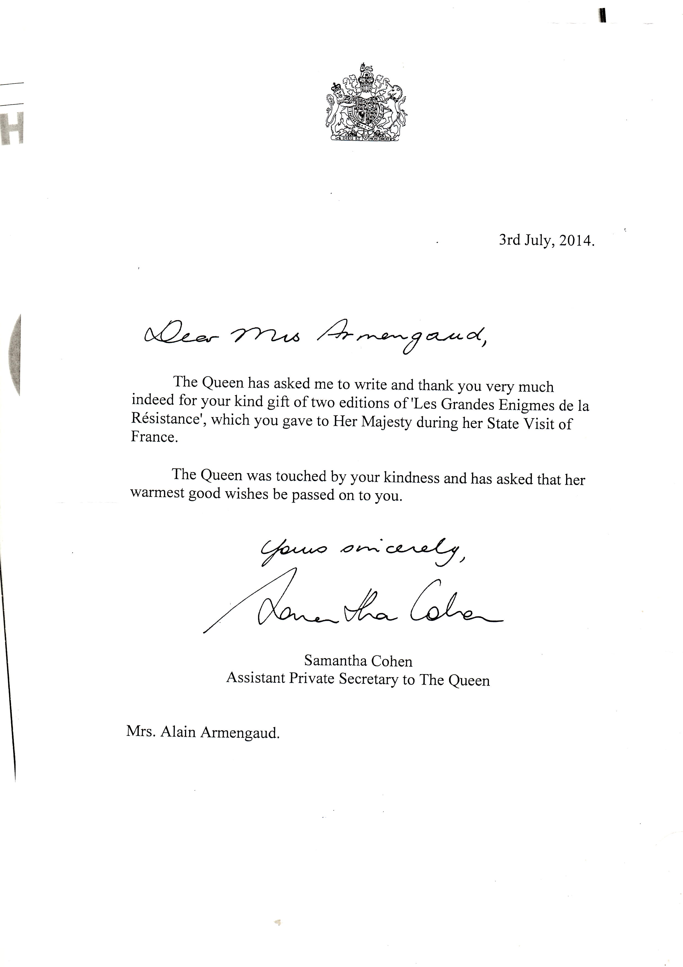
RBL MONTHLY LUNCHES

2015

January Thursday 22nd

February Thursday 19th

March Thursday 19th

April Thursday 16th

May Thursday 21st

June Thursday 11th

July Thursday 9th

August No lunch

September Wednesday 23rd

October Thursday 15th

November Thursday 26th

December Friday 18th

Please make out one cheque for each lunch date you intend to attend. We ask that you give us 3 days notice if you cannot attend so that we can return your cheque otherwise you will be charged for the lunch. Our Cook will cater for the numbers he is informed of. We also ask you to issue one cheque for each lunch date, this is for accounting purposes.

We enclose a reply slip for the first six monthly lunches.

Joan M. Hicks
Events Organiser

THE ROYAL BRITISH LEGION
PARIS BRANCH

REPLY SLIPS FOR LUNCH

I _______________________________________________________________________________

Would like to reserve _____________________ place(s)

For lunch on Thursday 22nd January, 2015*

For lunch on Thursday 19th February, 2015*

For lunch on Thursday 19th March, 2015*

For lunch on Thursday 16th April, 2015*

For lunch on Thursday 21st May, 2015*

For lunch on Thursday 11th June, 2015*

* Please tick the lunch you wish to attend

I enclose one cheque for each of the dates I have indicated above made payable to 'The Royal

British Legion. The cost of the lunch is € 16.00 per person I therefore enclose my cheque for

€………

I understand that I must give 3 days notice if I have to cancel to recoup my cheque otherwise I will be charged for the lunch I say I intend to attend.

Signed ______________________________________________________________

Dated _______________________________________________________________

The Royal British Legion
Christmas Tombola Results 2014

Name Ticket number Prize Taken/Not Taken

Mr. Serena 00786 Sparkling Pink Wine Not Taken
Oliver Riols 01954 Childrens Books + DVD Taken
Michel Mambret 01866 Whisky Taken
Gyles Longley 01226 Chocolates Taken by R. Thorn
Tony Bennett 01787 Grants Whisky Taken
Claude Chernart 021261 Christmas pudding Not Taken
Charlotte Hadley 01424 Baileys Liqueur Taken
Joseph Sigwood 00757 China Tea Mug Not Taken
David Bean 01487 Brittany Ferries Tickets Taken
Robert Gillespie 01590 Man Bag Not Taken
Peter Huggins 00319 Vodka Not Taken
Graham Scott 00840 Lunch for 1 person Voucher Taken
Riols, C 01960 Mixed Bag of goodies Taken
Muriel Langle 01262 Quality Street Chocolates Not Taken
David Lees 00074 Lunch for 2 at Legion Voucher Not Taken
Humbert Peridi 02624 Christmas Candle Holder Not Taken
Joan Hicks 00430 Ceramic Kitchen Knife Set Taken by V. Millet
Clair Fullerton 01629 DFDS Ferry Crossing Taken
Jim Cockle 00258 Multi Vap Digital Steamer Taken by J. Warby

The Officers and Committee would like to thank all those who took part in this Tombola. Would anyone wishing to collect their prize please contact Miss Joan Hicks on 01 30 54 33 06 or 06 19 17 34 48. We will then arrange with you a suitable time for collection at the Legion.

