Loong, Hashimi D.

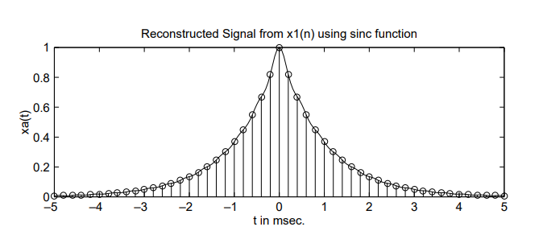

**EXAMPLE 3.21** From the samples x1(n) in Example 3.19a, reconstruct xa(t) and comment on the results.

**Solution:** x1(n) is obtained by sampling far(t) at Ts = 1/Fs = 0.0002 s. We will use a grid spacing of 0.00005 s on −0.005 ≤ t 0.005, which gives x(n) on −25 ≤ n 25.

**MATLAB script:**

% Discrete-time Signal x1(n)

>> Ts = 0.0002; n = -25:1:25; nTs = n*Ts; x = exp(-1000*abs(nTs));

% Analog Signal reconstruction

>> Dt = 0.00005; t = -0.005:Dt:0.005; >> xa=x* sinc(Fs*(ones(length(n),1)*t-nTs’*ones(1,length(t))));

% check >> error = max(abs(xa - exp(-1000*abs(t))))

error = 0.0363

The maximum error between the reconstructed and the actual analog signal is 0.0363, which is due to the fact that xa(t) is not strictly band-limited (and also we have a finite number of samples).

**EXAMPLE 3.22** From the samples x2(n) in Example 3.17b reconstruct xa(t) and comment on the results.

**Solution:** x2(n) is obtained by sampling xa(t) at Ts = 1/Fs = 0.001 s. We will again use a grid spacing of 0.00005 s on −0.005 ≤ t 0.005, which gives x(n) on −5 ≤ n 5

**MATLAB script:**

% Discrete-time Signal x2(n)

>> Ts = 0.001; n = -5:1:5; nTs = n*Ts; x = exp(-1000*abs(nTs));

% Analog Signal reconstruction >>

Dt = 0.00005; t = -0.005:Dt:0.005; >> xa=x* sinc(Fs*(ones(length(n),1)*t-nTs’*ones(1,length(t))));

% check >> error = max(abs(xa - exp(-1000*abs(t))))

error = 0.1852

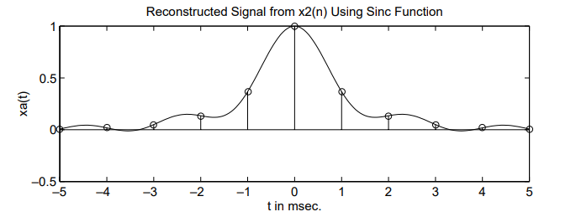

The maximum error between the real analog signal and the reconstructed signal is 0.1852, which is very significant and cannot be attributed to the band-unlimited nature of xa(t) alone. From Figure 3.17, it is observed that the reconstructed signal differs from the actual signal at many locations in the interpolation region. Here is a visual demonstration of aliasing in the time domain.