Mark Yen

EML 2023

Project Description:

**Objectives of the Design:**

The objective of this sharpener is to appeal to children and young adults who are fans of the Minions characters. In addition, the sharpener allows the user to sharpen twice as fast with a 2:1 gear ratio system. Finally, the sharpener can be attached to smooth surfaces for sharpening stability.

**Concept Selection:**

I chose design 3 because it was a mix of design 1 and 2. Design 1 had the crank to rotate the sharpener and suction cups to attach to tables, but it only had a pill-shaped outer shell. Design 2 had the Minion outer shell, but it did not have the crank nor the suction cups. Design 3 utilized both the speed of sharpening with the crank and the outer appeal to children as well as the suction cups.

However, in design 3, the Minion had a full smile with the hole for pencils in the center of the smile. In the actual project, the smile was not made because of the complexity of the shape of the mouth and the teeth. Therefore, only the hole was made.

**Functionality:**

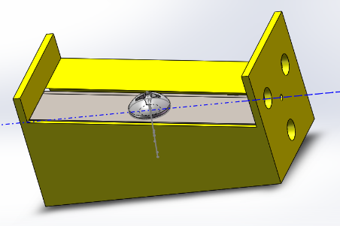A video of the sharpener assembly has been included in the zip folder.

A Philips screw will secure the blade to the sharpener plastic base. Drawing file for Philips screw came from McMaster-Carr.

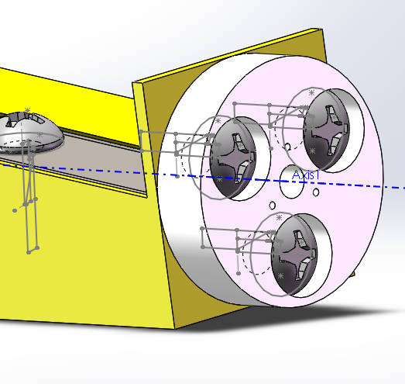

3 more Philips screws will secure a plastic rotational base to one end of the sharpener base. It is the end that does not have the hole for the pencils.

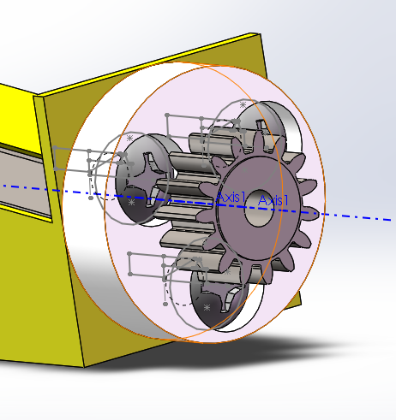

A small gear with 3 pegs will be fitted into 3 corresponding holes on the rotational base. The pegs and the holes should not slide easily.

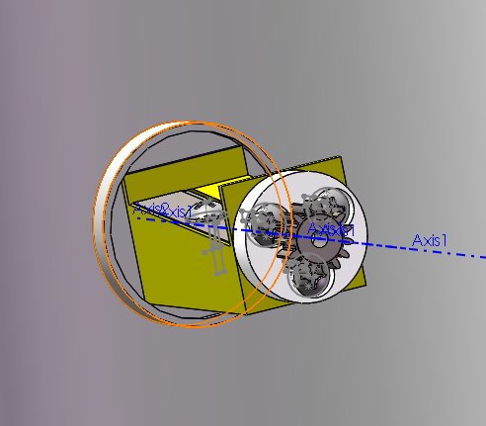

The other end of the sharpener base will then fit into a raised cylinder with a hole that is located in the interior of the front shell. The sharpener base and the hole should have a running fit. In addition, the hole for pencils in the sharpener base should be aligned with the hole for pencils in the front shell.

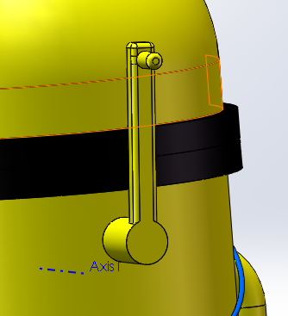

The crank handle will then be inserted into the large hole in the back shell. The crank handle and the hole should have a running fit.

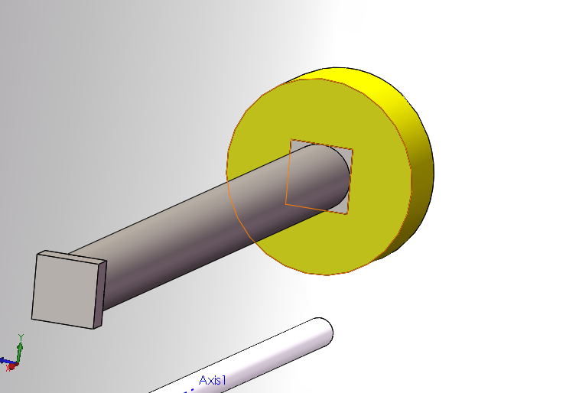

In the interior of the back shell, a crank bar with the longer rectangular peg will be fitted inside the rectangular hole of the crank handle. The peg and the hole should not move easily.

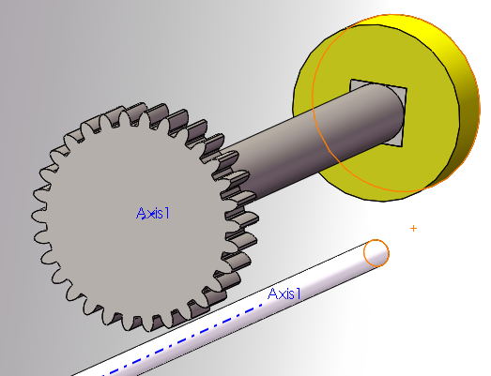

A large gear with a rectangular hole will be fitted with the other end of the crank bar (the end with the smaller rectangular peg). The hole and the peg should not move easily.

The next 2 steps should occur simultaneously.

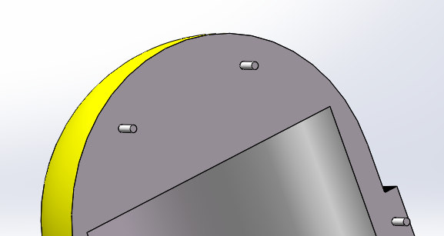 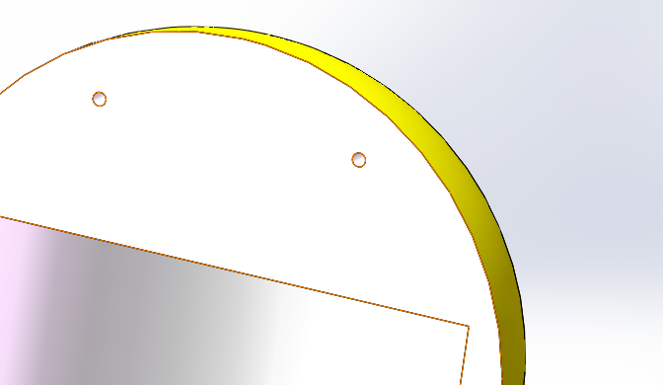

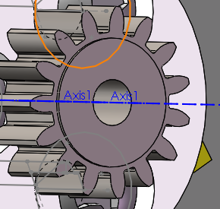 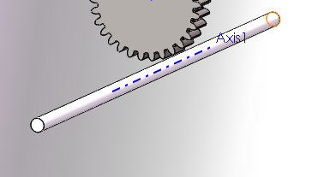

The 8 pegs of the front shell (top left picture) will be fitted with the corresponding 8 holes of the back shell (top right picture). The fit should be tight, but easy enough to disassemble if the user needs to repair the internal mechanisms for any reason.

The hole of the small gear (bottom left picture) will be fitted with the long shaft of the back shell (bottom right picture). The fit should be running freely.

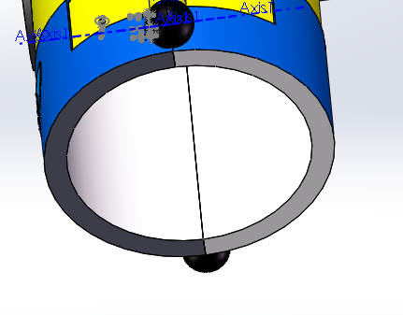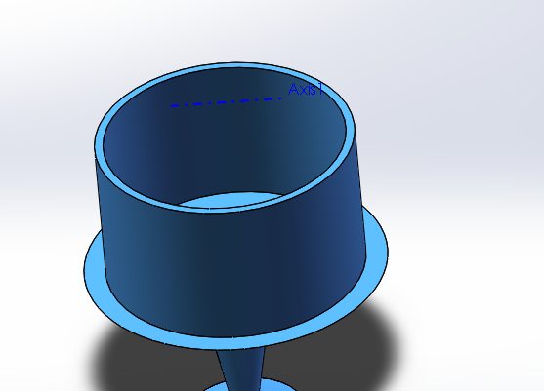

Finally, the hole that results from joining the front and back shells (left picture) will be fitted with the hollow cylinder of the bottom compartment (right picture). The fit should be tight but easy to remove so that the user can throw out the pencil debris.

**How the device works:**

Within the sharpener, there are 2 gears in a 0.56 inch : 0.28 inch ratio, so for every single turn of the larger gear, the smaller gear will turn twice. The crank handle is responsible for turning the crank bar, which in turn rotates the larger gear. The larger gear turns the smaller gear, which is attached to the sharpener, thus sharpening the pencil. The outer shells and the bottom compartment are hollow so that it could hold the pencil debris. Whenever the user needs to empty the sharpener, he/she will simply pull down on the bottom compartment to reveal the debris. Whenever the user needs to fix the internal compartments of the sharpener, such as removing a stuck lead, then he/she will simply pull apart the 2 shells to reveal the inside mechanisms.

The bottom compartment also comes equipped with suction cups as feet (not shown in pictures) so that the user can attach it to smooth surfaces such as a smooth table. This allows the sharpener to be held in place while the user is turning the crank handle. In addition, this allows the sharpener to stand upright like an actual Minion. Whenever the user needs to remove the sharpener from the table, he/she must pull up from the bottom compartment, not from the shells, otherwise the shells and the bottom compartment will separate.

**Conclusion:**

**Advantages:**

Many of the parts are made from ABS plastic, which is cheap and durable, allowing the costs to be brought down. Only the blade, small gear, large gear, and crank bar are made of steel, which gives the internal mechanism added strength. The screws are cheap and durable from McMaster-Carr.

The outer design is very appealing to children and young adults, which will allow it to be sold very easily. In addition, since it comes with suction cups that can be attached to tables, it reduces the chance of the sharpener being knocked over and spilling.

The 2:1 gear ratio allows the pencil to be sharpened faster with fewer rotations by the user’s hand.

Finally, the interior of the front shell has a raised cylinder that keeps the actual sharpener towards the center of the entire object. This design protects children who likes to stick their fingers into the holes meant for pencils only.

**Disadvantages:**

If the sharpener is attached to the table, the user must pull up from the bottom compartment to remove the sharpener. If the user attempts to pull up from the shells, then the bottom compartment will remain attached to the table while the sharpener separates, spilling the pencil debris onto the table. In addition, since the bottom compartment and the shells depend on a tight fit to remain together, then over time, the 2 surfaces may become worn out, causing the fit to be looser, which can cause the bottom compartment to fall out on its own.

The front and the back shells also depend on a tight fit to remain together. If the user continuously disassemble and reassemble the shells, then over time the pegs and the holes will have a looser fit, which may also cause the shells to separate on their own.

Finally, since there is nothing shielding the gears from debris, pieces of the wood or lead may end up getting stuck between the gears, forcing the user to have to disassemble the shells to manually remove the stuck debris.