**System Function by User Type**

**Administrator can:**

* Manage Course Information - (CRUD) create and update information of the courses.
* Manage Department Information - (CRUD) create and update information of the departments.
* Manage Department User Information - (CRUD) create and update information of the department users.
* Manage Student Information - (CRUD) create and update information of the students.
* Manage Faculty Information - (CRUD) create and update information of the faculty.
* Manage Deliverable Information - (CRUD) create and update information of the deliverables.
* Print Clearance Statistics Report

**Department User can:**

* View List of Deliverables
* Review and process student and faculty deliveratble
* Review uploaded files of student/faculty
* View Messages

**Faculty/Student can:**

* View and Process Deliverables
* Manage Profile

**Admin Account**

**Admin Dashboard**

* Number of student
* Number of faculty
* Number of department
* Number of users
* Number of courses

**Manage Course**

* Course Code
* Course Description

**Manage Department**

* Department name

**Department Users**

* Department Name
* Assigned Personnel
* Username
* Password
* Account Status

**Manage Student Information**

* ID number
* Last name
* First name
* Middle name
* Course
* Year Level
* Contact
* Email
* Username
* Password
* Account Status

**Manage Faculty Information**

* ID number
* Last names
* First name
* Middle name
* Contact
* Email
* Username
* Password
* Account Status

**Deliverables**

* Department
* Category – student, faculty
* Deliverable/Requirement name
* Description

**Clearance Report by Faculty**

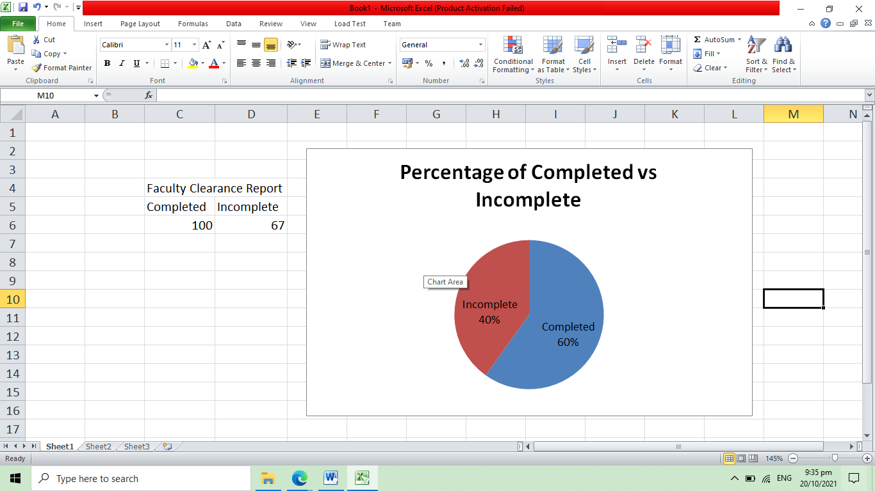

**Clearance Report by Student**

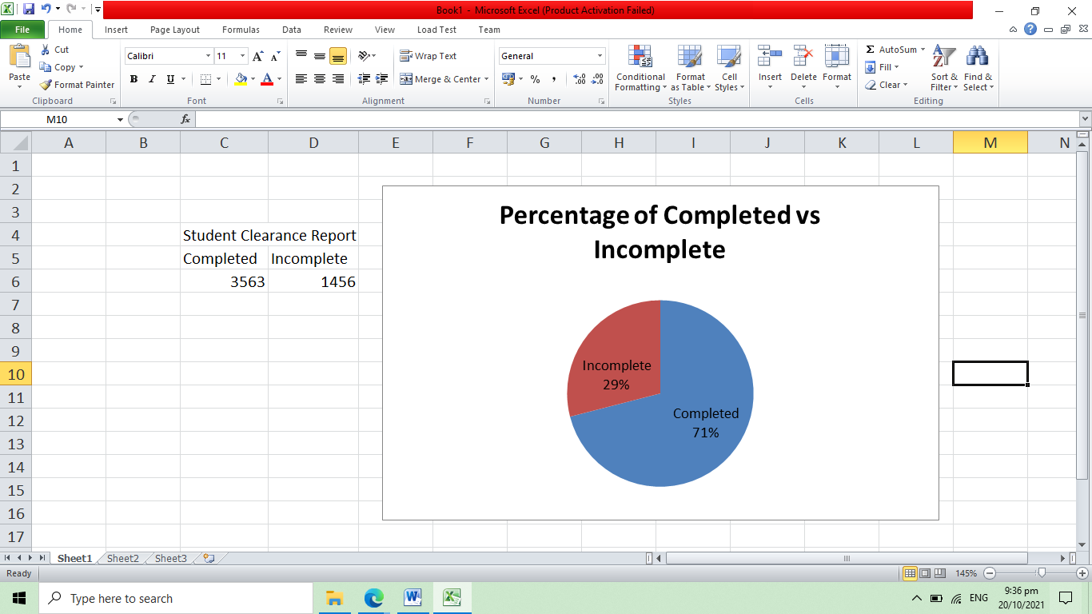

**Clearance Report by Student by Department**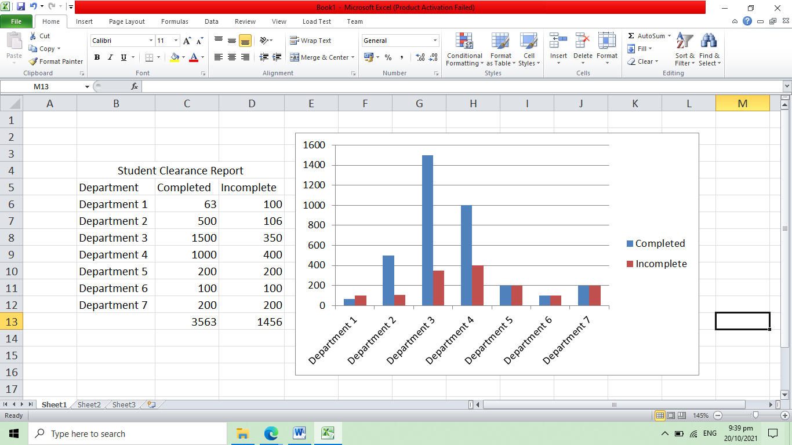

**Department User Account**

**Department User Dashboard**

* Number of student cleared
* Number of faculty cleared

**View List of Deliverables**

* Deliverable/Requirement name
* Description
* View Uploaded files by student/faculty

**View Uploaded Files**

* Deliverable/Requirement name
* File Uploaded
* Student/Faculty name

**Approve and Disapprove Module – table and form**

* Student Faculty Name
* Deliverable Name
* Status – cleared, not cleared
* Message

**View Message**

* Student Faculty Name
* Deliverable Name
* Message

**Student/Faculty Account**

* Number of deliverables
* Number of cleared
* Number of not cleared

**List of Deliverables/Requirement**

* Deliverable/Requirement name
* Description
* Status – cleared, not cleared
* Message
* Message Button – if not cleared the student can send message to the department
* Upload Attachment

**Manage Profile**

* Last name
* First name
* Middle name
* Contact
* Email
* Username
* Password