Baseline-First Crop Yield Forecasting with Reliability Diagnostics for Small Official Statistics
Olena Kopishynska1 Mark Fedorchenko1 Yurii Utkin1
Igor Sliusar1 Viktor Liashenko2 Alla Svitlychna3 and Svitlana Pysarenko3
1 Poltava State Agrarian University, Department of Information Systems and Technologies, Poltava 36003, Ukraine
2 Poltava State Agrarian University, Department of Plant Science, Poltava 36003, Ukraine
3 Poltava State Agrarian University, Department of Entrepreneurship and Law, Poltava 36003, Ukraine
olena.kopishynska@pdau.edu.ua
Abstract. Crop yield forecasting from small official statistics is different from forecasting with dense satellite, field, or weather datasets. The sample is short, temporal leakage is easy to introduce, and a machine-learning model should not be accepted unless it beats transparent baselines. This paper presents a baseline-first and reliability-aware workflow for wheat, maize, and sunflower yield forecasting in Poltava region, Ukraine, using harmonised AgroStats records for 2010-2024. ElasticNet, XGBoost, and LightGBM are compared with naive lag-1, linear-trend, LINEST, and ARIMA baselines under a forward temporal design. The new contribution is a decision layer that recommends ML only when it clears a practical MAE margin over the best baseline and then attaches reliability diagnostics: empirical validation-residual bands, test coverage, feature-group ablation, and compact forecast cards. The workflow recommends FORECAST.LINEAR for wheat (MAE 0.49 t/ha), LightGBM for maize (MAE 0.69 t/ha), and LightGBM for sunflower (MAE 0.04 t/ha). The wheat case is intentionally retained as a negative/control case because the baseline remains safer than ML. The results show that machine learning can help in small official-statistics settings, but only when it is checked against simple baselines and presented with reliability diagnostics.
Keywords: crop yield forecasting, small datasets, official statistics, baseline-first selection, reliability diagnostics, machine learning
- Introduction
Digital agriculture often assumes that good forecasting requires dense data: satellite images, farm-level measurements, detailed weather grids, soil properties, and management logs. Such data are valuable, but they are not always available for regional institutions. In many real tasks the stable source is official annual agricultural statistics. These records are public and repeatable, but they are short and aggregated.
This creates a practical research problem. A machine-learning model can be trained on a small annual table, but the result may be fragile. Random splitting is not appropriate because the next year is the forecasting target. Hyperparameter tuning can leak future information if it is not constrained. Even when a model gives a good score, it may not be better than a simple linear trend or a lag-1 rule.
The original long study already built a leakage-safe pipeline for AgroStats data and compared ML models with baselines. The present project moves the idea further. The central question is no longer which model has the lowest test MAE. The central question is which method should be recommended after baseline comparison and reliability checks.
This change is important for the scientific story. In small-data forecasting, a negative result can be as useful as a positive one. Wheat is the main example in this project: the selected ML model is not recommended because the best simple baseline remains safer. Maize and sunflower show the opposite case, where ML provides enough improvement to be useful.
The paper therefore presents a baseline-first, reliability-aware workflow. It combines ordinary model evaluation with a recommendation rule, validation-residual bands, coverage checks, feature-group ablation, and forecast cards. These additions turn the project from a model comparison into a small decision-support framework for official agricultural statistics.
A second motivation is reproducibility. Agricultural forecasting papers often describe the model and the final accuracy but leave many operational choices implicit: which years were used for tuning, whether baselines were tuned with the same information, and how a user should interpret a forecast when the error in a new year is larger than expected. The present repository makes these choices explicit and keeps the generated outputs as CSV and Markdown files.
The proposed workflow is intentionally modest. It does not claim that annual official statistics are enough for production forecasting at farm level. It is better understood as a transparent benchmark layer that can be run before more expensive data collection is planned. If a simple baseline is already competitive, then extra modelling complexity has to justify itself. If an ML model wins, then its recommendation is still accompanied by a reliability warning rather than presented as a certain forecast.
This also makes the work relevant for regional universities and public agencies. Such organisations may not control satellite archives or field sensors, but they often have access to official statistics and need a reproducible way to compare forecasting options. A small, auditable workflow is more useful in that setting than a large black-box model that cannot be defended when the sample contains only fifteen annual observations per crop.
- Materials and Methods
The case study uses official AgroStats records for Poltava region, Ukraine, from 2010 to 2024. The target crops are wheat, maize, and sunflower. The raw data are stored as separate CSV files by crop and indicator. The pipeline loads these files, harmonises crop names and indicators, converts units, and builds one annual crop-level table.
Yield is converted to tonnes per hectare. Fertiliser indicators are represented as comparable per-hectare or share variables where possible. Irrigation volume is converted into cubic metres per hectare and millimetres. The main feature set uses lagged values and five-year historical means, so the model receives only information that could be known before the forecasted harvest year.
The temporal design is fixed. Years up to 2018 form the initial training period, 2019-2021 are used for validation and hyperparameter selection, and 2022-2024 are held out for the main test. For each forecast year, preprocessing is fitted only on previous years. This prevents imputation, scaling, or parameter choices from using future data.
The ML models are ElasticNet, XGBoost, and LightGBM. They are deliberately tuned on a constrained grid because the dataset is too small for broad automated search. Baselines include naive lag-1, linear trend, LINEST with lagged predictors, and ARIMA. Forecast accuracy is reported as MAE, RMSE, and MAPE, with MAE used as the main selection metric.
The code is organised as a reproducible pipeline. Running `python run_all.py` loads raw data, builds features, validates the dataset, trains models, computes baselines, runs reliability diagnostics, and exports figures and report tables. The article values are taken from generated CSV files, not copied from manual calculations.
Feature construction follows a strict time direction. For each crop-year, lagged yield and lagged input variables are used instead of contemporaneous values. Rolling means are based on earlier years only. This is a small detail technically, but it is central for the interpretation of the results. Without it, the model could learn from information that would not be known at the time of making the forecast.
The validation design is also deliberately simple. The 2019-2021 window is large enough to expose the model to recent variation, but small enough to preserve the 2022-2024 period as a final test. Because the whole dataset contains only fifteen years, no single split can fully represent uncertainty. The split is therefore treated as a transparent benchmark protocol rather than as proof of general performance.
Baselines are implemented as first-class models, not as an afterthought. The naive lag-1 rule is a persistence forecast. The linear trend baseline uses time as the only predictor. LINEST represents a spreadsheet-friendly regression option that is easy for non-programming users to reproduce. ARIMA represents a standard univariate time-series competitor. This mix is important because a practical user may prefer a weaker but transparent method if the ML gain is small.
The metrics are interpreted at crop level. A one-tonne error has a different meaning for maize than for sunflower. For that reason the reports include both absolute metrics and narrative interpretation. MAE remains the selector metric because it is easy to explain and less dominated by a single bad test year than RMSE. MAPE is reported for context but is not used as the primary selector.
- Reliability-Aware Forecasting Workflow
The new decision layer starts from a conservative rule: recommend ML only if it beats the best simple baseline by a practical MAE margin. In this project the margin is 0.05 t/ha. If ML does not clear the margin, the output label is `baseline safer`. This makes the wheat case explicit instead of hiding it inside a general model ranking.
The second layer is reliability labelling. For the selected ML model, the workflow calculates the 80th percentile of absolute validation residuals and places a symmetric empirical band around test predictions. This is not a formal confidence interval. It is a small-sample diagnostic that asks whether test-year errors are within the recent validation error scale.
The third layer is feature stability. Feature-group ablation removes whole groups such as yield history, nitrogen, mineral-treated share, or irrigation. If removing a group increases MAE, that group is treated as useful for the selected forecast. This is easier to explain to agronomic users than a large list of individual model features.
The final output is a forecast card for each crop. A card reports the recommended method, recommended MAE, best ML MAE, best baseline MAE, ML gain or loss, test coverage inside the empirical band, the most useful feature group, and a short interpretation. This is the project output that would be easiest for a regional analyst to read.
In the current run, wheat receives `baseline safer` and is assigned to FORECAST.LINEAR. Maize receives `outside validation error scale` and is assigned to LightGBM. Sunflower receives `within expected error` and is assigned to LightGBM. These labels are deliberately simple because the dataset is small.
The practical margin is intentionally separated from statistical significance. With only three test years, formal pairwise tests would be unstable and easy to overinterpret. The margin is instead a user-facing threshold: if the ML improvement is smaller than 0.05 t/ha, the additional complexity is not treated as worthwhile. The value can be changed in the code for other regions or decision contexts.
The empirical bands are based only on validation residuals. This prevents the test period from defining its own uncertainty. The band width is the recent error scale observed before the final evaluation period. If a test observation falls outside that band, the problem is not automatically model failure, but it is a warning that the new year behaves differently from the validation period.
The warning labels are designed for conservative use. `Within expected error` means the selected method clears the baseline rule and the test errors mostly stay inside the validation band. `Outside validation error scale` means that ML wins by MAE but the residual pattern is less reliable. `Baseline safer` means the model has not earned a recommendation over the best simple alternative.
Forecast cards deliberately combine numbers and text. A table of metrics alone does not tell a user what to do. A text recommendation alone hides the evidence. The card format connects the recommendation to the baseline comparison, the empirical band, and the most useful feature group. This is the main operational difference between the new project and the original long manuscript.
Forecast-card summary generated by the reliability layer:
Wheat: recommended method FORECAST.LINEAR; MAE 0.49 t/ha; best baseline MAE 0.49 t/ha; test coverage 67%; label baseline safer.
Maize: recommended method LightGBM; MAE 0.69 t/ha; best baseline MAE 0.86 t/ha; test coverage 33%; label outside validation error scale.
Sunflower: recommended method LightGBM; MAE 0.04 t/ha; best baseline MAE 0.17 t/ha; test coverage 100%; label within expected error.
The labels are diagnostic warnings for a small benchmark dataset, not production-grade guarantees.
- Experimental Results and Discussion
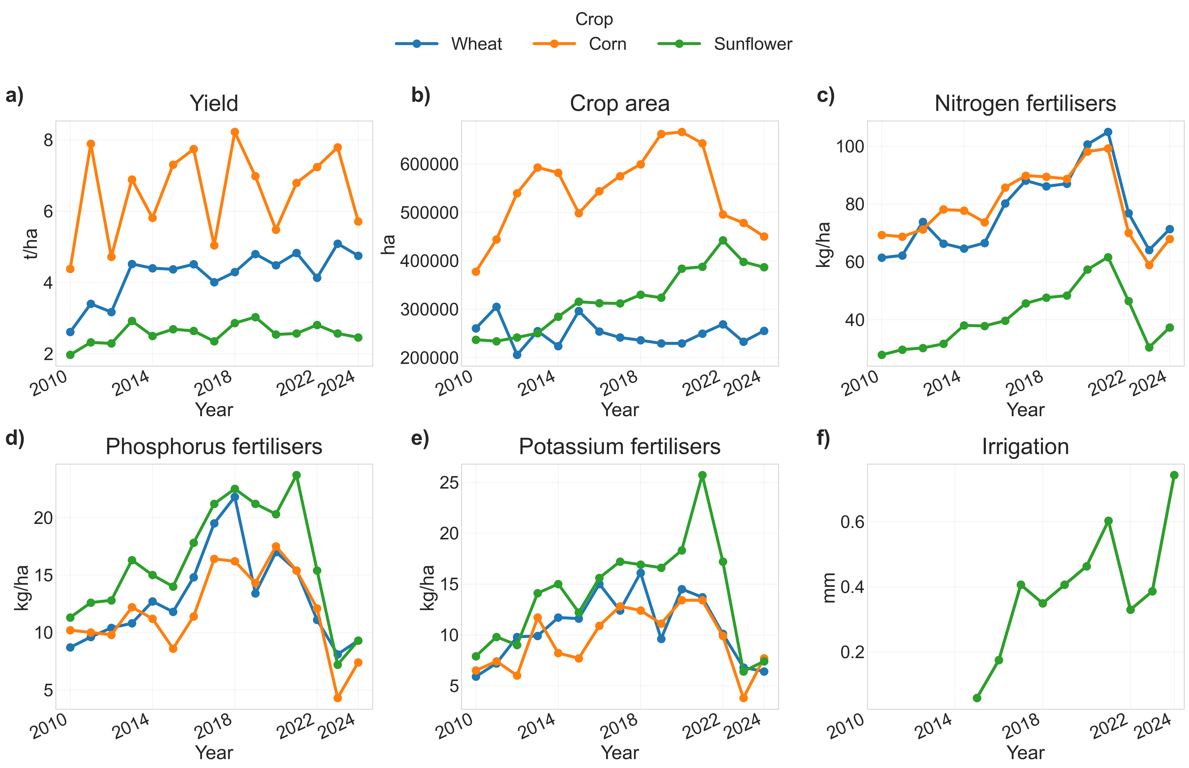
Fig. 1. Long-term trends of yield, crop area, fertiliser use, and irrigation in Poltava region, 2010-2024.
The descriptive trends show that the three crops have different scales and dynamics. Maize has the largest yield range and the largest absolute errors. Sunflower has a narrower range, so low MAE values must still be interpreted together with percentage error. Wheat is comparatively stable but still hard to forecast because trend and year-to-year variation coexist in a short series.
The baseline-first selector changes the interpretation of the results. For wheat, the best ML model has MAE 0.54 t/ha, while the best baseline has MAE 0.49 t/ha. The recommendation is therefore FORECAST.LINEAR, not ML. This is the negative/control result of the study.
For maize, ML is more useful. The recommended method is LightGBM with MAE 0.69 t/ha. The best baseline has MAE 0.86 t/ha, so the ML gain is 0.17 t/ha. This improvement clears the practical margin.
For sunflower, the recommendation is also LightGBM with MAE 0.04 t/ha. The best baseline has MAE 0.17 t/ha. The absolute errors are small, but this should be read against the lower yield scale of the crop.
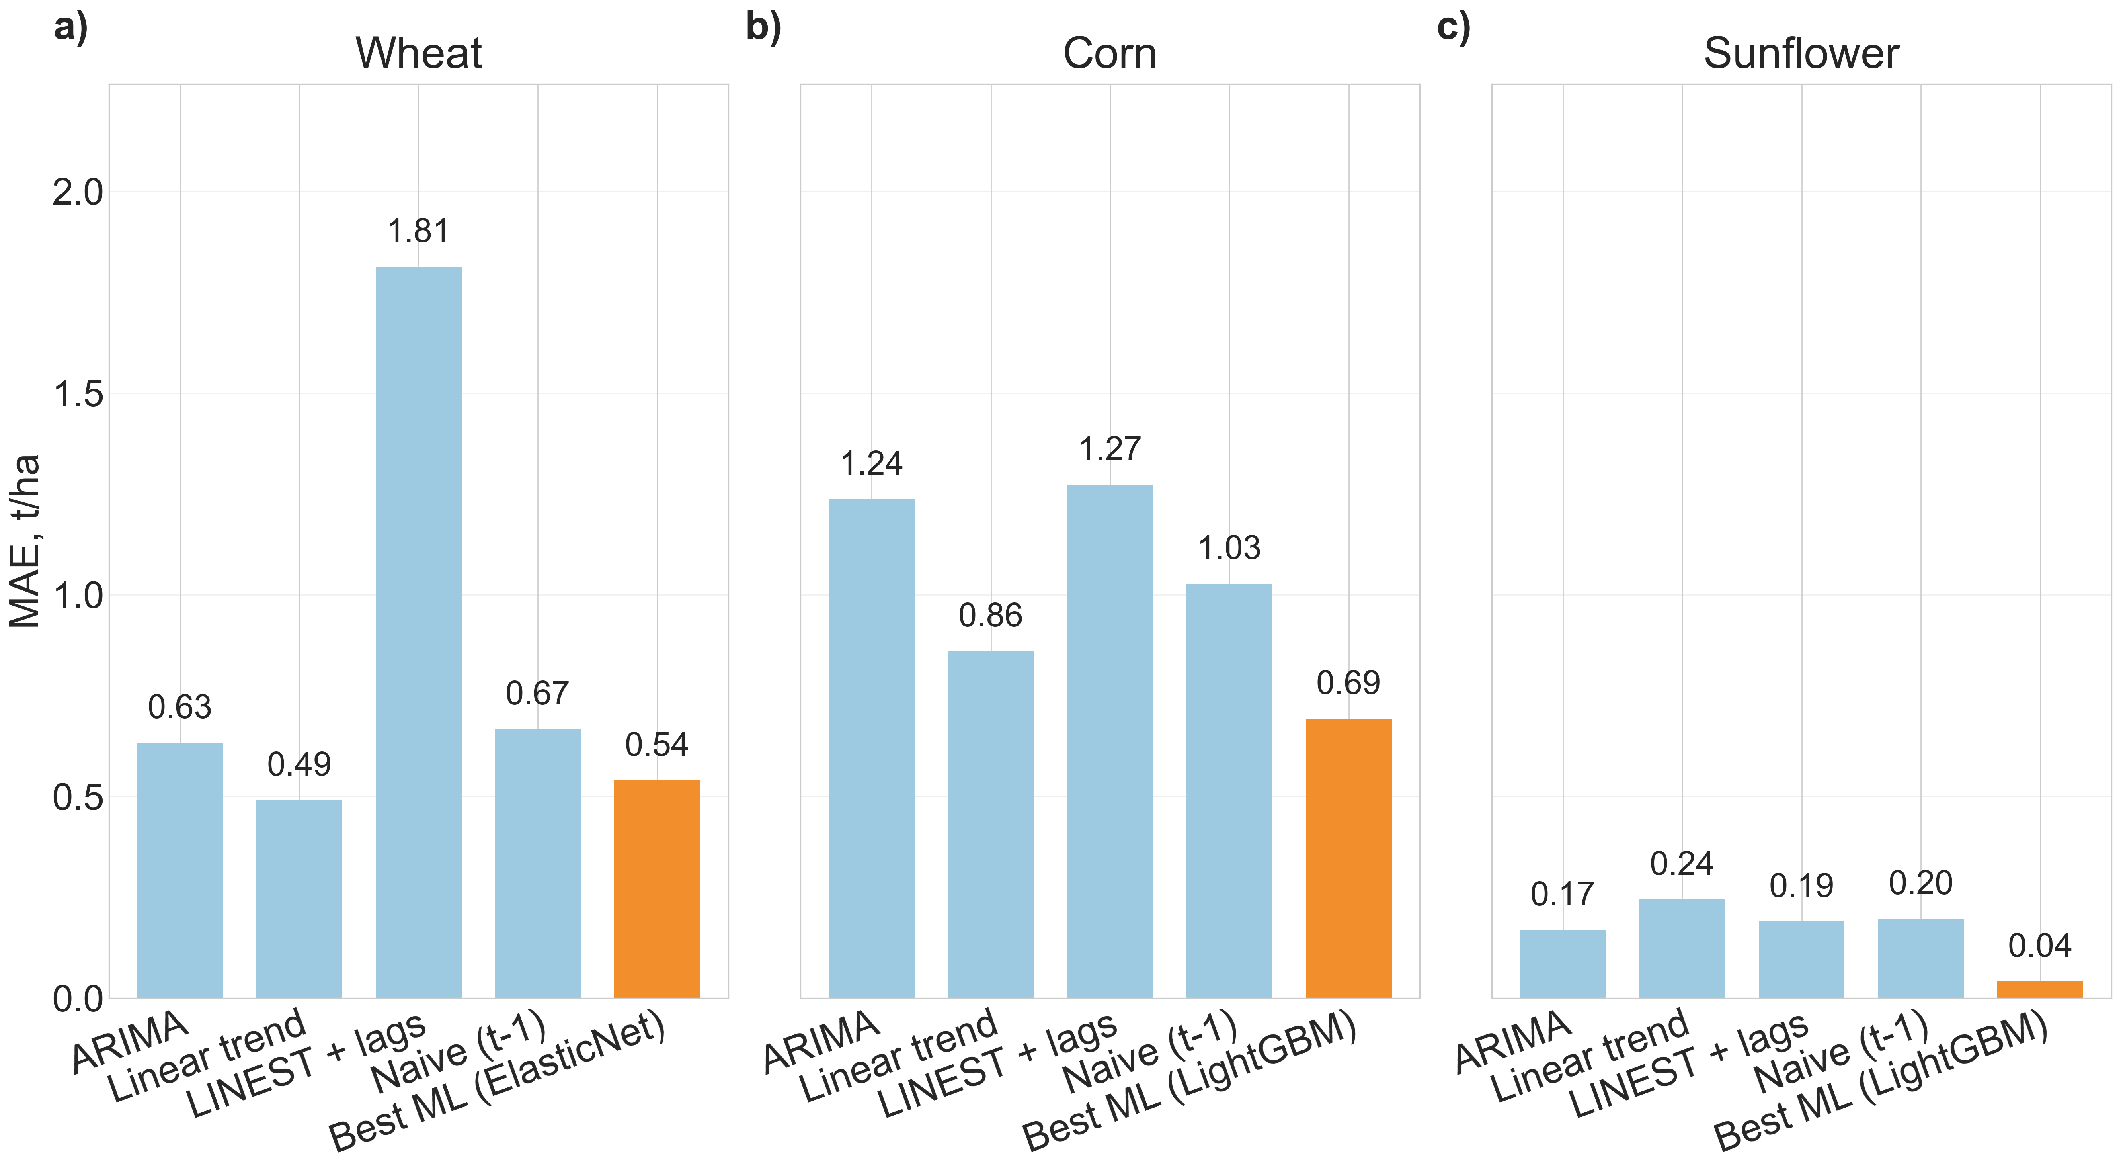
Fig. 2. Baselines versus selected ML models on the 2022-2024 test window.
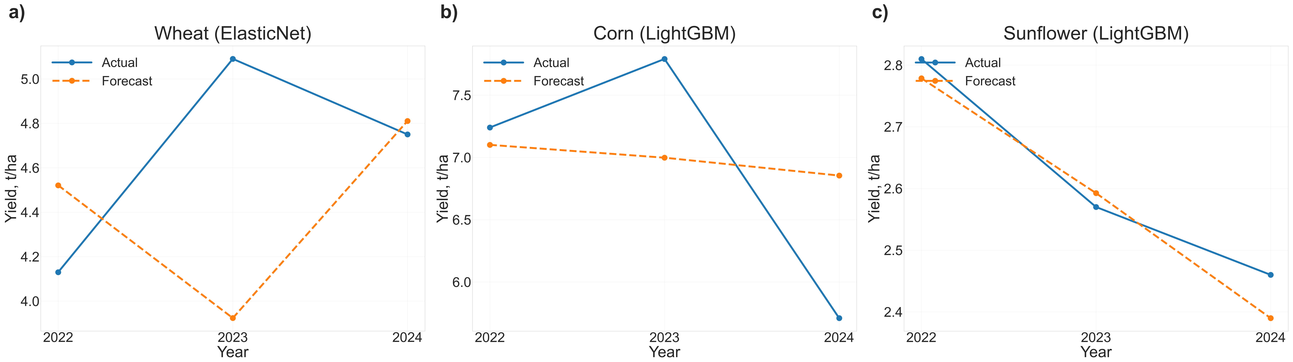
Fig. 3. Actual and forecast yield for the selected lag-only ML models.
The reliability bands add a second view. Test coverage inside the empirical validation-residual band is 66.7% for wheat, 33.3% for maize, and 100.0% for sunflower. These values are not calibrated probability levels. They simply show whether test errors are ordinary relative to the validation period.
The feature-group diagnostics also differ by crop. Wheat is most sensitive to mineral-treated share, maize to mineral-treated share, and sunflower to phosphorus fertiliser. This supports the main argument: under small official datasets, there is no universal predictor group or universal model winner.
The maize result is useful but still cautious. The selected model improves MAE, yet its reliability label warns that test errors are often outside the validation error scale. In practice this means the forecast should be used together with the diagnostic band and not as a single certain number.
The wheat result is the strongest argument for the baseline-first design. A traditional paper could still report the trained ML model and discuss its predictors. This project instead says that the baseline is safer. That makes the conclusion narrower, but more honest and more useful.
The baseline comparison also prevents a common interpretation error. If all attention is placed on the lowest ML score, the wheat result can look like a model-selection problem. In the reliability-aware view, it is a decision problem. The question is whether the model should be recommended to a user who could instead use a transparent baseline. For wheat, the answer is no.
For maize, the result is more positive but still not unconditional. The selected ML method improves the absolute error enough to clear the practical margin. At the same time, the empirical coverage signal shows that the test years are not fully ordinary relative to validation residuals. This is the type of mixed message that should be preserved in a small-data publication rather than smoothed away.
For sunflower, the model result is more stable in absolute terms, but the smaller yield scale means that percentage errors remain relevant. The forecast card therefore keeps both the recommendation and the caution visible. In a practical workflow this would support a lightweight decision: use the ML forecast as the primary value, but keep the empirical band and recent baseline close for comparison.
The feature-group ablation supports an agronomic reading without overstating causality. When the removal of a group increases MAE, the group is useful for prediction in this dataset and split. It does not prove that the group is a causal driver of yield. The distinction matters because official statistics aggregate many management and environmental processes into a small number of annual indicators.
The SHAP and ablation diagnostics are best read together. SHAP highlights individual predictors used by a fitted model, while ablation asks how model error changes when a whole predictor group is removed. Agreement between the two gives more confidence that a feature group is not just a random artefact. Disagreement is treated as a warning, not as a reason to force a single explanation.
The project also clarifies the role of climate data. The original codebase included climate-sensitive experiments, but the mini article focuses on the small official-statistics setting. Climate variables can improve some forecasts, yet they also increase the risk of opportunistic modelling when the annual sample is very short. The published workflow keeps the lag-only recommendation central and treats climate extensions as diagnostics rather than the main claim.
Several limitations follow directly from the design. The dataset contains one region and three target crops. The test set has only three years. The empirical bands are small-sample bands and must not be read as calibrated confidence intervals. The feature diagnostics are descriptive and model-dependent. These limitations do not weaken the contribution; they define the correct use case for the repository.
The strongest use of the workflow is comparative. A researcher can add another region, a longer time period, or a new group of predictors, then ask whether the recommendation changes after the same baseline-first rule and reliability checks. This makes the code useful as a research scaffold even when the present numerical results remain local to Poltava region.
Another practical advantage is that the workflow separates modelling success from communication success. A model can have a lower MAE and still be difficult to communicate if the user receives only a point forecast. The forecast card changes the conversation: the point value is presented together with the best baseline, the diagnostic band, and a simple warning. This is closer to how decisions are actually made under uncertainty.
The output also helps identify where better data would matter most. If the baseline remains safer, as in wheat, the next research step is not necessarily a more complex model. It may be a better explanatory variable, a longer regional history, or a crop-specific management indicator. If ML wins but coverage is weak, as in maize, the next step is to understand whether the validation period underestimates recent shocks.
The current results therefore should not be read as a final ranking of algorithms. They should be read as a demonstration of an evaluation protocol. ElasticNet, XGBoost, and LightGBM are useful because they represent different modelling families, but the contribution is the protocol around them: temporal validation, baseline-first recommendation, residual-band diagnostics, and forecast-card reporting.
This distinction is useful for reviewers because it makes the novelty more precise. The paper is not trying to compete with large remote-sensing yield forecasting systems. Instead, it addresses the narrower but common case where the available data are official annual statistics and the research question is whether an ML workflow can be trusted enough to recommend over transparent baselines.
The same logic can be extended without changing the core design. Additional regions would create a panel dataset and allow region-wise reliability summaries. Additional crops would test whether the baseline-first rule is crop-dependent. Additional weather or price variables could be added as new feature groups and evaluated through the same ablation table. The decision layer would remain unchanged.
For institutional users, the most useful deliverable is not the trained model object but the trace from input data to recommendation. The repository keeps this trace visible: raw CSV files are transformed into processed features, model metrics, baseline metrics, reliability bands, recommended-method tables, and forecast cards. Each article claim can therefore be checked against a named output file.
This traceability also reduces the risk of accidental optimism. If a future change improves one crop but makes another crop worse than its baseline, the recommended-method table will expose that trade-off. In this sense the project is designed to make inconvenient results visible. That is important for small-data studies because optimistic model selection can easily look convincing when only a few test years are available.
The approach is therefore conservative by design. It rewards improvement, but only when the improvement survives comparison with simple methods and remains understandable through the diagnostic outputs. This is a practical compromise between purely statistical benchmarking and the needs of applied agricultural decision support.
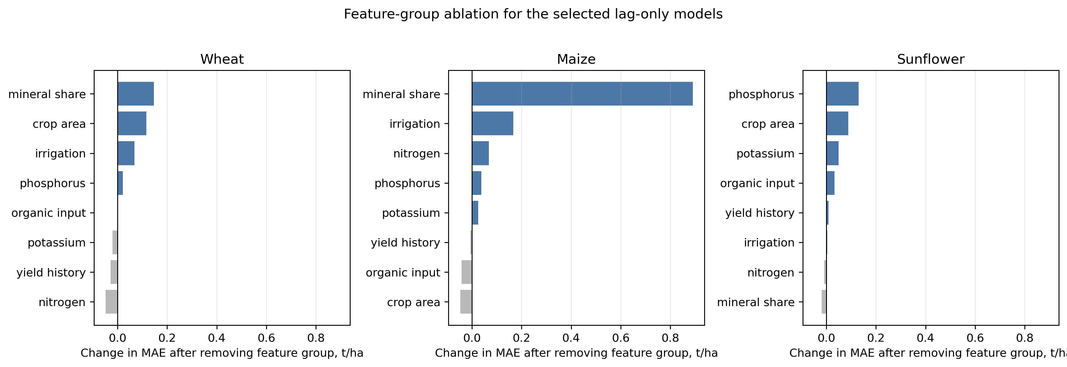
Fig. 4. Feature-group ablation for the selected lag-only models.
- Conclusions
The project shows that small official agricultural datasets can support a reproducible forecasting benchmark, but only if evaluation is conservative. The main contribution is the baseline-first and reliability-aware decision layer. It prevents ML from being recommended automatically and makes model uncertainty visible through simple diagnostics.
The final recommendations are crop-specific. Wheat remains better served by a transparent baseline. Maize and sunflower benefit from LightGBM, but maize also receives a reliability warning. This mixed result is stronger than a universal ML-superiority claim because it matches the evidence in the data.
Future work should extend the same workflow to more regions, longer time periods, and a small number of carefully selected exogenous variables. The code is prepared for this because the recommendation tables, forecast cards, diagnostics, and article figures are generated from reproducible scripts.
For publication purposes, the key point is the change in framing. The article does not claim that machine learning is always better for crop yield forecasting. It claims that, for small official datasets, a model should pass a baseline-first decision rule and should be reported with reliability diagnostics. This framing is more defensible and easier to reproduce.
The public repository therefore contains not only model training code, but also the decision layer needed to read the results. The expected outputs include recommended methods, prediction bands, feature-group ablation, forecast cards, and a short reliability summary. These files make the numerical claims in the article traceable to the pipeline.
In its present form the workflow is a publication benchmark and a methodological template. It is not a replacement for local agronomic judgement, field observations, or operational early-warning systems. Its value is that it makes small-data forecasting claims harder to overstate and easier to reproduce.
- References
- Kamilaris A., Kartakoullis A., Prenafeta-Boldu F.X. A review on the practice of big data analysis in agriculture. Computers and Electronics in Agriculture. 2017;143:23-37.
- Jeong J.H. et al. Random forests for global and regional crop yield predictions. PLOS ONE. 2016;11:e0156571.
- Chlingaryan A., Sukkarieh S., Whelan B. Machine learning approaches for crop yield prediction and nitrogen status estimation in precision agriculture. Computers and Electronics in Agriculture. 2018;151:61-69.
- van Klompenburg T., Kassahun A., Catal C. Crop yield prediction using machine learning: a systematic literature review. Computers and Electronics in Agriculture. 2020;177:105709.
- Muruganantham P. et al. A systematic literature review on crop yield prediction with deep learning and remote sensing. Remote Sensing. 2022;14:1990.
- Khaki S., Wang L. Crop yield prediction using deep neural networks. Frontiers in Plant Science. 2019;10:621.
- Cao J. et al. Integrating multi-source data for rice yield prediction across China using machine learning and deep learning approaches. Agricultural and Forest Meteorology. 2021;297:108275.
- Peng B., Guan K., Pan M., Li Y. Benefits of seasonal climate prediction and satellite data for forecasting U.S. maize yield. Geophysical Research Letters. 2018;45:9662-9671.
- Meroni M. et al. Yield forecasting with machine learning and small data: what gains for grains? Agricultural and Forest Meteorology. 2021;308-309:108555.
- Sweet L. et al. Transdisciplinary coordination is essential for advancing agricultural modeling with machine learning. One Earth. 2025;8:101233.
- AgroStats portal. Regional agricultural statistics of Ukraine. https://agrostats.uhmi.org.ua. Accessed 01.12.2025.
- NASA POWER Project. Prediction Of Worldwide Energy Resources daily meteorological data. https://power.larc.nasa.gov.
- Tibshirani R. Regression shrinkage and selection via the Lasso. Journal of the Royal Statistical Society Series B. 1996;58:267-288.
- Zou H., Hastie T. Regularization and variable selection via the Elastic Net. Journal of the Royal Statistical Society Series B. 2005;67:301-320.

