Expansion of Customer Relationship Management Functionality Using Recurrent LSTM Networks for Automation Demand Forecasting
Olena Kopishynska¹ [⁰⁰⁰⁰⁻⁰⁰⁰²⁻³¹³⁸⁻⁷²¹⁵] Yurii Utkin²[⁰⁰⁰⁰⁻⁰⁰⁰³⁻²⁷³²⁻⁴⁴³⁸]
Igor Sliusar^{3[0000-0003-1197-5666}] Mykola Somych4[0000-0001-7049-9992]
Danylenko Viktoriia⁵[0000-0001-8676-0622] Diadyk Tetiana^{6[}0000-0002-8422-3775]
and Iryna Zahrebelna^{7[0000-0002-8316-1656]}
1,2,3,4,5,6,7 Poltava State Agrarian University, Poltava 36003, Ukraine
olena.kopishynska@pdau.edu.ua
Abstract. The study is dedicated to analyzing the relevance of using Customer Relationship Management (CRM) systems for a wide range of business processes in marketing activities and highlights ways to improve their efficiency through integration with artificial intelligence (AI). The authors present a solution for automating data flow processing and demand forecasting in a selected sales segment by developing a neural network and integrating it with CRM systems that are not AI-driven. A practical example demonstrates the development of an LSTM recurrent neural network model in Python and methods for its implementation. Various applications of other neural network models and future research directions in the field of AI are also discussed.
Keywords: CRM, Artificial Intelligence, Recurrent neural network, Python, Software Market, demand forecasting
- Introduction
Customer Relationship Management (CRM) is a combination of practices, strategies, and technologies that companies use to manage and analyze customer interactions and data throughout the customer lifecycle. The purpose of these systems is to improve customer service, retain clients, and stimulate sales growth amid the development of electronic forms of external interaction between enterprises, suppliers, and customers, as well as the digitalization of business [1].
The demand for modern CRM-class systems is constantly growing, as evidenced by analytical data from Gartner Group and IDC on the state of the global software market since the early 2000s [2-3]. CRM systems have undergone several stages of development, evolving from traditional to digital solutions and increasingly incorporating artificial intelligence (AI) in the implementation of core functions [4].
The relevance of this study is driven by the need to enhance and automate operations using CRM systems, as well as to introduce new tools for more effective problem-solving in business companies operating in a dynamic environment. Cloud computing, big data processing, artificial intelligence, and other technologies have the potential to transform CRM usage paradigms and provide a significantly higher level of service for a wide variety of businesses.
The following sections provide an overview of statistical data on the development of the CRM market, confirming the relevance of studying modern trends in AI adoption. The results of developing an LSTM (Long Short-Term Memory) neural network model in Python for fast and accurate demand forecasting based on the analysis of past data have been demonstrated. The model is integrated via the API of the SalesDrive CRM system, which was chosen as an example [5].
In the final section of the study, a commentary on the evaluation of the obtained results is provided, along with an outline of promising directions for future research.
- Analysis of CRM Market Development Trends
The emergence of the CRM software market began in the 1980s, when the concept of sales was evolving, and automation became a necessity. Businesses increasingly began analyzing market needs and data on the results of interactions with leads. Extensive research and compelling results of the successful use of traditional CRM systems are presented in the works of well-known marketing theorists and practitioners [6-8]. However, the list of criteria for classifying types of CRM systems was only outlined in 2009 when the consulting company Gartner held the first known Customer Relationship Management Summit. This summit summarized experiences and discussed case studies on how to implement CRM strategies and technologies to better understand business processes, manage and develop them, build relationships with customers, and generate profit [9]. It was also at this event that the advantages of cloud solutions for CRM were first substantiated.
By analyzing data from annual reports of leading analytical companies such as IDC, Gartner, and others, one can understand the statistics of the past two decades and the trends in the development of CRM-class products for the near future.
The overall global trend of CRM system sales growth in the software market over the past 12 years, as well as forecast data, is presented in Fig. 1. These figures are based on various industry reports and analyses. For instance, the 2012-2022 revenue is reported by IDC [10], while the 2023-2025 figures come from Statista [11]. In summary, the CRM software market has shown robust growth from 2012 through 2023 and is expected to continue expanding through 2029. The trend line exhibits an exponential character. The market volumes of CRM services and sales systems, both in monetary terms, have grown over the past 12 years at a rate of 10% to 15%. It is expected that global spending on CRM will reach $145.6 billion by 2027 [11]. Trends such as hyper-personalization of customer service, the use of AI, automation, as well as the implementation of reliable customer service on social media, integration with other businesses (logistics, payment systems, web integration), can help reduce costs, increase response times, enhance customer satisfaction, and boost the adoption of CRM relationship management platforms across various industries. Together, these factors are the primary drivers of market growth.

Fig. 1. Summary of the market's revenue 2012 - 2027 (Designed by authors)
The high profitability and prospects of CRM systems explain the significant attention given to statistical data by analytical companies. One of the methods used by the international analytical company Gartner is the so-called "Gartner Magic Quadrant," which visually demonstrates the distribution of software players in the market across four key categories: Leaders, Challengers, Visionaries, and Niche Players.
The Magic Quadrant is a tool that provides a graphic competitive positioning of technology vendors to help consumers make informed investment decisions. With a unified set of evaluation criteria, the Magic Quadrant offers an overview of four types of technology vendors in any industry [12].
- Leaders perform well despite their current vision of changing market rules, but they are still facing challenges.
- Visionaries understand where the market is heading or have a vision of changing market rules, but they are not yet adept at executing this vision.
- Niche players focus successfully on a small segment, or are not focused and fail to innovate or outpace competitors.
- Challengers perform well today or can dominate a large segment but do not demonstrate an understanding of market direction.
In its 2023 report, Gartner presented the results of a new study dedicated to the CRM solution market. Sixteen companies have been included in the new quadrant. The leaders are Salesforce, Pegasystems, ServiceNow, Oracle, ZenDesk, and Microsoft. SAP has been classified as a Challenger. Emagia has been placed in the Visionaries category. The remaining eight market participants have been included in the Niche Players section: Verint, Applan, Creatio, eGain, SugarCRM, Zoho, Cherwell, and CRMNEXT. These companies have become innovators in the field of specialized business software development while also being competitors seeking the most in-demand and promising solutions.
As a leading global research and analytics company, Gartner provides IT and business leaders with insights on how to navigate the software market and choose solutions that help organizations achieve their goals.
The development of customer communication management systems is remarkable for its pace, rapid adoption of cutting-edge technologies, and growing popularity. Today, CRM system sales lead the software market. Modern CRM systems for customer service must operate seamlessly on a unified platform, utilizing shared development and integration tools, open APIs, and a common graphical user interface.
Thus, CRM is the largest and fastest-growing category of enterprise application software. The experience of using CRM proves that businesses need a future-oriented strategy focused on customers. CRM technology transforms multiple data streams from sales, customer service, marketing, and social media monitoring into valuable business insights.
- Prospects of Using AI in CRM
The beginning of the new millennium brought humanity face-to-face with the emergence of new global trends and phenomena. For example, in 2016, during the World Economic Forum in Davos (Switzerland), objective factors of the Fourth Industrial Revolution, also known as Industry 4.0, were recognized and named [13]. A significant feature of the Industry 4.0 era is the dominance of knowledge and digital data. However, the common denominator for all manifestations of this new paradigm is four key technologies: smart automation using AI and the Industrial Internet of Things (IIoT), big data analytics, and decentralized management. It is important to realize that many of the technologies of Industry 4.0, particularly big data and AI, are based on the premise that these data are already digitized at the collection level [14]. One of the tasks of this work is to explore the potential for expanding CRM systems' functions using AI, particularly in the realm of big data processing in business, analytics, and other fields.
The integration of artificial intelligence (AI) into customer relationship management (CRM) systems has shown significant growth over the past three years.
Several recent studies have explored trends in the increasing number of AI-driven CRM systems [4,15-17]. Most of these studies focus on large AI language models such as ChatGPT-3, ChatGPT-4 Turbo by OpenAI, and Copilot Edits AI by Microsoft. Among the CRMs that have fully integrated AI into their management processes are some of the most well-known market leaders and niche players, according to Gartner’s research: Salesforce, Zoho, Creatio, and C3 AI CRM [16]. Leading CRM technology companies are prioritizing the use of AI and Big Data. For instance, Creatio Copilot Edits AI is a centralized workspace designed for configuring and deploying generative AI (GenAI) use cases, including CRM applications and AI-powered app development [18]. It offers users numerous pre-configured use cases for common needs while also enabling the creation of custom GenAI applications.
Gartner predicts that by 2025, AI-generated content will account for 30% of all outbound marketing messages from large companies, a significant increase from less than 5% in 2022. Thus, there is a significant segment of popular CRM solutions that are not integrated with AI but are widely used by local and regional companies, as well as small and medium-sized businesses, based on the price-quality optimization criteria.
As previously mentioned, CRM systems primarily focus on processing customer interactions, including purchases, product deliveries, promotional messaging, and marketing campaigns. The key task in CRM is maintaining customer engagement throughout the purchasing process, especially post-order. For developers of such systems, it is common practice to design and adapt software to meet the specific business processes of their clients.
Despite the growing adoption of AI in CRM, there is still a significant gap in fully utilizing AI capabilities, as companies strive to develop meaningful customer interactions. A clear knowledge gap exists when it comes to understanding the strategic integration of AI to enable personalized customer engagement, even though numerous studies highlight AI’s advantages in CRM [19]. For CRMs that have yet to integrate AI, the development of specialized neural networks for processing data streams, conducting analytics, and forecasting key metrics is being considered. A case study for AI integration has been conducted using the characteristics of the popular Ukrainian CRM system SalesDrive and its open API.
- Experimental Results and Discussion
The authors conducted a study to determine how AI can be strategically integrated into CRM systems. This research aims to bridge existing gaps by providing an in-depth analysis of approaches used to incorporate AI-driven personalization strategies into CRM platforms. The study employs a mixed-methods approach, combining qualitative case study analysis with an examination of AI-powered CRM deployments.
In particular, the study focuses on methods for creating specialized neural networks with machine learning algorithms to analyze personalized data and customer behavior data, in order to provide companies with a competitive advantage through improved customer retention rates. When a company tries to implement CRM, several stages occur, such as identifying customers based on geography or financial gain, retaining customers, and attracting new ones.
For the experiment, the task was formulated as follows: develop a neural network model based on TensorFlow/Keras [20] to forecast demand for the Apple iPhone 16 Pro Max 512GB Black Titanium (MYX03) in an online store for the upcoming year. This is the latest release in 2024, and the demand is high, allowing the company to maintain a premium price. Therefore, it is important to perform the analysis quickly and predict user behavior for the specified period.
The LSTM (Long Short-Term Memory) model was used for the work, as it is well-suited for working with time-series data [21]. Before starting the work, a historical dataset of device sales is required, containing dates, the number of units sold, and, if possible, additional factors such as seasonality, promotions, and competition.
STM is a type of recurrent neural network (RNN) designed to work with sequential data. The main feature of LSTM is its ability to effectively remember long-term dependencies in sequences, unlike classical RNNs, which often face the problem of vanishing gradients [22]. For writing the neural network in Python, the integrated development environment Visual Studio Code was used with a special extension: code editing was done with the help of Copilot Edits AI. The full listing of the neural network code is presented in Fig. 2.
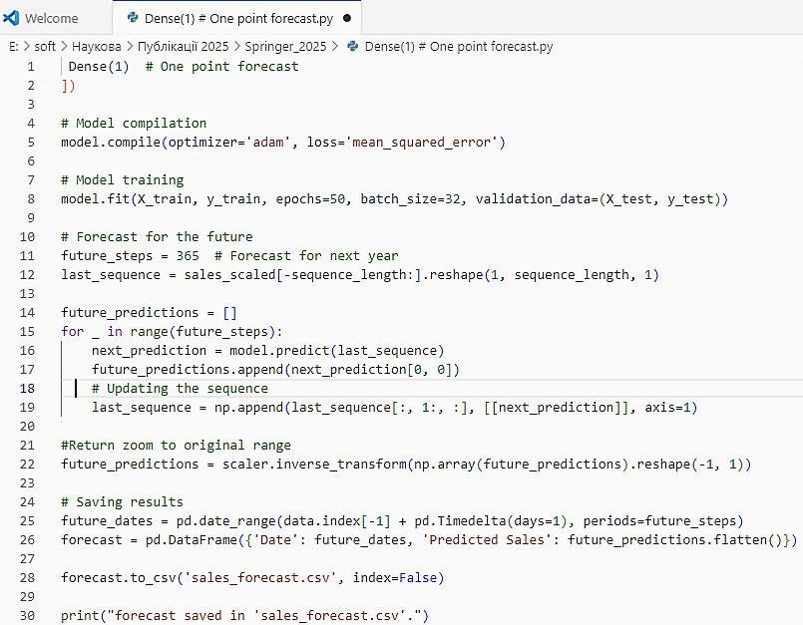
Fig. 1. Listing of the neural network code.
Explanation of the results and functions of the created artificial intelligence model for the most important areas:
- Regarding the data: we assume that the input data contains two columns: Date and Sales. If there are other variables (prices, seasonality), they can be added as additional features.
- Scaling: the data is scaled for optimal performance of LSTM.
- LSTM Model: it is used for analyzing sequential data (time series). Dropout is applied to prevent overfitting.
- Forecast: the model predicts sales for the next 365 days.
- Result: the forecast is saved in CSV format, which can be opened for analysis.
We will provide a detailed description of the Python script (see Fig. 2) that performs sales forecasting based on time series using LSTM. A code fragment for loading data is as follows:
data = pd.read_csv('sales_data.csv')
data['Date'] = pd.to_datetime(data['Date'])
data.set_index('Date', inplace=True)
- The data is loaded from the file sales_data.csv. It is assumed that the file contains the columns Date (date) and Sales (sales). The date is converted to the datetime format, and the date column is set as the index.
- Data Preparation:
  - Normalization: sales data is normalized to the range [0, 1] using MinMaxScaler, which is necessary for the stability of the neural network training.
  - Sequence Formation: sequences of 30 days (sequence_lengh) are created from the raw data for forecasting the sales of the next day. For example:
Input (x): Sales for the last 30 days.
Output (y): Sales on the 31st day.
- The data is split into: training set (80% of all sequences), and test set (20%, for model validation).
- Model Construction:
model = Sequential ([
LSTM (50, return_sequences=True, input_shape=(X_train.shape[1], 1)),
Dropout (0.2),
LSTM (50, return_sequences=False),
Dropout (0.2),
Dense (25),
Dense (1)
])
The proposed model includes:
- Two LSTM layers: for extracting dependencies in sequences.
- Dropout: to prevent overfitting.
- Dense layer: the final layer that forecasts sales for one day.
The model is compiled with the Adam optimizer and the loss function mean_squared_error. The model is trained for 50 epochs with a batch size of 32. 80% of the data is used for training, and the remaining 20% for testing.
Forecasting. The model generates forecasts following this algorithm:
It starts with the last sequence of scaled data.
The predicted day is added to the sequence, and the sequence is updated to forecast the next day.
Inverse Scaling and Saving. The forecasted values are returned to the original scale and saved in sales_forecast.csv along with the dates.
As a result, the created script forecasts future sales and saves them in the CSV file sales_forecast.csv, which contains the dates and the corresponding forecasted values. This process can be repeated multiple times. The data can also be used for analysis or visualization.
Important. For effective use, it is necessary to provide correct data in sales_data.csv.
The following code snippet represents a POST HTTP request used for sending the sales forecast to the API of the SalesDrive CRM system (Fig. 3). This ensures the integration of the AI model with other functions of the system.
In this case, your_salesdrive_instance should be replaced with the actual address of the existing SalesDrive server (this information is unavailable in our experiment). Below is a code snippet that is a function for automatically uploading sales forecasts to the SalesDrive API (Fig. 4).
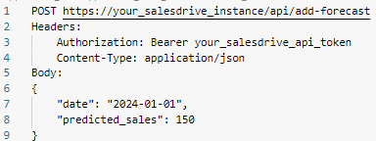
Fig. 1. HTTP Request for Sending Sales Forecast to API.
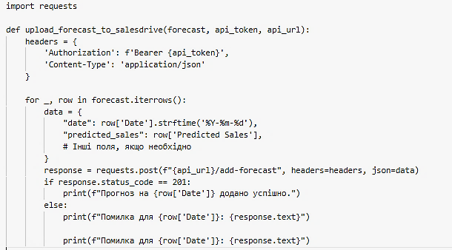
Fig. 1. Code for automatic uploading of sales forecasts to the SalesDrive API.
The function upload_forecast_to_salesdrive sends data about forecasted sales to the SalesDrive API service (see Fig. 4). It: accepts a forecast in the form of a DataFrame, an API token, and the API URL as input; generates HTTP requests for each record in the forecast; sends the data in JSON format using the POST method. The request body is formed as shown in Fig. 5.
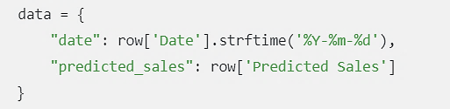
Fig. 1. – Formation of the request body for each data row and output of the forecast
The created model is ideal for:
- Forecasting retail sales.
- Analyzing product demand.
- Any tasks related to time series (weather forecasting, traffic volume, etc.).
Further actions (upon availability of the dataset for model training and successful completion):
- Visualization of the forecast: it is possible to create graphs to analyze trends;
- Adjustment of hyperparameters (number of layers, neurons, sequence length);
- Additional factors: integration of promotions, marketing expenses, or seasonality.
Thus, by uploading forecasts from LSTM models into CRM, they are used for further analysis or integration with business processes. This allows for the automation of sales forecast reporting. Interaction with the API will enable data to be stored and updated.
- Directions for further research
The choice of LSTM was due to the well-known characteristics of this type of network as being better for solving complex tasks with very long dependencies, such as text processing or time series with long patterns. It was not expected to use devices with limited resources. As alternative neural network models for applied tasks, GRU (Gated Recurrent Unit), which also belongs to RNNs and is used for processing sequential data, can be used. GRU has several advantages over LSTM [23]:
- GRU has a less complex architecture, as it uses only two gates (update and reset), while LSTM has three (input, output, and forget). This makes GRU faster during both training and inference. On small datasets, GRU shows higher performance.
- GRU contains fewer parameters, which reduces memory requirements and makes it more suitable for devices with limited resources, such as Raspberry Pi 5. Due to its fewer parameters, GRU is less prone to overfitting on small datasets, which is important when working with limited computational resources.
- GRU is simpler to implement and configure compared to LSTM, more efficiently retains long-term dependencies due to its simplified gradient control mechanism.
Thus, there are technologies that can improve and diversify solutions for integrating artificial intelligence into systems that do not fully rely on AI.
- Conclusions
The use of AI for sales forecasting significantly increases the economic efficiency of a business by optimizing resources, reducing costs, and improving strategic planning. The main aspects of efficiency can be divided into financial benefits, cost reduction, operational advantages, and increased competitiveness.
Thanks to artificial intelligence, the dynamics of the commercial world have changed. To successfully respond to customer requests and enhance customer loyalty, companies use AI-based CRM systems. Today, there is a significant shortage of capabilities to fully utilize AI within CRM, as companies strive to develop meaningful interactions. However, there is a clear knowledge gap when it comes to offering a complete understanding of the strategic integration of AI to establish personalized customer interactions, despite numerous studies showing the benefits of AI in CRM.
The economic effectiveness of applying neural networks for sales forecasting can be evaluated from several perspectives.
The proposed solution does not involve one of the problematic outcomes of using AI - uncontrolled use of customer personal data - as it utilizes a set of anonymized statistical data.
Disclosure of Interests. It is now necessary to declare any competing interests or to specifically state that the authors have no competing interests.

References
- Nuseir, M., & Refae, G. El. The effect of digital marketing capabilities on business performance enhancement: Mediating the role of customer relationship management (CRM). International Journal of Data and Network Science, 6(2), 295–304 (2022). https://doi.org/10.5267/j.ijdns.2022.1.008.
- Gartner, https://www.gartner.com/en/documents/5371263, last accessed 2025/02/20.
- IDC, IDC Report, https://www.idc.com/getdoc.jsp?containerId=US51295023, last accessed 2025/02/20.
- Ledro, C., Nosella, A., & Vinelli, A. Artificial intelligence in customer relationship management: Literature review and future research directions. Journal of Business & Industrial Marketing, 37(13), 48–63 (2022). [DOI 10.1108/JBIM-07-2021-0332]
- SalesDrive, https://salesdrive.ua/features/, last accessed 2025/02/20.
- Kotler, P., Kartajaya, H., & Setiawan, I. Marketing 4.0: Moving from Traditional to Digital. John Wiley & Sons (2017).
- Buttle, F., & Maklan, S. (2019). Customer Relationship Management: Concepts and Technologies (4th ed.). Routledge.
- Adlin, F. N., Ferdiana, R., & Fauziati, S. (2019). Current trend and literature on electronic CRM adoption review. Journal of Physics: Conference Series, 1201(1), 12058. https://doi.org/10.1088/1742-6596/1201/1/012058
- Gartner, CRM Strategies and Technologies to Understand, Grow and Engage Customers – Gartner Customer 360 Summit, https://www.gartner.com/imagesrv/summits/docs/na/customer-360/crm_summit_brochure.pdf, last accessed 2025/02/20.
- IDC, Analyse a Future, https://www.idc.com/cis/research, last accessed 2025/02/20.
- Statista. (n.d.). Customer Relationship Management Software Market Outlook. URL: https://www.statista.com/outlook/tmo/software/enterprise-software/customer-relationship-management-software
- Gartner. (2023, November 1). Gartner Magic Quadrant for the CRM Customer Engagement Center. URL: https://www.gartner.com/en/documents/4899431?ref=null
- Kopishynska, O., Utkin, Y., Sliusar, I., Muravlov, V., Makhmudov, K., & Chip, L. (2023). Application of modern enterprise resource planning systems for agri-food supply chains as a strategy for reaching the level of Industry 4.0 for non-manufacturing organizations. Engineering Proceedings, 40(1), 15. https://doi.org/10.3390/engproc2023040015
- Kopishynska, O., Utkin, Y., Makhmudov, K., Kalashnik, O., Moroz, S., & Somych, M. (2023). Digital transformation of resource management of territorial communities based on the cloud ERP system in the concept of Industry 4.0. In N. Callaos, J. Horne, B. Sánchez, & M. Savoie (Eds.), Proceedings of the 17th International Multi-Conference on Society, Cybernetics and Informatics: IMSCI 2023 (pp. 13-20). International Institute of Informatics and Cybernetics. https://doi.org/10.54808/IMSCI2023.01.13
- Ozan, Ş. (2021). Case studies on using natural language processing techniques in customer relationship management software. arXiv preprint, arXiv:2106.05160. https://doi.org/10.48550/arXiv.2106.05160
- Kusasi, F., & Tiyasiningsih, E. Implementation of artificial intelligence in customer relationship management and its implications. Proceedings of SNEBIM 2024, Tanjungpinang. (2024).
- Yau, K. L. A., Saad, N. M., & Chong, Y. W. Artificial intelligence marketing (AIM) for enhancing customer relationships. Applied Sciences, 11(18), 8565 (2021). https://doi.org/10.3390/app11188565
- Creatio, https://www.creatio.com/company/news/23686, last accessed 2025/02/20.
- Averineni, A., M, F. C., Vamsi, V. S., Manikanta, A. M., Rajasekhar Reddy, A., & Sravan Reddy, K. D. Strategic integration of artificial intelligence in customer relationship management: A path to personalization. In Proceedings of the 2nd International Conference on Disruptive Technologies (ICDT 2024), Greater Noida, India (pp. 107-111). IEEE. (2024). https://doi.org/10.1109/ICDT61202.2024.10489346
- Notebook Community. (n.d.). Sequence Classification with LSTM Recurrent Neural Networks in Python with Keras, : https://notebook.community/sysid/nbs/lstm/SequenceClassification_LSTM_CNN, last accessed 2025/02/20.
- Braun, S. (2018). LSTM Benchmarks for Deep Learning Frameworks. arXiv:1806.01818 [cs.LG]. URL: https://ar5iv.labs.arxiv.org/html/1806.01818
- Staudemeyer, R. C., & Morris, E. R. (2019, September 12). Understanding LSTM: A tutorial into long short-term memory recurrent neural networks. arXiv:1909.09586 [cs.NE]. URL: https://arxiv.org/pdf/1909.09586
- Slyusar, V. I., Kondratenko, Y. P., Shevchenko, A. I., & Yeroshenko, T. V. (2024). Some aspects of artificial intelligence development strategy for mobile technologies. Journal of Mobile Multimedia, 20(3), 525–554. https://doi.org/10.13052/jmm1550-4646.2031.

