Marlene Azevedo

CS-499-Q4508 Computer Science Capstone



Milestone 4: Enhancement Three

Databases

**A. Briefly describe the artifact. What is it? When was it created?**

For the checkers code artifact, I felt like building a database based on the games played was the perfect data to add. The data keeps track of the different types of outcomes whenever the user played against the computer. Since in the class, IT-450 AI, we had to play the game many times to test how well the game worked. I created a score board of the different types of results for every game played. The results varied but was unable to play for too long since the game kept freezing. For now, there are ten different total game plays built using SQL queries.

**B. Justify the inclusion of the artifact in your ePortfolio. Why did you select this item? What specific components of the artifact showcase your skills and abilities in software development? How was the artifact improved?**

I selected this type of database since it presents how well the game plays. Since the game is posted in the Codio.io website, I was unable to fully test the code itself. The result was that the game score database showed different outcomes of wins and losses.

Creating this database is a great way to showcase my skills because I was able to code a data built in a different programming language other than Python. The data was created using SQL queries which is a skill that is high in demand.

**C. Did you meet the course objectives you planned to meet with this enhancement in Module One? Do you have any updates to your outcome-coverage plans?**

My original objective is a bit different from my final result. My plan was to create a query where it displayed the wins/losses of each color player, showed the number of pieces that reached the back row, and how many kings where able to capture the opponents’ piece. I felt like the original columns might have made the queries too complicated to follow, so I enhanced it by using different values. What I used instead was number of pieces that remain on the board, Kings that reached the back row (Made_Kings), Kings lost, the result outcome of the game (win or lose), and the color of the player (white or black). From there, I was able to create the table, update, and delete with no errors.

**Column Values of the Table:**

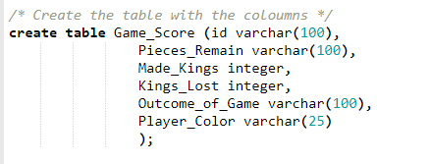

**D. Reflect on the process of enhancing and/or modifying the artifact. What did you learn as you were creating it and improving it? What challenges did you face?**

There where quite a few challenges creating the database. The primary and tedious challenge was running and testing my code. I was unable to run it using Visual Studio. It required me to connect to a SQL server. It took me several hours to get this connected which the result was unsuccessful. Lucky, I found a free online compiler known as [Paiza.io](https://paiza.io/en/languages/mysql). where I was able to run and test my code.

The SQL coding part was the easiest part of the whole process. Coming up with the correct database was a bit challenging because I had to come up with a CRUD query that would fit well with the checkers code. I think I would have been able to complete this part of the ePortfolio sooner except trying to connect to a server truly slow me down.

Perhaps, if I can reflect on the whole process, what I would say I learned from this section is finding ways to put everything together along with the main code. I do not think it was as complicated as I first believed it would be. Once I got the SQL code to work, I noticed it was much easier than I thought. I do feel like I should have added more to the database, but the timing did not allowed me to do so.

**Code:**

I built and tested the code using a free online compiler known as Paiza.io.

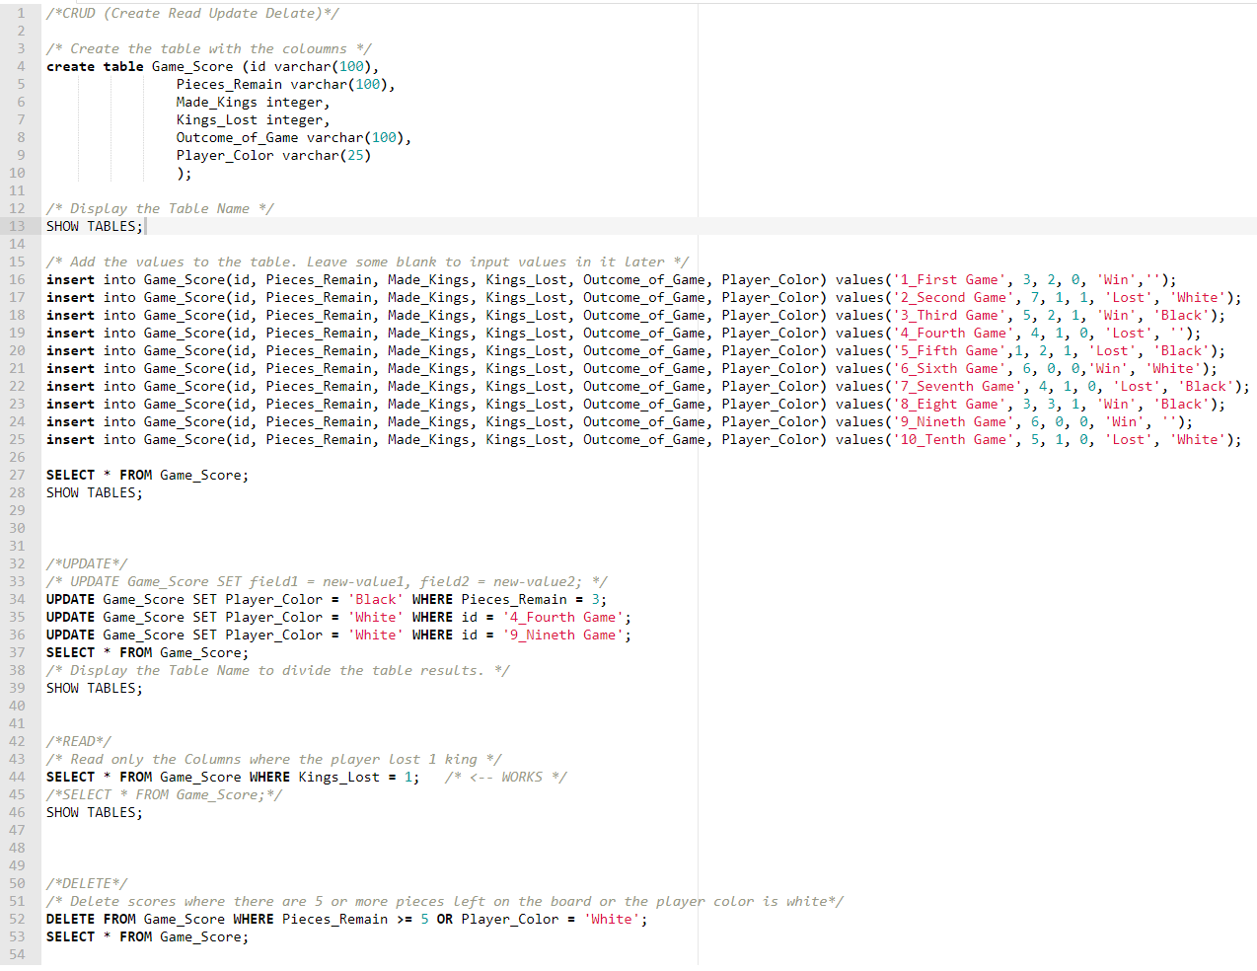(Code Link: <https://paiza.io/projects/LoAFBgPnjjb6Mc_tFHFrQg?language=mysql>)

**Code Table Output:**  
  
For the output results, I used the name of the table ‘*Game_Score*’ to separate the different the searches of the table.

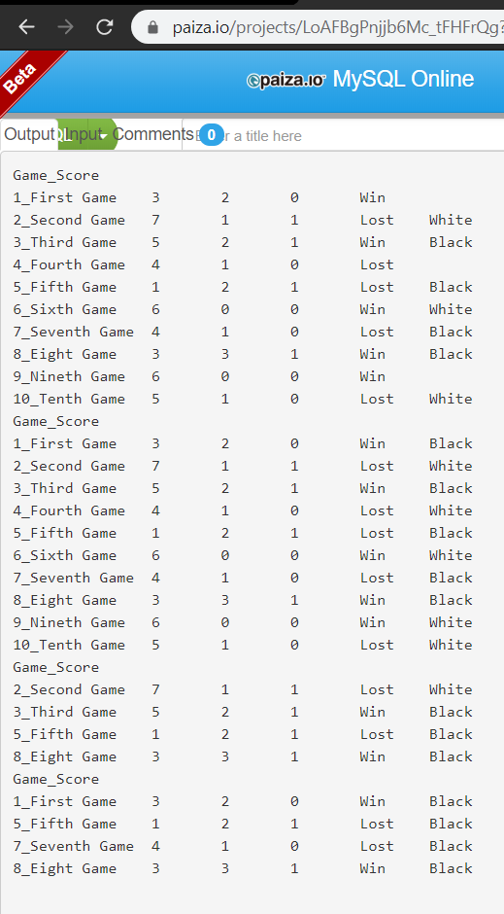

**Codio.io:**

I included a folder called ‘*Database*’ to store the Game_Score file.

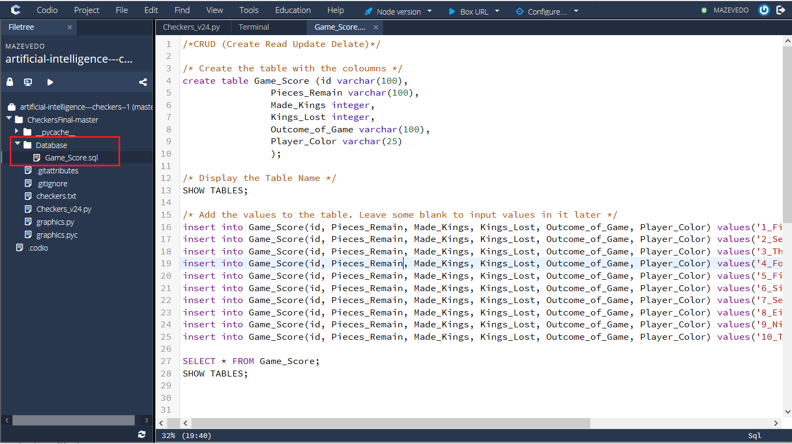

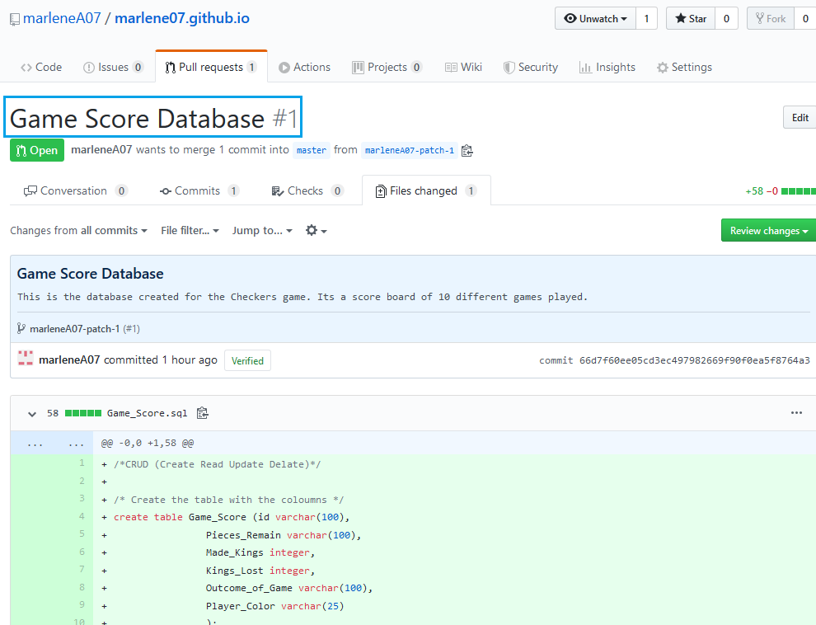

**Published it to GitHub:**

Finally, I upload my Database to GitHub.

**References:**

1. Paiza.io Cloud Ide, *MySQL Compiler*, retrieved from <https://paiza.io/projects/LoAFBgPnjjb6Mc_tFHFrQg?language=mysql>
2. GitHub, Game Score Database, retrieved from <https://github.com/marleneA07/marlene07.github.io/pull/1/commits/66d7f60ee05cd3ec497982669f90f0ea5f8764a3>