Marlene Azevedo   
CS-499-Q4508 Computer Science Capstone



Milestone 2: Enhancement One

Software Design and Engineering

**A. Briefly describe the artifact. What is it? When was it created?**

The artifact that I chose was a project for a class I took two terms ago which was IT 450 Artificial Intelligence. We had to fix and play around with a code for a Checkers game in Python language. The game was played using Codio.io and we were able test it through the website.

**B. Justify the inclusion of the artifact in your ePortfolio. Why did you select this item? What specific components of the artifact showcase your skills and abilities in software development? How was the artifact improved?**

I chose this artifact because there were plenty of lines in the code that needed modification. The code allowed the students to play around, improve the code and possibly fix any bugs lurking in the code. I think this is the perfect artifact to choose because it will allow me to fix the code, test it, and see how well I can improve the code. Since the code has plenty of lines that state, “this does not always work”, it will allow me to correct those problems. This will help me showcase my skills in the software development section because I am able to correct mistakes, change the design around, and be creative.

I improved the code in the way it is displayed. I think it makes it easier for the user to understand. The buttons are not put in order well and the way they were arranged could have cause some confusion. I wanted to make it easier to follow while the user plays along with the computer. For example, the user should be able to easily view the ‘X’ button if they desired to quit the game.

**C. Did you meet the course objectives you planned to meet with this enhancement in Module One? Do you have any updates to your outcome-coverage plans?**

I did complete some of the planned objectives, however, I figured some buttons do not need to be rearranged. This would create more confusion within the code because the way they are currently setup makes more sense. For example, the buttons that keep score of the colors who have more tokens, has been perfectly created and is easy to follow. If I were to change these buttons, it could throw an error or not work properly. I did move the ‘Start’ button to the far right because it is easier to view when starting the game. I also moved the ‘Save’, ‘Load’, and ‘Resign’ to the top middle right. When the player Starts the game, the rest of the buttons automatically disappear while only these 3 buttons become visible (Save, Resign, and X). Where they were placed originally, at the bottom right, it was harder to see. The user had to scroll down to select these buttons if necessary. Technically, these buttons would have been okay where they were, except the game tends to freeze from time to time and keeps the user from scrolling down. By moving them to the top, if the game freezes, the user is able to save the game without losing any data.

**Before After**

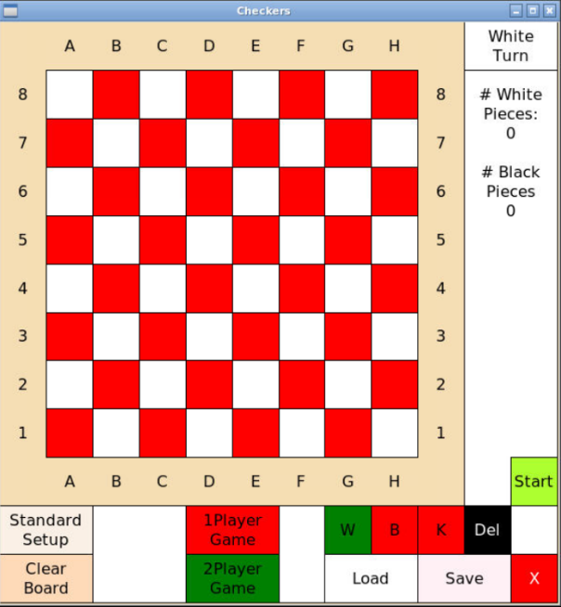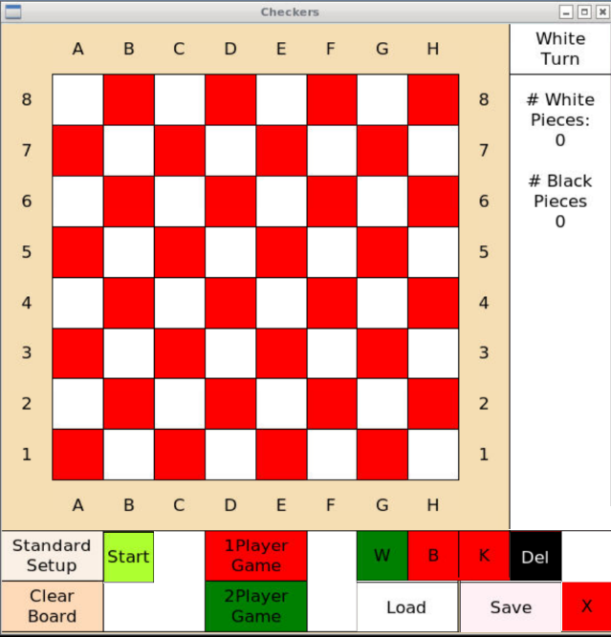

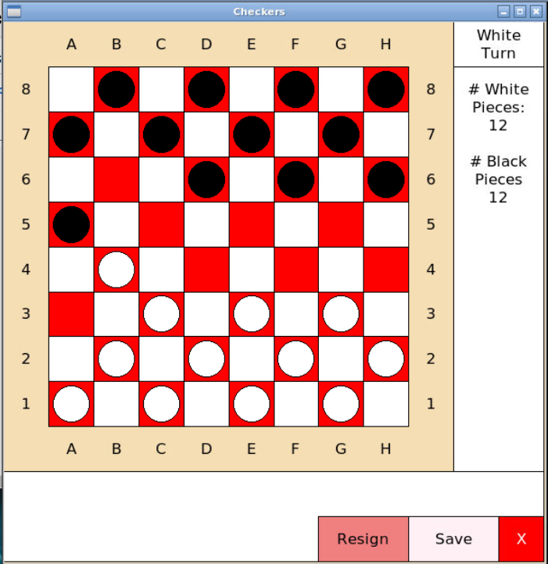 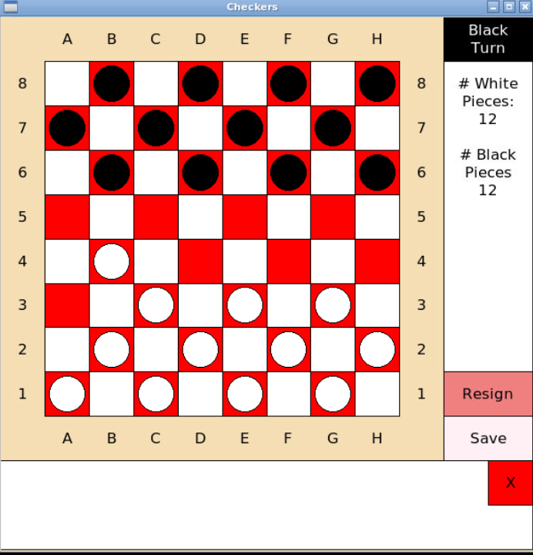

**D. Reflect on the process of enhancing and/or modifying the artifact. What did you learn as you were creating it and improving it? What challenges did you face?**

There were quite a few things that occurred when rearranging the code. I had to carefully review the code and decide what I could modify without creating any errors.

**Learn:** I learned how rearranging buttons takes more than just changing a simple line of code. Every line is connected to another line that requires change. If this is not done right then it will throw an error. I had to document everything with notes and screenshots to keep track of what I was changing and what required modification. This really shows how keeping track of everything that I change is very important. If no documentation is done, then one can easily make several mistakes.

**Challenges:** The code was not giving me what I was trying to do such as rearranging the coordinates. Some of the coordinates where off. I had to do research on the python x y coordinates to learn on how to rearrange the buttons. Then whenever I clicked, say the Start button, it was not starting the game but whenever I clicked where the Start button originally was, then the game would start. I noticed that I had to also rearranged the mouse click coordinates. I had to play around for a while until I was able to get it where I wanted the buttons to be located at.

**Coding Modifications:**

Adjust **Start!** Button coordinates



Modify Start ‘Mouse Clicks’: Change so when clicking on the button, it Starts the game



**Original Final**

