[GitHub - Vooban/Smoothly-Blend-Image-Patches: Using a U-Net for image segmentation, blending predicted patches smoothly is a must to please the human eye.](https://github.com/Vooban/Smoothly-Blend-Image-Patches)

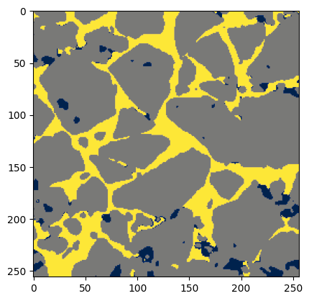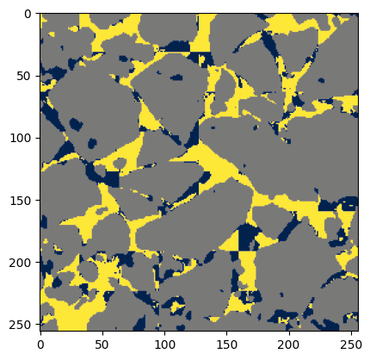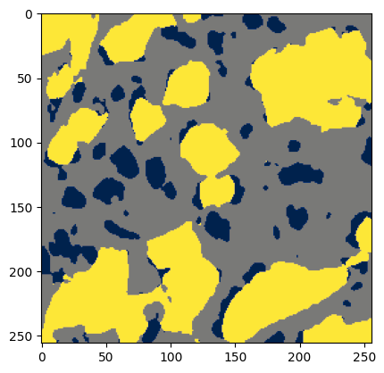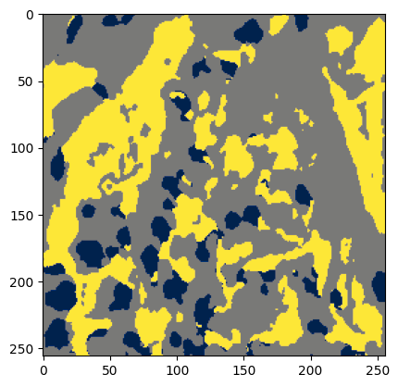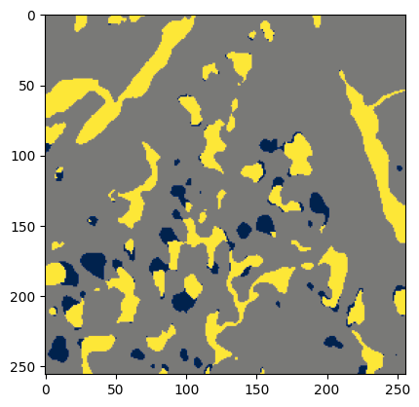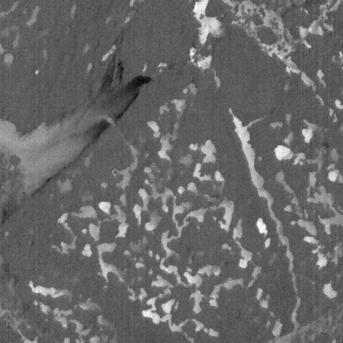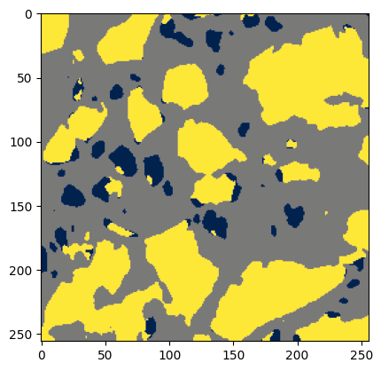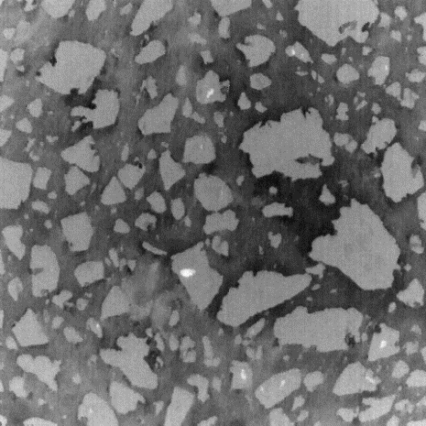

**Old prediction Smooth prediction**

**Original IR patch size 32 patch size 256**