Programmer’s guide for TSBTool.

Requirements:
- Microsoft .NET SDK (try this link http://www.dotnetgerman.com/links/dl_distri.asp ).
- Some programming skills.

Since TSBTool.exe is written in a .NET language, it is pretty easy for any .NET programmer to use many of the functions contained within ‘TSBTool.exe’. You just to know what functions to call and to reference ‘TSBTool.exe’ at compile time.

To figure out what functions you can use you can make use of Lutz Roeder’s .NET Reflector (it’s a free download http://www.aisto.com/roeder/dotnet/ ).

Example: Make Even Teams.

Open up TSBTool with Reflector, turn on the disassembler view [ Tools → Disassembler], and browse to the class ‘TecmoTool’.

We see that TecmoTool resides in the namespace ‘TSBTool’. So we will need a ‘using TSBTool’ declaration in our code if we ant to use the classes inside TSBTool.

Have a look at the SetXXAbilities functions. The following image shows the SetQBAbilities function.

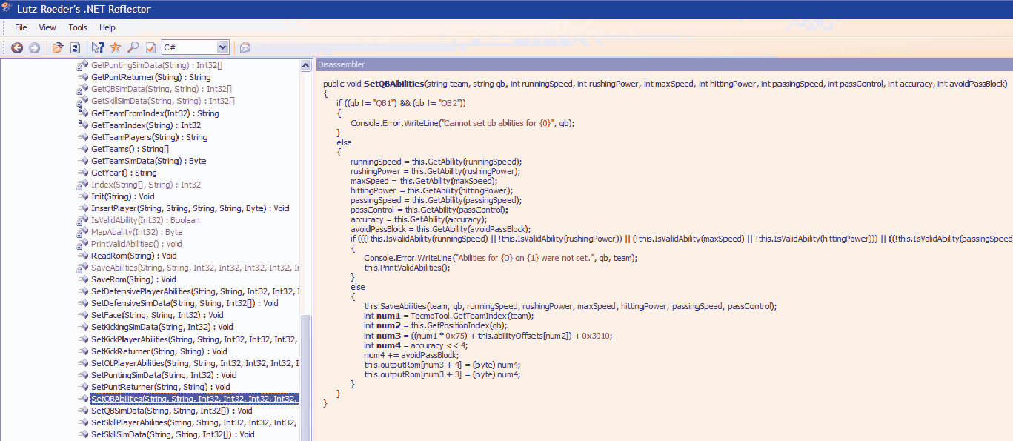

As you can see, it shows you the entire implementation of the function ‘SetQBAbilities’. The important part is the function ‘signature’. In this case the signature is :
public void SetQBAbilities(string team, string qb,
int runningSpeed, int rushingPower, int maxSpeed, int hittingPower,
int passingSpeed, int passControl, int accuracy, int avoidPassBlock)

This function takes 10 arguments, ‘team’, ‘qb’, and the Tecmo Super Bowl attributes you should already be familiar with.

Also have a look at functions SetDefensivePlayerAbilities, SetSkillPlayerAbilities, SetOLPlayerAbilities and SetKickPlayerAbilities.

Before we can use these functions we need to construct a ‘TecmoTool’ object. Now lets have a look at the constructors ( .ctor ) for TecmoTool. In this case there are 2. One that takes a string and a constructor that takes no arguments. We want to use the one that takes the ‘fileName’ argument (this is the input ROM file).

So in our code we can create a TecmoTool like this:
TecmoTool tool = new TecmoTool(“TSPRBOWL.nes”).
Now we can call the functions associated with this object like this:
tool.SetQBAbilities( “bills”, “QB1”, 25,69,13,13, 56, 81, 81, 81);
We have just set the attributes for the bills’ #1 QB.
We also may want to set the QB’s sim data, have a look at SetQBSimData:
public void SetQBSimData(string team, string pos, int[] data)
This function takes 3 arguments, ‘team’, ‘pos’ and data. The ‘data’ is an int array. The QB’s sim data consist of 3 numers, [Sim run ability, Sim pass ability, Sim Pocket].
Lets set the sim data for the bills QB1.
int[] data = { 2, 2, 2};
tool.SetQBSimData(“bills”, “QB1”, data);

Ok, by now you should be starting to figure things out.

Now let’s show a code example (C# in this case):
============EvenTeams.cs=======================================
using System;
using TSBTool;

class EvenTeams
{
public static void Main(string[] args)
{
// this array was taken from the static constructor for TecmoTool
string[] teams = new string[] {
"bills", "colts", "dolphins", "patriots", "jets",
"bengals", "browns", "oilers", "steelers",
"broncos", "chiefs", "raiders", "chargers", "seahawks",
"redskins", "giants", "eagles", "cardinals", "cowboys",
"bears", "lions", "packers", "vikings", "buccaneers",
"49ers", "rams", "saints", "falcons"
};
// We assume your input ROM is TSPRBOWL.nes. To change that simply
// modify the string below.
TecmoTool tool = new TecmoTool("TSPRBOWL.nes");

for( int i = 0; i < teams.Length; i++)
{
//Qbs
tool.SetQBAbilities( teams[i], "QB1", 25,69,13,13, 56, 81, 81, 81);
tool.SetQBAbilities( teams[i], "QB2", 25, 69, 13, 13, 31, 44, 25, 50);
//RBs
tool.SetSkillPlayerAbilities( teams[i], "RB1",38, 69, 31, 50, 50, 25 );
tool.SetSkillPlayerAbilities( teams[i], "RB1",38, 69, 31, 50, 50, 25 );
tool.SetSkillPlayerAbilities( teams[i], "RB3",38, 69, 31, 50, 50, 25 );
tool.SetSkillPlayerAbilities( teams[i], "RB4",38, 69, 31, 50, 50, 25 );
// WRs
tool.SetSkillPlayerAbilities( teams[i], "WR1",38, 69, 38, 13, 50, 44 );
tool.SetSkillPlayerAbilities( teams[i], "WR2",38, 69, 38, 13, 50, 44 );
tool.SetSkillPlayerAbilities( teams[i], "WR3",38, 69, 38, 13, 50, 44 );
tool.SetSkillPlayerAbilities( teams[i], "WR4",38, 69, 38, 13, 50, 44 );
// TEs
tool.SetSkillPlayerAbilities( teams[i], "TE1",25, 69, 25, 50, 50, 38 );
tool.SetSkillPlayerAbilities( teams[i], "TE2",25, 69, 25, 50, 50, 38 );
//OL
tool.SetOLPlayerAbilities( teams[i], "C", 25, 69, 25, 50 );
tool.SetOLPlayerAbilities( teams[i], "LG", 25, 69, 25, 50 );
tool.SetOLPlayerAbilities( teams[i], "RG", 25, 69, 25, 50 );
tool.SetOLPlayerAbilities( teams[i], "LT", 25, 69, 25, 50 );
tool.SetOLPlayerAbilities( teams[i], "RT", 25, 69, 25, 50 );
//DL
tool.SetDefensivePlayerAbilities( teams[i], "NT", 25, 31, 25, 50, 19, 19 );
tool.SetDefensivePlayerAbilities( teams[i], "LE", 25, 31, 25, 50, 19, 19 );
tool.SetDefensivePlayerAbilities( teams[i], "RE", 25, 31, 25, 50, 19, 19 );
// LBs
tool.SetDefensivePlayerAbilities( teams[i], "LOLB", 25, 31, 38, 50, 25, 38 );
tool.SetDefensivePlayerAbilities( teams[i], "LILB", 25, 31, 38, 50, 25, 38 );
tool.SetDefensivePlayerAbilities( teams[i], "RILB", 25, 31, 38, 50, 25, 38 );
tool.SetDefensivePlayerAbilities( teams[i], "ROLB", 25, 31, 38, 50, 25, 38 );
// CBs, SS, FS
tool.SetDefensivePlayerAbilities( teams[i], "RCB", 38, 44, 56, 56, 56, 56 );
tool.SetDefensivePlayerAbilities( teams[i], "LCB", 38, 44, 56, 56, 56, 56 );
tool.SetDefensivePlayerAbilities( teams[i], "FS", 38, 44, 56, 56, 56, 56 );
tool.SetDefensivePlayerAbilities( teams[i], "SS", 38, 44, 56, 56, 56, 56 );
// P, K
tool.SetKickPlayerAbilities( teams[i], "P", 25, 56, 44, 31, 75, 38 );
tool.SetKickPlayerAbilities( teams[i], "K", 25, 56, 44, 31, 75, 38 );
}

// now for Sim Data
int[] qbData = { 5, 5, 5 };
int[] skillData = { 5,5,5,5 };
int[] defenseData = { 5,5 };
for(int i = 0; i < teams.Length; i++)
{
//Qbs
tool.SetQBSimData( teams[i], "QB1", qbData);
tool.SetQBSimData( teams[i], "QB2", qbData);
//RBs
tool.SetSkillSimData( teams[i], "RB1", skillData );
tool.SetSkillSimData( teams[i], "RB1", skillData );
tool.SetSkillSimData( teams[i], "RB3", skillData );
tool.SetSkillSimData( teams[i], "RB4", skillData );
// WRs
tool.SetSkillSimData( teams[i], "WR1", skillData );
tool.SetSkillSimData( teams[i], "WR2", skillData );
tool.SetSkillSimData( teams[i], "WR3", skillData );
tool.SetSkillSimData( teams[i], "WR4", skillData );
// TEs
tool.SetSkillSimData( teams[i], "TE1", skillData );
tool.SetSkillSimData( teams[i], "TE2", skillData );
// no sim data for the OL

// Defense
//DL
tool.SetDefensiveSimData( teams[i], "NT", defenseData );
tool.SetDefensiveSimData( teams[i], "LE", defenseData );
tool.SetDefensiveSimData( teams[i], "RE", defenseData );
// LBs
tool.SetDefensiveSimData( teams[i], "LOLB", defenseData );
tool.SetDefensiveSimData( teams[i], "LILB", defenseData );
tool.SetDefensiveSimData( teams[i], "RILB", defenseData );
tool.SetDefensiveSimData( teams[i], "ROLB", defenseData );
// CBs, SS, FS
tool.SetDefensiveSimData( teams[i], "RCB", defenseData );
tool.SetDefensiveSimData( teams[i], "LCB", defenseData );
tool.SetDefensiveSimData( teams[i], "FS", defenseData );
tool.SetDefensiveSimData( teams[i], "SS", defenseData );
// P, K
tool.SetKickingSimData( teams[i], 5 );
tool.SetPuntingSimData( teams[i], 5 );
}
tool.SaveRom("output.nes");
}
}
===============================================================
You will need to compile it like this (from the command line):
csc /out:EvenTeams.nes /r:TSBTool.exe EvenTeams.cs
In my version of Visual Studio, I’m not allowed to reference an ‘exe’ but I have no problem doing so from the command line.

