**Project 2 Report**

This project involved installing a kernel, writing a kernel module, creating system calls and generating a patch.

**Kernel Installation**

First, we compiled the kernel, then we rebooted the system and selected the Linux 2.6.36 kernel. In this image we can see that the kernel booted correctly.

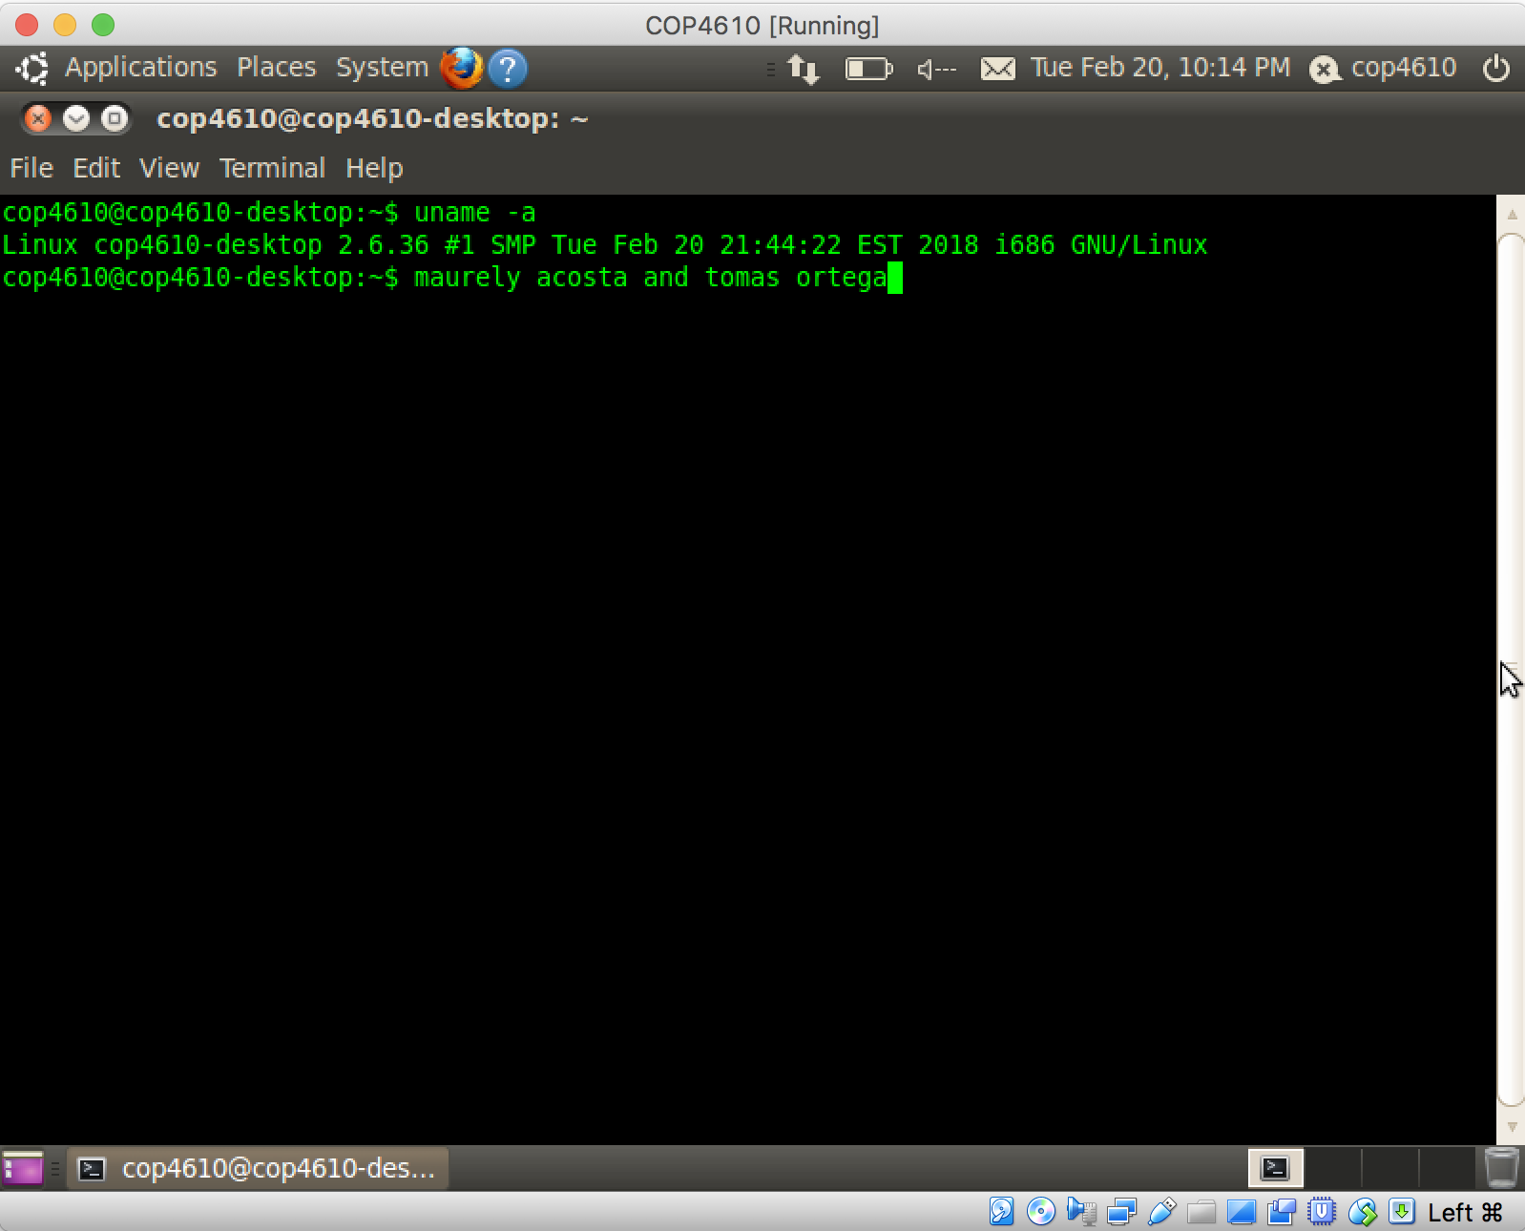

**Creating and Inserting Kernel Modules**

After we created the test-toy.c file, we compiled it using the Makefile to get test-toy.ko. We then inserted the module into our kernel using the command insmod test-toy.ko.

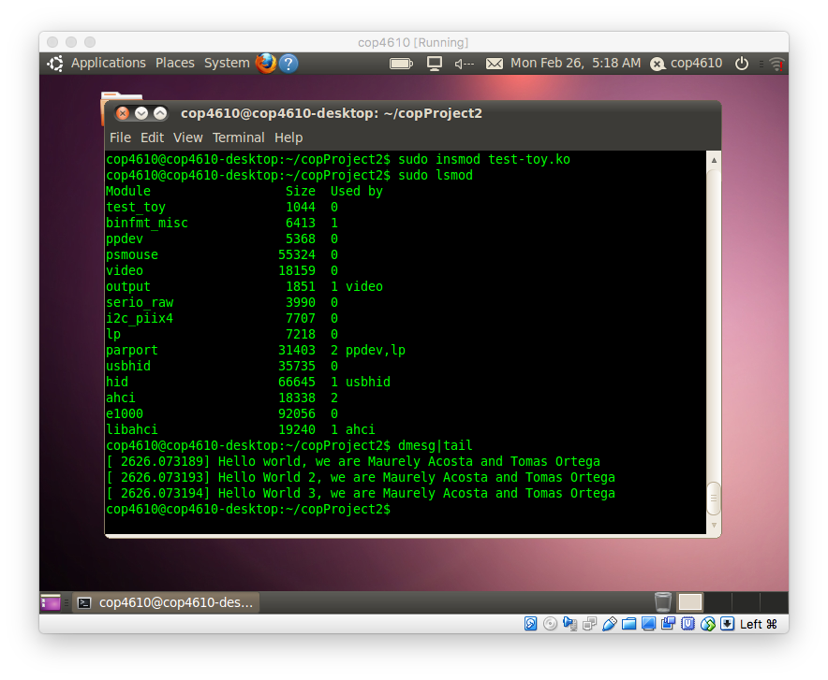

**Removing Kernel Modules**

We used the rmmod command to remove the kernel we just inserted.

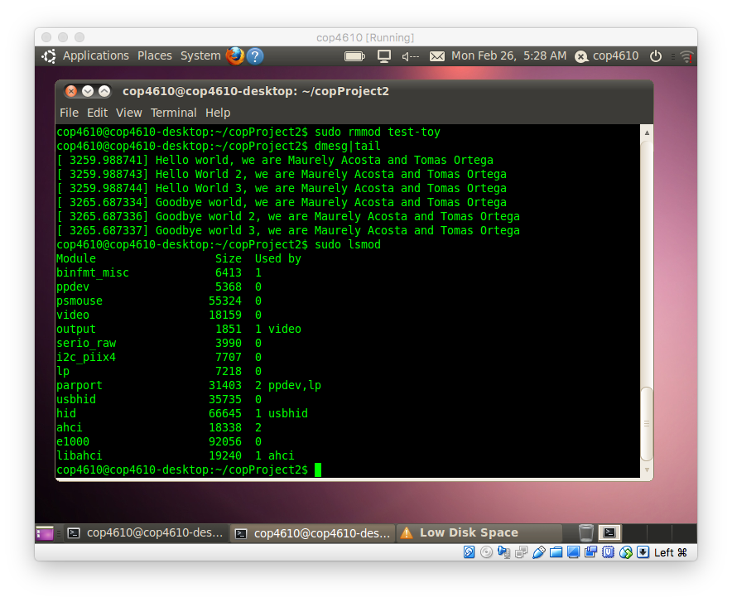

**New System Call**

To make our system call we first had to modified a few kernel files such as syscall_table_32.S, unistd_32.h, syscalls.h, and Makefile. Then we created the source file mycall.c. We modified the code given to us so that it displays the current system time. We also created files in user space to be able to test our system call. Here we can see that after running the testmycall program it outputs the correct message with the correct human readable system time.

