**Evidence for Analysis and Design Unit.**

Marta Beveridge

Cohort E20

**A.D.1 Use case Diagram**

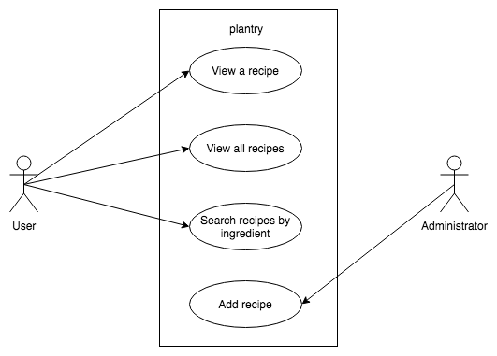

Evidence for unit

**A.D.2 Class diagram**

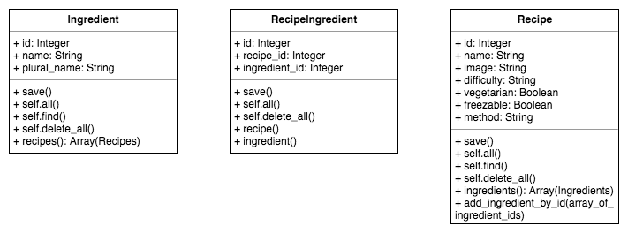

Evidence for unit

**A.D.3 Object diagram**

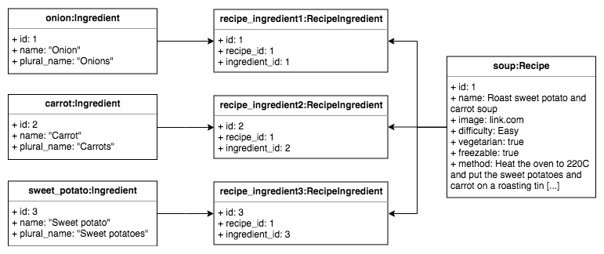

Evidence for unit

**A.D.4 Activity diagram**



Evidence for unit

**A.D.5 Inheritance diagram**



Evidence for unit

**A.D.6 Implementations Constraints**

|  |  |  |
| --- | --- | --- |
|  | **Constraint and possible effect** | **Solution** |
| **Hardware and software platforms** |  |  |
| **Performance requirements** |  |  |
| **Persistent storage and transactions** |  |  |
| **Budgets** |  |  |
| **Time** |  |  |