**Evidence for Analysis and Design Unit.**

Marta Beveridge

Cohort E20

**A.D.1 Use case Diagram**

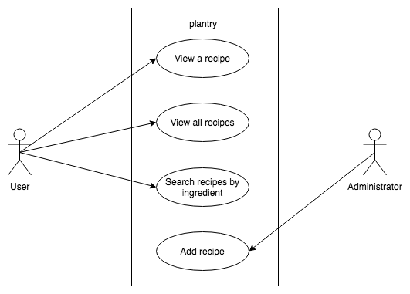

**A.D.2 Class diagram**

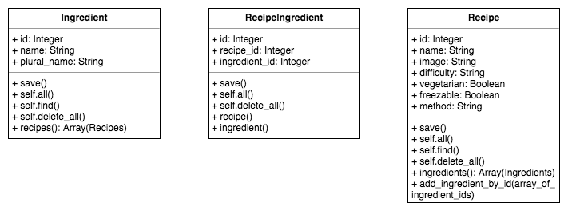

**A.D.3 Object diagram**

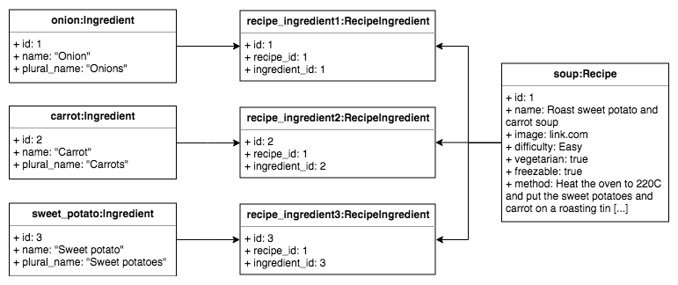

**A.D.4 Activity diagram**

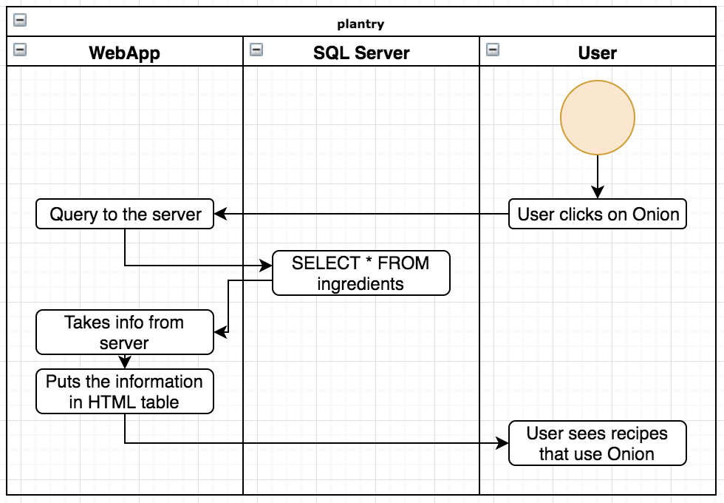

**A.D.5 Inheritance diagram**

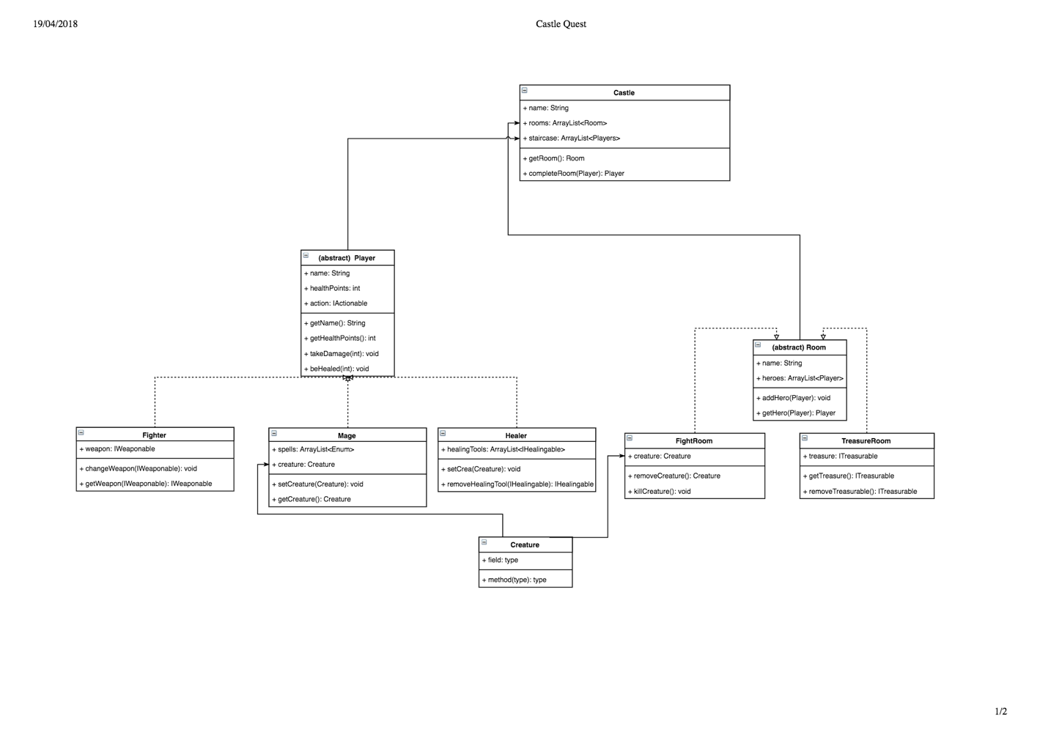

**A.D.6 Implementations Constraints**

