**Evidence for Implementation and Testing.**

Marta Beveridge

Cohort E20

**I.T 1- Demonstrate one example of encapsulation you have written in a program.**

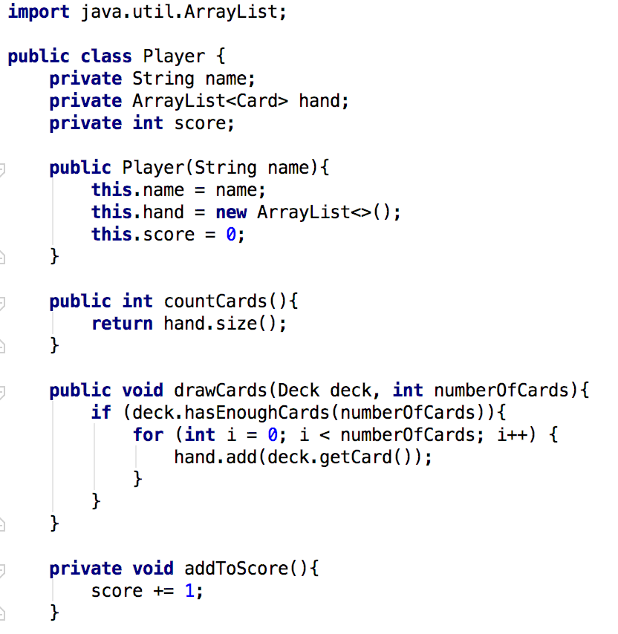

**I.T 2 - Example the use of inheritance in a program.**

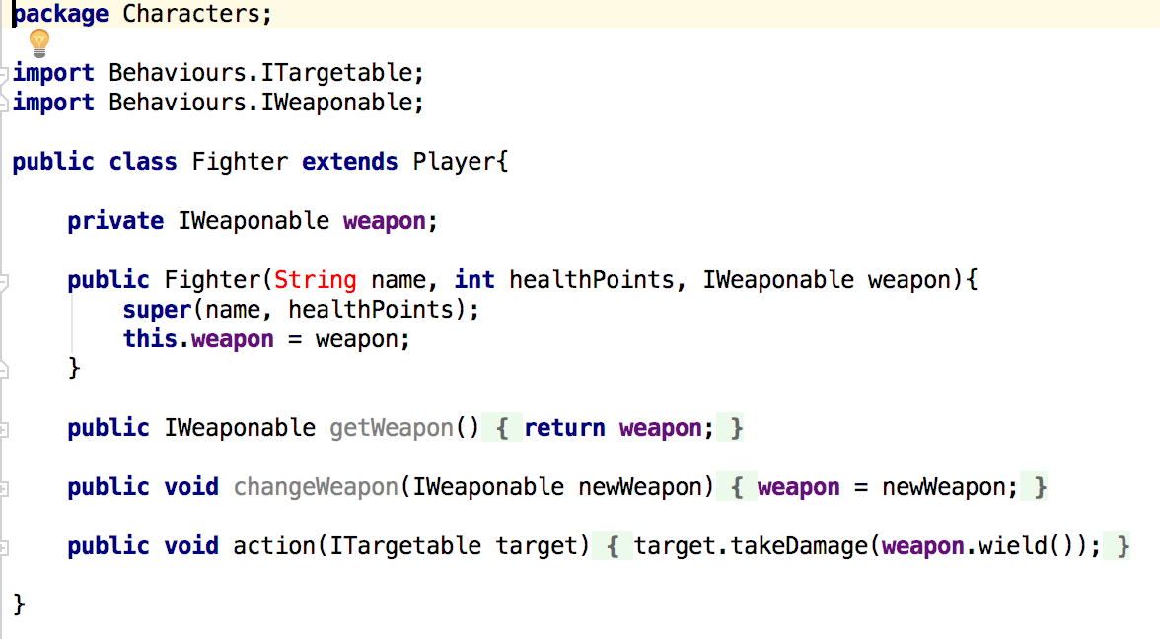

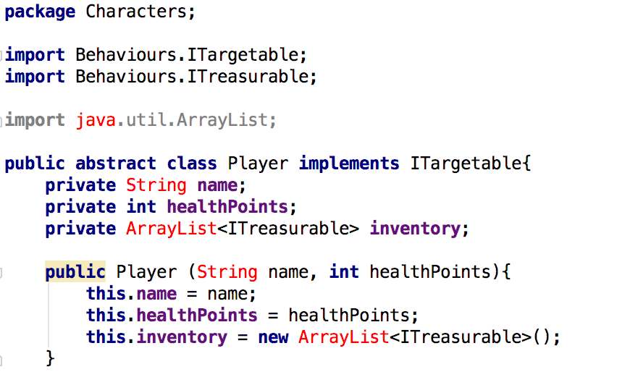

**I.T 3 - Example of searching**

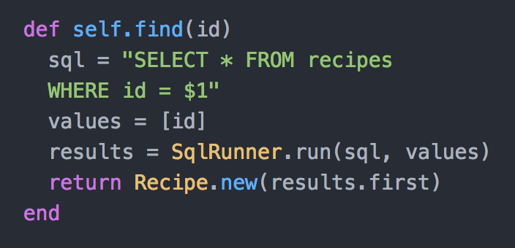

**I.T 4 – Example of sorting**

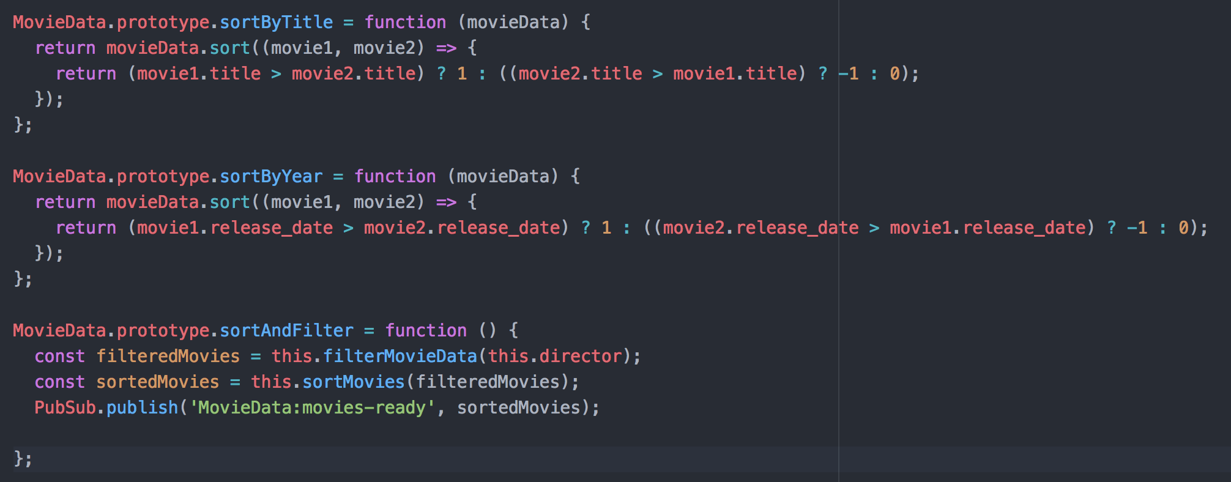

**I.T 5 - Example of an array, a function that uses an array and the result**

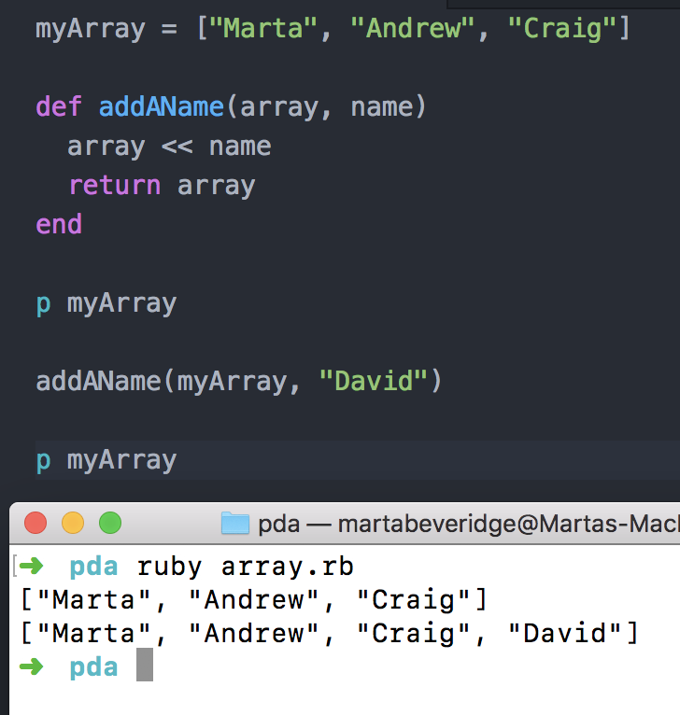

**I.T 6 - Example of a hash, a function that uses a hash and the result**

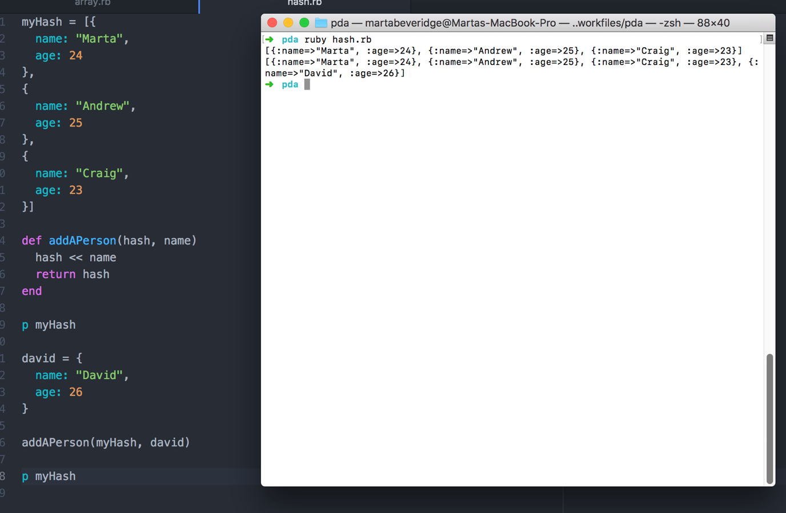

**I.T 7 - Example of polymorphism in a program**

