ALL-STAFF PD · CULTURE FOUNDATIONS · FACILITATOR SCRIPT
Schoolwide Systems & Classroom Procedures
Facilitator: Amanda Kayte
Duration: 89 minutes total (4 min Opening · 45 min Part 1 · 30 min Part 2 · 10 min Part 3)
Session Goal: Every adult in the building holds schoolwide systems and procedures the same way, every adult holds classroom procedures consistently all year, and every teacher leaves naming both the accountability and the celebration work still to come.
OPENING · WHY WE PRACTICE (4 MIN)
The Founder — The Tennis Court Kitchen

4 MIN — The Tennis Court Kitchen  NOTE Confirm access to the approved Founder (2016) Speedee Service System tennis-court clip before presenting. The deck intentionally does not embed or publicly link licensed media.  SAY “Before we start, I want to show you a clip. Watch for what this team is doing, and why they're doing it before a single customer ever walks in.”  DO Play the clip. Keep it to the tennis-court rehearsal scene only — no need to play more than that.  SAY “They chalked out the entire kitchen, full size, on a tennis court — every station, every counter — and walked it, timed it, ran it again and again. No customers watching. Just getting the motion right before it mattered.”  SAY “That's exactly what today is. Every read-aloud, every partner practice, every script we say out loud in this room — that's our tennis court. We get it right here, together, before a single student ever walks through the door.”  DO Advance to the main title slide and move directly into Part 1. | 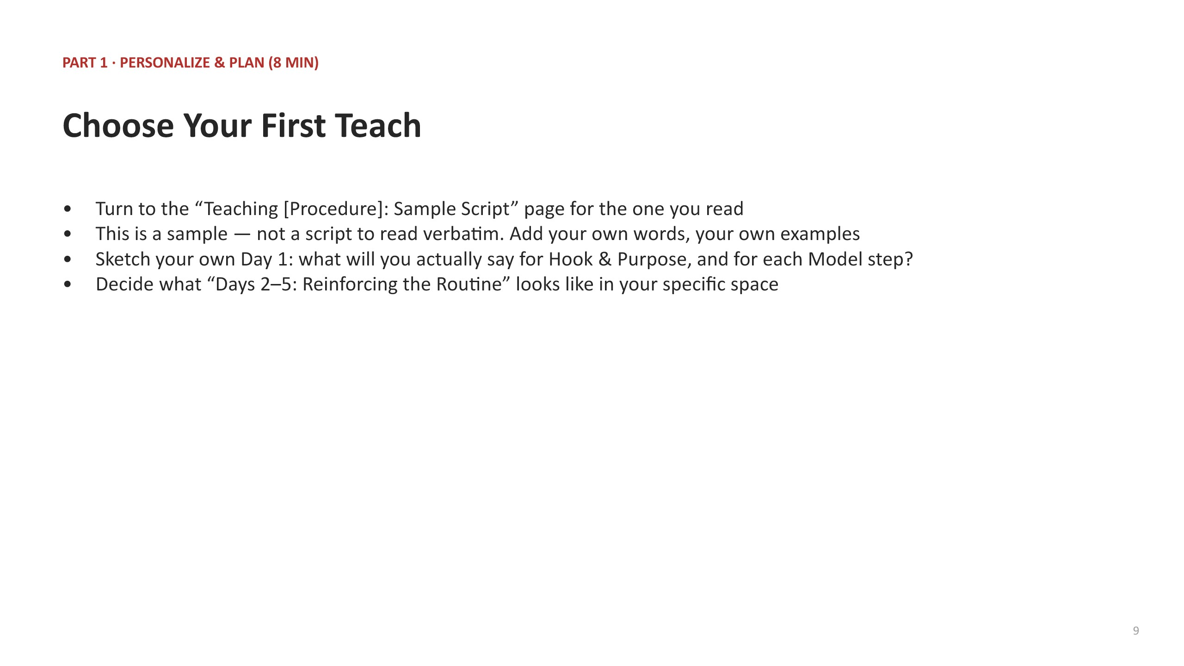  Slide 1

PART 1 · SCHOOLWIDE SYSTEMS & PROCEDURES (45 MIN)
Morning Meeting remains live year-round · Updated workshop cards: Morning Entry · Dismissal · Hallway Transitions · Restroom · Lunch · Recess · Refresher

4 MIN — Framing & Purpose  SAY “Morning Meeting remains our live year-round schoolwide system. The seven updated procedure cards in this workshop supplement it; they do not replace it. Everything we cover in the next 45 minutes is already true buildingwide, and every adult holds it the same way.”  SAY “These are different from your own classroom routines — there's no 'Our Room's Specifics' column here. The specification IS the specification, building-wide.”  DO Advance to the framing slide. Distinguish the shared schoolwide systems and procedures from classroom procedures (which come in Part 2) so the room understands why today has two distinct halves.  NOTE If your team already has copies of all seven procedure documents in hand, hold them up here so people can see the full stack before you walk the anatomy. | 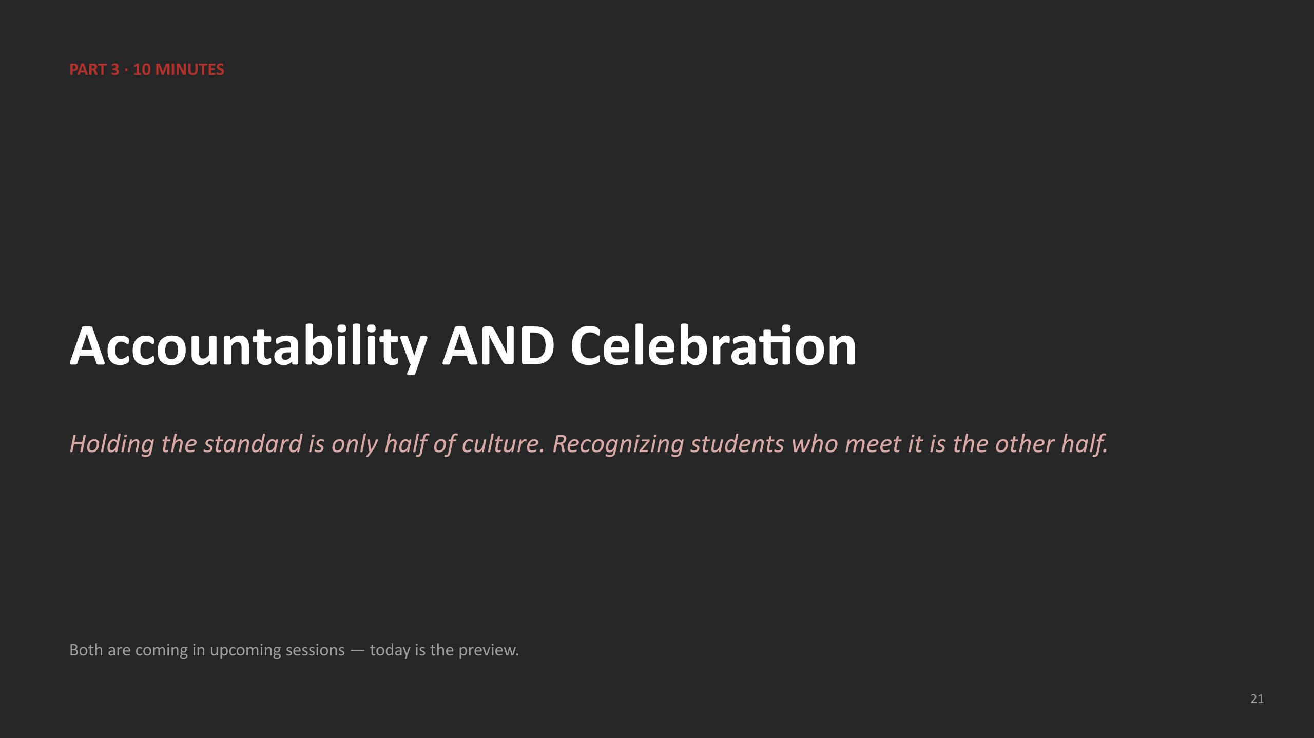  Slide 5

5 MIN — Document Anatomy  SAY “Every one of these seven cards follows the same shape: a Rationale, a Routine table, Non-Negotiables, Sample Teacher Language, and a Teaching Script for how to actually roll it out.”  SAY “A few calls in these documents are marked with this pencil icon — ‘Called for Now.’ That means it's a real decision, but it's not permanent. If it doesn't hold up in practice, we revise it and move on.”  DO Hold up one procedure card as a physical model and point to each part as you name it: Rationale, Routine table, Non-Negotiables, WTD language, Teaching Script. | 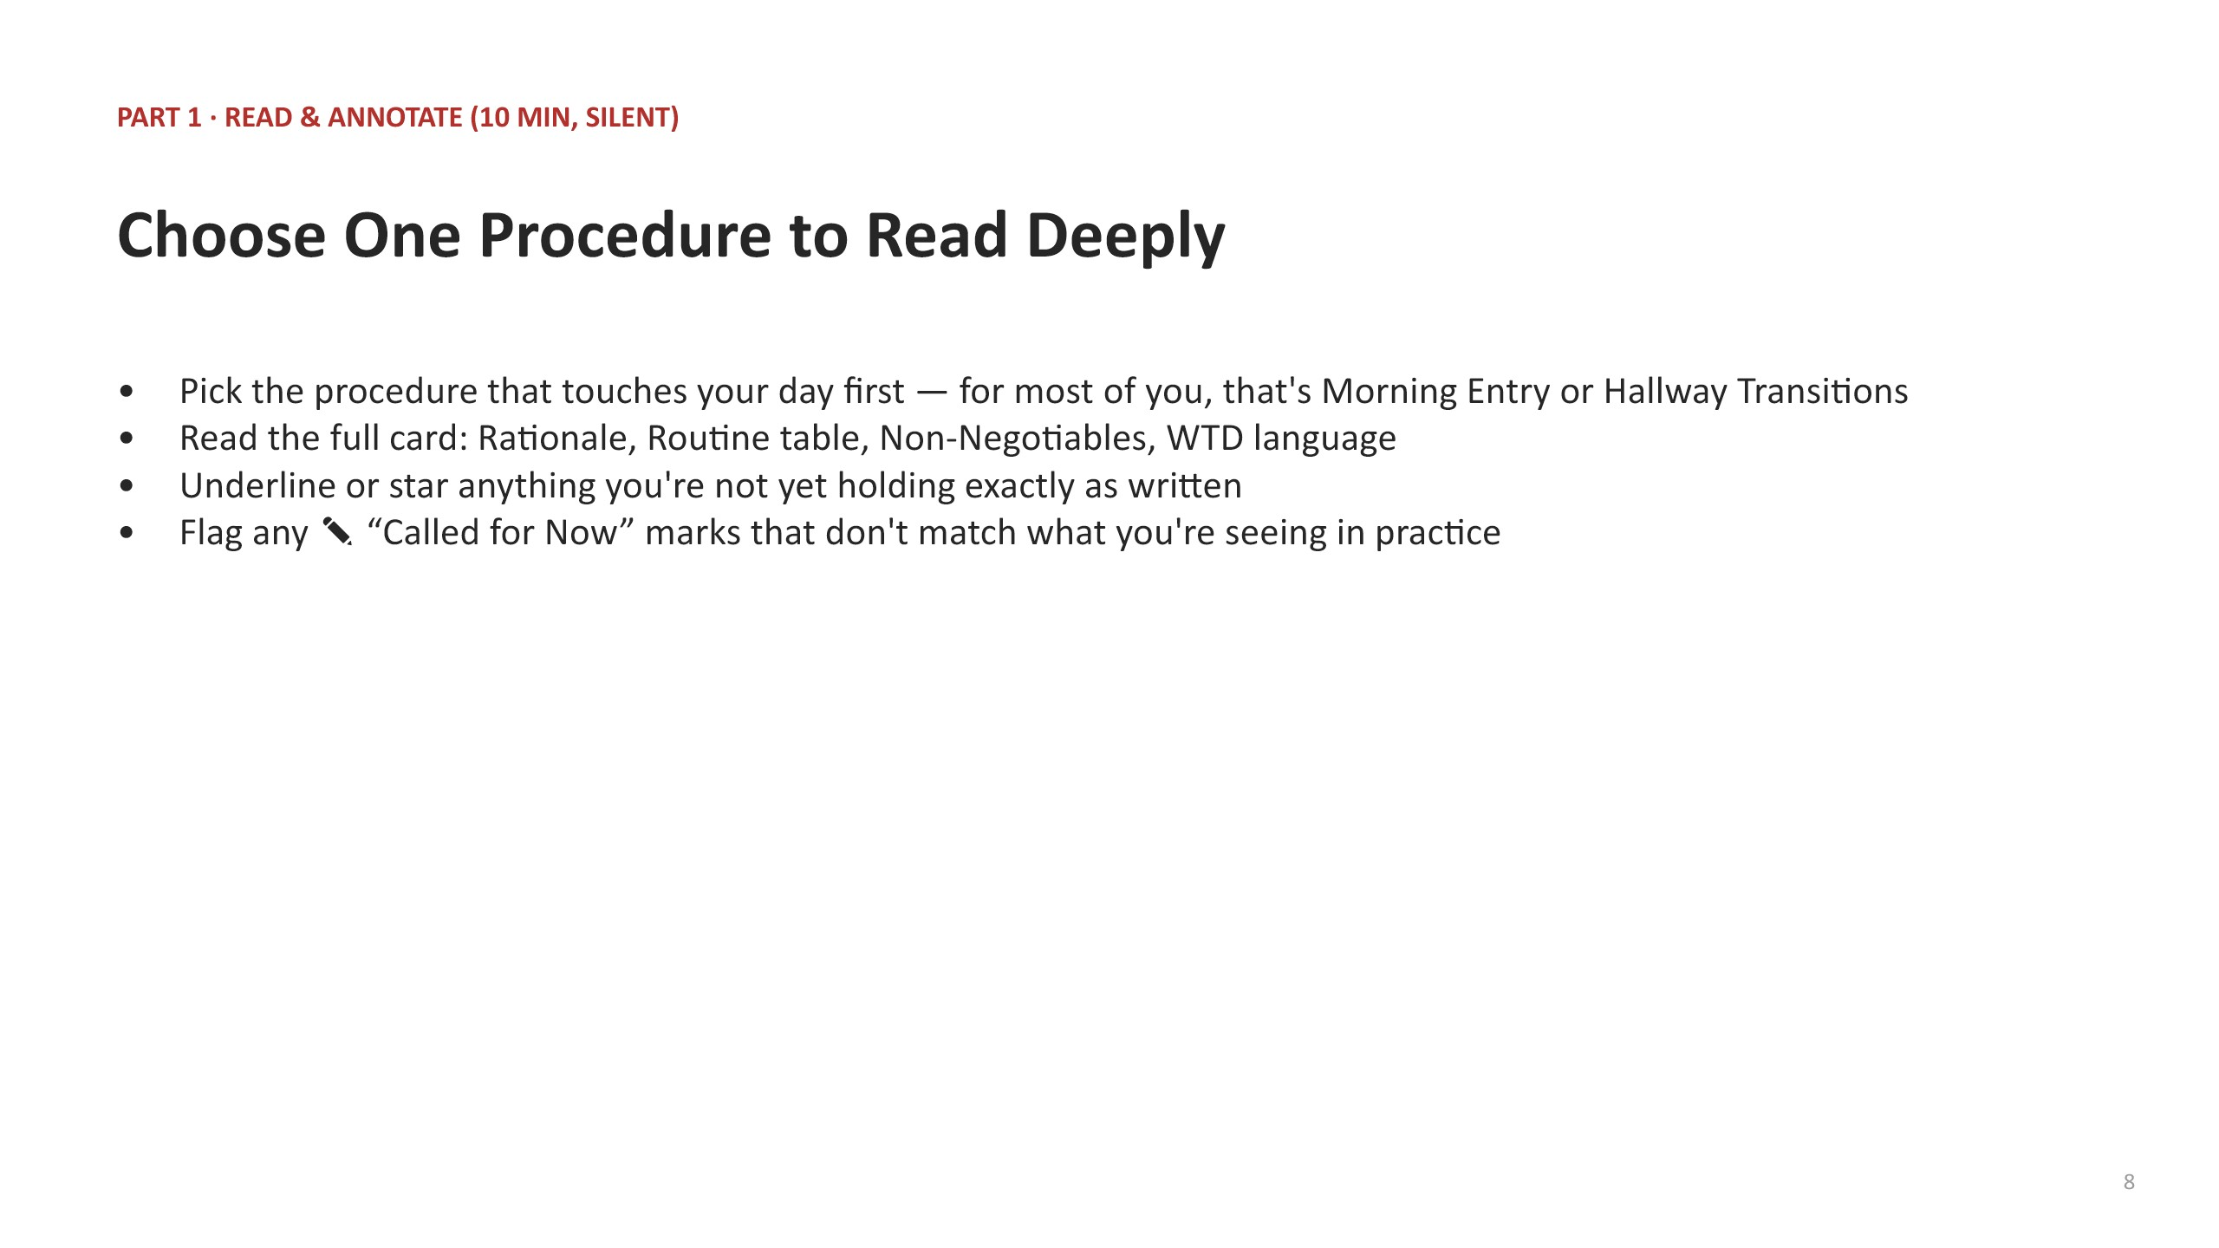  Slide 6

8 MIN — Walk the Full Set  SAY “Morning Meeting stays live separately. Now let's move fast through the seven updated procedure cards, so you know what's coming across your whole day: Morning Entry, Hallway Transitions, Restroom, Lunch, Recess, Dismissal, and the Refresher on dress code, cell phones, backpacks, and hall passes.”  DO Advance through the full-set slide, naming one non-negotiable per procedure out loud as you go (e.g., 'Hallway Transitions: voice 0, no exceptions'). Keep pace brisk — this is a tour, not a teach.  NOTE This is intentionally fast. The deep read happens in the next block, on one procedure only. | 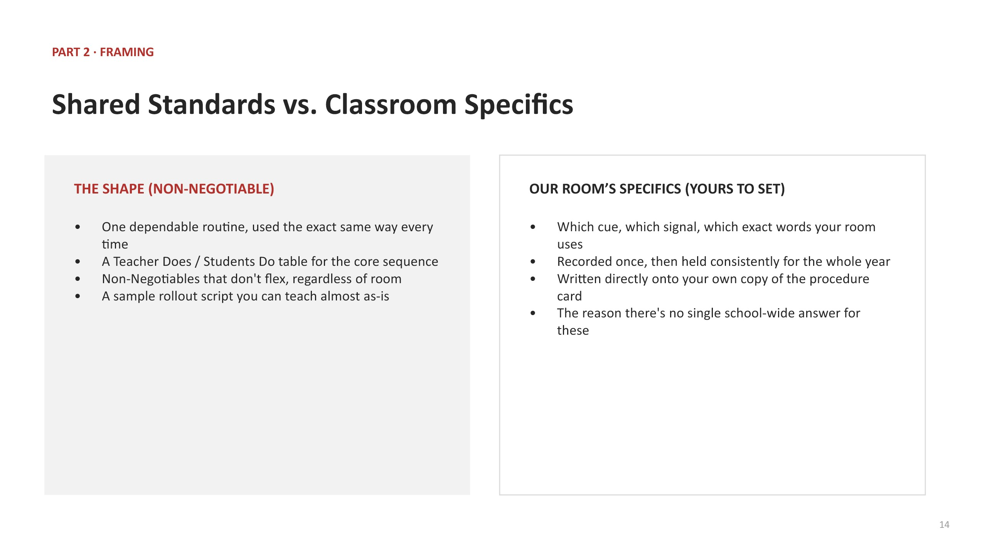  Slide 7

10 MIN — Read & Annotate  DO Give the direction, then go silent: “Choose the one procedure that touches your day first. Read the whole card. Underline anything you're not yet holding exactly as written.”  DO Circulate the room during the silent read. Do not narrate or interrupt — this block is individual and silent by design.  NOTE If someone finishes early, prompt them to read a second procedure rather than sit idle. | 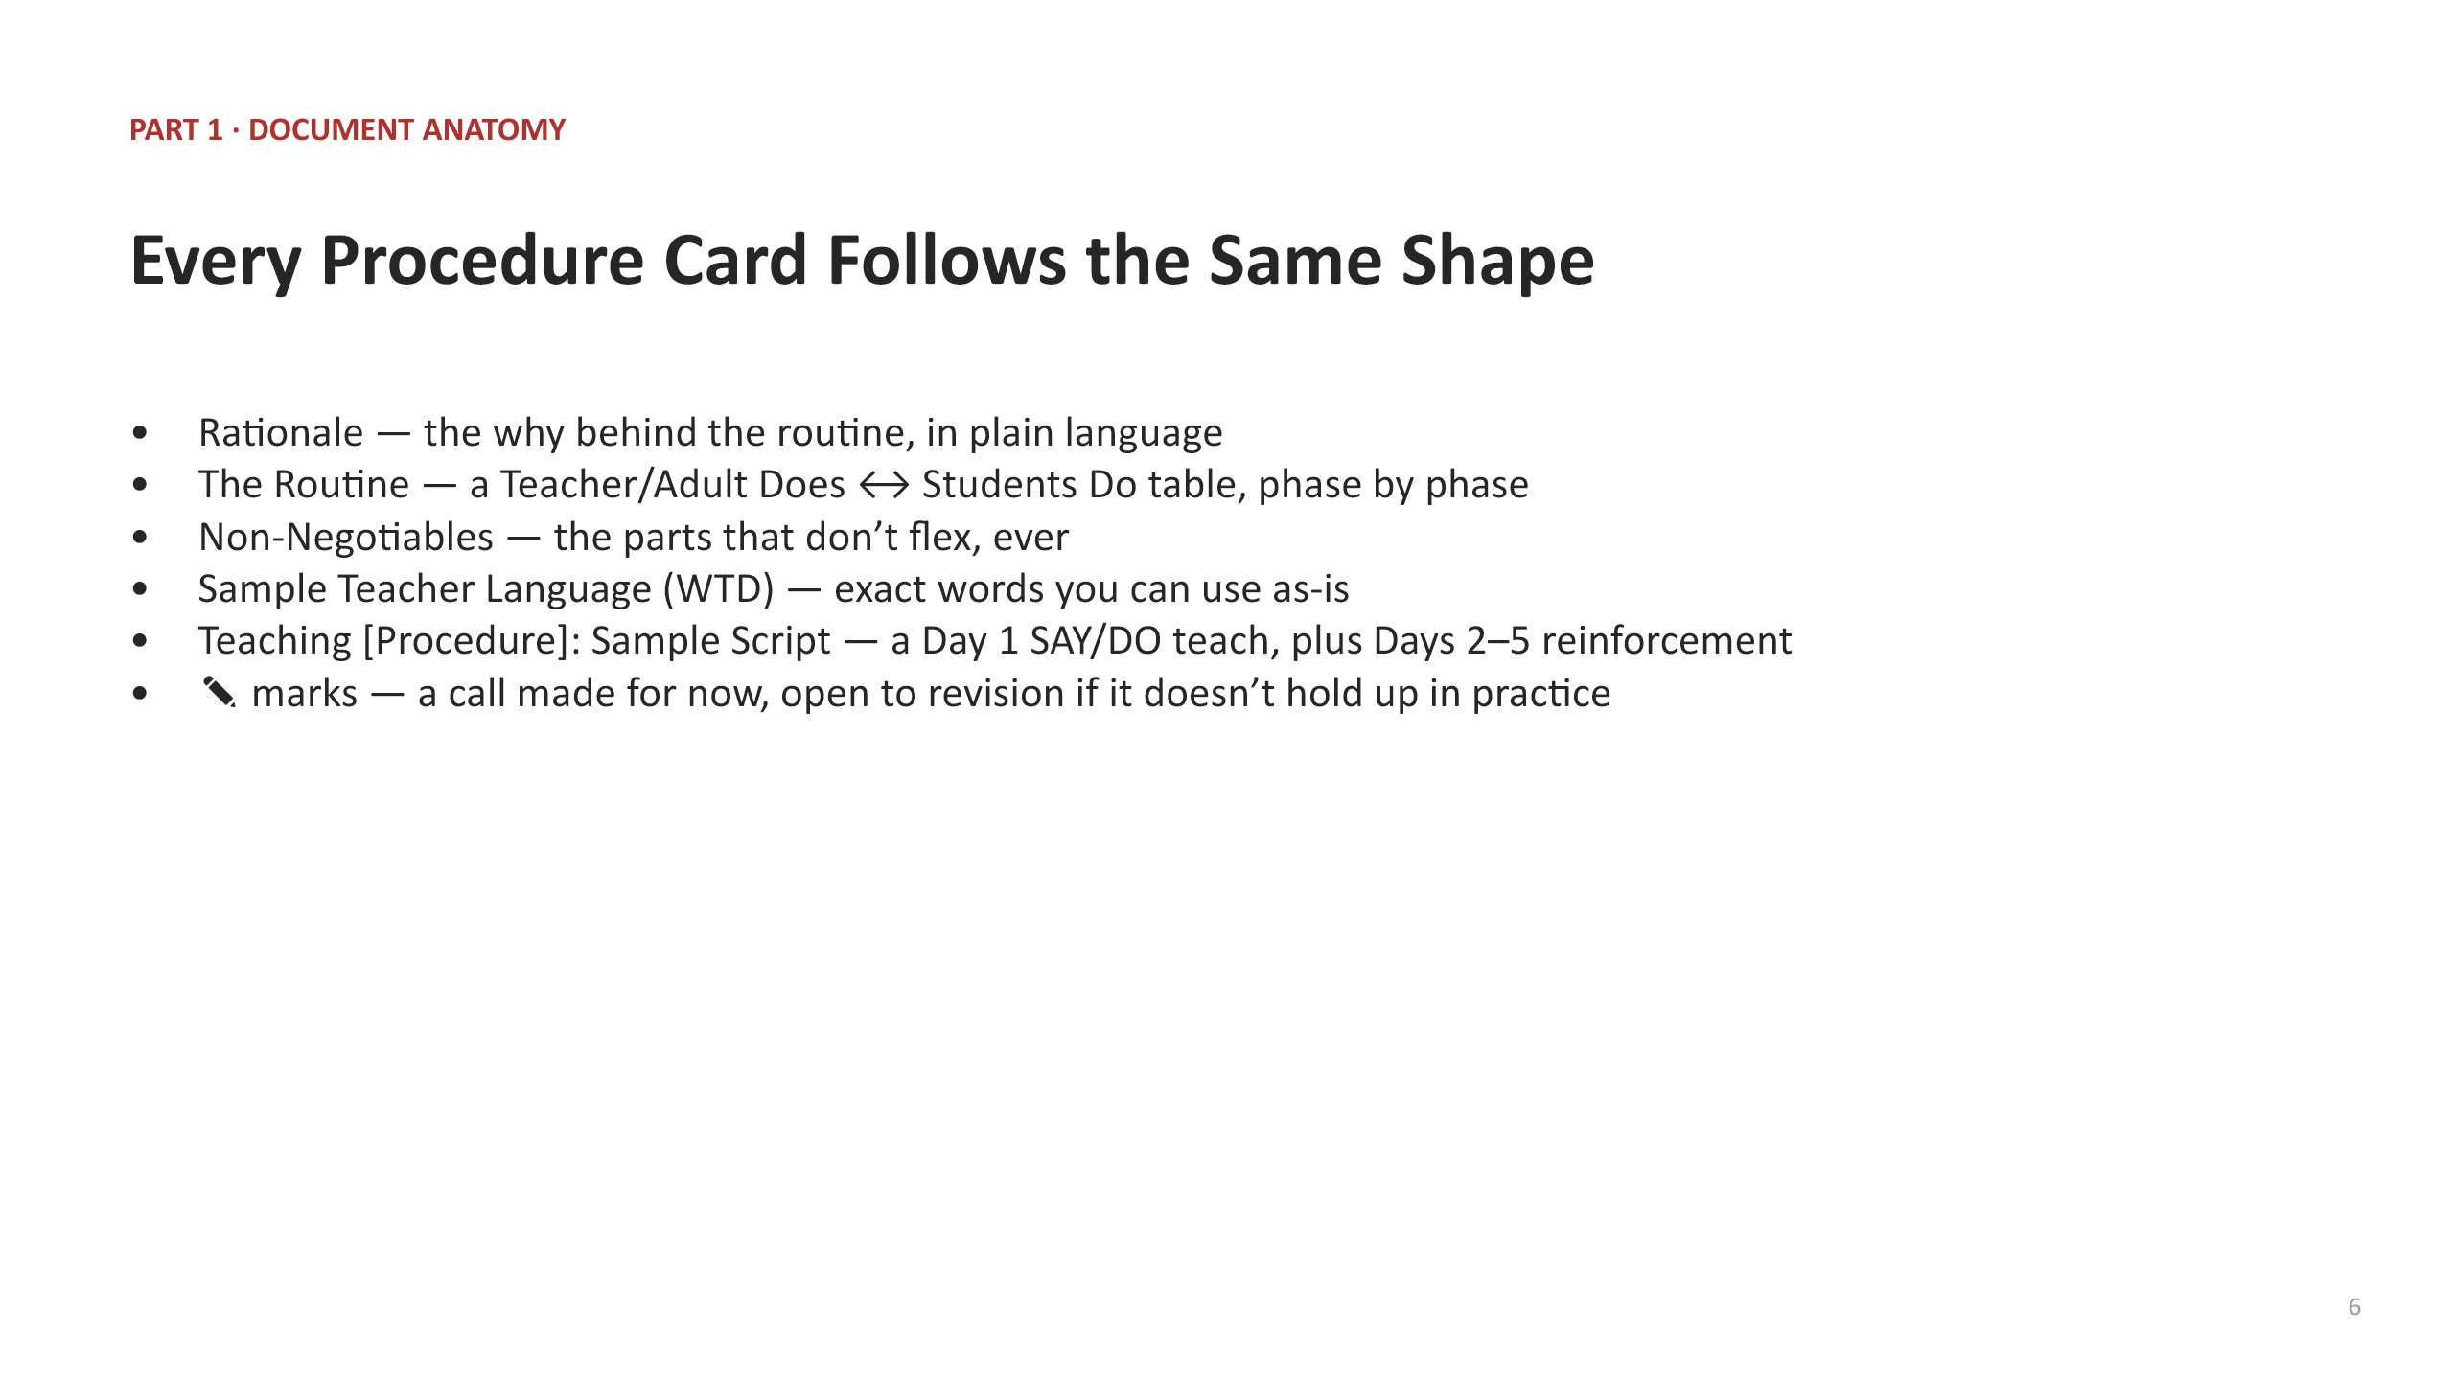  Slide 8

8 MIN — Personalize & Plan  SAY “Turn to the Teaching Script page for the procedure you just read. Remember — this is a sample, not something to read verbatim. Sketch what you'll actually say for your Hook & Purpose, and for each Model step.”  DO Give participants time to write directly on their own copy. Circulate and spot-check that people are writing in their own voice, not just copying the sample word for word. | 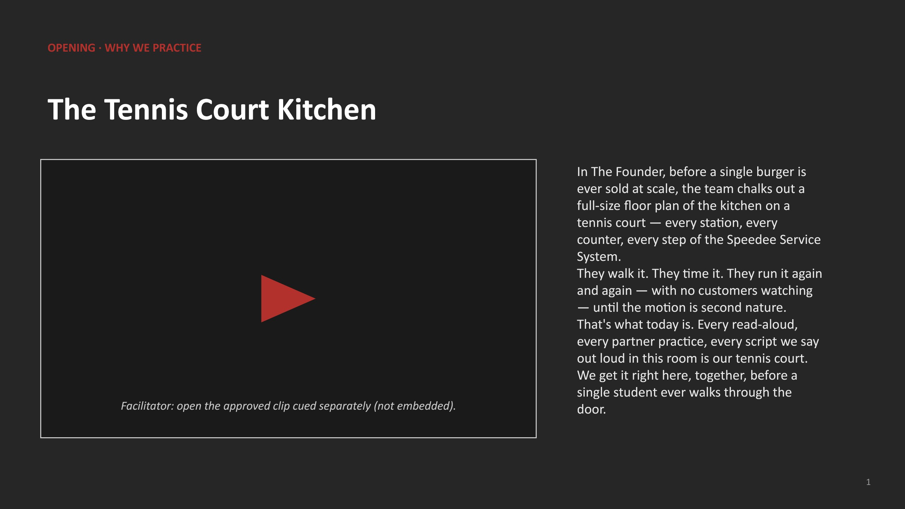  Slide 9

7 MIN — Practice  SAY “Pair up with someone teaching a similar age band or space. Take turns reading your Day 1 plan out loud — actually say it, don't just summarize it.”  DO Set a visible timer for roughly 3–4 minutes per partner. If the room is short on time, cut to one volunteer reading theirs cold to the whole group instead of full partner practice.  NOTE Listen for calm, clear, Strong Voice language while circulating — flag anywhere it sounds over-explained. | 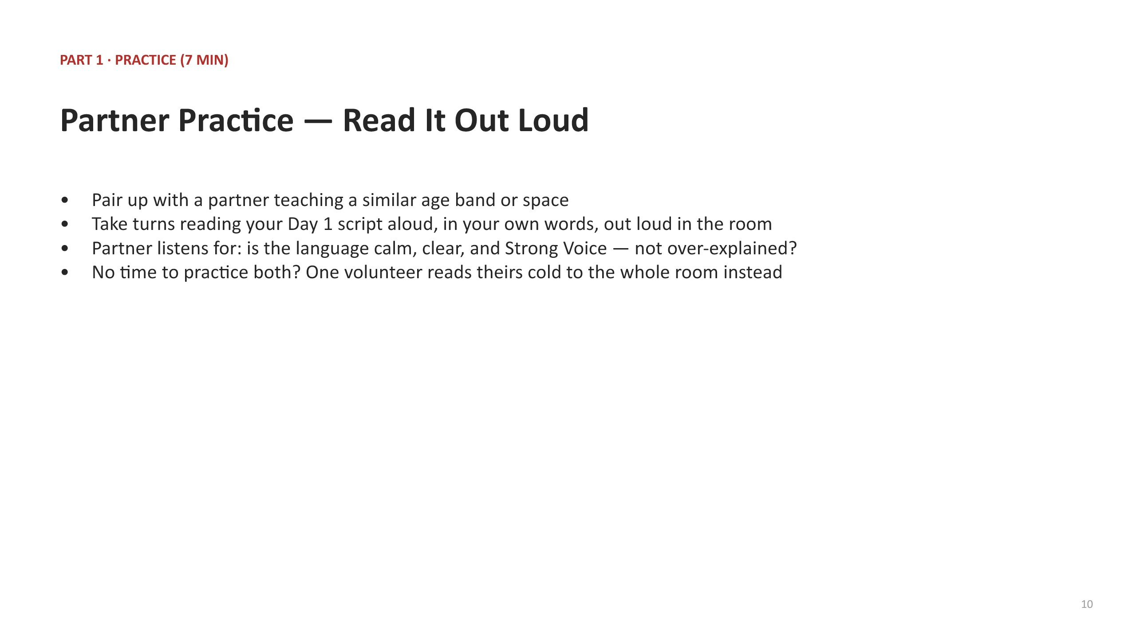  Slide 10

3 MIN — Close & Commit  SAY “Before we move to Part 2 — say out loud, to your partner or your table, which procedure you are teaching first, and roughly when.”  DO Cold-call two or three people to share their commitment with the whole room before transitioning.  SAY “Now let's shift from shared schoolwide systems and procedures to the routines used when students enter, learn, and exit instructional spaces.” | 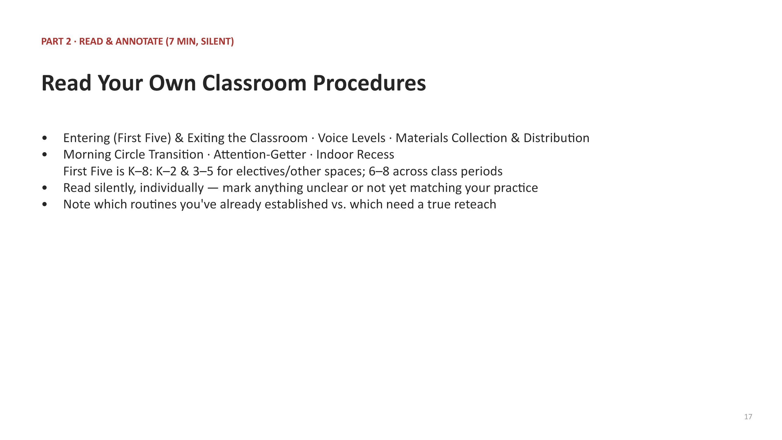  Slide 11

PART 2 · CLASSROOM PROCEDURES (30 MIN)
Entering (First Five) & Exiting · Voice Levels · Materials · Morning Circle · Attention-Getter · Indoor Recess

3 MIN — Framing & Purpose  SAY “Part 1 was buildingwide — the same for every adult, everywhere. Part 2 covers classroom procedures: the shape is non-negotiable, but the specifics are yours to set and hold all year. First Five applies to every K–8 band: K–2 and grades 3–5 use it when entering electives and other instructional spaces; grades 6–8 use it throughout class-period changes. It is separate from Morning Entry and Dismissal.”  DO Advance to the framing slide and contrast the two column headers directly: 'The Shape (Non-Negotiable)' vs. 'Our Room's Specifics (Yours to Set).' | 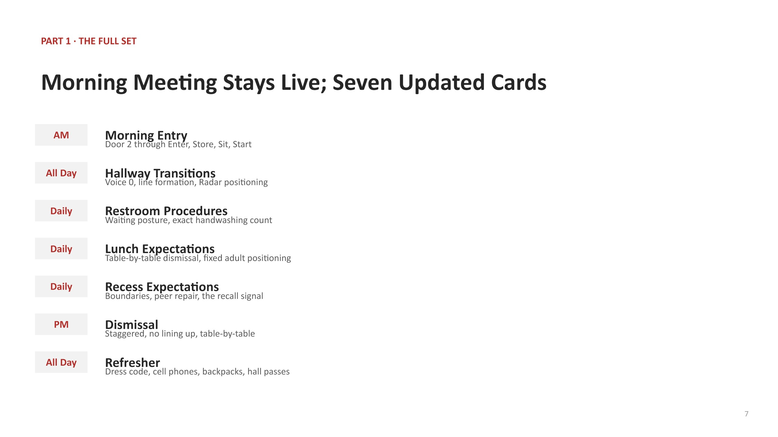  Slide 14

3 MIN — Document Anatomy  SAY “Each of your classroom procedure cards has five parts: a Rationale, a note on shape vs. specifics, the Teacher Does / Students Do table, Non-Negotiables and Sample Language, and a rollout script.”  DO Hold up one classroom procedure card and walk the five parts, same as you did for the schoolwide set in Part 1. | 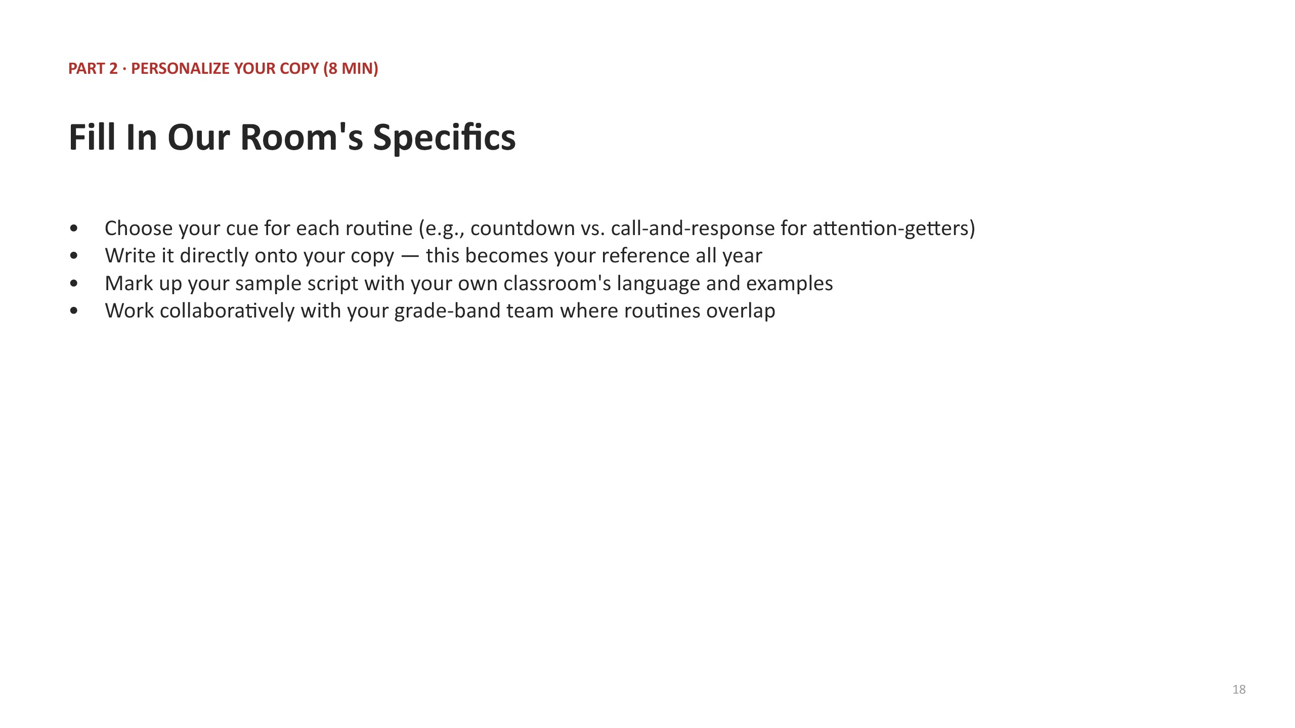  Slide 15

2 MIN — Using the Sample Script  SAY “You can use the sample script almost word for word if it already sounds like you — or use it only as a model and write your own. Either way, once you pick your cue or your routine, it holds all year.”  DO Advance to the sample-script slide. Keep this brief — it's a quick instruction, not a new concept. | 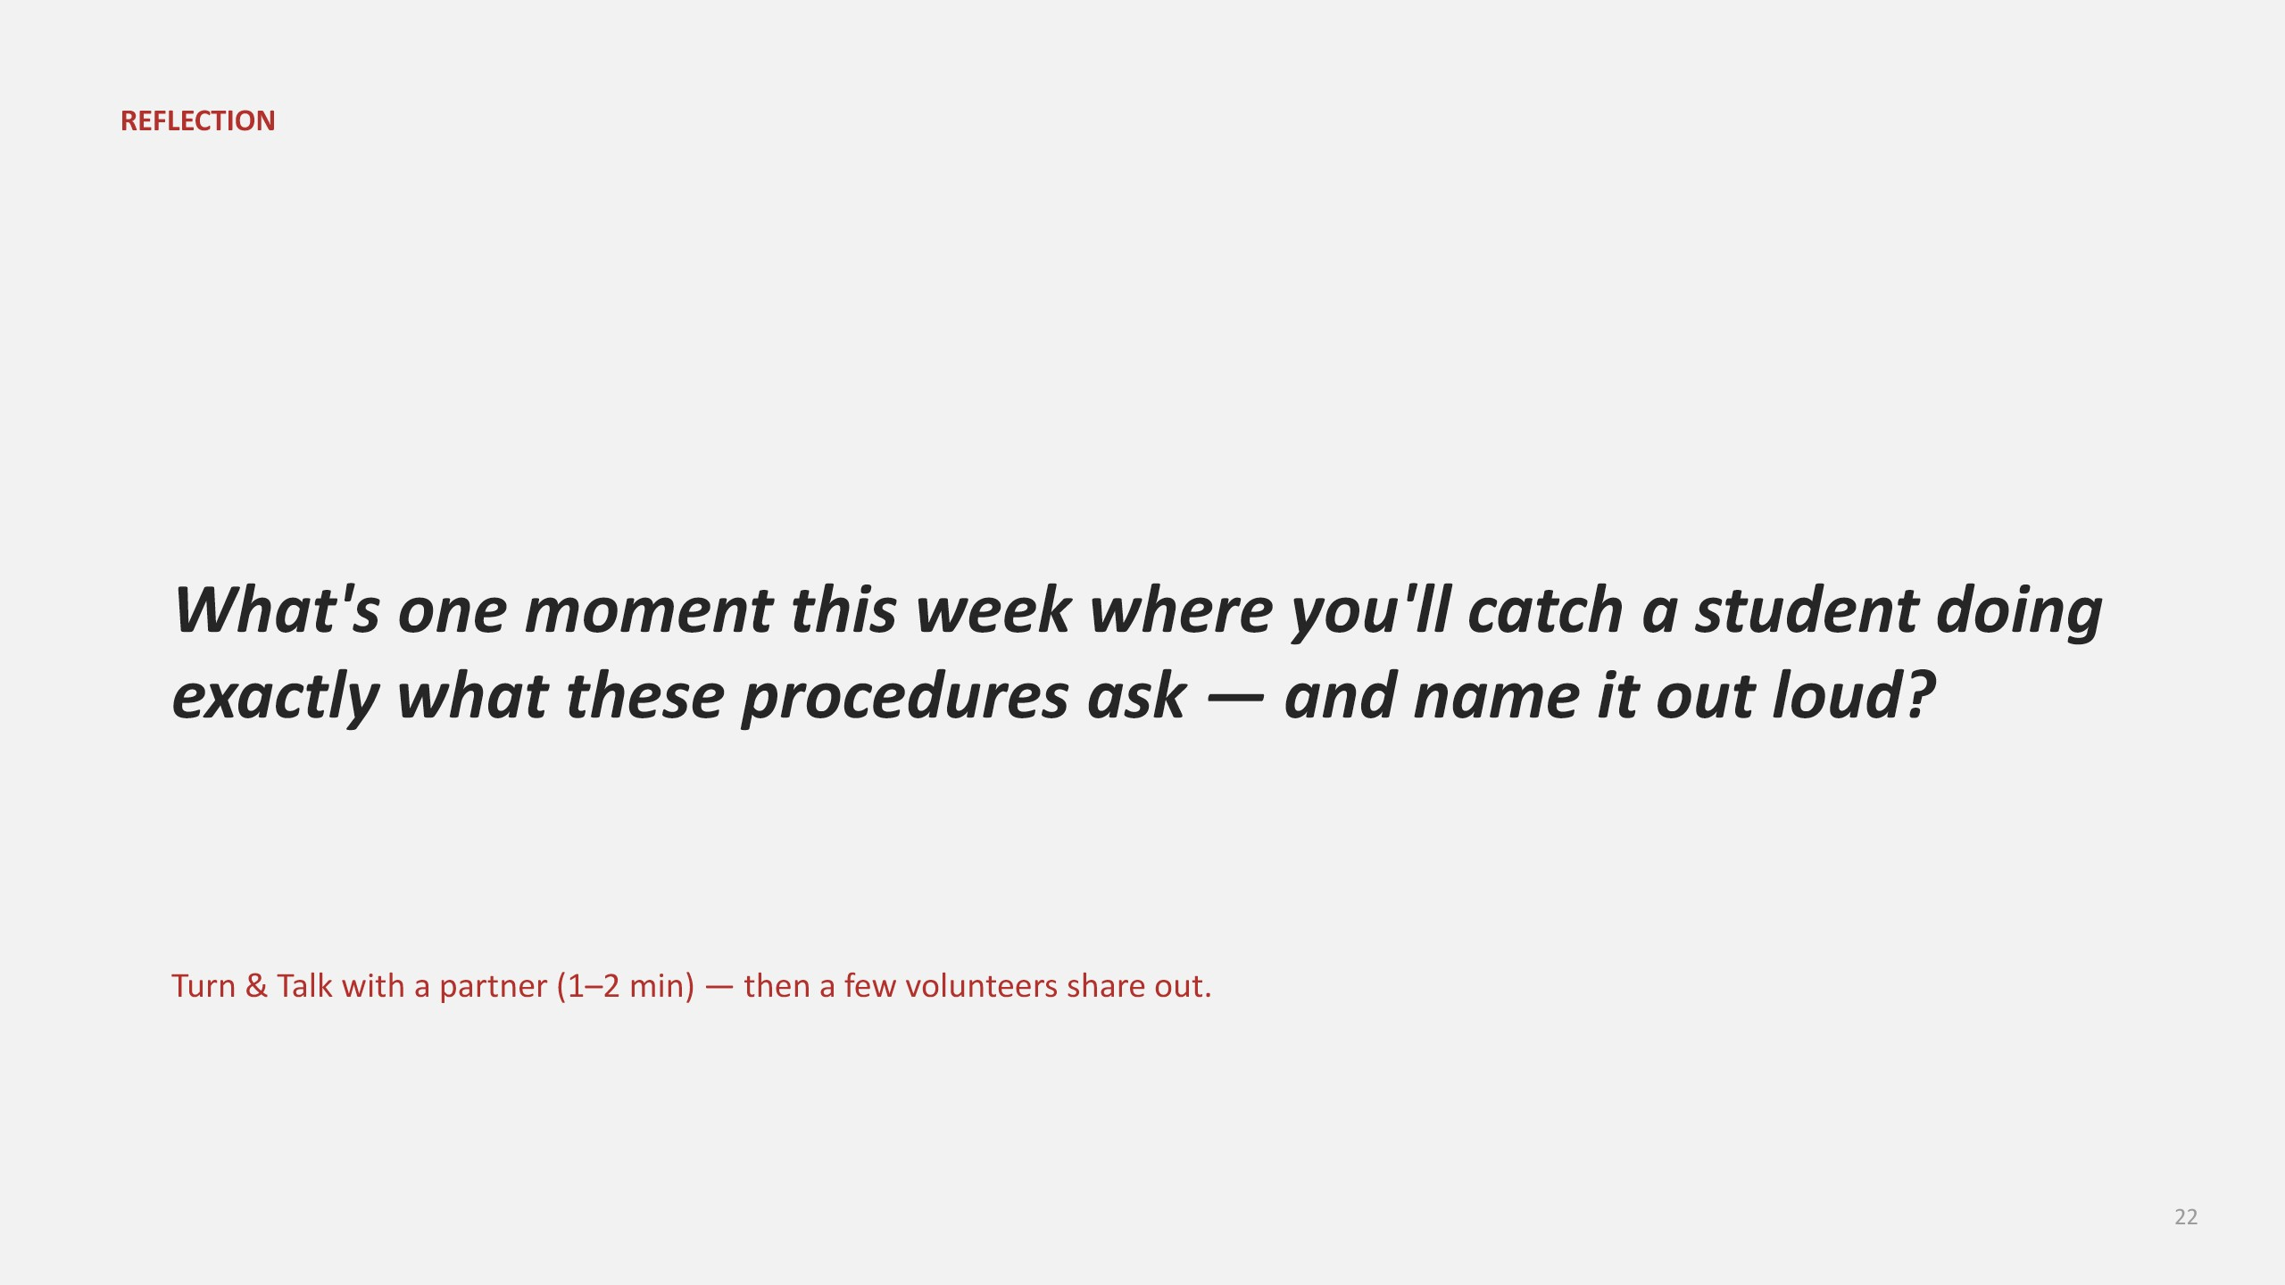  Slide 16

7 MIN — Read & Annotate  DO Give the direction, then go silent: “Read your own copies of Entering (First Five) & Exiting, Voice Levels, Materials, Morning Circle, Attention-Getter, and Indoor Recess. Mark anything unclear or not yet matching your practice.”  DO Circulate silently. This is an individual read, same as Part 1's Read & Annotate block. | 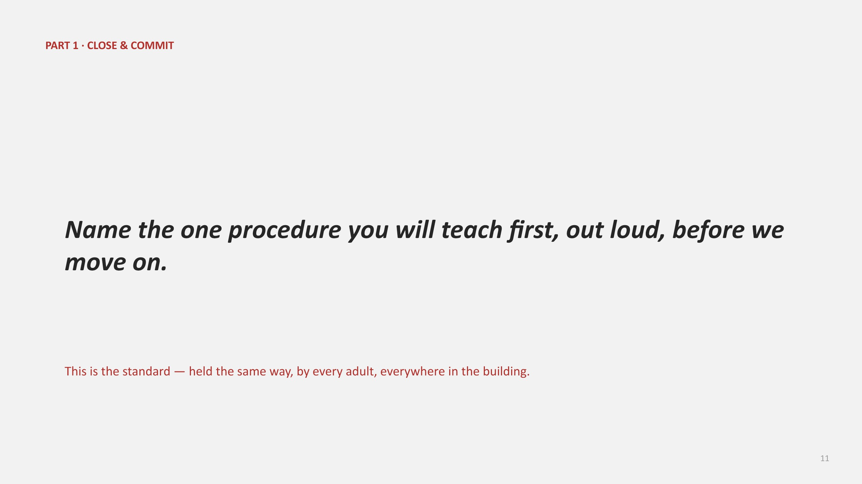  Slide 17

8 MIN — Personalize Your Copy  SAY “Now choose your actual cue for each routine — your countdown or call-and-response, your attention-getter, your materials helper system — and write it directly onto your copy.”  DO Encourage grade-band teams sitting together to align on shared routines (e.g., a shared hallway attention-getter) where it makes sense, while still allowing room-level choice.  NOTE Point participants to the 'Our Room's Specifics' column specifically here — this is the moment it gets filled in. | 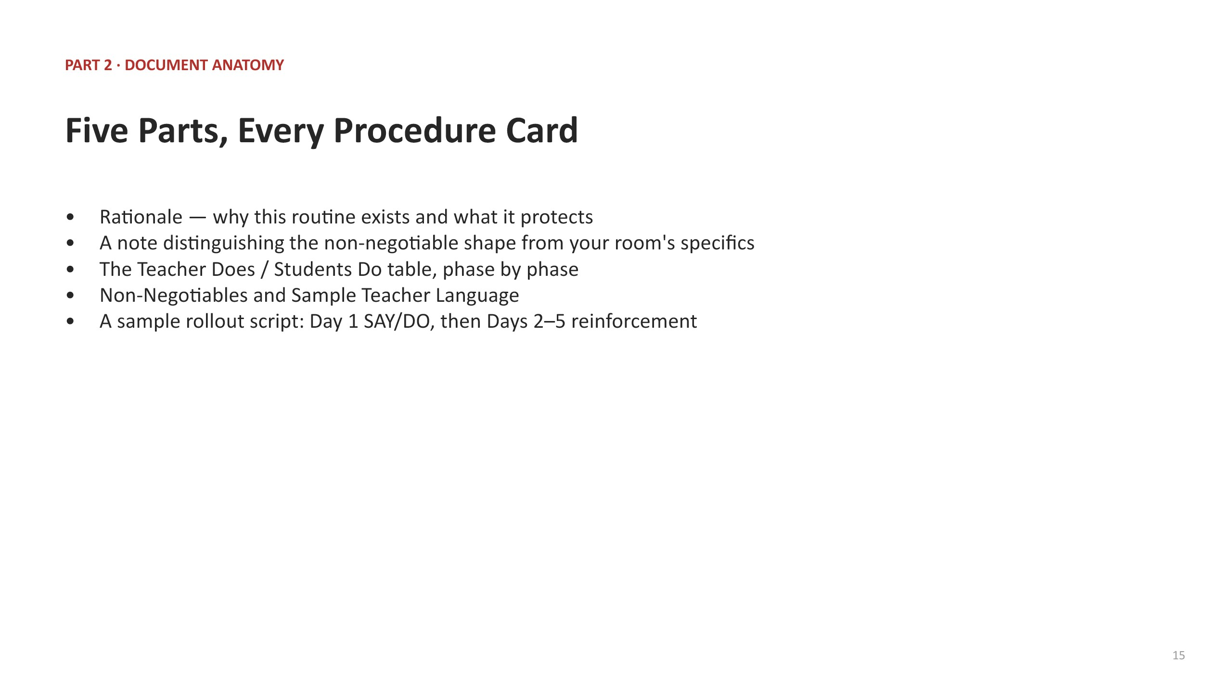  Slide 18

5 MIN — Practice  SAY “Pair up again and take turns reading one personalized script aloud, start to finish.”  DO Set a visible timer. If time is short, one volunteer reads theirs cold to the whole room instead of full partner practice. | 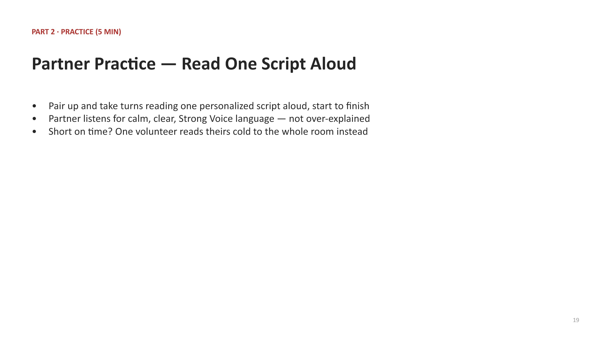  Slide 19

2 MIN — Close & Commit  SAY “Say out loud which classroom procedure you're teaching first, and when.”  DO Cold-call one or two people, then transition directly into Part 3 without a break. | 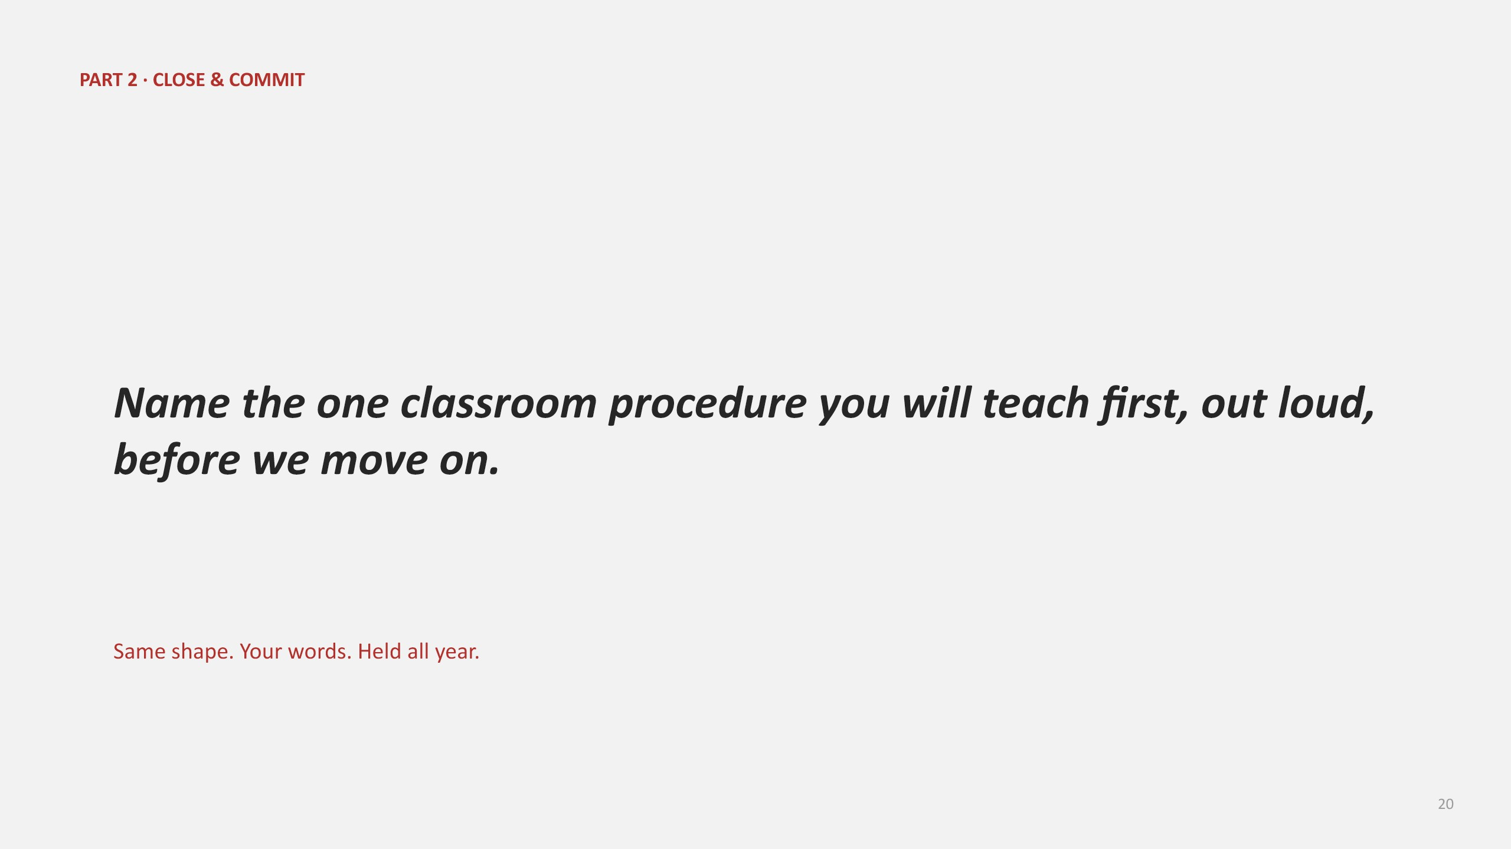  Slide 20

PART 3 · WRAP-UP (10 MIN)
Accountability AND Celebration — a preview of what's coming next

5 MIN — Accountability AND Celebration  SAY “Everything we've covered today is about holding a standard — and holding a standard means there has to be accountability when it's not met. That's necessary, and it's coming in an upcoming session.”  SAY “But accountability is only half of culture. The other half is just as necessary: catching and celebrating the students who ARE meeting these expectations, every single day. That's also coming in an upcoming session.”  SAY “Today was about the systems and procedures. In the coming days, we'll dig into both sides — how we hold the line, and how we celebrate what's going right.”  DO Advance to the Part 3 title slide. Keep this section brief and declarative — it's a preview, not a full teach. Do not attempt to teach the accountability or recognition content today.  NOTE Resist the urge to answer detailed 'what does accountability look like' questions here — name that it's coming, and keep moving toward reflection. | 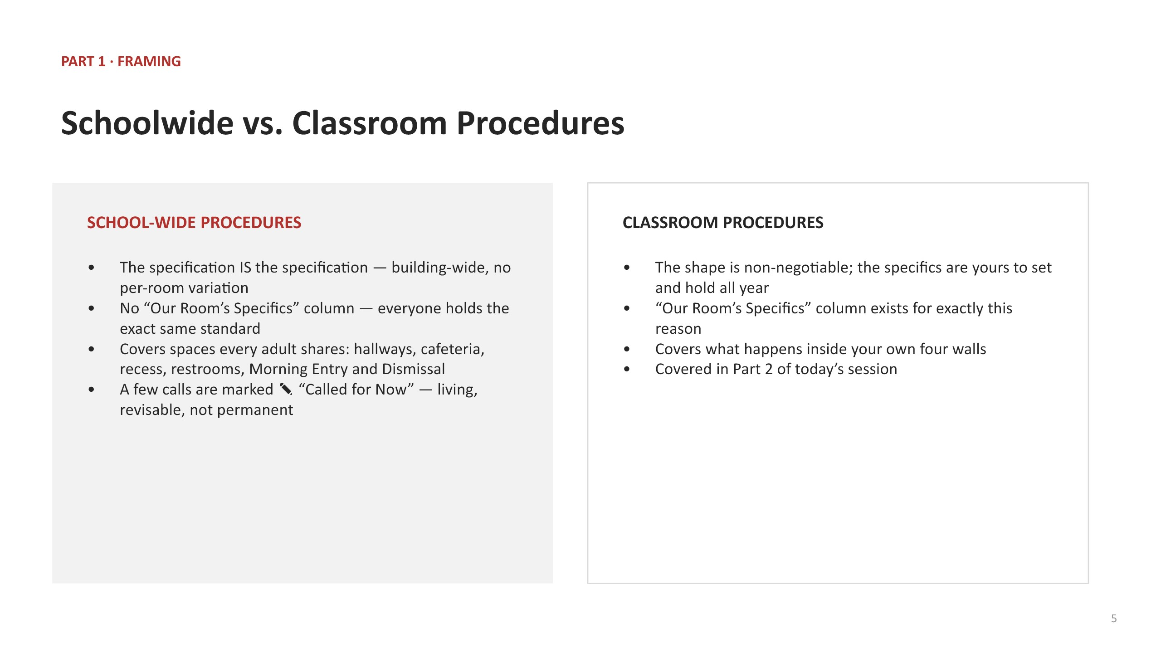  Slide 21

3 MIN — Reflection: Turn & Talk  SAY “Turn and talk with a partner: what's one moment this week where you'll catch a student doing exactly what these procedures ask — and name it out loud?”  DO Give partners 1–2 minutes to talk. Then open the floor: “Who's willing to share what you or your partner said?” and take 2–3 volunteers.  NOTE Keep this moving — the goal is a quick, warm close, not a long discussion. | 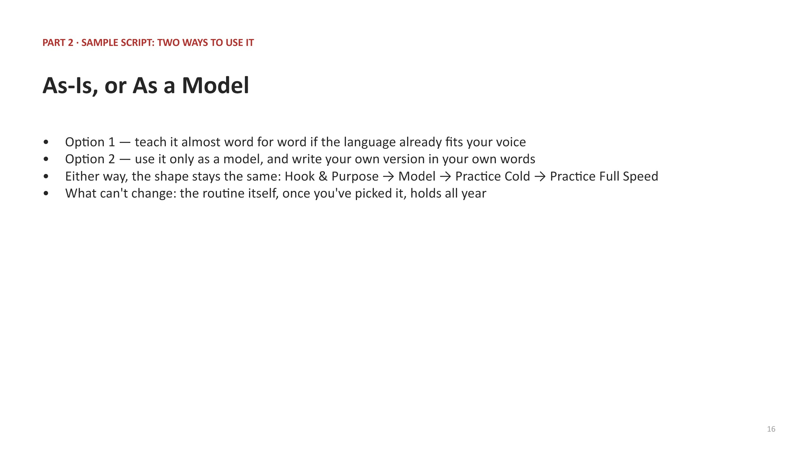  Slide 22

2 MIN — Close & Transition  SAY “Thank you for the work today — both the shared schoolwide systems and procedures and your classroom procedures. Hold them consistently, every day, starting now.”  DO No slide change. End the session here. |   Slide 22 (cont.)

MATERIALS CHECKLIST
- The approved Founder (2016) Speedee Service System tennis-court clip, licensed and cued separately; confirm access before the session (the deck does not embed media)
- Printed copies of the seven updated schoolwide procedure cards (Morning Entry, Dismissal, Hallway Transitions, Restroom, Lunch, Recess, Refresher), one set per participant; these supplement, and do not replace, the separate live Morning Meeting system
- Printed copies of all six classroom procedure bundles (Entering (First Five) & Exiting, Voice Levels, Materials, Morning Circle, Attention-Getter, Indoor Recess), one set per participant
- Pens or pencils for annotating and personalizing copies
- A visible timer for the Practice blocks in Part 1 and Part 2
- This slide deck, projected and advanced at each cue
WHAT THIS SESSION DELIBERATELY DOES NOT COVER
- The full student accountability / consequence hierarchy — that is its own upcoming session
- Student recognition and celebration systems in depth — also its own upcoming session
- Any procedure not already documented in the schoolwide or classroom procedure bundles
- Individual coaching or feedback on today's practice reads — that happens through the normal coaching cycle, not in this session

