**Cohort C Case Study: ELA-R Intervention**

Source: TEA STAAR Performance: https://tea.texas.gov/student-assessment/student-assessment-results/staar-performance-standards

**Section 1: Introduction — Problem of Practice and Intervention**

In 2023, our campus identified a critical problem of practice through STAAR data analysis and teacher observations:

* Rising 5th grade students demonstrated notable weaknesses in **nonfiction comprehension**, especially in analyzing author’s purpose, organizational structures, and synthesizing information.
* Writing performance, particularly in structured academic writing (informational and argumentative), lagged behind expectations, with strengths mainly in narrative storytelling.
* Additionally, explicit instruction in grammar and conventions had been deprioritized over past years, creating foundational gaps.

In response, we implemented a targeted instructional shift grounded in the Science of Reading, emerging Science of Writing, and new models emphasizing explicit language structures. Our model centered on:

* **Author’s purpose** as cognitive anchors for all reading and writing tasks.
* **Screen to Scratch**, an annotation system bridging digital reading analysis with structured written.
* **AI Data-Informed Planning** to provided targeted literacy instruction while faced with staffing shortages.

**Section 2: Cohort Overview — Corrected Data Table**

| **Cohort** | **Grade** | **Year** | **Approaches** | **Meets** | **Masters** |
| --- | --- | --- | --- | --- | --- |
| B* | 4th | 2022 | **79%** | **66%** | **30%** |
| B | 5th | 2023 | **81%** | **63%** | **31%** |
| C | 4th | 2023 | **70%** | **39%** | **19%** |
| C | 5th | 2024 | **77%** | **59%** | **31%** |

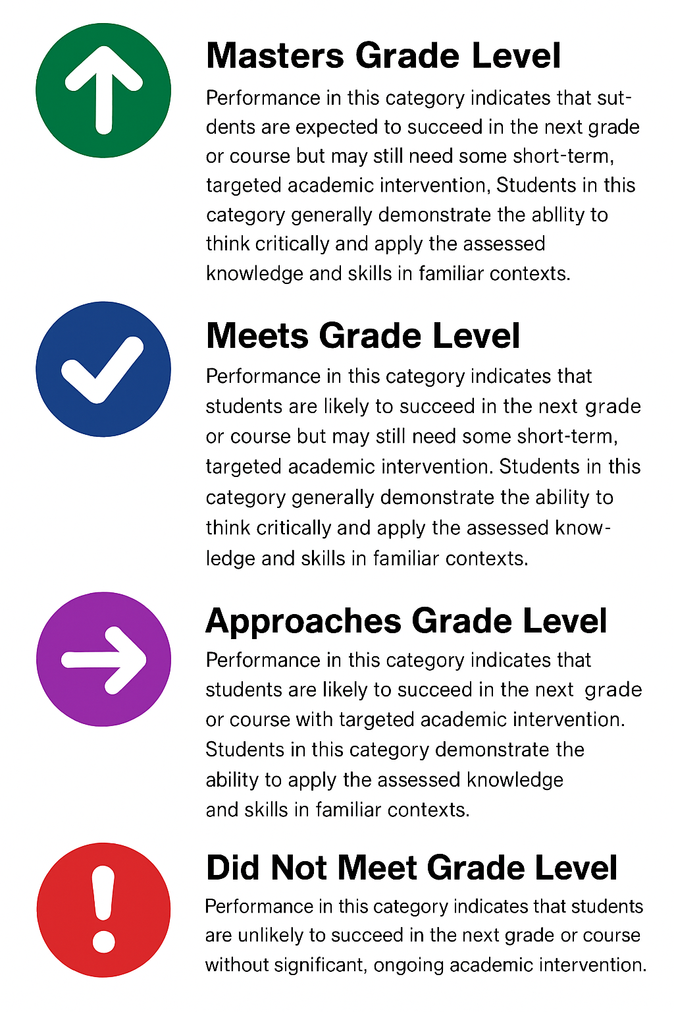

* **Cohort C** demonstrated significant gains from 4th to 5th grade:
  + +7 points in Approaches
  + +20 points in Meets
  + +12 points in Masters
* By 5th grade, Cohort C matched Cohort B’s Masters performance at 31%, despite extreme staffing instability.

*Outcomes before 2023 STAAR Redesign, including writing and varied questioning options.

**Section 3: Reading Comprehension Outcomes**

Students showed notable improvement in targeted comprehension areas:

* **Author’s Purpose (TEKS 10.A):** Campus performance exceeded state averages by +8–10 points.
* **Text Structure (TEKS 10.B):** Full-credit rates rose above region and state benchmarks.

According to Fisher & Frey, teaching students to analyze author’s purpose builds both comprehension and critical thinking, and our results mirror this. Duke and Roberts emphasize that purposeful reading structures improve retention, matching observed gains.

**Higher-Order Thinking:**

* Students outperformed the state on several analysis/synthesis items.
* Gains in metacognitive inference aligned with structured annotation practices and strategic modeling.

**Section 4: Writing Outcomes — Sentence Construction and Essay Analysis**

**Constructed Response (Essay) Score Distribution (2024)**

| **Score Range** | **Campus %** |
| --- | --- |
| 0–2 (Low) | 5–10% |
| 6–8 (Middle) | 50–60% |
| 9–10 (High) | 5–7% |

**Interpretation Writing Conventions and Grammar:**

* **Campus did not see overall gains in writing**
* Very low mastery demonstrated
* Trends from the previous year remained
* Students performed moderately on editing standards (e.g., TEKS 11.D).
* Stronger performance on basic punctuation items, especially Question 38 (punctuation editing, 64% campus vs 54% state).
* Consistent with Graham & Perin’s findings that sentence combining and direct grammar instruction raise writing quality.

**AI’s Role:**

* AI-supported exercises likely strengthened student awareness of grammatical structure.
* Research by McKnight and Roscoe shows AI feedback improves mechanics, confirming the value of our approach.

**Section 5: Subgroup Reading Growth Outcomes**

| **Subgroup** | **2023 Reading Growth Met** | **2024 Growth Met** | **Gain** |
| --- | --- | --- | --- |
| Eco Dis | 49% | 80% | +31 pts |
| EL | 37% | 69% | +32 pts |
| SPED | 35% | 77% | +42 pts |

**Interpretation:**

* Growth far exceeded standard STAAR expectations across all priority groups.
* SPED subgroup showed a particularly remarkable +42 point growth gain.
* This affirms that integrated cognitive supports (Screen to Scratch) especially benefited historically underserved populations, consistent with findings from Amplify and Graham & Hebert on cross-genre literacy intervention impact.

**Section 6: Accelerated Learning (AL) Outcomes**

| **Grade** | **Year** | **Campus % in AL** |
| --- | --- | --- |
| 5th | 2023 | 35% |
| 5th | 2024 | 47% |

**Interpretation:**

* A rise to 47% AL meets passing standard in 5th grade Reading (2024) shows targeted support scaled dramatically.
* Despite higher AL rates (and therefore larger at-risk groups), fifth graders still showed cohort-leading gains in Meets and Masters rates.

**Section 7: Instructional Strategy Integration — The Power of Screen to Scratch**

The **Screen to Scratch** system merged:

* Digital reading annotation focused on author’s purpose and structural analysis.
* Writing engagement requiring students to synthesize annotations into purposeful compositions.
* Application across content areas (science/social studies) when ELA staffing gaps existed.

By embedding authorial intention across all text engagement, we anchored reading and writing development in cognitive strategy as the foundation, and supplemented learning with Shanahan’s research stresses that integrated reading and writing elevate student outcomes beyond siloed instruction.

AI-enhanced grammar exercises supplemented formal instruction gaps, particularly around sentence-level editing, without replacing the need for future explicit conventions teaching.

**Section 8: Key Findings and Conclusions**

* **Cohort C’s growth trajectory validates** the intervention’s impact, especially given extreme staffing instability.
* **Screen to Scratch scaled across classrooms**—including substitutes—because of its conceptual clarity and transferability.
* **Subgroup acceleration provides equity evidence** that cognitive-based literacy approaches reduce gaps for Eco Dis, EL, and SPED populations.
* **Writing still demands more explicit conventions instruction**, a natural next step given the students’ strengthened comprehension and sentence structuring abilities.

This case story provides strong, research-aligned evidence of how intentional cognitive framing, cross-content transfer, and technology-supported scaffolds can accelerate student outcomes—even in challenging environments.