K–2 BEHAVIOR TOOLKIT · MORNING MEETING
Gentle Hands with Grown-Ups
Teacher Guide · Topic 8 of 12 · Value: Safe
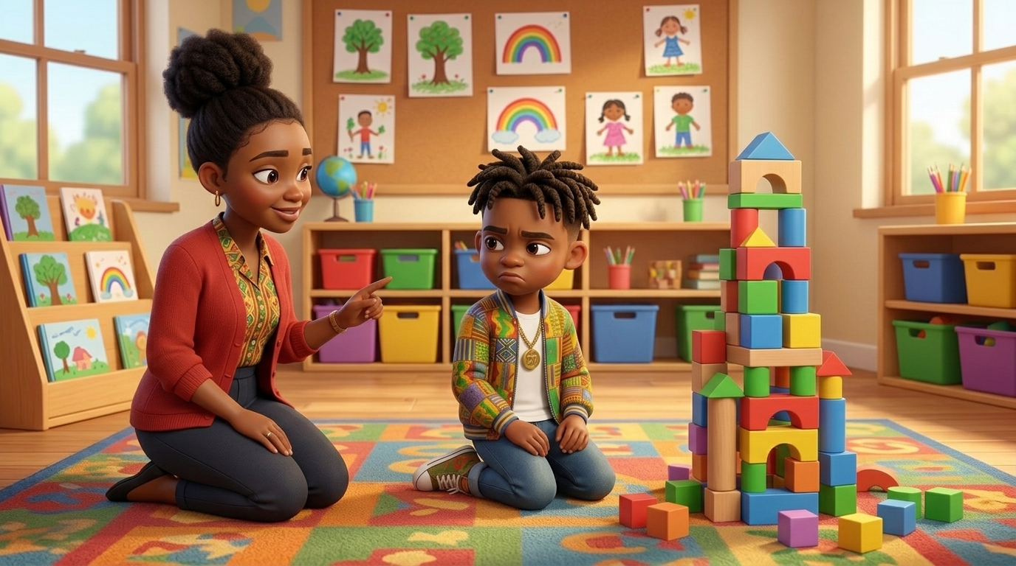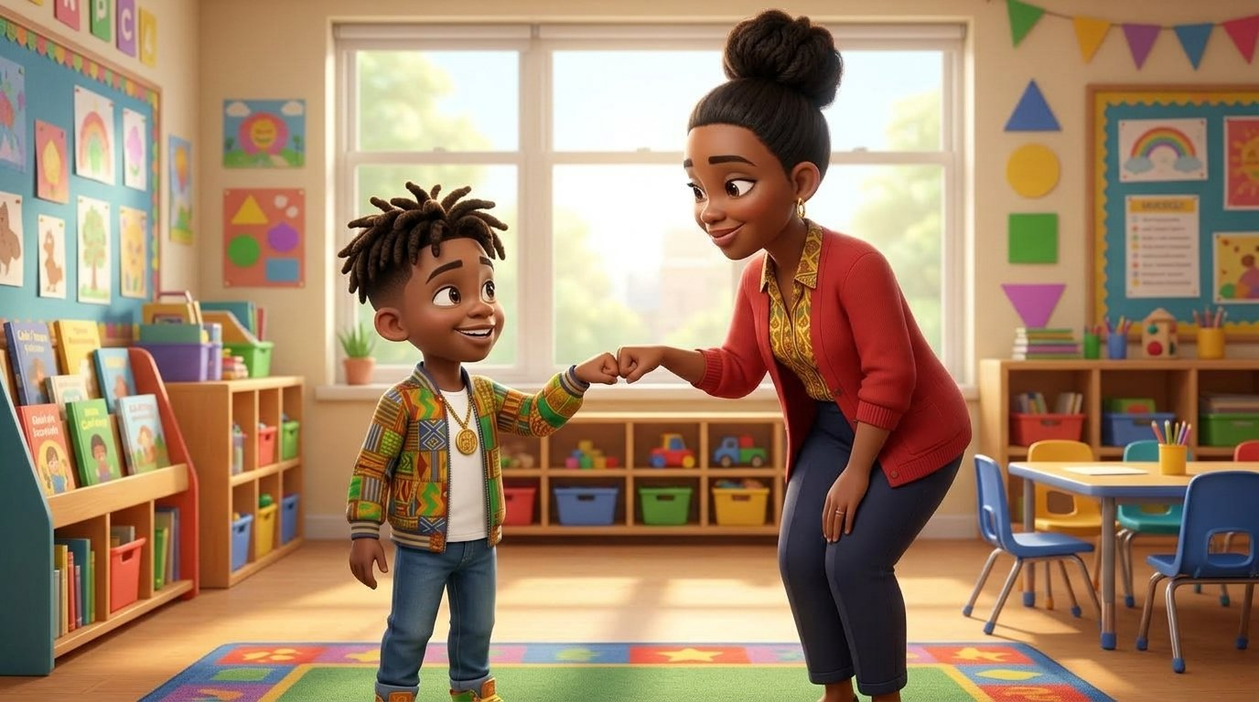
At a glance
Goal | Students keep grown-ups safe when they feel mad, especially when a grown-up says “no” or “not now”: hands down, step back, take a slow breath, and use their words. Mad is okay; hurting is not.
Time | 15 minutes in Morning Meeting, in place of the general lesson. Centers run during the week.
When | Teach after Topic 7, Gentle Hands with Friends. Teach it on a calm day, never the morning after a student hurt an adult.
In the bundle | Student deck (7 slides, press N for notes) · Poster (letter and 11×17) · Center kit (sort, sequence, act it out, desk strips, coloring) · Mini book · Family half-sheet
Words we use | “Hands down. Step back. Breathe. Use my words.” · “I feel mad.” · “Mad is okay. Hurting is not.”

Before you teach
- Plan a two-minute warning for every transition this week. Most of these moments start when an activity ends without warning.
- Practice your own calm response first: a low, slow voice and few words. The adult response is the intervention.
- Hang the poster at child height near your meeting space or the transition spot students see before clean-up.
- Decide the yes you can offer when the answer is no, such as “Let’s take a picture of your tower” or “You can finish after lunch.”
- Tape a desk strip at the table of any student who has hit, kicked, or grabbed an adult.
- Pair students who need support with a steady turn-and-talk partner before the lesson starts.

The lesson, slide by slide
The same script is in the deck’s presenter notes. Press N while presenting.
Slide | Say and do | Look for | Engagement move
1 · Title & Promise (R2) | “Grown-ups keep you safe all day. We keep them safe too, even when we feel mad.” Say together: “Safe hands with grown-ups too!” | Students repeat the line in a calm voice. | Equity stick: “Name one grown-up who helps you at school.”
2 · Get Calm First (R1) | Do it with them. “Smell the flower. Blow out the candle. Long and slow. Three times.” | Exhale longer than inhale; shoulders drop. | LiveSchool point: “You breathed slow three times.”
3 · What Did Tee Do? (R2, R3) | Point to each picture. “The teacher said clean-up time. Tee felt mad. He put his hands down, stepped back, took a breath, and said, ‘I feel mad. I am not done.’ They were okay.” Class says: “Hands down. Step back. Breathe. Use my words.” | Students follow the pictures; whole class repeats the line. | Equity stick: “Which picture shows Tee using his words? Point.”
4 · Turn and Talk (R3, R4) | Model knee to knee. “Tee feels mad at clean-up time. Tell your partner: Tee can ___.” 30 seconds, then two shares. | Partners take turns; any safe step on the slide is right. | Equity stick: two shares.
5 · Watch Me, Then Show Me (R3, R4, R5) | Play the grown-up and say kindly, “Clean-up time.” A student shows a mad face and the four steps. Then try “Your break is over,” and practice once all together. | Hands down; one step back; a long breath out; calm words. | LiveSchool point for the student model.
6 · My Promise Today (R2, R5) | Hand on heart. “Say it with me: I keep my grown-ups safe too.” Then: “When you feel mad, point to one.” | Every student says the promise and points to one picture. | Equity stick: three names. Pointing counts.
7 · How We Leave (R1, R4, R5) | “Stand up. Safe hands. Walk. Ready to learn.” Do not time this at K–2. | Safe hands while moving; calm walking. | LiveSchool point for the table that walks with safe hands the whole way.

Practice bridges for slide 5
Students model, not the teacher. The teacher narrates and asks the class what they saw.
If the model is… | Say
Excellent | “Show us again. Everyone, watch his hands stay down even with a mad face.”
Partly right | “Your hands stayed down. Now use your words: I feel mad. Try again.”
Silly | “Thank you. Let’s see it the safe way.” Call a new student. No commentary.

Centers
Print one kit per group. Laminate the mats and cards so they last. Students work in groups of 2 to 4.
Center | Set up | Read to students | Done looks like
Sort It | Sort mat (landscape page) and 8 cut picture cards. | “Look at each picture. Is this friend keeping the grown-up safe? Put it on the side where it goes.” | 4 cards on Safe, 4 on Not safe. Accept any sort a student can explain.
Put It in Order | Sequencing mat and 4 cut cards. | “Put Tee’s story in order: first, next, then, last. Tell your partner the story.” | Students retell: clean-up time, hands down, I feel mad, we are okay.
Act It Out | 4 role-play cards in a stack. | “Pick a card. Read it with me. Show me how you keep your grown-up safe.” | Each student shows hands down, a step back, a breath, and the words “I feel mad.”
Safe With Grown-Ups Steps | Desk strips, one per student. | “Point to each step and say it.” | Each student says all four steps.
Color | Coloring page and crayons. | “Color Tee and his teacher. Then show your safe hands.” | A colored page and hands pressed down.

Answer keys
- Sort, Safe: Tee puts his hands down · Tee takes a slow breath · Tee tells his teacher he feels mad · Tee and his teacher fist bump.
- Sort, Not safe: Diego with fists at the teacher · Malik pulls the teacher’s sleeve · Sofia grabs the teacher’s clipboard · Kiara pushes the teacher’s hand away.
- Put It in Order: 1 The teacher says clean-up time · 2 Tee puts his hands down · 3 Tee says, “I feel mad” · 4 Tee and his teacher are okay.

The mini book (one child, Tier 2)
- For a child who has hit, kicked, grabbed, or pushed an adult. Read it one-on-one at a calm time, before the hardest part of the day.
- Read it every day for a week. Practice each step as you read it, especially the words “I feel mad.”
- Never read it as a consequence or right after an incident.
- On the back, the child colors a star each day they keep grown-ups safe. Celebrate every star.

When a student hurts a grown-up
Follows the Responsive Behavior Plan: the adult response is the intervention. Fewer words as escalation rises.
- Safety first. Step back out of reach, keep your voice low and slow, and keep other students safe. Call for support if needed.
- Fewer words. “You are mad. Hands down. I will wait.” Do not lecture or argue in the moment.
- Offer the steps. Point to the desk strip or poster: hands down, step back, breathe, words.
- Repair later. When the child is calm, use Topic 6, Fixing It: “What happened? How can we make it right?” Then start fresh.
- Do not take it personally. The child is protecting something and does not have a safer way yet. This lesson gives them one.
Next in the toolkit: Topic 9, Things Stay Safe.

Family connection
- Send the family half-sheet home the day you teach. It is in English, Spanish, and Haitian Creole.

