K–2 BEHAVIOR TOOLKIT · MORNING MEETING
Fixing It
Teacher Guide · Topic 6 of 12 · Value: Responsible
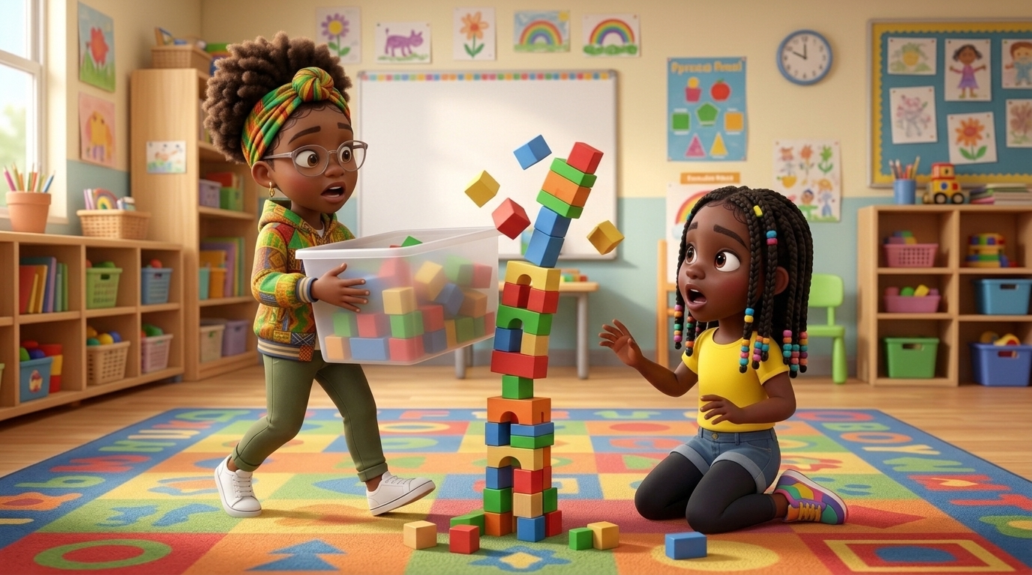
At a glance
Goal | Students know what to do after a mistake or accident: stop and look, say sorry for what happened, ask “How can I help?”, and help fix it. If a friend needs space, they give space and try again later.
Time | 15 minutes in Morning Meeting, in place of the general lesson. Centers run during the week.
When | Teach after Topic 5, Getting a Grown-Up’s Attention. It finishes the Skills I Can Use set and prepares students for the Safe Choices topics that follow.
In the bundle | Student deck (7 slides, press N for notes) · Poster (letter and 11×17) · Center kit (sort, sequence, act it out, desk strips, coloring) · Mini book · Family half-sheet
Words we use | “Stop. Say sorry. Ask how I can help. Help fix it.” · “I’m sorry I ___.” · “How can I help?” · “Okay. I can help later.”

Before you teach
- Set up a short tower of three blocks or books for the practice. Keep the bump soft and slow, and never knock over real student work.
- Decide how you will respond to a sorry all week: “Thank you for fixing it.” Keep it short and warm.
- Hang the poster at child height near your meeting space or block center. Students point to it all week.
- Do not force a sorry. A child who is upset can take a breath first, then help fix it.
- Tape a desk strip at the table of any student who often hides mistakes or blames others.
- Pair students who need support with a steady turn-and-talk partner before the lesson starts.

The lesson, slide by slide
The same script is in the deck’s presenter notes. Press N while presenting.
Slide | Say and do | Look for | Engagement move
1 · Title & Promise (R2) | “Everybody makes mistakes. What matters is what we do next.” Say together: “Oops? I can fix it.” | Students repeat the line in a calm voice. | Equity stick: “What is one mistake that can happen at school?”
2 · Get Calm First (R1) | Do it with them. “Smell the flower. Blow out the candle. Long and slow. Three times.” | Exhale longer than inhale; shoulders drop. | LiveSchool point: “You breathed slow three times.”
3 · What Did Lee Do? (R2, R3) | Point to each picture. “Lee bumped Kiara’s tower by accident. She stopped and looked. She said, ‘I’m sorry I knocked down your tower.’ She asked, ‘How can I help?’ They built it again together.” Class says: “Stop. Say sorry. Ask how I can help. Help fix it.” | Students follow the pictures; whole class repeats the line. | Equity stick: “Which picture shows Lee asking how she can help? Point.”
4 · Turn and Talk (R3, R4) | Model knee to knee. “The tower fell and Kiara is sad. Tell your partner: Lee can ___.” 30 seconds, then two shares. | Partners take turns; any step on the slide is right. | Equity stick: two shares.
5 · Watch Me, Then Show Me (R3, R4, R5) | Bump a small tower softly and model all four steps. A student then shows the four steps while you play the friend. Practice the space rule once: “Not right now.” “Okay. I can help later.” | Stops and looks; sorry names what happened; calm ask; hands help fix it. | LiveSchool point for the student model.
6 · My Promise Today (R2, R5) | Hand on heart. “Say it with me: I can help make it right.” Then: “When you make a mistake, point to one.” | Every student says the promise and points to one picture. | Equity stick: three names. Pointing counts.
7 · How We Leave (R1, R4, R5) | “Stand up. Calm body. Walk. Ready to learn.” Do not time this at K–2. | Calm bodies while moving; calm walking. | LiveSchool point for the table that walks with calm bodies the whole way.

Practice bridges for slide 5
Students model, not the teacher. The teacher narrates and asks the class what they saw.
If the model is… | Say
Excellent | “Show us again. Everyone, listen to how she says what happened.”
Partly right | “You said sorry. Now ask, ‘How can I help?’ Try again.”
Silly | “Thank you. Let’s see it the real way.” Call a new student. No commentary.

Centers
Print one kit per group. Laminate the mats and cards so they last. Students work in groups of 2 to 4.
Center | Set up | Read to students | Done looks like
Sort It | Sort mat (landscape page) and 8 cut picture cards. | “Look at each picture. Is this friend fixing it? Put it on the side where it goes.” | 4 cards on Fixing it, 4 on Not fixing it. Accept any sort a student can explain.
Put It in Order | Sequencing mat and 4 cut cards. | “Put Lee’s story in order: first, next, then, last. Tell your partner the story.” | Students retell: oops, I am sorry, how can I help, we fixed it.
Act It Out | 4 role-play cards in a stack. | “Pick a card. Read it with me. Show me how you help make it right.” | Each student stops, says sorry for what happened, and shows a fix.
How I Fix It Steps | Desk strips, one per student. | “Point to each step and say it.” | Each student says all four steps.
Color | Coloring page and crayons. | “Color Lee. Then show how you help fix it.” | A colored page and one fix the student can name.

Answer keys
- Sort, Fixing it: Lee stops and looks · Lee says sorry · Lee and Kiara rebuild the tower · Tee picks up the crayons he spilled.
- Sort, Not fixing it: Diego laughs at a fallen tower · Sofia blames someone else · Malik walks away from crayons he spilled · Nadege throws a block.
- Put It in Order: 1 Lee bumps the tower · 2 Lee says sorry · 3 Lee asks how she can help · 4 Lee and Kiara fixed the tower.

The mini book (one child, Tier 2)
- For a child who hides mistakes, blames others, or freezes after an accident, and who needs a calm, safe way to make it right.
- Read it one-on-one at a calm time. Practice each step as you read it, with a small real fix like stacking two blocks.
- Read it every day for a week. Let the child turn the pages and say the sorry line on page 3.
- On the back, the child colors a star each time they help make it right. Celebrate every star.

When fixing it gets tricky
Follows the Responsive Behavior Plan: the adult response is the intervention. Fewer words as escalation rises.
- A student says “It wasn’t me.” Stay calm and skip the question of blame: “Something fell. Let’s fix it together.” Fixing it first lowers the fear.
- A student will not say sorry. Do not force it. “Take a breath. You can help fix it first.” A sorry can come later, or as a picture or a note.
- A friend is still upset. Coach the space rule: “Your friend needs space. You can try again later.” Check back in a few minutes.
- A student says a quick “sorry” and runs off. “Thank you. Now tell her what happened and ask how you can help.” Walk them through it once.
- A student is unsafe. Safety first. Use Topic 7, Gentle Hands, and the Responsive Behavior Plan.
Next in the toolkit: Topic 7, Gentle Hands with Friends.

Family connection
- Send the family half-sheet home the day you teach. It is in English, Spanish, and Haitian Creole.

