K–2 BEHAVIOR TOOLKIT · MORNING MEETING
Gentle Hands with Friends
Teacher Guide · Topic 7 of 12 · Value: Safe
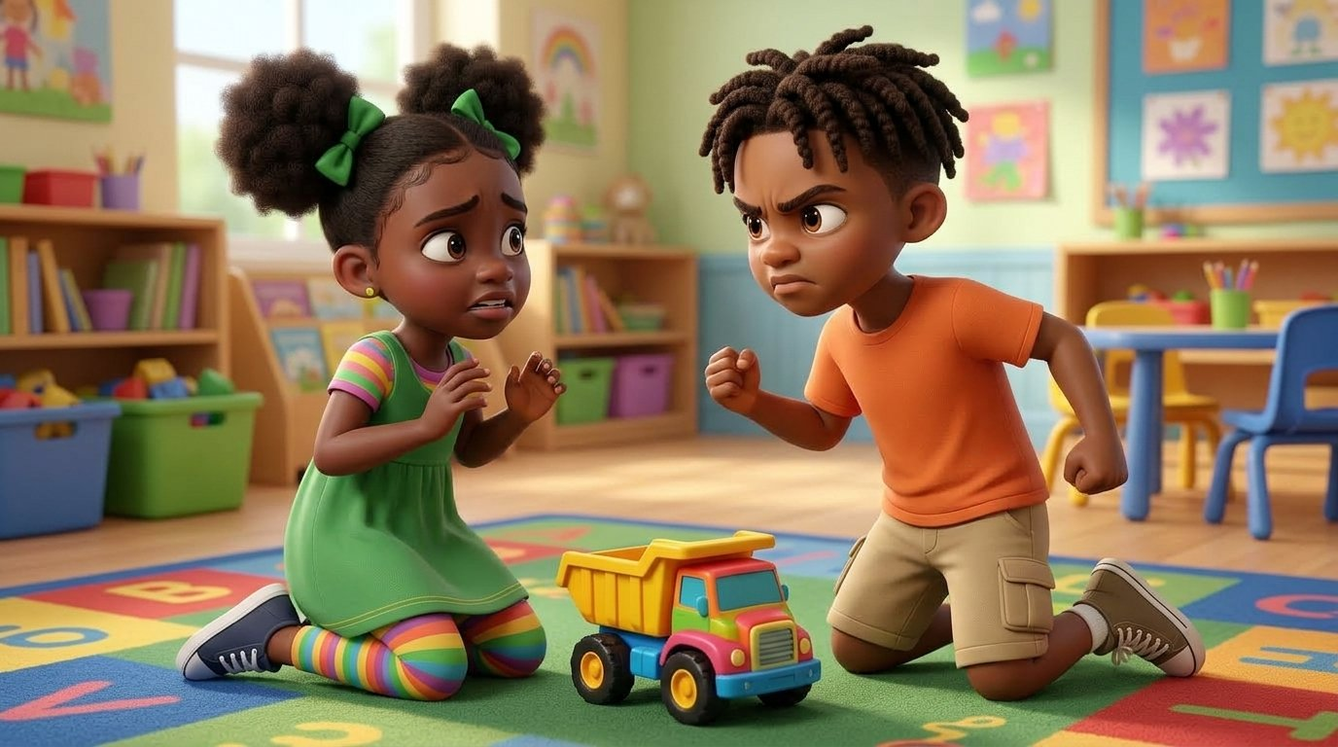
At a glance
Goal | Students say “Hitting hurts. We use gentle hands” and choose a calm move when they feel mad.
Time | 15 minutes in Morning Meeting, in place of the general lesson. Centers run during the week.
When | Teach before trouble. If a child in this room was hit today, wait a day.
In the bundle | Student deck (7 slides, press N for notes) · Poster (letter and 11×17) · Center kit (sort, sequence, act it out, desk strips, coloring) · Mini book · Family half-sheet
Words we use | “Hitting hurts. We use gentle hands.” · “When I feel mad, I can…” · “Can I have a turn?”

Before you teach
- Hang the poster at child height near the calm corner. Students point to it all week.
- The story uses Malik and Nadege, the toolkit’s classmates. Never cast a real student as the child who hits.
- Tape a desk strip at the table of any student who needs the calm choices close by.
- Pair students who need support with a steady turn-and-talk partner before the lesson starts.

The lesson, slide by slide
The same script is in the deck’s presenter notes. Press N while presenting.
Slide | Say and do | Look for | Engagement move
1 · Title & Promise (R2) | Hold up both open hands and wiggle the fingers. “These are my hands. Today we learn how our hands keep our friends safe. Show me your hands.” | Every student shows open hands. | Equity stick: “Show me gentle hands.” Praise any calm open hands.
2 · Get Calm First (R1) | Do it with them. “Smell the flower. Blow out the candle. Long and slow. Three times.” | Exhale longer than inhale; shoulders drop. | LiveSchool point: “You breathed slow three times.”
3 · What Happened? (R2, R3) | Point to each picture. “Malik was mad. He hit Nadege. Ouch! Nadege got hurt and felt sad. Malik could use gentle hands. Then everyone can play safe.” Class says: “Hitting hurts. We use gentle hands.” | Students follow the pictures; whole class repeats the line. | Equity stick: “Which picture shows gentle hands? Point.”
4 · Turn and Talk (R3, R4) | Model knee to knee. “Look at Nadege. Tell your partner: She feels ___.” 30 seconds, then ring back. | Partners face each other and take turns; most say or point to “sad.” | Equity stick: two shares. Praise the full sentence.
5 · Watch Me, Then Show Me (R3, R4, R5) | Read: “A friend takes my truck. I feel mad. I can…” A student models a mad face, then a calm move. Ask the class, “What did they do?” Then everyone rehearses deep breaths and “Can I have a turn?” | A student models; class names the calm move; whole class rehearses. | LiveSchool point for the student model. Name the calm move out loud.
6 · My Promise Today (R2, R5) | Hand on heart. “Say it with me: I use gentle hands.” Then: “Point to the calm move you will use today.” | Every student says the promise and points to one choice. | Equity stick: three names. Pointing counts.
7 · How We Leave (R1, R4, R5) | “Stand up. Gentle hands. Walk. Ready to learn.” Do not time this at K–2. | Hands to self while moving; calm walking. | LiveSchool point for the table that walks with gentle hands the whole way.

Practice bridges for slide 5
Students model, not the teacher. The teacher narrates and asks the class what they saw.
If the model is… | Say
Excellent | “Show the class again. Everyone, what calm move did you see?” Then the whole class does it together.
Partly right | “You showed the mad face. Now show us the calm move. Try again.”
Silly | “Thank you. Let’s see it the safe way.” Call a new student. No commentary.

Centers
Print one kit per group. Laminate the mats and cards so they last. Students work in groups of 2 to 4.
Center | Set up | Read to students | Done looks like
Sort It | Sort mat (landscape page) and 8 cut picture cards. | “Look at each picture. Is it gentle hands or not gentle? Put it on the side where it goes.” | 5 cards on Gentle, 3 on Not gentle.
Put It in Order | Sequencing mat and 4 cut cards. | “Put the pictures in order: first, next, then, last. Tell your partner the story.” | Students retell: mad, calm corner, back to the rug, play.
Act It Out | 4 role-play cards in a stack. | “Pick a card. Read it with me. Show a mad face. Then show a calm move from the pictures.” | Each student shows one calm move.
Calm Choices | Desk strips, one per student. | “Point to the calm choice you like best. Show me how you do it.” | Each student points and acts out one choice.
Color | Coloring page and crayons. | “Color Lee and Tee. In the box, draw a gentle hands move you can do.” | A drawing of a high five, a wave, or a fist bump.

Answer keys
- Sort, Gentle hands: Lee and Tee high five · friends building with blocks · Tee and Malik tossing a ball · Tee and Nadege doing a puzzle · Tee handing Kiara a block.
- Sort, Not gentle: Malik with tight fists over the truck · Nadege about to throw a block · Diego with fists at the teacher.
- Put It in Order: 1 Tee walks to the calm corner, mad · 2 Tee calms down in the corner · 3 Tee walks back to the rug · 4 friends play together.

The mini book (one child, Tier 2)
- For a child who has hit more than once. Read it one-on-one, at a calm time, before the hardest part of the day.
- Read it every day for a week. Let the child turn the pages and point to the calm choices.
- Never read it as a consequence or right after an incident.
- On the back, the child colors a star each day they use gentle hands. Celebrate every star.

When it happens
Follows the Responsive Behavior Plan: the adult response is the intervention. Fewer words as escalation rises.
- Safety first. Calmly step between. Care for the hurt child first: “Are you okay? Let’s get you help.”
- Few words. To the child who hit: “Hands down. Come with me.” Offer a break: break, reset, return. If hitting continues or anyone is in danger, call for support.
- Address, once calm. Point to the poster. “Hitting hurts. Next time, pick a calm choice.” Correct the routine, not the child.
- Document. Fill out the Live Card right away: facts only, in bullet points.
- Repair, after regulation. “I can see you were mad. Who got hurt? What can we do to help?” K–2 repair can be checking on the friend, helping rebuild, or drawing a picture. Never force an apology.
- Reflect. If it happens again, share the Live Cards with your coach and the counseling team.
If a student hits an adult, use Topic 8, Gentle Hands with Grown-Ups, and the same pathway.

Family connection
- Send the family half-sheet home the day you teach. It is in English, Spanish, and Haitian Creole.

