K–2 BEHAVIOR TOOLKIT · MORNING MEETING
Asking for a Break
Teacher Guide · Topic 4 of 12 · Value: Responsible
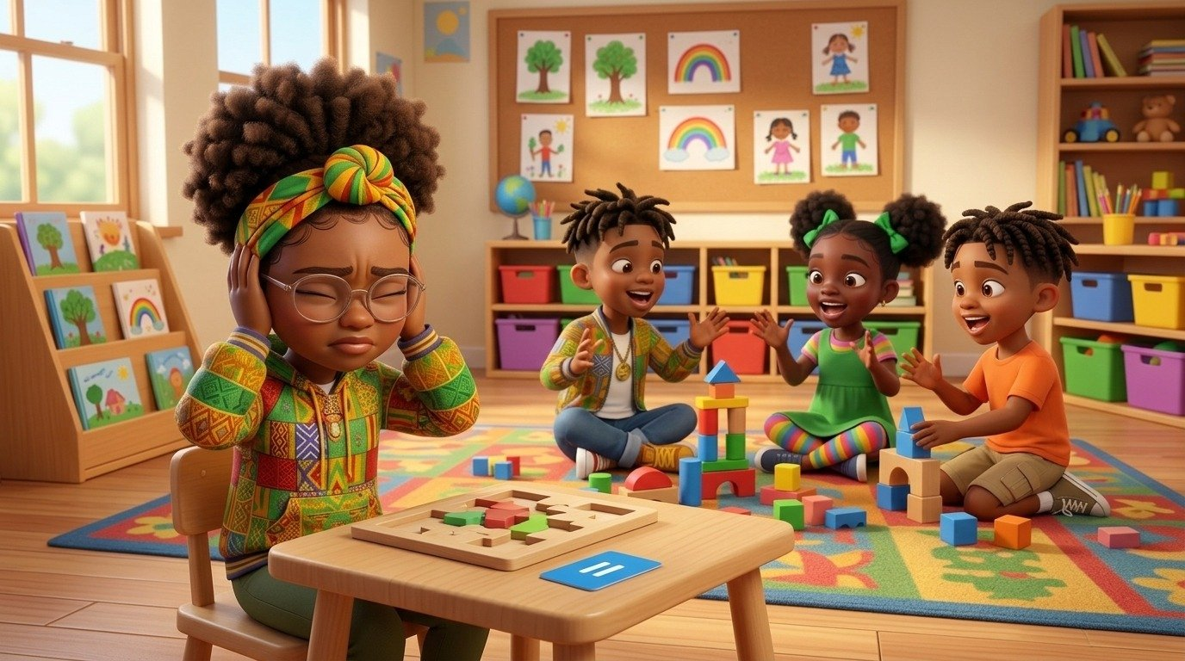
At a glance
Goal | Students ask for a break the calm way (break card or words), wait for a yes, take a short break in the calm corner, and come back to try again.
Time | 15 minutes in Morning Meeting, in place of the general lesson. Centers run during the week.
When | Teach after Topic 2, Using the Calm Corner, and Topic 3, Belly Breathing. Asking for a break is how students get to the calm corner.
In the bundle | Student deck (7 slides, press N for notes) · Poster (letter and 11×17) · Center kit (sort, sequence, act it out, desk strips, coloring, break cards) · Mini book · Family half-sheet
Words we use | “Can I have a break, please?” · “Card or words. Wait for a yes. Take a break. Come back.” · “Welcome back.”

Before you teach
- Print and cut the break cards in the center kit. Put them where every student can reach one, such as a cup on each table.
- Hang the poster at child height near your meeting space or the calm corner. Students point to it all week.
- Keep the sand timer in the calm corner. Breaks follow the calm corner routine from Topic 2: one friend at a time, about 3 to 5 minutes.
- Decide your “not yet” words before the lesson: “Not yet. Belly breathe at your seat, and I will come to you.”
- Pair students who need support with a steady turn-and-talk partner before the lesson starts.

The lesson, slide by slide
The same script is in the deck’s presenter notes. Press N while presenting.
Slide | Say and do | Look for | Engagement move
1 · Title & Promise (R2) | Hold up a break card. “Sometimes our body needs a short break. We do not run away or yell. We ask.” Say together: “Can I have a break, please?” | Students repeat the line in a calm voice. | Equity stick: “Show me how you hold up a break card.”
2 · Get Calm First (R1) | Do it with them. “Smell the flower. Blow out the candle. Long and slow. Three times.” | Exhale longer than inhale; shoulders drop. | LiveSchool point: “You breathed slow three times.”
3 · What Did Lee Do? (R2, R3) | Point to each picture. “At center time, the room got loud. Lee’s body felt like too much. She held up her break card. Her teacher said yes. She took her break with the timer, then came back and tried again.” Class says: “Card or words. Wait for a yes. Take a break. Come back.” | Students follow the pictures; whole class repeats the line. | Equity stick: “Which picture shows Lee asking? Point.”
4 · Turn and Talk (R3, R4) | Model knee to knee. “It feels like too much for Lee. Tell your partner: Lee can ___.” 30 seconds, then two shares. | Partners take turns; any calm tool on the slide is right. | Equity stick: two shares.
5 · Watch Me, Then Show Me (R3, R4, R5) | You play the teacher. A student asks with the card or words, waits for your yes, walks to the calm corner, turns the timer, and walks back. Then the class practices the words together. | Calm voice or raised card; waits for the yes; walks back on their own. | LiveSchool point for the student model.
6 · My Promise Today (R2, R5) | Hand on heart. “Say it with me: I can ask for a break with my words or my card.” Then: “When it feels like too much, point to one.” | Every student says the promise and points to one picture. | Equity stick: three names. Pointing counts.
7 · How We Leave (R1, R4, R5) | “Stand up. Calm body. Walk. Ready to learn.” Do not time this at K–2. | Calm bodies while moving; calm walking. | LiveSchool point for the table that walks with calm bodies the whole way.

Practice bridges for slide 5
Students model, not the teacher. The teacher narrates and asks the class what they saw.
If the model is… | Say
Excellent | “Show us again. Everyone, watch how she waits for my yes.”
Partly right | “You asked in a calm voice. Now wait for my yes before you go. Try again.”
Silly | “Thank you. Let’s see it the calm way.” Call a new student. No commentary.

Centers
Print one kit per group. Laminate the mats and cards so they last. Students work in groups of 2 to 4.
Center | Set up | Read to students | Done looks like
Sort It | Sort mat (landscape page) and 8 cut picture cards. | “Look at each picture. Is it a calm way to take a break? Put it on the side where it goes.” | 4 cards on Calm way, 4 on Not the calm way. Accept any sort a student can explain.
Put It in Order | Sequencing mat and 4 cut cards. | “Put Lee’s story in order: first, next, then, last. Tell your partner the story.” | Students retell: too much, ask, break, come back.
Act It Out | 4 role-play cards in a stack. | “Pick a card. Read it with me. Show your card or ask. Wait for my yes.” | Each student asks the calm way for a card.
How I Ask Steps | Desk strips, one per student. | “Point to each step and say it.” | Each student says all four steps.
Color | Coloring page and crayons. | “Color Lee and her break card. Then show how you ask.” | A colored page and one calm ask.

Answer keys
- Sort, Calm way: Lee holds up her break card · Lee asks her teacher with words · Lee takes her break with the sand timer · Lee comes back to her center.
- Sort, Not the calm way: a friend running · Sofia screaming · Nadege throwing · a friend jumping in the calm corner.
- Put It in Order: 1 The room is loud and it feels like too much · 2 Lee holds up her break card · 3 Lee takes her break with the timer · 4 Lee comes back and tries again.

The mini book (one child, Tier 2)
- For a child who leaves the area, yells, or shuts down when things feel like too much, and who needs a calm way to ask for space.
- Read it one-on-one at a calm time. Hand the child a break card and practice each step as you read it.
- Read it every day for a week. Let the child turn the pages and hold up the card on page 2.
- On the back, the child colors a star each time they ask for a break the calm way. Celebrate every star.

When asking for a break gets tricky
Follows the Responsive Behavior Plan: the adult response is the intervention. Fewer words as escalation rises.
- A student asks for a break every few minutes. Say yes and keep breaks short. When they come back, start with one small step. If the pattern continues, share it with the counseling team.
- A student does not come back when the timer is done. Walk over and get low: “The timer is done. Show me your first step.” Offer two choices: “Walk with me or walk beside me.”
- You cannot say yes right now. “Not yet. Belly breathe at your seat, and I will come to you.” Then follow through soon.
- A student leaves without asking. Do not chase if they are safe in the room. Later, at a calm time: “Next time, show me your card first.”
- A student is unsafe. Safety first. Use Topic 7, Gentle Hands, and the Responsive Behavior Plan.
Next in the toolkit: Topic 5, Getting a Grown-Up's Attention.

Family connection
- Send the family half-sheet home the day you teach. It is in English, Spanish, and Haitian Creole.

