K–2 BEHAVIOR TOOLKIT · MORNING MEETING
Getting a Grown-Up's Attention
Teacher Guide · Topic 5 of 12 · Value: Respectful
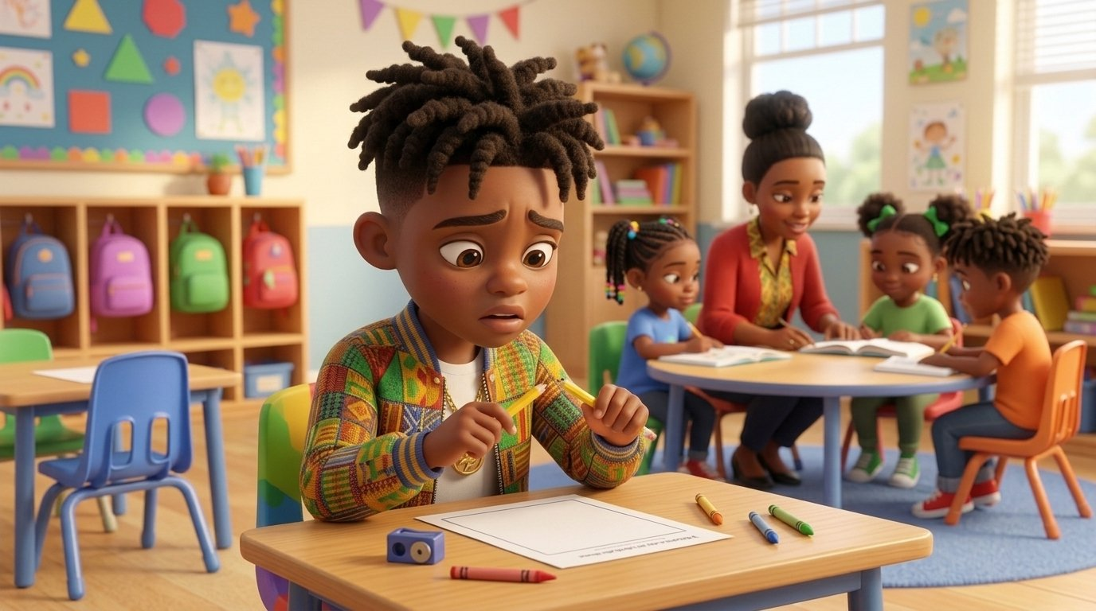
At a glance
Goal | Students get a grown-up’s attention the safe way. In class: raise a hand, stay seated, and wait with a calm body while the teacher comes to them. In the hall or outside: stand close, wait until the grown-up is done, and say “Excuse me.” In an emergency, they go right to a grown-up.
Time | 15 minutes in Morning Meeting, in place of the general lesson. Centers run during the week.
When | Teach after Topic 4, Asking for a Break. Teach it before Topic 8, Gentle Hands with Grown-Ups, because it gives students the safe way to reach a grown-up.
In the bundle | Student deck (7 slides, press N for notes) · Poster (letter and 11×17) · Center kit (sort, sequence, act it out, desk strips, coloring) · Mini book · Family half-sheet
Words we use | “Hand up. Wait calmly. Tell what I need. Say thank you.” · “Excuse me” in the hall or outside · “I need help now” for emergencies

Before you teach
- Choose your “I see you” signal before the lesson, such as a nod and one finger up for “one minute.” Use the same signal all week, then walk to the student.
- In class, students stay in their seats and you go to them. In the hall, at lunch, or outside, they stand close and wait until you are done.
- Hang the poster at child height near your meeting space or your small-group table. Students point to it all week.
- Teach the emergency rule with the lesson: if someone is hurt or not safe, students come right away and say, “I need help now.”
- Tape a desk strip at the table of any student who often calls out or tugs for attention.
- Pair students who need support with a steady turn-and-talk partner before the lesson starts.

The lesson, slide by slide
The same script is in the deck’s presenter notes. Press N while presenting.
Slide | Say and do | Look for | Engagement move
1 · Title & Promise (R2) | Raise your hand and wait a moment. “In class, we raise our hand, stay in our seat, and wait. The grown-up comes to us.” Say together: “Hand up. I can wait.” | Students repeat the line in a calm voice. | Equity stick: “Show me how you get my attention.”
2 · Get Calm First (R1) | Do it with them. “Smell the flower. Blow out the candle. Long and slow. Three times.” | Exhale longer than inhale; shoulders drop. | LiveSchool point: “You breathed slow three times.”
3 · What Did Tee Do? (R2, R3) | Point to each picture. “Tee’s pencil broke. His teacher was busy. He raised his hand, stayed in his seat, and waited. She walked over to him. He said, ‘My pencil broke,’ and then, ‘Thank you.’” Class says: “Hand up. Wait calmly. Tell what I need. Say thank you.” | Students follow the pictures; whole class repeats the line. | Equity stick: “Which picture shows the teacher coming to Tee? Point.”
4 · Turn and Talk (R3, R4) | Model knee to knee. “Tee needs help and his teacher is busy. Tell your partner: Tee can ___.” 30 seconds, then two shares. | Partners take turns; any safe step on the slide is right. | Equity stick: two shares.
5 · Watch Me, Then Show Me (R3, R4, R5) | Pretend to help a small group. A student raises a hand from a seat and waits; give your “I see you” nod and walk over. Then practice the hallway way once (stand close, wait, “Excuse me”) and the emergency rule once. | Seated, no calling out; hands to self while waiting; calm voice. | LiveSchool point for the student model.
6 · My Promise Today (R2, R5) | Hand on heart. “Say it with me: I can get a grown-up’s help the safe way.” Then: “When you need help, point to one.” | Every student says the promise and points to one picture. | Equity stick: three names. Pointing counts.
7 · How We Leave (R1, R4, R5) | “Stand up. Calm body. Walk. Ready to learn.” Do not time this at K–2. | Calm bodies while moving; calm walking. | LiveSchool point for the table that walks with calm bodies the whole way.

Practice bridges for slide 5
Students model, not the teacher. The teacher narrates and asks the class what they saw.
If the model is… | Say
Excellent | “Show us again. Everyone, watch how he stays in his seat and waits for me to come.”
Partly right | “You raised your hand. Now stay in your seat and I will come to you. Try again.”
Silly | “Thank you. Let’s see it the safe way.” Call a new student. No commentary.

Centers
Print one kit per group. Laminate the mats and cards so they last. Students work in groups of 2 to 4.
Center | Set up | Read to students | Done looks like
Sort It | Sort mat (landscape page) and 8 cut picture cards. | “Look at each picture. Is it a safe way to get a grown-up? Put it on the side where it goes.” | 4 cards on Safe way, 4 on Not the safe way. Accept any sort a student can explain.
Put It in Order | Sequencing mat and 4 cut cards. | “Put Tee’s story in order: first, next, then, last. Tell your partner the story.” | Students retell: I need help, hand up, she comes, I get help.
Act It Out | 4 role-play cards in a stack. | “Pick a card. Read it with me. Show me the safe way to get my help.” | Each student shows hand up and a calm wait. The hurt-friend card means go right away.
How I Get Help Steps | Desk strips, one per student. | “Point to each step and say it.” | Each student says all four steps.
Color | Coloring page and crayons. | “Color Tee. Then show how you get help.” | A colored page and one raised hand.

Answer keys
- Sort, Safe way: Tee raises his hand · the teacher comes to Tee while he waits · Lee waits in the hall · Lee asks her teacher for help.
- Sort, Not the safe way: Malik pulls the teacher’s sleeve · Sofia screaming · a friend running · Diego with tight fists.
- Put It in Order: 1 Tee’s pencil breaks · 2 Tee raises his hand and waits · 3 The teacher comes to Tee · 4 Tee gets a new pencil and says thank you.

The mini book (one child, Tier 2)
- For a child who calls out, tugs, grabs, or follows a grown-up closely to get help, and who needs a safe way that works.
- Read it one-on-one at a calm time. Practice each step as you read it, and answer the child’s raised hand right away.
- Read it every day for a week. Let the child turn the pages and raise a hand on page 2. Walk to the child each time.
- On the back, the child colors a star each time they get help the safe way. Celebrate every star.

When getting help gets tricky
Follows the Responsive Behavior Plan: the adult response is the intervention. Fewer words as escalation rises.
- A student calls out again and again. Do not answer the call-out. Look for the raised hand and go to it fast, at first within seconds. Then slowly stretch the wait.
- A student gets up, tugs, or grabs you. Stay calm and low: “Back to your seat. Hand up, and I will come to you.” Go as soon as the hand goes up.
- A student waits a long time and gives up. Use your “I see you” signal right away so the student knows the wait was noticed. Then follow through.
- Someone is hurt or not safe. Students do not wait. Thank the student who came right away: “You did the right thing.”
- A student is unsafe. Safety first. Use Topic 7, Gentle Hands, and the Responsive Behavior Plan.
Next in the toolkit: Topic 6, Fixing It.

Family connection
- Send the family half-sheet home the day you teach. It is in English, Spanish, and Haitian Creole.

