K–2 BEHAVIOR TOOLKIT · MORNING MEETING
Using the Calm Corner
Teacher Guide · Topic 2 of 12 · Value: Responsible
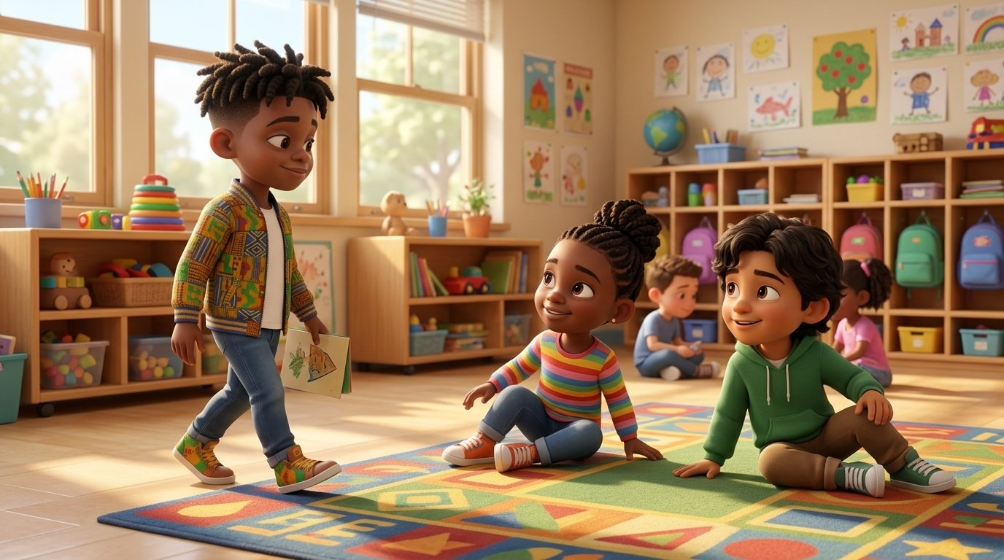
At a glance
Goal | Students follow the four calm corner steps (notice, walk, get calm, come back) and say “The calm corner helps me get calm. Then I come back.”
Time | 15 minutes in Morning Meeting, in place of the general lesson. Centers run during the week.
When | Teach early in the year and again after any long break. Teach it before the calm corner is needed, at a calm time.
In the bundle | Student deck (7 slides, press N for notes) · Poster (letter and 11×17) · Center kit (sort, sequence, act it out, desk strips, coloring) · Mini book · Family half-sheet
Words we use | “Big feelings are okay.” · “The calm corner helps me get calm. Then I come back.” · “I notice. I walk. I get calm. I come back.”

Before you teach
- Set up the calm corner before the lesson: a soft seat, the breathing pictures, and the feelings faces. Fidgets are not part of this routine.
- Hang the poster inside or right next to the calm corner. Students point to the steps all week.
- The calm corner is a tool, not a time-out. Never send a student there as a consequence, and never call it “time-out” or “the thinking spot.”
- One friend in the calm corner at a time. Most students are ready to come back in about 3 to 5 minutes. If a student stays longer, check in quietly.
- Pair students who need support with a steady turn-and-talk partner before the lesson starts.

The lesson, slide by slide
The same script is in the deck’s presenter notes. Press N while presenting.
Slide | Say and do | Look for | Engagement move
1 · Title & Promise (R2) | Point to your calm corner. “This is our calm corner. Everyone gets big feelings. Today we learn how the calm corner helps us get calm and come back.” Say together: “Big feelings are okay.” | Eyes on the slide or the real corner; students repeat the line. | Equity stick: “Point to our calm corner.” Pointing is a full answer.
2 · Get Calm First (R1) | Do it with them. “Smell the flower. Blow out the candle. Long and slow. Three times.” Tell them it is one of the calm corner tools. | Exhale longer than inhale; shoulders drop. | LiveSchool point: “You breathed slow three times.”
3 · What Did Tee Do? (R2, R3) | Point to each picture. “The work felt too hard. Tee got a big feeling. He walked to the calm corner. He got calm. Then he came back to the rug.” Class says: “The calm corner helps me get calm. Then I come back.” | Students follow the pictures; whole class repeats the line. | Equity stick: “Which picture shows Tee getting calm? Point.”
4 · Turn and Talk (R3, R4) | Model knee to knee. “Look at Tee. Tell your partner: Tee feels ___.” 30 seconds, then ring back. | Partners take turns; worried and frustrated are both right. | Equity stick: two shares. Praise the full sentence.
5 · Watch Me, Then Show Me (R3, R4, R5) | Read: “My tower falls down. I feel a big feeling. I…” A student models the four steps at your real calm corner, including coming back. Ask, “What did they do first? Last?” Then everyone practices the steps in place. | A student models all four steps; class names them in order. | LiveSchool point for the student model. Name the come-back step out loud.
6 · My Promise Today (R2, R5) | Hand on heart. “Say it with me: I get calm. I come back.” Then: “Point to the calm tool you will use.” | Every student says the promise and points to one tool. | Equity stick: three names. Pointing counts.
7 · How We Leave (R1, R4, R5) | “Stand up. Calm body. Walk. Ready to learn.” Do not time this at K–2. | Calm bodies while moving; calm walking. | LiveSchool point for the table that walks with calm bodies the whole way.

Practice bridges for slide 5
Students model, not the teacher. The teacher narrates and asks the class what they saw.
If the model is… | Say
Excellent | “Show the class again. Everyone, what was the last step?” Then the whole class does the steps together.
Partly right | “You got calm. Now show us the last step: come back. Try again.”
Silly | “Thank you. Let’s see it the calm way.” Call a new student. No commentary.

Centers
Print one kit per group. Laminate the mats and cards so they last. Students work in groups of 2 to 4.
Center | Set up | Read to students | Done looks like
Sort It | Sort mat (landscape page) and 8 cut picture cards. | “Look at each picture. Is it the calm way to use the calm corner? Put it on the side where it goes.” | 4 cards on The calm way, 4 on Not the calm way.
Put It in Order | Sequencing mat and 4 cut cards. | “Put the pictures in order: first, next, then, last. Tell your partner the story.” | Students retell: big feeling, walk, get calm, come back.
Act It Out | 4 role-play cards in a stack. | “Pick a card. Read it with me. Show the feeling. Then show a calm tool from the pictures.” | Each student shows one calm tool.
Calm Corner Steps | Desk strips, one per student. | “Point to each step and say it with me: notice, walk, get calm, come back.” | Each student points to all four steps in order.
Color | Coloring page and crayons. | “Color Tee getting calm. In the box, draw your favorite calm tool.” | A drawing of a calm tool, like a book, a soft friend, or slow breathing.

Answer keys
- Sort, The calm way: Lee hugs a teddy bear · Lee looks at a book · Tee points to the feelings chart · Lee breathes slow.
- Sort, Not the calm way: Diego and Malik have a pillow fight · Kiara jumps on the cushions · Sofia, Kiara, and Nadege crowd in and play · Nadege runs to the corner.
- Put It in Order: 1 Tee has a big feeling at his table · 2 Tee walks to the calm corner · 3 Tee gets calm in the corner · 4 Tee walks back to the rug.

The mini book (one child, Tier 2)
- For a child who needs extra practice using the calm corner: one who avoids it, stays a long time, or has trouble coming back.
- Read it one-on-one at a calm time, then walk to the real calm corner together and practice the steps.
- Read it every day for a week. Let the child turn the pages and act out each step.
- On the back, the child colors a star each day they get calm and come back. Celebrate every star.

When the calm corner gets tricky
Follows the Responsive Behavior Plan: the adult response is the intervention. Fewer words as escalation rises.
- A student needs the corner but does not go. Offer, do not order: “Do you want to go to the calm corner or breathe here with me?” Two choices, then wait.
- A student plays in the corner. Quietly: “The calm corner is for getting calm. Show me a calm tool.” If play continues, the student returns to the group and tries again later.
- A student does not come back. After about 5 minutes, kneel and check in: “Is your body calm? Show me thumbs up when you are ready.” Then walk back together.
- Two students want the corner at once. One friend at a time. The second student breathes at their seat with the desk strip, then gets the next turn.
- A student uses the corner to leave every task. Note it on the Live Card and talk with your coach and the counseling team. The calm corner is still never taken away.
- Unsafe in the corner. If a student is unsafe to self or others, follow the Responsive Behavior Plan and call for support.
Next in the toolkit: Topic 3, Belly Breathing, and Topic 4, Asking for a Break.

Family connection
- Send the family half-sheet home the day you teach. It is in English, Spanish, and Haitian Creole.

