K–2 BEHAVIOR TOOLKIT · MORNING MEETING
Things Stay Safe
Teacher Guide · Topic 9 of 12 · Value: Safe
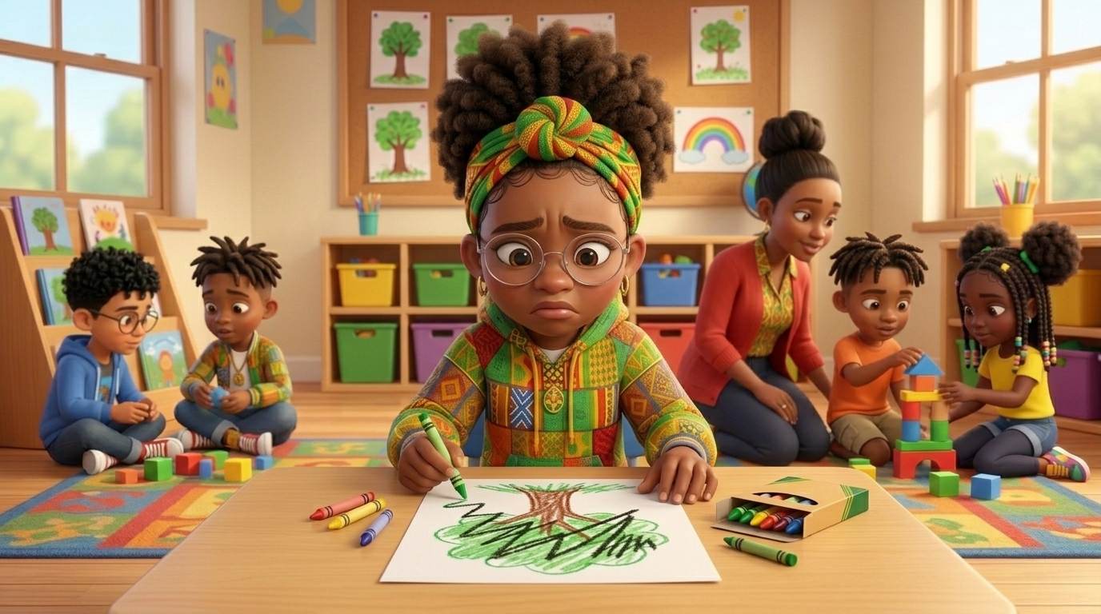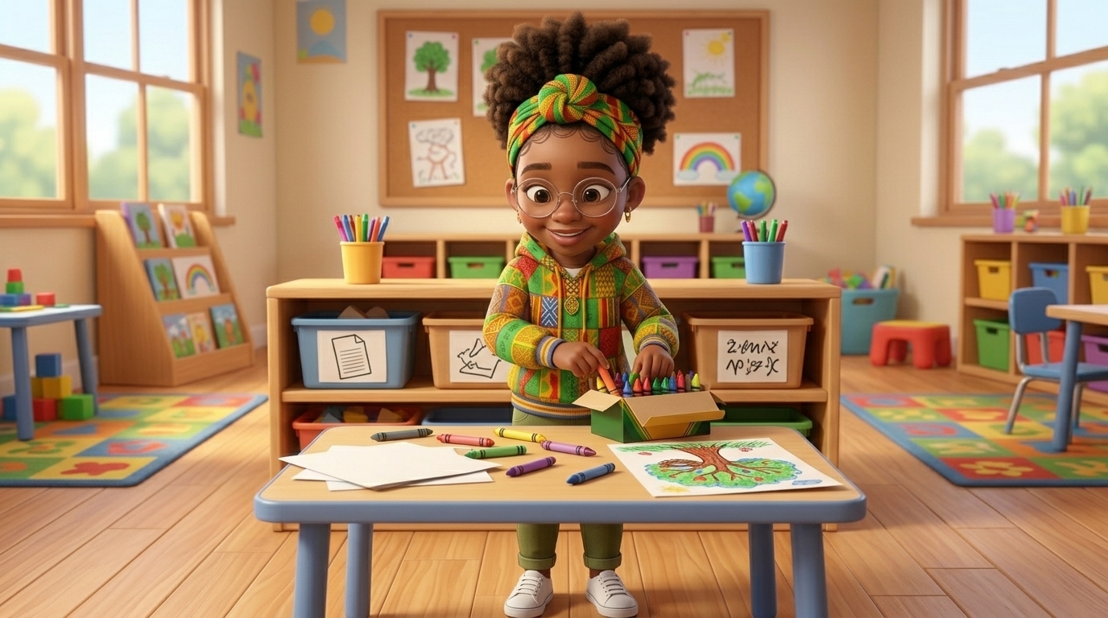
At a glance
Goal | Students keep classroom things safe when they feel mad: put it down gently, take a slow breath, ask for help, and put it back in its place. Mad is okay; throwing, ripping, and kicking things are not.
Time | 15 minutes in Morning Meeting, in place of the general lesson. Centers run during the week.
When | Teach after Topic 8, Gentle Hands with Grown-Ups. Teach it on a calm day, never the morning after a student threw or broke something.
In the bundle | Student deck (7 slides, press N for notes) · Poster (letter and 11×17) · Center kit (sort, sequence, act it out, desk strips, coloring) · Mini book · Family half-sheet
Words we use | “Put it down. Breathe. Ask for help. Put it back.” · “Can you help me, please?” · “Mad is okay. Throwing is not.”

Before you teach
- Give every shared material a labeled home (picture plus word) so “put it back in its place” has a clear answer.
- Practice your own calm response first: a low, slow voice and few words. The adult response is the intervention.
- Hang the poster at child height near the art table or the center where things get hard.
- Set out a crayon and a paper for the practice slide. Use only soft, light items for acting it out.
- Tape a desk strip at the table of any student who has thrown, ripped, or swept things off a table.
- Pair students who need support with a steady turn-and-talk partner before the lesson starts.

The lesson, slide by slide
The same script is in the deck’s presenter notes. Press N while presenting.
Slide | Say and do | Look for | Engagement move
1 · Title & Promise (R2) | Set a crayon down gently. “When we feel mad, our things stay safe.” Say together: “Our things stay safe!” | Students repeat the line in a calm voice. | Equity stick: “Name one thing in our room that we all share.”
2 · Get Calm First (R1) | Do it with them. “Smell the flower. Blow out the candle. Long and slow. Three times.” | Exhale longer than inhale; shoulders drop. | LiveSchool point: “You breathed slow three times.”
3 · What Did Lee Do? (R2, R3) | Point to each picture. “A big scribble landed on Lee’s tree. She felt mad and stuck. She put the crayon down gently, took a breath, and asked, ‘Can you help me, please?’ Her teacher helped her turn the scribble into a bird’s nest. Then Lee put the crayons back in the box.” Class says: “Put it down. Breathe. Ask for help. Put it back.” | Students follow the pictures; whole class repeats the line. | Equity stick: “Which picture shows Lee asking for help? Point.”
4 · Turn and Talk (R3, R4) | Model knee to knee. “Lee feels mad at her picture. Tell your partner: Lee can ___.” 30 seconds, then two shares. | Partners take turns; any safe step on the slide is right. | Equity stick: two shares.
5 · Watch Me, Then Show Me (R3, R4, R5) | Give a student a crayon. “Your picture is not working, and you feel mad.” The student shows the four steps. Then try “The tower falls down,” and practice once all together. | Set down, not tossed; a long breath out; asks for help; puts it back. | LiveSchool point for the student model.
6 · My Promise Today (R2, R5) | Hand on heart. “Say it with me: I keep our things safe.” Then: “When you feel mad, point to one.” | Every student says the promise and points to one picture. | Equity stick: three names. Pointing counts.
7 · How We Leave (R1, R4, R5) | “Things away. Stand up. Walk. Ready to learn.” Do not time this at K–2. | Items put away first; calm walking. | LiveSchool point for the table that puts everything back first.

Practice bridges for slide 5
Students model, not the teacher. The teacher narrates and asks the class what they saw.
If the model is… | Say
Excellent | “Show us again. Everyone, watch how gently she puts it down, even with a mad face.”
Partly right | “You put it down gently. Now ask for help: Can you help me, please? Try again.”
Silly | “Thank you. Let’s see it the safe way.” Call a new student. No commentary.

Centers
Print one kit per group. Laminate the mats and cards so they last. Students work in groups of 2 to 4.
Center | Set up | Read to students | Done looks like
Sort It | Sort mat (landscape page) and 8 cut picture cards. | “Look at each picture. Is this friend keeping our things safe? Put it on the side where it goes.” | 4 cards on Things stay safe, 4 on Not safe. Accept any sort a student can explain.
Put It in Order | Sequencing mat and 4 cut cards. | “Put Lee’s story in order: first, next, then, last. Tell your partner the story.” | Students retell: I feel mad, crayon down, help please, back in place.
Act It Out | 4 role-play cards in a stack. | “Pick a card. Read it with me. Show me how you keep our things safe.” | Each student sets something down gently, breathes, asks for help, and puts it back.
Things Stay Safe Steps | Desk strips, one per student. | “Point to each step and say it.” | Each student says all four steps.
Color | Coloring page and crayons. | “Color Lee and the art table. Then show how you put things back.” | A colored page, and the crayons back in the box.

Answer keys
- Sort, Things stay safe: Lee puts her crayon down gently · Lee takes a slow breath · Lee asks her teacher for help · Lee puts the crayons back in their place.
- Sort, Not safe: Nadege throws a block · Sofia rips a paper · Malik kicks a chair · Kiara pushes crayons off the table.
- Put It in Order: 1 A scribble lands on Lee’s tree and she feels mad · 2 Lee puts the crayon down · 3 Lee asks for help · 4 Lee puts the crayons back in the box.

The mini book (one child, Tier 2)
- For a child who has thrown, ripped, kicked, or broken classroom things. Read it one-on-one at a calm time, before the hardest part of the day.
- Read it every day for a week. Practice each step as you read it, especially the words “Can you help me, please?”
- Never read it as a consequence or right after an incident.
- On the back, the child colors a star each day they keep our things safe. Celebrate every star.

When a student throws or breaks things
Follows the Responsive Behavior Plan: the adult response is the intervention. Fewer words as escalation rises.
- Safety first. Move other students out of the way, keep your voice low and slow, and quietly clear nearby items. Do not grab things out of the child’s hands. Call for support if needed.
- Fewer words. “You are mad. Put it down. I will wait.” Do not lecture or argue in the moment.
- Offer the steps. Point to the desk strip or poster: put it down, breathe, ask for help, put it back.
- Repair later. When the child is calm, use Topic 6, Fixing It: help pick up, tape the paper, or fix what can be fixed. Then start fresh.
- Do not take it personally. The child is stuck and does not have a safer way to ask for help yet. This lesson gives them one.
Next in the toolkit: Topic 10, School Words.

Family connection
- Send the family half-sheet home the day you teach. It is in English, Spanish, and Haitian Creole.

