1. Create JAVA project, Import JAR file 1

2. Create JUnit skeleton test class 2

3. Run first test 2

4. SeatingTest executed 3

5. Run TicketTest 4

6. Create SellingTicketTest 4

# Create JAVA project, Import JAR file

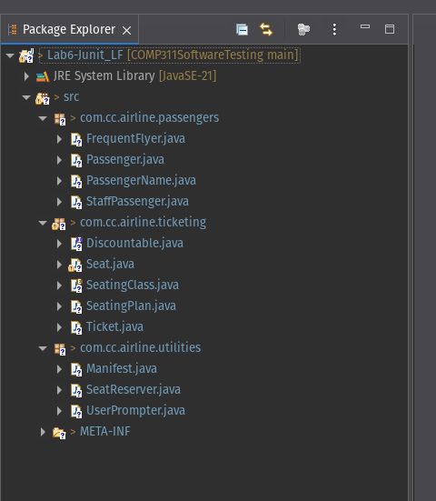

# Create JUnit skeleton test class

# Run first test

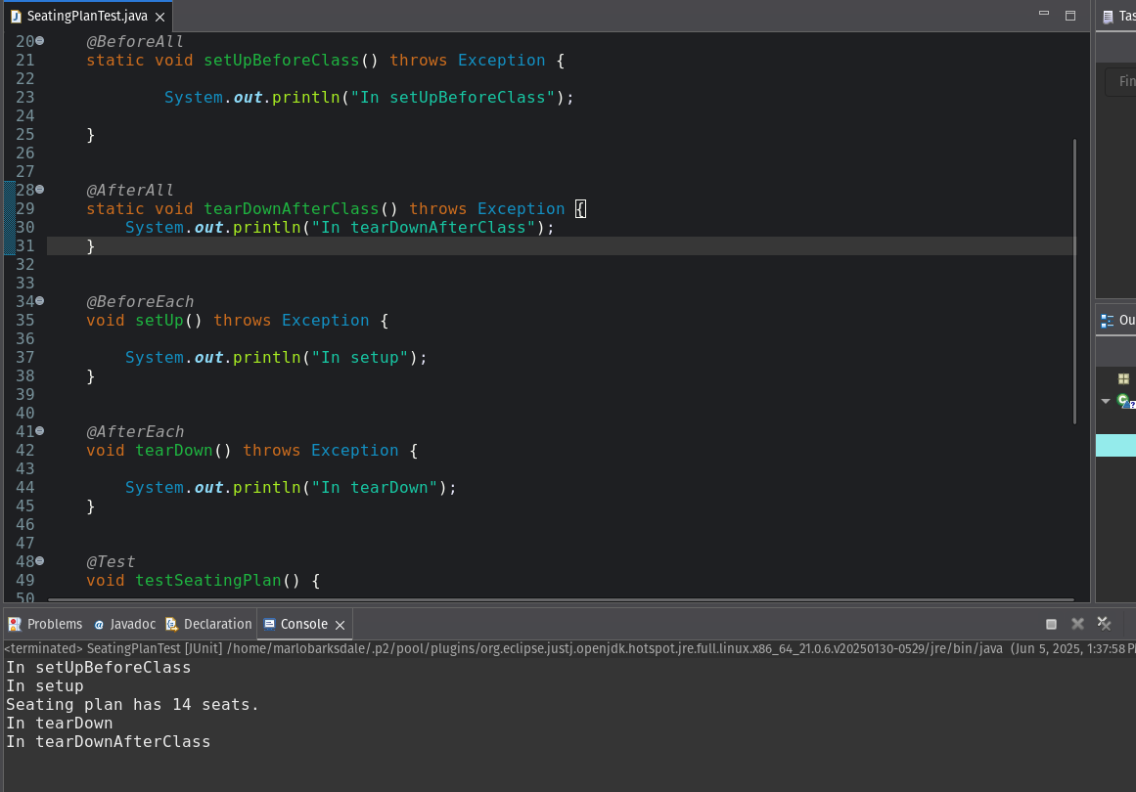

# SeatingTest executed

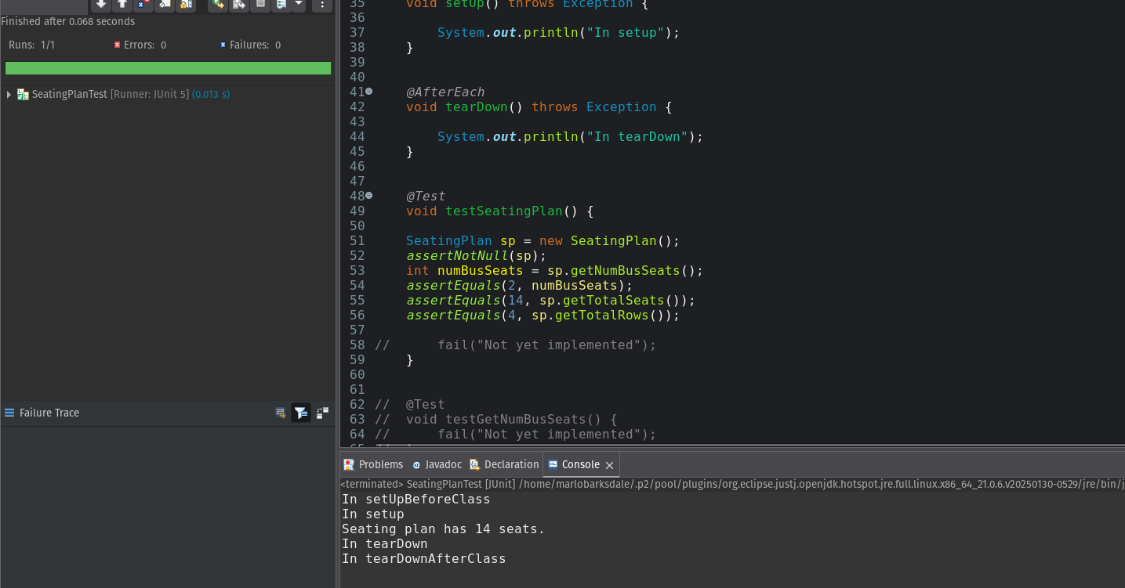

# Run TicketTest

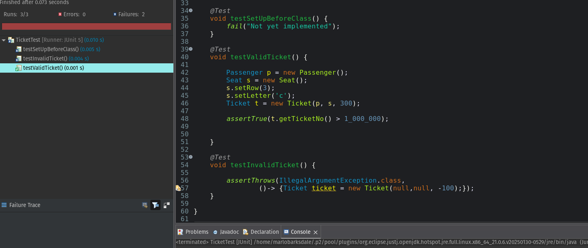

# Create SellingTicketTest

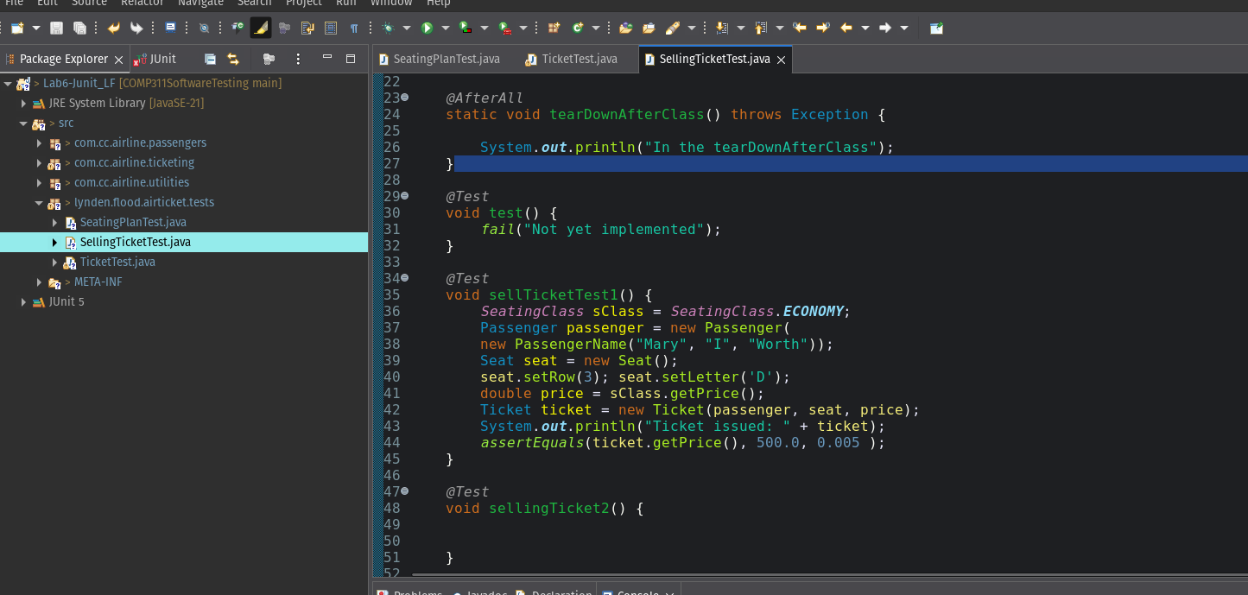

# Running all three tests of SellingTicketTest

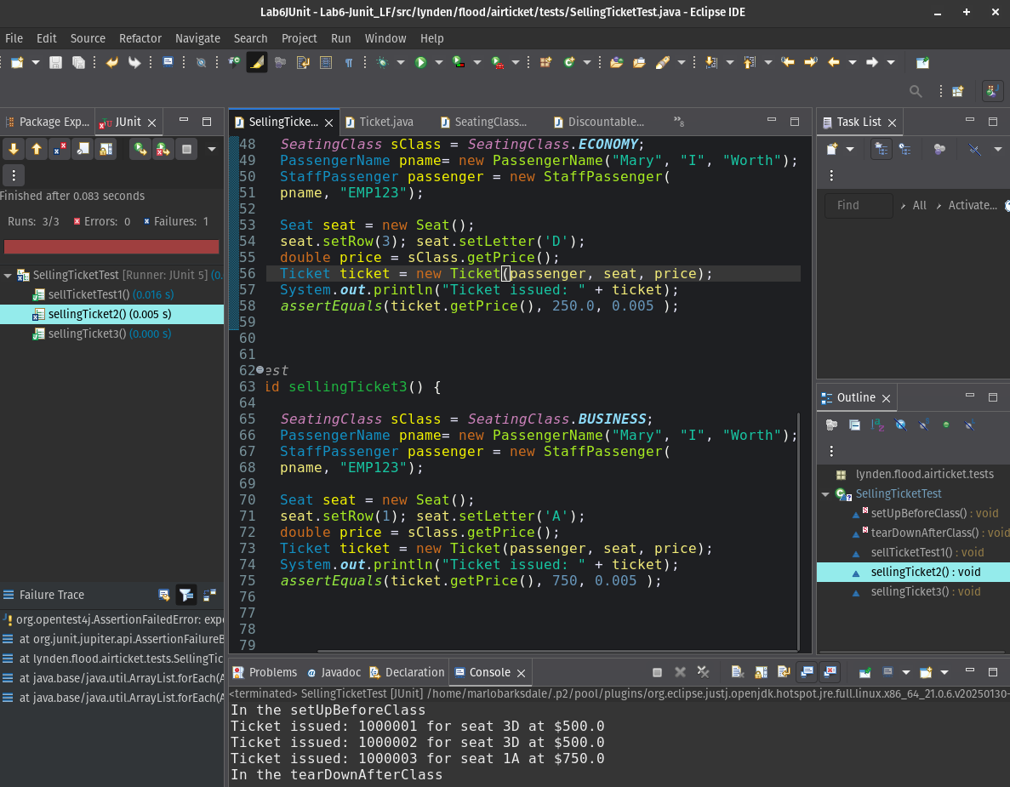

Since the Ticket class has the instance of Passenger, then the getPrice() could serve the function of applying discounts to ticket of Passengers who implement the Discountable interface.

# Test suite run

