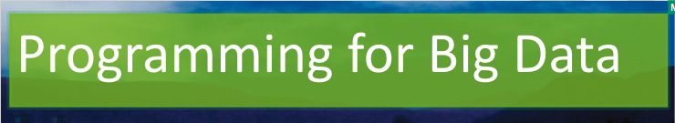

Lab 1

[Click here to Register Attendance](https://forms.gle/pesShFDe1ibVfS3L7)

|  |  |
| --- | --- |
| Name |  |
| Date |  |
| Student No |  |
| Student Email |  |

### **GitHub**

1. Go to <http://github.com>
2. Sign up for a GitHub Account (make sure to use your IT Sligo student email address when you signup as this will entitle you to a free Student that includes 5 free private repositories.
3. Enter your GitHub username here and also enter it into this [form](https://forms.gle/2WXr81guCMnnAb989):

|  |
| --- |
|  |

1. Once your account has been setup, try creating a new Repository called **firstrepo** using the Add Repository button below your profile picture.
2. Use the Add File button to add a new file to your repository, give your new file a name, type some text and save the file.
3. On your Laptop/Desktop, install GitHub Desktop from here: <https://desktop.github.com/>
4. Using GitHub Desktop, Clone a repository from your GitHub account to your laptop/computer
5. On your Laptop/Desktop, create a repository called **secondrepo**
6. In your secondrepo folder add a file and save it, then **commit** the change and **push** it to your GitHub account
7. Paste a screenshot here of your pushed **secondrepo** repository on GitHub.com

### **Installing Hadoop**

1. Go to VirtualBox.org downloads - <https://www.virtualbox.org/wiki/Downloads>
2. Download VirtualBox - I’m using version 6
3. Install Virtual Box and post a screenshot here

|  |
| --- |
|  |

1. Download the HortonWorks HDP Sandbox version 2.5:  
   (HortonWorks merged with Cloudera in 2019)  
   Select HDP environment: <https://www.cloudera.com/downloads/hdp.html>  
   Fill in your information in the downloads registration page  
   Select the HDP Sandbox 2.5 - download file called HDP_2.5_virtualbox.ova
2. Import HDP Sandbox 2.5 into VirtualBox and power it on and post a screenshot here

|  |
| --- |
|  |

1. Explore your Hadoop ecosystem using the Ambari browser interface:  
   Open a browser window and enter: 127.0.0.1:8888  
   Login: maria_dev  
   Password: maria_dev  
   and post a screenshot here

|  |
| --- |
|  |