

Lab 2

[Click here to Register Attendance](https://goo.gl/forms/J9WP2kj83JC1mKYU2)

|  |  |
| --- | --- |
| Name | Ronan Culkin |
| Date | 14/02/2022 |
| Student No | S00225953 |
| Student Email | S00225953@mail.itsligo.ie |

### 

### **Brainstorming for Project Ideas - Preparation**:

Personal Reflection:

|  |  |
| --- | --- |
| Personality traits - what are yours | INTJ |
| Personal values |  |
| What are you interested in? | Reading, History, Music, Computers |

Collaborative brainstorming:

* Brainstorm for 2 minutes - go wild!
* Check in with at least 2 other classmates and explain your ideas in more detail

|  |  |
| --- | --- |
| Idea 1 |  |
| Idea 2 |  |
| Idea 3 |  |
| Idea 4 |  |
| Idea 5 |  |

**GitHub Collaboration**

1. Add me (marloftitsligo) and at least one classmate as a **Collaborator** on your **SecondRepo** repository
2. **Fork** this repository to your local machine using Github Desktop: <https://github.com/marloftitsligo/SecondRepo>
3. Clone that forked repository to your local machine on Github Desktop
4. Add a new Branch to this forked repository and add a file, commit and push to your Github
5. Add a pull request to marloftitsligo and ask to merge your branch changes to the original repo
6. Paste a screenshot of your pull request on Github.com
7. Fork a repository from a classmate and add a Branch for your changes
8. Make a pull request to your classmate asking them to merge the changes
9. Process any pull requests you have received and paste a screenshot of your completed requests from Github.com

### **Arduino Coding Digital & Analog Examples**

1. Open the Arduino Create Integrated Development Environment (IDE), create an account and login <https://create.arduino.cc/editor>

**OR**   
Download the Arduino IDE to your own computer <https://www.arduino.cc/en/software>

1. Click Examples -> Built-in -> **Digital** and choose the Button sketch

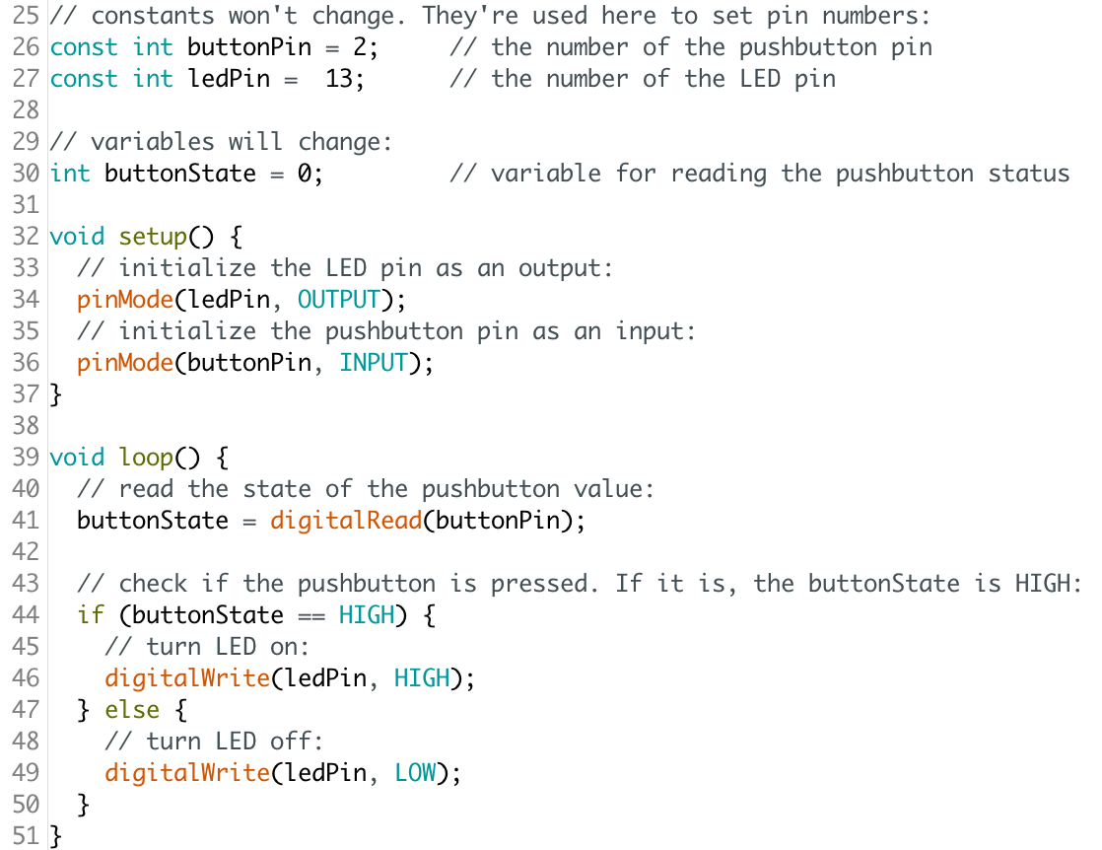

1. Compile the Button sketch and confirm it compiles correctly
2. Edit the Button sketch so, it \***blinks\*** the LED when the button is pushed and upload your code to your Github **fourthrepo** repository
3. Click Examples -> Built-in -> **Basics** and choose the AnalogReadSerial sketch  
   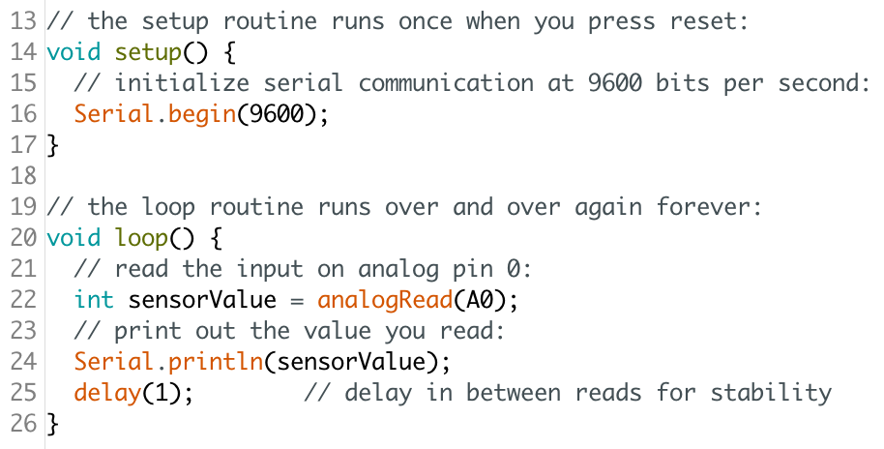
4. Edit the AnalogReadSerial sketch, so it blinks an LED in Digital Pin 3 if the value reading in Pin A0 goes above 500. Hint: reuse elements of the Button sketch to achieve this and in the comments, attribute the original authors of the Button sketch
5. Save your edited file as *AnalogBlinkAboveValue.ino* and Upload your revised code to your Github **fourthrepo** repository