<https://www.hackerrank.com/challenges/python-arithmetic-operators/problem>



<https://www.hackerrank.com/challenges/python-division/problem>



<https://www.hackerrank.com/challenges/python-loops/problem>



<https://www.hackerrank.com/challenges/write-a-function/problem>



<https://www.hackerrank.com/challenges/find-second-maximum-number-in-a-list/problem>

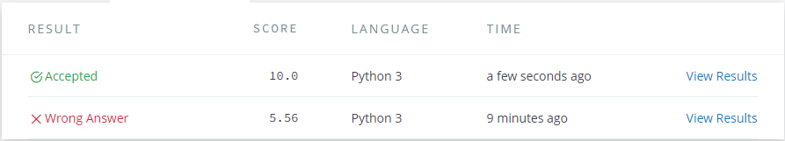

<https://www.hackerrank.com/challenges/finding-the-percentage/problem>



<https://www.hackerrank.com/challenges/python-lists/problem>

