**Random Forrest**

**Finding the best parameters to predict the outcome more accurately**

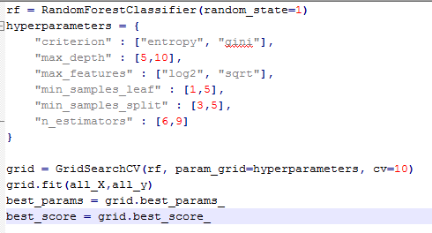

**Rewritten as**

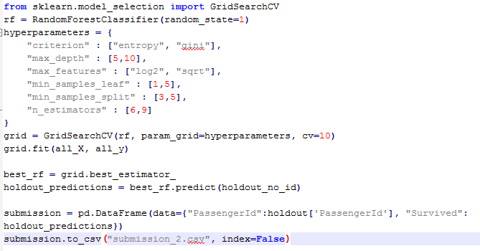

**Result after running the code**

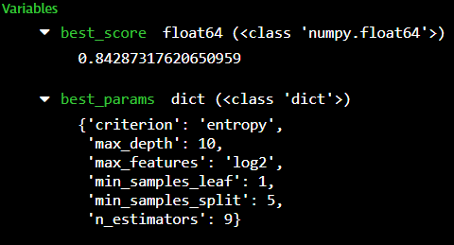

GridSearchCV is used to perform a grid search for as well as CV (cross validation) to find the parameters that gives the best score for the model. The result below shows the best score and the parameters that gives that score.