Evidence document

|  |  |  |
| --- | --- | --- |
| Project | Execution time | Final Result |
| Test Automation Framework | 26.67 | Failed |

# test_invalid_login_1___tomsmith2____SuperSecretPassword_2__

Login_was_successfull_1565985381297.png

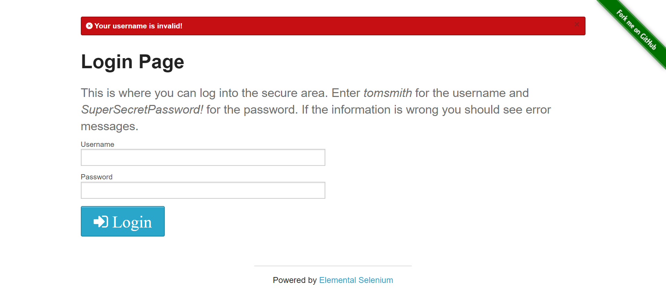

# test_valid_login_1___tomsmith____SuperSecretPassword___

Login_was_successfull_1565985390838.png

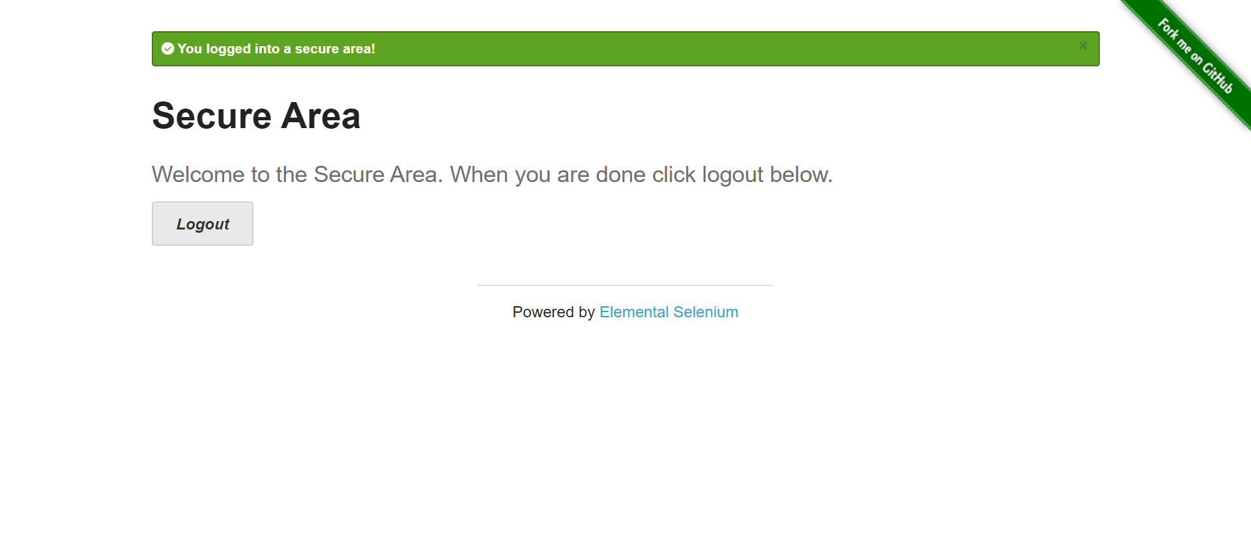

# test_valid_login_2___tomsmith____SuperSecretPassword_2__

Login_was_successfull_1565985399317.png

