**Exercise Description**

**Rock, Paper, Scissors, Lizard, Spock.**

In this week's exercise, you will train your model in the browser using your webcam. You will train your model in exactly the same way as in the Rock, Paper, Scissors example but now you will include the Lizard and Spock hand gestures.

Below are a few tips that can help you get started.

1. To prevent overfitting do not add a lot a of dense layers. Using the same layers as in the Rock, Paper, Scissors example should be good enough.

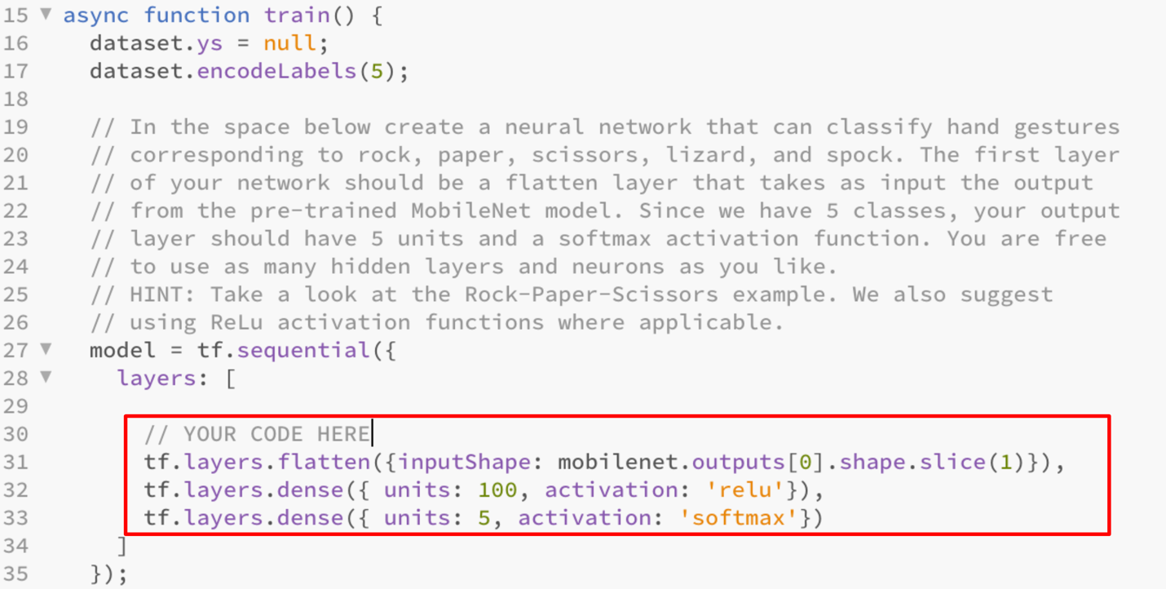

2. Collecting between 50 to100 images for each hand gesture should be good enough for most models. However, feel free to experiment and try to train your model with less or more images.

3. **Wait until Training has Finished before you Download the Model**. To make sure training has completed, open the Developer Tools and look at the Console output. When the browser alerts that "Training is Done!" click Ok. After you click Ok, you will see the value of the LOSS being printed in Console. Once the LOSS values stop being printed, you can go ahead and click the "Download Model" button to download the model and its weights.

4. Your model will be graded based on how it performs on our test set. Below are a couple of images from our testing set:

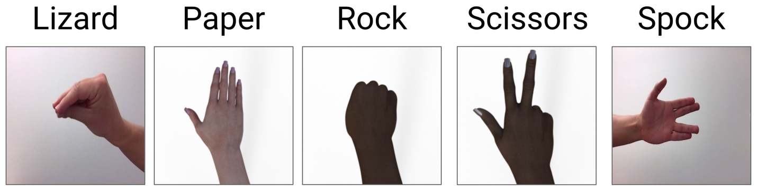

5. To train your model, don't stand too far away from the webcam and it's much better if you do not wear sleeves. Below are some sample training images.

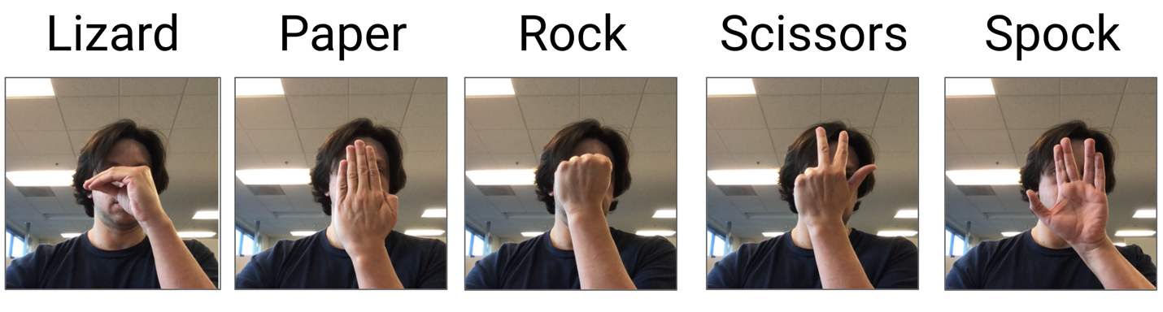

**Possible Issues**

Because some of the weights of your model are initialized randomly, your model might get stuck in a local minima during training. When this happens your model may not perform optimally and may cause your submission to fail. If you are confident you did everything correctly and your submission didn't pass, try re-training the model and re-submitting it.

**Instructions**

Your exercise this week is to adapt the Rock, Paper, Scissors code to a much more interesting game of [Rock Paper Scissors Lizard Spock](https://the-big-bang-theory.com/rock-paper-scissors-lizard-spock/) from the TV Show “The Big Bang Theory” .

In this exercise, you will train your model in the browser using your webcam. You will train your model in exactly the same way as in the Rock, Paper, Scissors example but now you will include the Lizard and Spock hand gestures. Once you are confident that you have a good model, you will be able to download it. **Note**: In this exercise, it can be a bit tricky to train a model well. So, don't get frustrated if you don't get it right the first time.

Use Brackets to open the **C1_W4_Assignment.js** file found in the following folder in the GitHub repository:

[tensorflow-2-public/C1_Browser-based-TF-JS/W4/assignment/](https://github.com/https-deeplearning-ai/tensorflow-2-public/tree/main/C1_Browser-based-TF-JS/W4/assignment)

Follow the instructions given in the code and fill-in the missing code in the parts labeled:

// Your Code Here

Once you have filled-in the missing code, run the **rpsls.html** file in the Chrome browser using the Web Server. Once you have trained your model, and ran the code successfully, the code will automatically download your model and its weights to your downloads folder. **It is important to note that your browser might prompt you to allow multiple files to be downloaded. If this happens, allow the browser to download multiple files.**

Once the files have been downloaded, you must upload these two files in a **single Zip file** to be graded. This single Zip file must only contain 2 files:

1. **my_model.json**: Contains the model architecture, i.e. the type and size of each layer.
2. **my_model.weights.bin**: Contains the weights of the model.

Good Luck!