Nama : Horas Marolop Amsal Siregar  
Nim : 11321067  
Kelas : 32TI2

**Exercise 1**

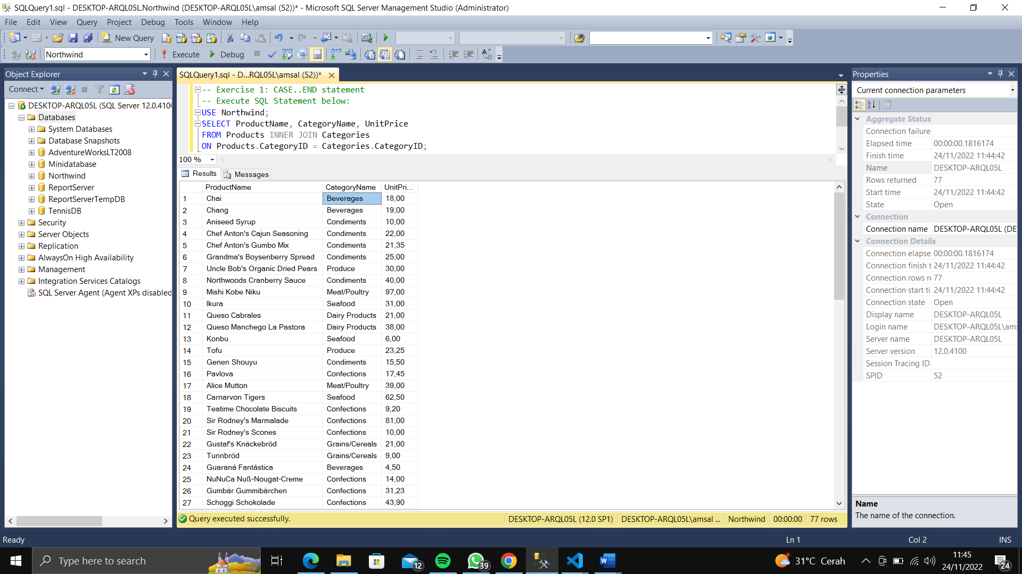

Task 1

Use Case…End statement to create t-sql query to display the products’ price and category as

Not Yet Priced, Cheap Products, Medium, and Expensive. The condition for categorization

is as follows:

* If certain products not priced (the value in column price is empty/null), then ‘Not Yet Priced’.
* If less than or equal 50, then ‘Cheap Product’.
* If 50<price< =150, then ‘Medium’.
* If >150 then ‘Expensive’.

The figure below depicts the result if your query executed successfully (result set: 77 rows).

Use join between products and categories table.

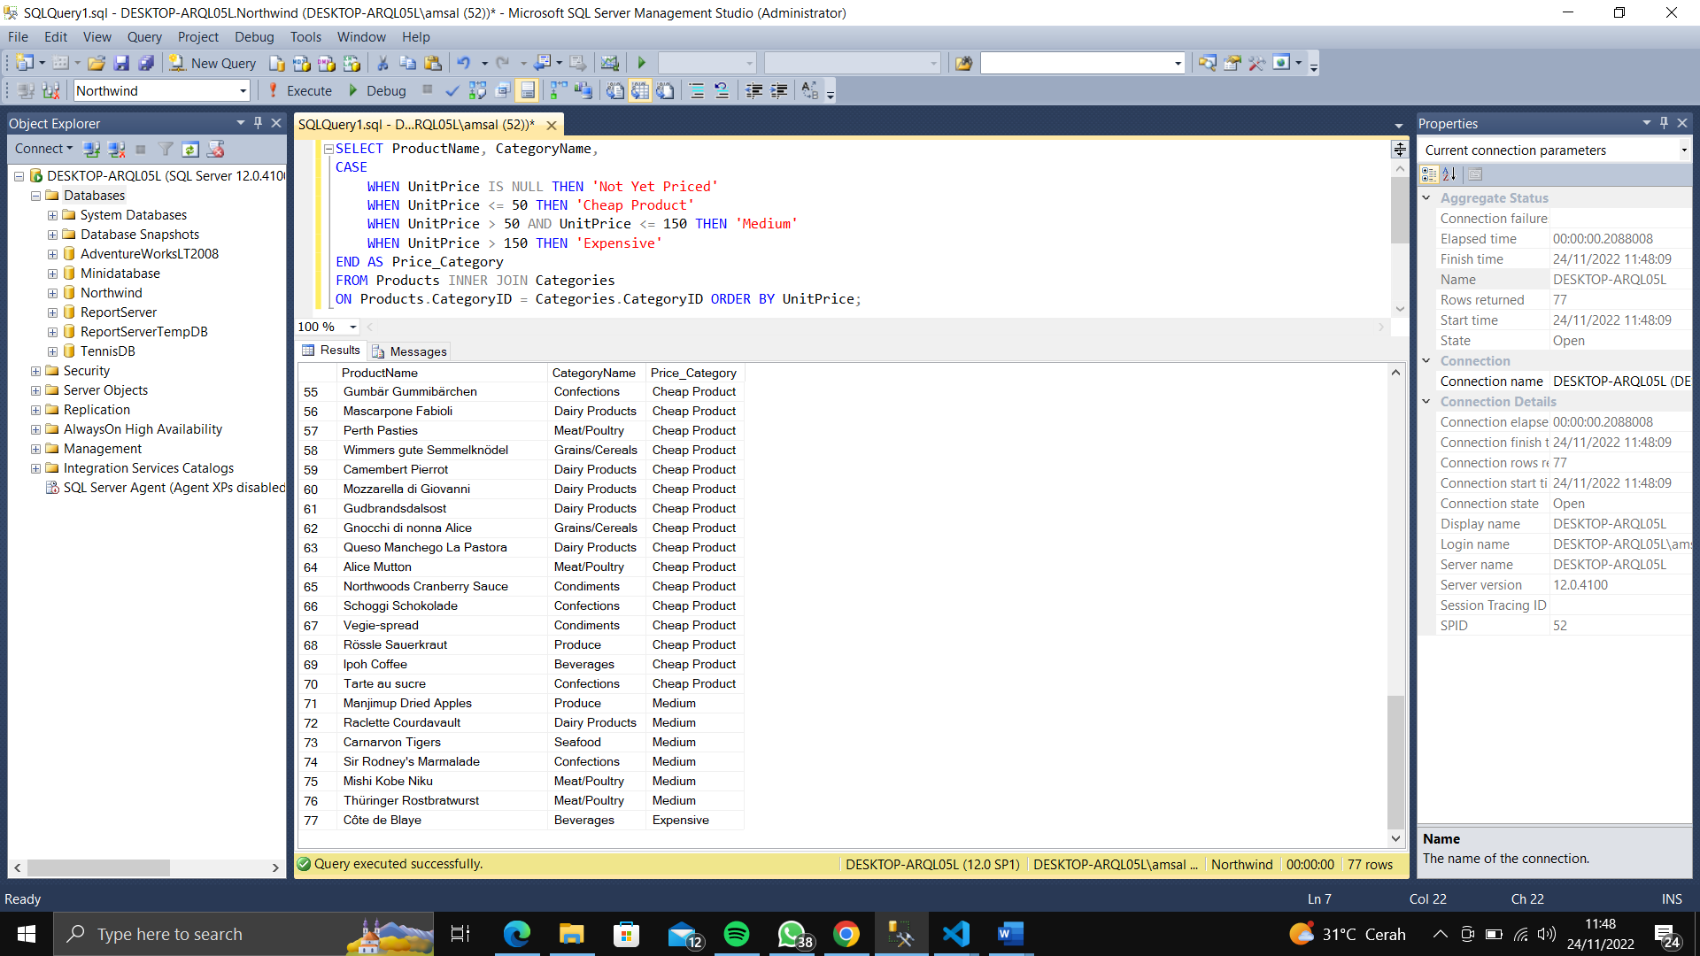

**Exercise 2**

Task-1 Execute SQL Statement below:

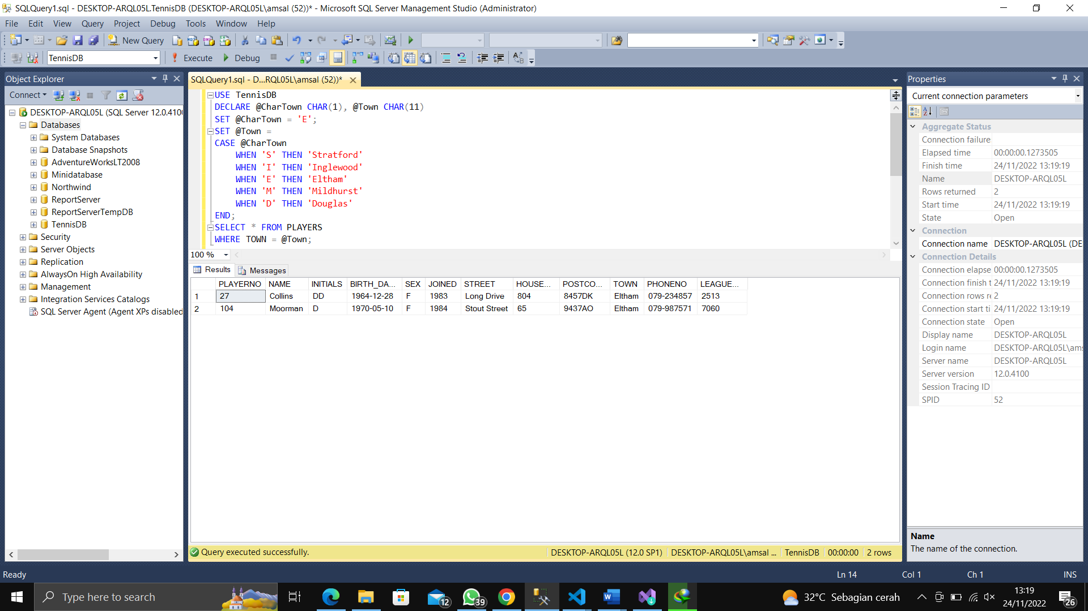

Modify the SQL statement above using IF…Then…Else….Statement.

Task 2 Use TennisDB Database. Display in text field (not in grid◊PRINT bukan SELECT), the information (playerno,name, nr_won) about the player who won more than 1 matches.

Result:



Pada Statements pertama pada Batch diatas, merupakan hasil eksplorasi mendalam terkati Database_Engine , yaitu sp_sqlexec. System store procedure tersebut, memiliki fungsi untuk Melakukan USE Database, memanfaatkan variable local.

Nah pada Statements kedua, merupakan declarasi variable, dan statements ketiga kita akan melakukan Setter pada Variabel tersebut berdasarkan nilai yang di seleksi oleh Select klausa.

Dan pada Statements terakhir, kita akan menampilkan text pada console (Not in grid) menggunakan fungsi Print dengan Format sesuai String yang kita buat. (kalua ga salah to_String bila di PHP, JAVA, C++ etc)

**Exercise 3**

Then, find the average of ListPrice:

**Then result are** 744.5952. Consider the condition below and use **while** to build PL/SQL statement for the condition. If the average ListPrice of product is less than $1000, use **while** to:

1. doubles the ListPrice for every products and.
2. If the maximum ListPrice is less than or equal to $4000, then WHILE loop restarts and doubles the prices again. This loop continues doubling the prices until the maximum price is greater than $4000, and then exits the WHILE loop and prints a message.

