

|  |  |
| --- | --- |
| **Profesor:** Alejandro De Gante | **Fecha:** 26/Marzo/21 |
| **Nombres:**  Lizbeth Maribel Melendez Delgado  Gerardo Novelo De Anda | **Matrículas:**  A01232559  A01638691 |

Actividad 3.1

Practicando los lenguajes regulares

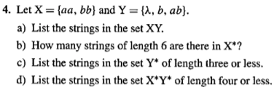

1. XY = {aa, bb, aab, bbb, aaab, bbab}
2. X* = {aaaaaa, aaaabb, aabbaa, aabbbb, bbbbbb, bbbbaa, bbaabb, bbaaaaaa}

8 strings of length 6

1. Y* = {λ, b, ab, bb, bbb, bab, abb}
2. X* = {aa, bb, aaaa, aabb, bbbb, bbaa}

Y* = {λ, b, bb, bbb, bbbb, ab, abab, bab, abb, babb, abbb, bbab}

X*Y* = { aa, bb, aaaa, aabb, bbbb, bbaa, λ, b, bb, bbb, bbbb, ab, abab, bab, abb, babb, abbb, bbab}

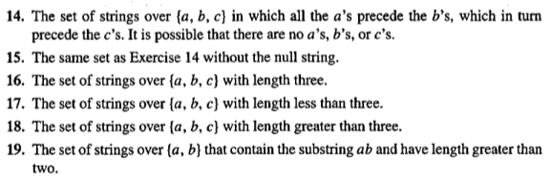

{w | w ⇒ a*b*c*}



**{** w | w ⇒ aa*bb*cc\***}**

**O {** w | w ⇒ (aa* b* c*) + (a* bb* c*) + (a* b* cc*) }







