LIME
LIME (Local Interpretations Model-Agnostic Explanations) is a method developed by Marco Tulio Ribeiro to explain “any black box classifier, with two or more classes”.
It’s able to explain local predictions of almost any machine learning problem, no matter is a computer vision problem, a NLP problem or a problem based on tabular data. As it’s model-agnostic it’s also able to explain every single algorithm, as it considers the model as a black box.
The implementation of this method is available in the GitHub of the author (https://github.com/marcotcr/lime) with a BSD-2 Clause license, so everyone can use the method. This has made this method very famous, being very used by the community.
The usage of the tool is very easy. Users have to implement a function that takes as input a NumPy array with instances and outputs the result of the prediction, with the probability for each class.
Advantages:
- Model-agnostic: It can explain any machine/deep learning model.
- Easy visualization.
- Fast computation.
Disadvantages:
- Local: Lime is just local explainer, it cannot explain the entire model behavior.
- Randomness: score can be different every time as it generates samples randomly so it lacks of consistency.

Method description:
This algorithm takes the assumption that is possible to fit a simple interpretable model around a single observation that will mimic how the global model behaves at that locality. This is what makes LIME a model-agnostic method, as it will explain the new model created, which is an interpretable model (RIDGE), regardless the type of the model to be explained.
It works by perturbing the input and seeing how the predictions change for each perturbed input. It first generates a neighborhood data by randomly hiding features (words in this case) from the text instance. Then, it generates an explanation by approximating the underlying model by an interpretable one learned on the perturbations of the original instance (e.g., removing words).
This way, it learns locally weighted linear models on this neighborhood data to explain each of the classes in an interpretable way and indicate the impact of word existence.

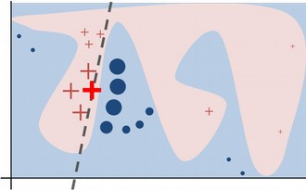

In the Figure X, the blue/pink background corresponds to the non-linear model being used in the predictions, that has two labels, crosses and circles. While explaining a local predictions (the red cross), LIME generates random samples and weights them according to the distance to the prediction being explained (the size of the crosses/circles). The dashes line correspond to the linear model created by LIME and its the one being actually explained by LIME.

Applicability to LM:
As LIME is a model-agnostic method, it’s able to explain every type of model, included Language Models. LIME is going to consider the original Language Model a black box, creating an additional model, fitted with perturbations of the input. This way, is able to interpret local predictions of Language Models. The perturbations will be made over the instance of the local prediction by, for instance, removing words.
Language Models are based on the prediction of the next word (or sequence), which is more like a regression problem. Even when LIME is also able to explain regression problems, is more focused on the classification problems. Nevertheless, the most of the Language Models used nowadays aren’t used to predict the next sequence, but to do complex NLP tasks, such as text classification, Named Entity Recognition or Question Answering, and this is done by adding additional layers at the top of the model. This layers will be different depending on the kind of the problem, but most of them can be treated as classification problems. For instance, the Named Entity Recognition problem consists on classify each token as a named entity or not. This way, LIME could be used not only to explain the Language Models themselves, but also the complex model built on top of them, such as BERT.

Applicability to QA:
Question Answering models can be classified into two different types. The ones that try to extract the answer directly from the text, given as the result the tokens inside the text that answer the question (with datasets such as SQuAD) and the ones that try to select the correct answer among the possible answers given, which are known also as Multiple-Choice problems (with datasets such as RACE).
Depending on the QA type (extractive or multiple-choice) the way to proceed is different, but both of them can be treated as classification problems. In the extractive ones, span classification layer is added on top on the base model (such as BERT), and in the multiple-choice ones a classification layer is added on top of the pooled output to classify which one is the correct answer.
This way, considering the QA problem as a classification one, is easy to adapt LIME to use it in this kind of tasks.

Experiments:
Four different experiments have been developed to test the LIME tool and to try to understand which parts are more important for the model in order to make its prediction.
- The first one was based on perturb just the question.
- In the second one, the options given to the model were perturbed.
- The third one consisted on perturb the article.
- In the final one, both the options and the question were perturbed.
The main idea behind this experiments is to check if LIME is able to detect which parts are the most important for the model (the article, the question or the options), and this way know if LIME is useful to understand the result and if the result is legit or not.
Besides this, to look for the words that are important for the prediction result is also expected from the experiments.
In order to use LIME with BERT for Multiple-Choice (the same as with any other model), a function has to be developed that takes as input a list of perturbed instances, makes the prediction and return the probability for each class.
Even when is not the efficient, the easiest and most common way to fit the model is by repeating the article, joined to the question and one of the options, for instance while predicting in RACE dataset, the result would be four instances with the same article and the same question, but with a different option.
So, in order to develop the function used by LIME, this four instances have to be created inside it with the perturbations made by the method. Depending on the experiment, this instances will be different because the perturbations will be just the question, the article, the options and so on, and will be concatenated with the original parts that are not being perturbed.
Then, the instances are converted to the features to make the prediction. The result is transformed with a Softmax function and finally is returned to LIME, which analyzes the outputs related to the perturbations made, given as the result a score based on the importance of the word for the prediction.

Results:

1st Experiment
The first idea was to try to explain which words of the question are important for the prediction, because at the end the model has to take as input the question and look for the answer. This way, the question the user asks to the model will determine the result of the prediction, and to know which words of the question are important is a good way to know how to make good questions.
Thus, the first experiment consisted on make LIME perturb just the question and see what words are important for the model. This was tested with different samples of the test set and the results showed that LIME is able to detect the words that are indeed important for the model, as can be seen in Figure x.
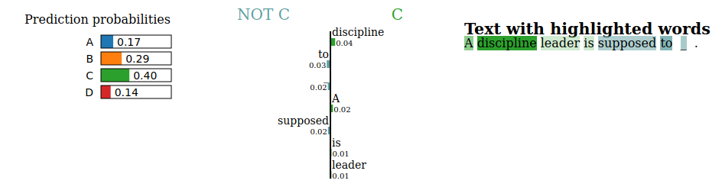
In that example, the real label was “C”, and LIME was able to detect that the important word was “discipline”, so if we change this word the result will vary, but if we change the rest of the question, the result shouldn’t change too much.
So the next steps were to check if that idea was true. In order to do this some changes have been made in both the question and the options to see if the result is the same.
The first change consisted on paraphrase the question without changing the most important word, in this case “discipline”. The change was the next one:
Original question: A discipline leader is supposed to _
New question: What is a discipline leader supposed to?
It is not a big change but is enough to see if the question form is important for the model. As the important word, discipline, has not being removed, the model shouldn’t have any problem to get the correct answer. Nevertheless, the model failed by selecting the answer “A” instead of the correct answer in this case.
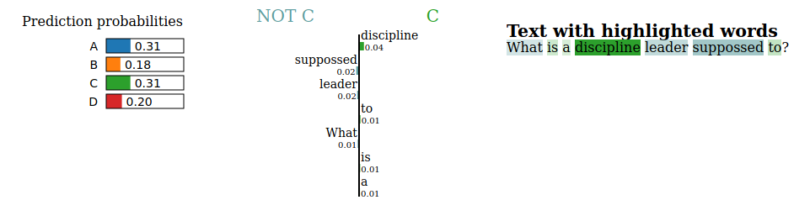
But, attending to the probabilities of the prediction, it can be seen that both “A” and “C” options have almost the same probability. And, according to LIME, “discipline” is still important for the “C” option.
The next change was made to test if the question form is really important for the model. So the question form used before is maintained, having the new question:
New question: What is a discipline leader?
In this case was needed to change also the answer, adapting them to the answer form expected. For instance:
Original option: take care of the whole group
New option: A person supposed to take care of the whole group
The change was made trying to do not change the meaning of the original ones, but adapting them to the answer expected by a “What is...” question.
The result in this case was that the model also failed, but in this case it fails by choosing “B” as the correct answer.
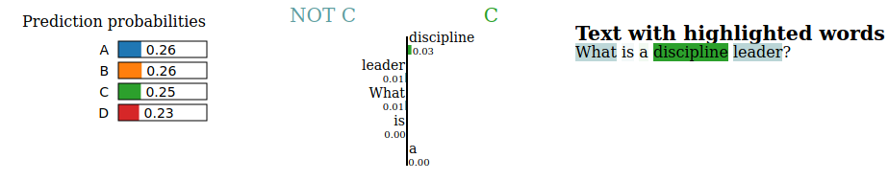
To see if the question form was indeed so important and to see if the “discipline” word was important or not, a second change was made. This change consisted on replacing the “discipline” word with a synonym, “orderliness”. This is interesting because in the original text the word “discipline” appears with the correct answer, but the word “orderliness” don’t appear at all, so if the model is able to choose the correct answer could be due to the understanding of the model of the language, knowing the synonyms.
So the changes made before by paraphrasing the question were made now, but replacing “discipline” with “orderliness”. The results were interesting because, in this case, the model chose the correct answer in both cases, something that didn’t happened while preserving the original “most important” word.
As said before this could be because of the ability of the model to understand the language, but this was just an idea until LIME was used to check the importance of the word to see that the word “orderliness” was the most important word of the new question. The important thing here is that the importance score of “orderliness” is bigger in this case than the importance score of “discipline” in the other questions, what could explain the fact that in this case the model has been able to find the correct answer.
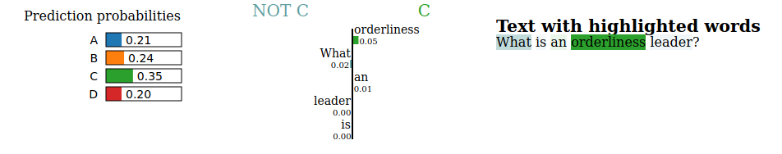
By looking at the result of these changes it seems that the question form is not that important because the model is able to find the correct answer with that kind of question. But then, it is not clear why has it failed with the first changes that preserved “discipline” in the question. Another change was made in order to try to explain this. In this case the options were changed to see if the relation between the question and the options was important. The change consisted on paraphrase the options. For instance for the question of the second change:
Question: What is a discipline leader?
The original option,
Original option: A person supposed to make sure that nobody chats in class
was changed into this new one:
New option: A person that has to assure that nobody chats in class
This way, both the question and the options have been changed, and in this case some words of the original one have been removed, like “supposed”. In this case, again, the model chose the correct answer, focusing again on the word “discipline”.
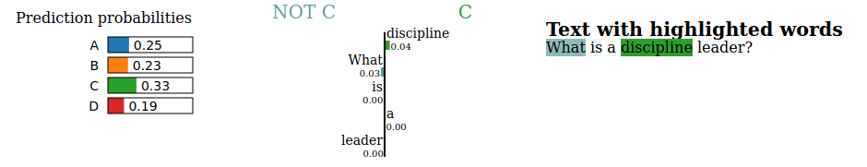

2nd Experiment
After the question, the most important part on the multiple-choice problems is the set of options given to the model, because it has to choose between some of this options. Taking this into account, it is different the way to understand the model if it is a multiple-choice problem or an extractive question answering problem.
When analyzing the explanations obtained with LIME for the same test example, it has been seen that LIME is able to detect the words of the label being explained, but it is curious that an -a priori important word like “chats” it is not weighted by LIME, nor positive nor negative, with all experiments and modifications done.
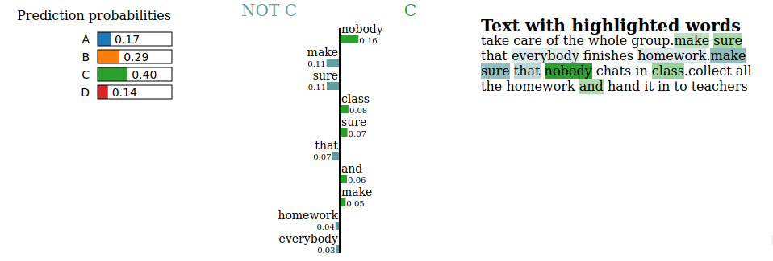
This is curious, because the other words of the options are common and/or related to the same domain, the school, meanwhile “chats” is a verb of a different domain – and more related to “discipline”, the most important word of the question-, but “nobody”, which is also a “different” word and related in someway to “discipline” it is detected and it’s detected as the most important word for the model, which makes sense.

3rd Experiment
In the third experiment the article was perturbed to see if LIME was able to find the most important words within it. The results showed that LIME knows how to deal with large texts (inputs), but as the model’s input size is not too large (due to hardware limitations in the training phase), the most important words of the text can not be captured by LIME.
Even when this is obviously a problem, the experiment is not a complete failure, because it has been seen one of the most possible causes for the model to fail, this is, the input size is not as large as it should. For this kind of problems in which the input are large texts (such articles), the input size plays an important role in the results.
Nevertheless the model is still able to choose the correct option sometimes. This could be due to the knowledge the model has about the language. In these cases, where the model can’t see the sentences the evidence is into, the model knows which one is the correct answer by understanding what the question requires and the meaning of the important words of the question and linking them to the most similar answer.

4th Experiment
In the final experiment, both the question and the options are going to be analyzed. The results showed that the model focus more on the options than in the question. Even when explaining a specific label, LIME returns a greater weight for words in other options than in the question itself.
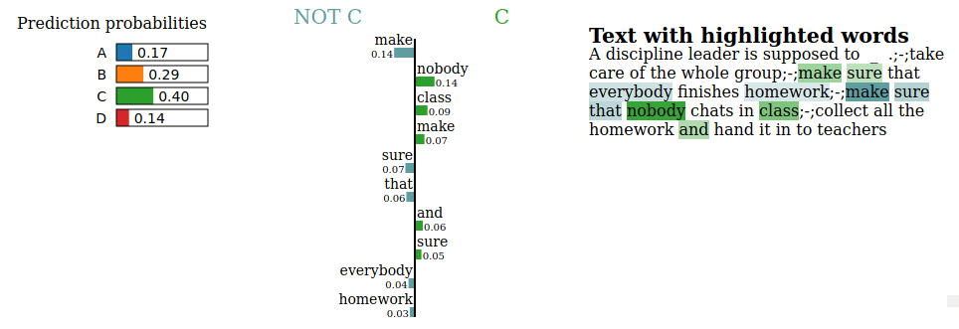
This could mean that, if that words of other options are changed, the model could choose them as correct answer.

Conclusions:
After several experiments, it can be seen that LIME is able to detect the most important words (or spans) the model focus on when making its prediction. But it’s still not clear why the model makes a prediction, because LIME explains the most important words for each class, but does not explain why the model choose a class over the other ones.
This way, LIME can help to understand the words that are important for the prediction, an this can help to understand the best way to create questions or to give the model the correct options. But it have been also seen that to change this words or this options does not mean the model is going to change its prediction. For instance, in the experiments in which the most important word “discipline” was replaced with a synonym “orderliness”, the model predicted the good label meanwhile with the word “discipline” that appeared in the original text the model did not, and in the experiment in which the options given to the model were perturbed trying to preserve all the important words in the original question (like “supposed”) the model also failed in its prediction.
So it is not clear which one is the correct way to make a question, or why the model has chosen a class instead of another one.
Besides this, when the model fails, LIME does not really help to know why the model has failed, because the explanations of each of the classes will give us the important words for that class, but will not tell why a class is chosen beyond the others.
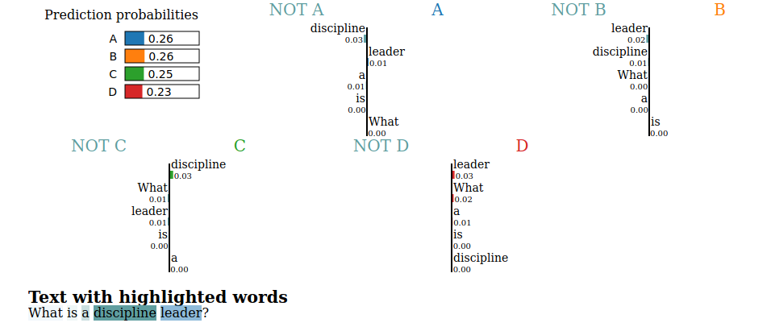

Citation:
@inproceedings{lime,
author = {Marco Tulio Ribeiro and
Sameer Singh and
Carlos Guestrin},
title = {"Why Should {I} Trust You?": Explaining the Predictions of Any Classifier},
booktitle = {Proceedings of the 22nd {ACM} {SIGKDD} International Conference on
Knowledge Discovery and Data Mining, San Francisco, CA, USA, August
13-17, 2016},
pages = {1135--1144},
year = {2016},
}

