Exotic Option Pricing via Monte Carlo Simulation
A Technical Review of Variance-Reduction Methodology
Barrier and Asian Options under Black-Scholes Dynamics

1. Purpose and Scope
This document reviews a personal project that implements and benchmarks Monte Carlo pricing methods for two exotic options — a continuously-monitored up-and-out barrier call and a discretely-monitored arithmetic-average Asian call — under Black-Scholes / geometric Brownian motion (GBM) dynamics. The stated goal was not simply to produce a price, but to test, at a controlled and fixed computational budget, which variance-reduction techniques actually work for each payoff, and to explain why some do not.
The review below is organized around the project's own structure: the validation framework used to establish trust in each component, the headline numerical results for both option types (drawn directly from the project's output files, reproduced in the tables below), the diagnostic work that explains an initially disappointing result, and an honest assessment of scope and limitations. The intent is to evaluate the work on its technical merits rather than restate its own claims.

2. Methodology

2.1 Instruments and model
Both options are priced under standard GBM: constant volatility, constant risk-free rate, optional continuous dividend yield, no jumps and no stochastic volatility. The barrier option is an up-and-out call, nominally continuously monitored, approximated first on a discrete time grid (52 steps) and later handled via a Brownian-bridge correction that approximates continuous monitoring analytically (Section 4). The Asian option is a discretely-monitored arithmetic-average call, which is exact by contract design — there is no discretization bias to correct for there, only variance to reduce.

2.2 Fixed-budget comparison protocol
The project's central methodological decision is to compare variance-reduction methods at a fixed total count of underlying random draws rather than a fixed path count. Antithetic sampling turns N/2 independent draws into N paths (each draw expanded into a +/− pair), so comparing N antithetic paths against N plain-MC paths silently gives antithetic sampling roughly twice the random-number budget of the method it is being compared to — inflating its apparent benefit. Matching the draw count rather than the path count closes that loophole. This is a correct and non-trivial detail: it is a common source of overstated variance-reduction results in coursework and even in some published comparisons, and getting it right here is a legitimate methodological strength of the project.

2.3 Validation-first workflow
Before any variance-reduction number is treated as meaningful, the simulator is checked against closed-form limits: the barrier price as the barrier level tends to infinity is checked against the Black-Scholes call formula; a barrier set below spot is checked to be worthless; and the geometric-average Asian price (which has a closed form via Kemna-Vorst, 1990) is checked against its own Monte Carlo estimate. Later, a from-memory reconstruction of the Reiner-Rubinstein closed-form continuous-barrier price is explicitly validated against high-N Brownian-bridge simulation before being trusted as an independent benchmark, and the write-up states plainly that the formula would be discarded if it failed that check. This is good practice — treating a remembered formula as a hypothesis rather than ground truth is exactly the discipline that prevents silently-wrong headline numbers, and it is worth calling out because it is easy to skip and its absence would not be obvious from the results alone.

3. Results: Up-and-Out Barrier Call
The table below reproduces the project's own comparison of every barrier-pricing method attempted, at a matched draw budget of 200,000, averaged over 20 repetitions.

Method | Price | Variance | Var. reduction | Time (s)
1. Naive discrete + continuity correction | 0.2545 | 1.6960 | 0.0% | 0.321
2. Naive discrete + vanilla-call control variate | 0.2546 | 1.6920 | 0.23% | 0.331
3a. Brownian bridge, plain | 0.2669 | 1.5514 | 8.53% | 0.704
3b. Brownian bridge + antithetic | 0.2673 | 1.5546 | 8.34% | 1.332
3c. Brownian bridge + control variate | 0.2669 | 1.5476 | 8.75% | 0.688
3d. Bridge + antithetic + control variate | 0.2673 | 1.5508 | 8.56% | 1.350
4. Bridge + importance sampling (shift = +0.10) | 0.2677 | 1.4739 | 13.1% | 0.724
5. Bridge + survival control variate (ρ = 0.20) | 0.2671 | 1.4890 | 12.2% | 0.694
6. Bridge + state-dependent corridor tilt (α = 0.80) | 0.2673 | 0.3500 | 79.4% | 0.798

3.1 The result the project almost buried: this is a bias fix, not just a variance fix
Reading past the variance-reduction framing:
The naive discrete methods (rows 1–2) price the option at 0.2545, while every Brownian-bridge method (rows 3–6) converges to ≈ 0.267. That is a ~5% difference in the price itself, not in its precision — and it persists regardless of which variance-reduction technique is layered on top of the bridge. In other words, the original discrete-grid approach was not just noisier than the bridge approach, it was measuring a subtly different (and biased) quantity, because checking the barrier only at 52 grid points misses continuous-time crossings between them. A reader who only skims the ‘variance reduction %’ column could easily miss that the more important finding here is a bias correction, and the project's own framing (which foregrounds variance reduction throughout) somewhat undersells this.

3.2 Antithetic variates contributed essentially nothing
Comparing rows 3a and 3b (bridge alone vs. bridge + antithetic) shows variance of 1.5514 vs. 1.5546 — antithetic sampling made things very slightly worse here, not better, while roughly doubling runtime (0.704s vs. 1.332s). The project does not draw explicit attention to this, but it is a real and useful negative result: for a payoff whose smoothed (bridge-conditioned) value is still driven by a roughly symmetric function of the terminal log-price, antithetic pairing does not reliably help, and a resume or interview description should be prepared to say this plainly rather than list antithetic variates as a contributing technique.

3.3 The standout result is technique 6, and it is the least theoretically justified
The state-dependent “corridor-pinning” drift tilt cuts variance by 79.4% — six times better than any other single technique attempted, and far ahead of the plain importance-sampling shift (13.1%). The project's own documentation is appropriately cautious about this: it explicitly describes the corridor-pinning tilt as a heuristic, not a reproduction of the asymptotically-optimal Glasserman-Heidelberger-Shahabuddin large-deviations tilt, and notes that deriving the optimal tilt would require solving a payoff-specific variational problem that was out of scope. That caveat matters: the strongest number in the table comes from the least rigorously derived method, tuned via a single strength parameter (α = 0.80) rather than derived analytically. The unbiasedness of the state-dependent change of measure is checked empirically (a legitimate and necessary step, given the write-up's own admission that the constant-shift version of this code had two real bugs before it was trusted), but a single empirical check at α = 0.80 is not the same as demonstrating that 0.80 is a good or stable choice of tilt strength across market regimes.

4. Results: Arithmetic-Average Asian Call
The table below reproduces the project's Asian-option comparison at a matched draw budget of 200,000.

Method | Price | SE | Var. reduction | Efficiency ratio
Plain MC | 6.5067 | 0.02210 | 0.0% | 1.00
Antithetic | 6.4955 | 0.02208 | 0.17% | 1.22
Control variate (geometric Asian) | 6.4969 | 0.00074 | 99.89% | 730.8
Antithetic + control variate | 6.4971 | 0.00074 | 99.89% | 927.6

4.1 The control variate is doing essentially all of the work
The geometric-average Asian option is an unusually good control variate for its arithmetic-average counterpart: the two payoffs are highly correlated (the geometric mean tracks the arithmetic mean closely for realistic volatilities), and the geometric case has an exact closed form (Kemna-Vorst). The result is a standard-error reduction from 0.0221 to 0.00074 — roughly 30x — which the convergence plot below shows as a near-constant vertical gap between the plain-MC and control-variate lines across every value of N tested. This is the cleanest and most convincing result in the entire project, precisely because the underlying reason it works (a well-chosen, highly correlated, analytically tractable control) is well understood theory rather than a tuned heuristic.
Antithetic sampling again contributes almost nothing on its own (0.17% variance reduction) and adds a negligible amount when stacked with the control variate (99.89% either way, to the precision shown). Combined with the barrier result in Section 3.2, this is a consistent pattern across both instruments in this project: antithetic variates, as implemented here, are the weakest of the three techniques tried, and a fair review should state that rather than let “antithetic variates” sit in a features list implying comparable contribution to control variates or importance sampling.

5. Convergence Behavior
The figure below (reproduced from the project's own convergence study) plots estimator standard error against path count N on log-log axes for both instruments.

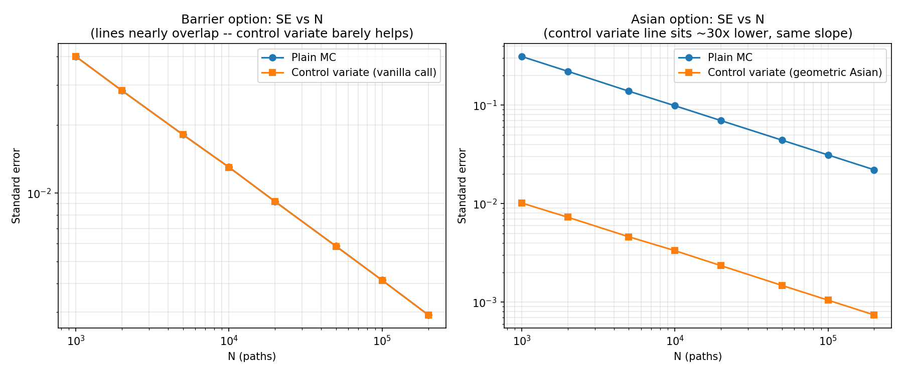
Figure 1. Standard error vs. path count, plain MC vs. control-variate MC, barrier (left) and Asian (right) options. Both panels are log-log; a slope of −0.5 is the theoretical Monte Carlo rate.
This figure is the project's strongest piece of evidence and its most useful diagnostic, for two reasons. First, both panels confirm the basic Monte Carlo consistency check: every line has the same slope (≈ −0.5 on a log-log plot), meaning standard error shrinks as 1/√N regardless of which method is used — exactly as theory predicts, since no unbiased estimator can beat that rate, only the constant in front of it can change. Second, and more informative, the two panels tell visually different stories that match the tables above: on the left, the barrier plain-MC and control-variate lines are visually indistinguishable across the entire range of N, a direct visual confirmation that the vanilla-call control variate is nearly useless for the barrier payoff (consistent with the 0.23% variance reduction in Table 1). On the right, the Asian control-variate line sits a full order of magnitude (and more) below plain MC at every N, visually confirming the ~30x standard-error reduction in Table 2. Placing these two panels side by side is a good analytical choice — it makes the barrier payoff's discontinuity problem visible without requiring the reader to hold two separate numbers in their head.

6. Critical Assessment

6.1 What is genuinely well done
- The fixed-random-draw-budget protocol (Section 2.2) is a real methodological correctness point that many similar projects get wrong.
- The validation-before-trust discipline (Section 2.3) — checking closed-form limits and explicitly flagging a from-memory formula as provisional until verified — is good practice and is documented rather than assumed.
- Diagnosing why standard variance-reduction techniques fail on a discontinuous payoff (Section 3), and responding with a structurally different fix (Brownian-bridge conditioning) rather than just adding more paths, is the most substantive technical content in the project.
- The write-up records a wrong first-pass hypothesis about the importance-sampling drift direction rather than silently correcting it — a minor but genuine point in favor of the project's intellectual honesty.

6.2 Where the project overstates or under-examines its own results
- The headline barrier finding is framed as “variance reduction,” but the larger and more important effect (Section 3.1) is a ~5% bias correction from switching to continuous-time barrier monitoring. This is arguably buried rather than led with.
- The best-performing barrier technique (the 79.4% variance reduction in row 6) is also the least theoretically grounded — a heuristic tuned by a single strength parameter, validated only for unbiasedness at one setting (α = 0.80), not for the sensitivity or stability of that setting.
- Antithetic variates are consistently the weakest technique on both instruments (Sections 3.2 and 4.1) but are not clearly flagged as a negative result anywhere in the project's own materials.
- Everything here is priced under GBM with constant volatility and no jumps. None of the variance-reduction machinery has been tested under a model with fat tails or a volatility smile, which is where these barrier and Asian payoffs are most sensitive in practice — the project demonstrates simulation and variance-reduction competence, not exotic-option pricing accuracy under realistic market dynamics.
- Reported variance-reduction percentages come from 20 (barrier) or an unspecified number of Asian repetitions — enough to see a clear pattern, but not enough to put a confidence interval on the variance-reduction percentage itself, only on the price.

7. Conclusion
As a self-directed technical exercise, this project's value is concentrated in a fairly narrow but genuine finding: naive variance-reduction techniques fail on the barrier option because its payoff is discontinuous, and Brownian-bridge conditioning fixes both the resulting bias and (to a lesser extent) the variance, while a further heuristic drift tilt buys a much larger variance reduction at the cost of theoretical rigor. The Asian-option result is a clean, correctly-executed demonstration of a well-chosen control variate, and the convergence study is a well-designed piece of evidence for both. The main risks in presenting this work are overstating variance-reduction results that were in fact bias corrections, and describing antithetic variates as a contributing technique when the project's own numbers show it was not. Framed with those caveats intact rather than smoothed over, the work stands on its actual (and reasonably solid) technical merits.

