Name- parikh marmik

Ethernet Assignment

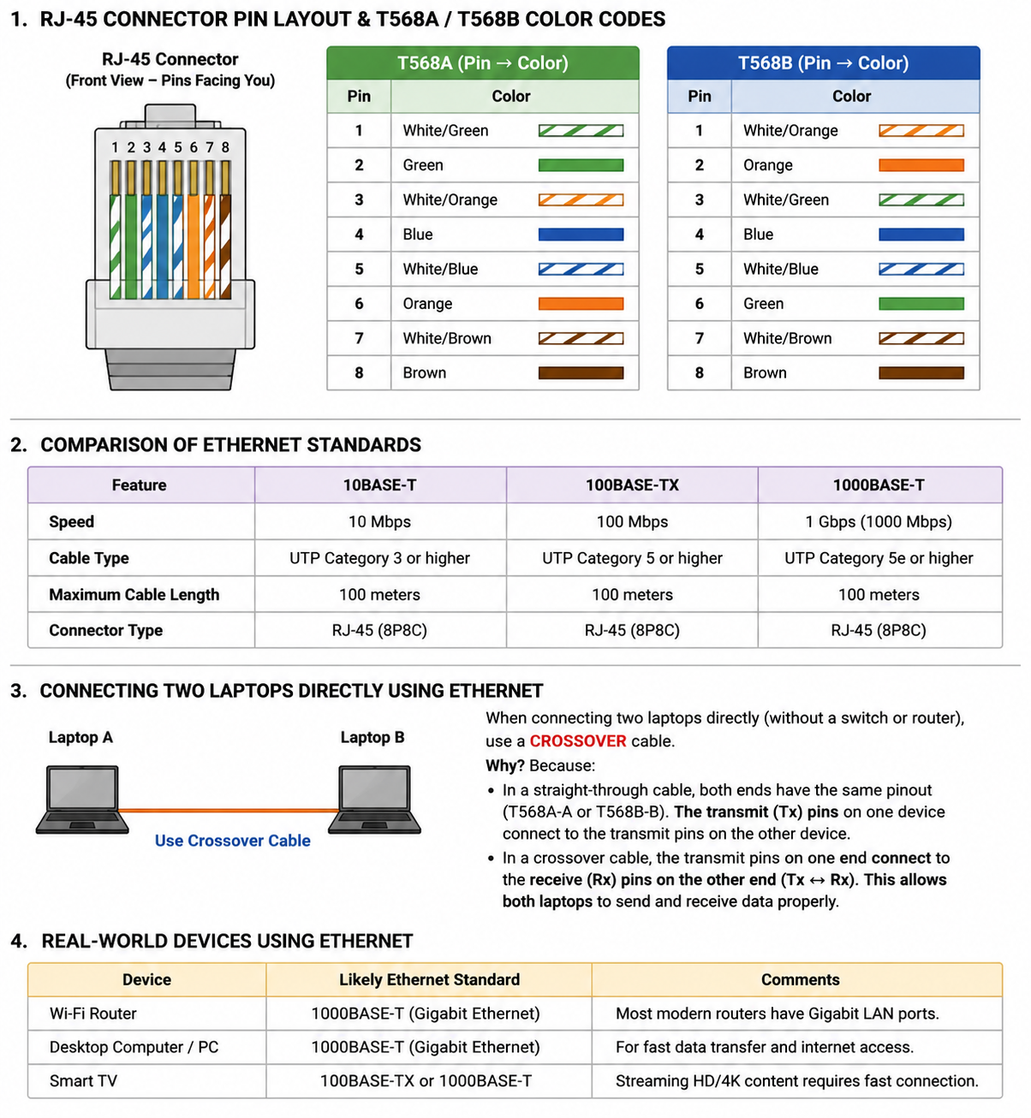

2. Ethernet Standards Comparison

Standard | Speed | Cable Type | Max Length | Connector
10BASE-T | 10 Mbps | Cat3 or higher UTP | 100 m | RJ-45
100BASE-TX | 100 Mbps | Cat5 or higher UTP | 100 m | RJ-45
1000BASE-T | 1 Gbps | Cat5e/Cat6 UTP | 100 m | RJ-45

3. Two Laptops Direct Connection
Use a crossover cable because it swaps the transmit (Tx) and receive (Rx) pairs, allowing both laptops to communicate directly. Modern laptops with Auto-MDI/MDIX can also work with a straight-through cable, but the traditional answer is crossover.

4. Real-world Ethernet Devices
• Wi-Fi Router - 1000BASE-T
• Desktop PC - 1000BASE-T
• Smart TV - 100BASE-TX / 1000BASE-T

