### Problem 1: To code or not to code

Coding reduces the Bit Error Rate but adds redundancy which reduces the throughput. In some situations (when the BER is sufficiently low), coding is not worth the added overhead. In other situations the use of coding is necessary. Consider a communication link that has the option to use a Hamming code (n=15,k=11,d=3).

1. How many bits can this code correct?  
   (d-1)/2 => 1  
   This code can correct one bit
2. What is the probability that a received codeword has more errors than the error correction capability of the Hamming code (15, 11, 3)?  
     
   PCB )  
     
   = 105 (p2 (1-p)13) + 455 (p3 (1-p)12) + 1365 (p4 (1-p)11) + 3003 (p5 (1-p)10) + 5005 (p6 (1-p)9) + 6435 (p7 (1-p)8) + 6435 (p8 (1-p)7) + 5005 (p9 (1-p)6) + 3003 (p10 (1-p)5) + 1365 (p11 (1-p)4) + 455 (p12 (1-p)3) + 105 (p13 (1-p)2) + 15 (p14 (1-p)) + 1 (p15)
3. Compute this probability for BER=10-3 and 10-3  
   **For BER 10-3**  
   PCB = 105 (p2 (1-p)13) + 455 (p3 (1-p)12) + 1365 (p4 (1-p)11) + 3003 (p5 (1-p)10) + 5005 (p6 (1-p)9) + 6435 (p7 (1-p)8) + 6435 (p8 (1-p)7) + 5005 (p9 (1-p)6) + 3003 (p10 (1-p)5) + 1365 (p11 (1-p)4) + 455 (p12 (1-p)3) + 105 (p13 (1-p)2) + 15 (p14 (1-p)) + 1 (p15)  
     
   = 0.0001040940  
     
   **For BER 10-4**  
   PCB = 105 (p2 (1-p)13) + 455 (p3 (1-p)12) + 1365 (p4 (1-p)11) + 3003 (p5 (1-p)10) + 5005 (p6 (1-p)9) + 6435 (p7 (1-p)8) + 6435 (p8 (1-p)7) + 5005 (p9 (1-p)6) + 3003 (p10 (1-p)5) + 1365 (p11 (1-p)4) + 455 (p12 (1-p)3) + 105 (p13 (1-p)2) + 15 (p14 (1-p)) + 1 (p15)  
   = 0.00000104909
4. Frame error rate without coding  
   FER = (1 - BER)L  
   Frame error rate with coding  
   FERc = (1 – BERc)L  
   Where BERc = PCB )
5. What is the net throughput for coded and uncoded communication as a function of L and FER or FERc?  
     
   Throughput = (1-BER) * Bit Rate  
     
   Throughput without coding: (1 - BER) * Bit Rate   
    = FER1/L * Bit Rate [Since FER = (1 - BER)L]  
     
   Throughput with coding: (1 – BERc) * Bit Rate   
   = FERc1/L * Bit Rate [Since FERc = (1 – BERc)L]
6. Compute the net throughput for a communication with and without coding, for   
   BER=10-3 and 10-4, and for L=50,100,1500 bytes.  
     
   For BER 10-3 :  
     
   Throughput without coding: (1 - BER) * Bit Rate  
    = (1-10-3) [Since Bitrate = 1 ]  
    = 0.999  
     
   Throughput with coding: (1 – BERc) * Bit Rate  
   BERc for Uncoded Bitrate 10-3 is **0.0001040940** [From Q2]  
     
   Throughput = (1 - 0.0001040940) * 1 [Assume Bitrate is 1]  
   Throughput = 0.999895906   
     
   **For BER 10-3, Throughput without coding = 0.999   
   Throughput with coding = 0.999895906**  
   For BER 10-4:  
   Throughput without coding: (1 - BER) * Bitrate  
    = (1 – 10-4) * 1  
    = 0.9999  
     
   Throughput with coding: (1 - BERc) * Bitrate  
   BERc for Uncoded Bitrate 10-3 is **0.00000104909** [From Q2]  
      
   Throughput = (1 – 0.00000104909 )  
    = 0.99999895091   
   **For BER 10-4, Throughput without coding = 0.9999  
   Throughput with coding = 0.99999895091**
7. In which cases does it make sense to use coding?

Since there is not much improvisation in Throughput in both the cases when BER is 10-4 when BER is 10-3 compared to uncoded throughput, added overhead due to coding isn’t worth it. But as seen as the BER increases Difference between the throughput increases, hence at sufficiently high BER, it makes sense to use coding.

### Problem 2: Hamming Codes

The goal of this assignment is to make sure that you know how to build a Hamming code. Consider Hamming code (n=15, k=11, d=3).

1. Build the Generator matrix G for this code?

One possible G for this code would be:

1. Code the following message (1,0,1,1,0,0,0,0,0,0,1)?  
     
   Codeword =   
   [1 0 1 1 0 0 0 0 0 0 1] = [1 0 1 1 1 0 1 1 0 0 0 0 0 0 1]  
     
   Codeword = 1 0 1 1 1 0 1 1 0 0 0 0 0 0 1
2. Build the Parity check matrix H for this code  
     
   H =
3. Is the following received message (1,1,0,1,0,0,0,0,0,0,1,0,0,0,1) a valid codeword  
     
   v HT = =

Since vHT is not equal to 0, it is not a valid code word.

### Problem 3: Decoding of Convolutional Codes

The goal of this assignment is to make sure that you know who to build to decode a convolutional code using Viterbi's algorithm. Consider the convolutional code presented on slide 52 in the lecture notes. Assume that the following message is received: (11,00,00,01,10,01,11,00,11). Show on the Trellis diagram (step by step) how to decode it and what was the original message before coding?.

Decoded code: 11 00 01 01 10 11 11 00 10

Step 1: Decoded Code(11)

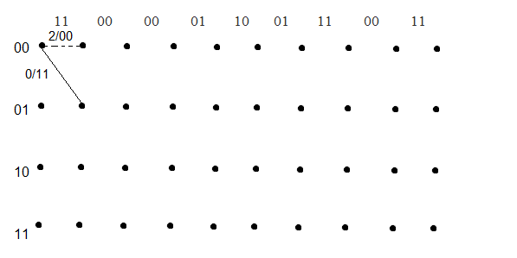

Step 2: Decoded code(11 00)

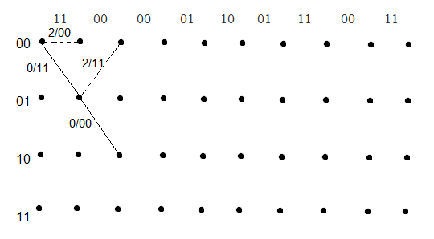

Step 3:

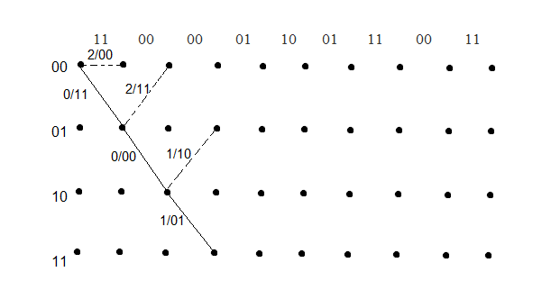

Step 4(Decoded code: 11 00 01 01):  
  
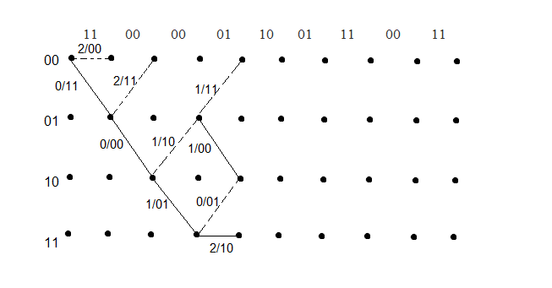

Step 5 (Decoded code: 11 00 01 01 10):

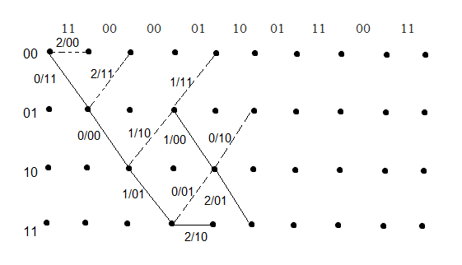

Step 6 :

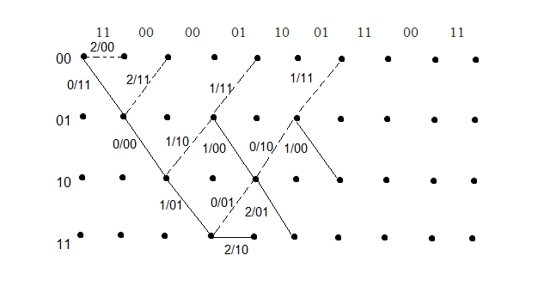

Step 7 (Decoded code: 11 00 01 01 10 11 11) :

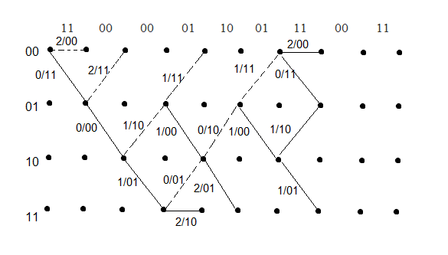

Step 8 (Decoded code: 11 00 01 01 10 11 11 00):

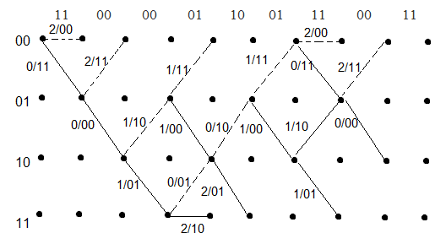

Step 9 (Decoded code: 11 00 01 01 10 11 11 00 10):

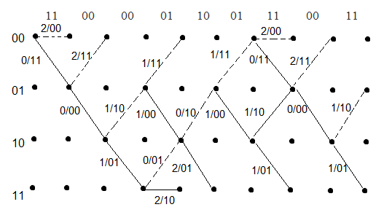

### Problem 4: Reed Solomon Codes for Multicast Communication

The goal of this assignment is to make sure that you know how to build a code similar to Reed Solomon codes but only for the purpose of erasures correction. To avoid getting into the details of defining the operations over finite fields that are typically used GF(2q) in computer and communication systems, we will restrict ourselves to GF(p)where p is prime and operations are modulo p. In this assignment we will assume p=11. Let u0=1,u1=3,u2=0,u3=2 be the messages to be coded and multicast to a set of receivers. For that we define the polynomial Pu(x)=∑3i=0uixi. The transmitter sends Pu(0),Pu(1),Pu(2),Pu(3).

1. Compute Pu(0),Pu(1),Pu(2),Pu(3). Remember that all calculations should be mod 11.  
   Pu(x) =   
     
   Pu(0) = = 1  
   Pu(1) = = (1 + 3 + 0 + 2) = 6  
   Pu(2) = = (1 * 1 + 3*2 + 0*4 + 2*8) = 23  
   Pu(3) = = (1 * 1 + 3*3 + 0*9 + 2*27) = 64  
     
   **Pu(0) = 1  
   Pu(1) = 6  
   Pu(2) = 23  
   Pu(3) = 64**
2. Assume that one receiver (R1) did not receive P_u(0), and another receiver (R2) did not receive P_u(1) and P_u(2). The transmitter then sends P_u(4) and P_u(5). Show how R2 can recover the initial messages u0=1,u1=3,u2=0,u3=2 using the Lagrange Interpolation technique we covered in class.  
     
   Pu(4) = = (1 * 1 + 3*4 + 0*16 + 2*64) = 141  
   Pu(5) = = (1 * 1 + 3*5 + 0*25 + 2*125) = 266  
     
     
   R2 didn’t receive **Pu(1), Pu(2)**So,   
   **Pu(0) = 1  
   Pu(1) = ?**  
   **Pu(2) = ?  
   Pu(3) = 64  
   Pu(4) = 141  
   Pu(5) = 266  
     
   L(x) = 1 * (x-3)*(x-4)(x-5)/ (0-3)(0-5) (0-4) + 64 * (x-0) (x-4)(x-5)/ (3-0)(3-4) (3-5) +141 * (x-0) (x-3)(x-5)/ (4-0)(4-3) (4-5) + 266 * (x-0)(x-3) (x-4)/ (5-0 )(5-3)(5-4)**

**= 1+ 3x + 2x3**  
  
Since,  
L(x) = Pu(x), It’s possible for receiver to retrieve U0,U1,U2,U3