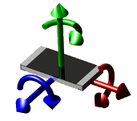 | Printed Circuit Board Workbench for FreeCAD (PCB)  Flexible Printed Circuit Board Workbench for FreeCAD (FPCB)
marmni (marmni@onet.eu)
Copyright 2013, 2014, 2015
http://sourceforge.net/projects/eaglepcb2freecad/

Index
Introduction 4
Requirements 5
Supported files 5
Installation 6
GNU/Linux 6
Windows 6
Configuration 8
STP file format colors definition 8
Accessing the Workbench 10
Set PCB module as main workbench 11
Menu Bar 12
Toolbars 13
PCB View toolbar 13
PCB Settings toolbar 14
Displaying toolbars 17
Specification Tree 18
Customizing Workbench 20
Assign models 24
Example of adding part to database 30
Multi model definition for one part 32
Download models 34
Display modes 35
Layers 37
Python 38
Grouping parts 39
Open/Import board 40
Unit system 41
Create new project 43
Python 44
Create PCB 45
Cut to board outline 49
Create glue path 51
Add annotation 52
Add model 58
Update models 62
Create constraint area 64
Explode 67
Bounding box 71
Python 73
Export board 74
Supported files 74
Unit system 76
Python 77
Export Bill Of Materials (BOM) 78
Python 80
Export hole locations 82
Python 85
Export hole locations report 87
Python 88
Create drilling map 89
Python 91
Create drill center 92
Python 93
Add assembly 94
Python 95
Update assembly 96
Python 97
Export to Kerkythea 98
Objects properties 99
Annotation/Object Name/Object Value 99
Board 100
Part model not found in database 100
Explode 101
Part model found in database 101
Constraint area 102
Glue path 102
Main assembly object 102
File format 103
Scripts 105
Eagle 105
Razen 105
Errors code 106
Licence 107
Changelog 108
ToDo list 112
Errors 113

Introduction
[ENG]
Mod allow you to import/create PCB boards in FreeCAD. Scope of mod:
- support for many different layers,
- possible to choose colours, transparency and names for each layer,
- mod allows you to import IGES/STP models with colours,
- possible to show holes/vias independent.

[PL]
Moduł pozwala na importowanie/tworzenie płytek PCB w programie FreeCAD.
Możliwości modułu:
- wsparcie dla wielu różnych warstw,
- wyświetlanie otworów, przelotek niezależnie od siebie,
- możliwość wyboru koloru, przeźroczystości oraz nazwy dla poszczególnych warstw,
- importowanie modeli zapisanych w formacie IGS/STP wraz z kolorami.
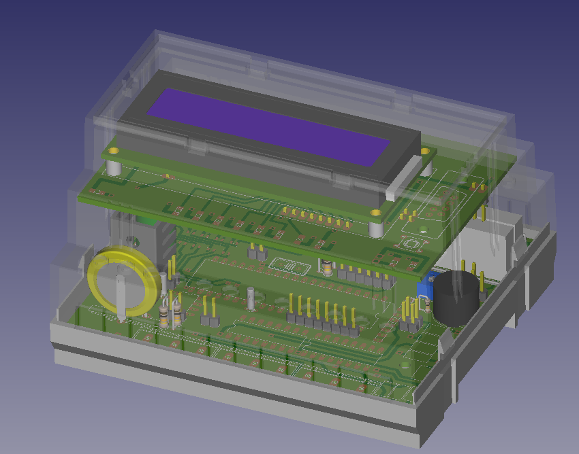

Requirements
FreeCAD-PCB require FreeCAD in version 14.0 or never. Module was tested on Windows and GNU/Linux.

Supported files
- Eagle (*.brd),
- Razen (*.rzp),
- FreePCB (*.fpc),
- gEDA (*.pcb),
- FidoCadJ (*.fcd),
- KiCad (*.kicad_pcb),
- IDF v2/v3,
- HyperLynx (*.HYP).

Installation
Unpack downloaded zip file and copy extracted folder to direction where FreeCAD is installed (subfolder Mod).

GNU/Linux
Example:
FreeCAD path:

~/Programs/FreeCAD

So copy mod to folder

~/Programs/FreeCAD/Mod

You can also copy files to folder ~/.FreeCAD/Mod .

Next change read/write permission to 777. Please don't forget about parameter -R!
Example:
chmod 777 -R PCB

Windows
Example:
FreeCAD path:

C:/Program Files/FreeCAD-0.14

So copy mod to folder

C:/Program Files/FreeCAD-0.14/Mod
Next change read/write permission for all users. Click right button on folder PCB and choose Properties → Security → Edit → Users and mark all checkboxes under 'Allow' option.
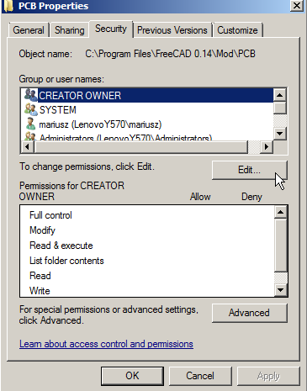

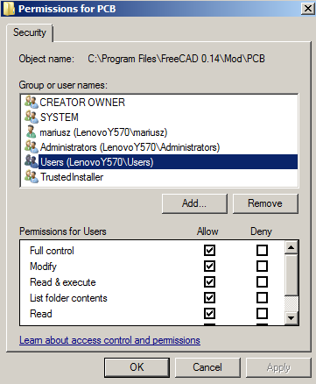

Configuration
At this moment some settings need to be configured in file PCBconf.py. You can open this file in any text editor (please avoid Notepad).

STP file format colors definition
During loading board, You can meet with error connected with missing STP color definition. To fix that problem just add new color definition in PCBconf.py file in spisKolorowSTP variable.
For example:
Missing color name:
red
Actual situation:
spisKolorowSTP = {
"white": (1.0, 1.0, 1.0),
"black": (0.0, 0.0 ,0.0)
}
Write to file:
spisKolorowSTP = {
"red": (1.0, 0.0 ,0.0),
"white": (1.0, 1.0, 1.0),
"black": (0.0, 0.0 ,0.0)
}

Where:
"red": (1.0, 0.0 ,0.0), => „colorName”: (R / 255, G / 255, B / 255)

 | Caution!
Please do not change anything else in the PCBconf.py file!
More configuration options You can find in Customizing Workbench section.

Accessing the Workbench
There are two methods to access to the PCB workbench:
- In toolbar 'File' locate drop down list and choose 'Printed Circuit Board'.

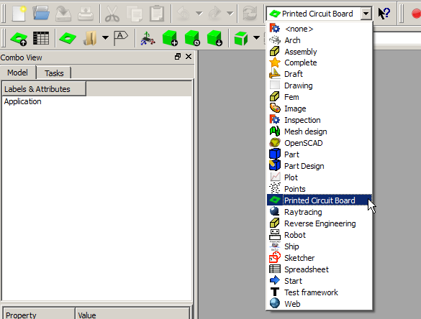
- From top menu bar choose View → Workbench → Printed Circuit Board.

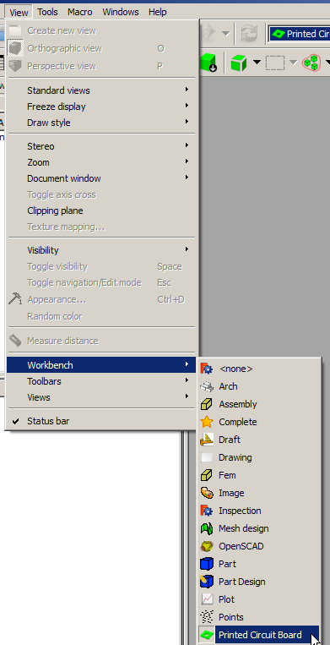

Set PCB module as main workbench
There is possibility to set PCB module as main workbench. To do this choose from top menu bar Edit → Preferences, in settings window choose General and tab General. In displayed tab You should find 'Start up' section, where You can set which workbench should be loaded after FreeCAD start.

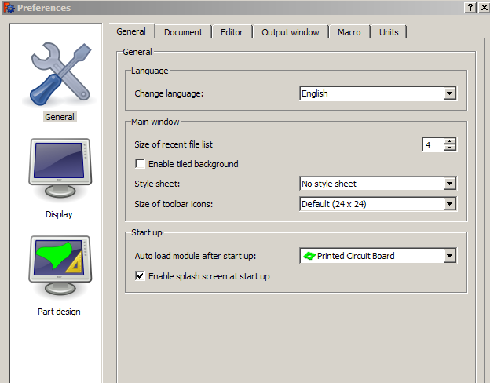

Menu Bar
Menu bars are not available.

Toolbars
Three toolbars are available in PCB workbench:
- PCB View.
- PCB Settings.
- Sketcher.

This section describes the various icons available in mentioned toolbars.

PCB View toolbar

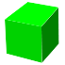 | Change display mode to Shaded | See Display modes section
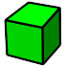 | Change display mode to Flat Lines | See Display modes section
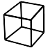 | Change display mode to Wireframe | See Display modes section
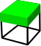 | Change display mode to Internal View | See Display modes section
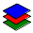 | Layers settings | See Layers section
 | Cut to board outline | See Cut to board outline section
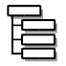 | Ungroup models in 'Parts' folder | See Grouping parts section
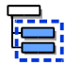 | Group models in 'Parts' folder | See Grouping parts section
 | 3D rendering: export to Kerkythea | See Kerkythea section
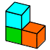 | Load file as assembly | See Add assembly section
 | Update selected assemblies | See Update assembly section

PCB Settings toolbar
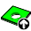 | Export PCB | See Export board section
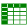 | Export BOM | See Export Bill Of Materials (BOM) section
 | Export hole locations | See Export hole locations section
 | Export hole locations report | See Export hole locations report section
 | Create drilling map | See Create drilling map section
 | Create drill center | See Create drill center section
 | Create new project | See Create new project section
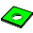 | Create PCB | See Create PCB section
 | Create glue path | See Create glue path section
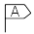 | Add annotation | See Add annotation section
 | Assign models | See Assign models section
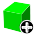 | Add model | See Add model section
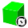 | Update models | See Update models section
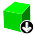 | Download models | See Download models section
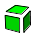 | Explode | See Explode section
 | Create constraint area | See Create constraint area section
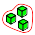 | Bounding box | See Bounding box section

Displaying toolbars
When mentioned toolbars are not displaying after choosing PCB workbench in main FreeCAD window, You need to do it manually. From top menu bar choose View → Toolbars and mark toolbars from Printed Circuit Board workbench.

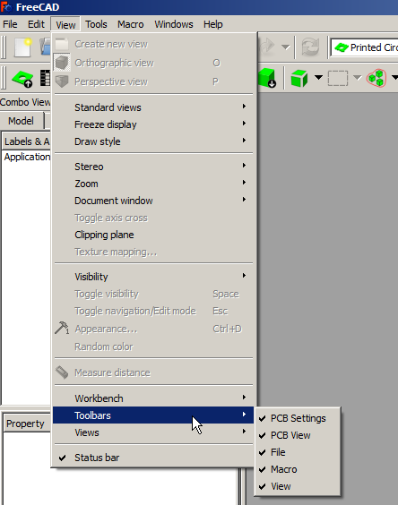

Specification Tree
There are few object types directly connected with PCB workbench. They can be identified in the 'Combo view' by the specific icons.

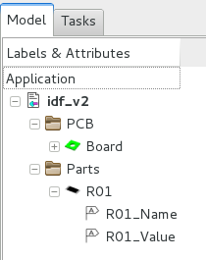
Board
 | Constraint area
 | Explode
 | Layer
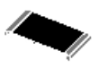 | Part model found in database
 | Part model not found in database
 | Annotation/Object Name/Object Value
 | Glue path
 | Main assembly object
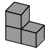 | Main assembly subcomponent

More info about mentioned objects You can find in Objects properties section.

Customizing Workbench
To access to the PCB workbench settings You need to choose from top menu Edit → Preferences: section PCB.
Preference tab for module contain three groups:

- General
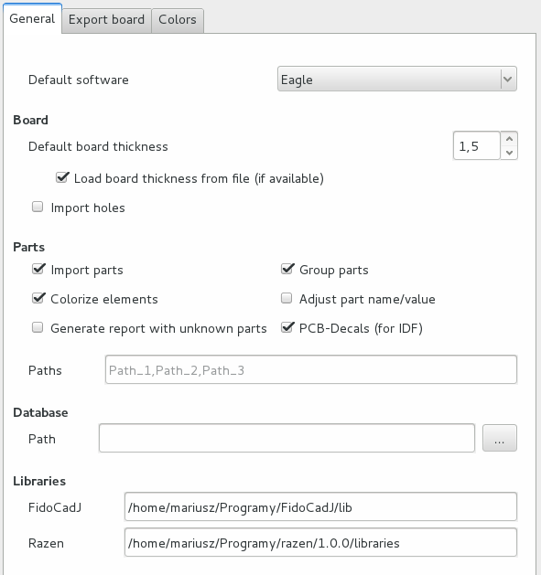
This section contains default settings for import process:
- Default software: this field allow You to set default used by you software,
- Board thickness: default value is 1.5mm,
- Paths to: database, 3D models, extra libraries,
- Checkboxes associated with importing parts/colors/holes,
- Checkbox associated with generating report with unknown parts.

If checkbox 'Group parts' is checked, imported parts will be splitted to groups according to Category they belong.

Caution!
For more information about grouping parts see 'Grouping parts' section.

Caution!
It is recommended to keep parts and database.cfg outside PCB folder.

Caution!
To set libraries for FidoCadJ you can indicate folder or main jar file.

- Export board
Default settings associated with exporting board to one of supported formats can be set in this tab.

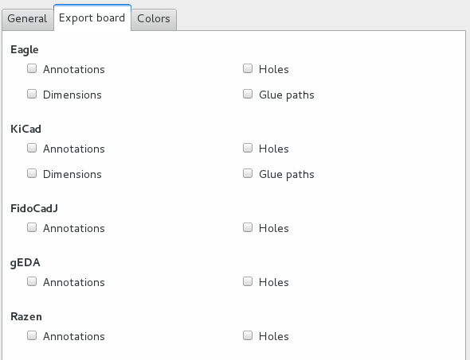

- Colors
All default color can be set in 'Colors' section.

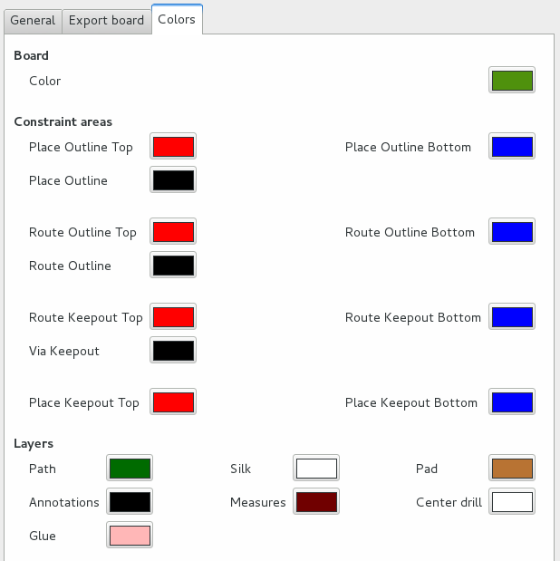

Assign models
Window 'Assign models' allow for assigning 3D models to corresponding part from one of supported
software.

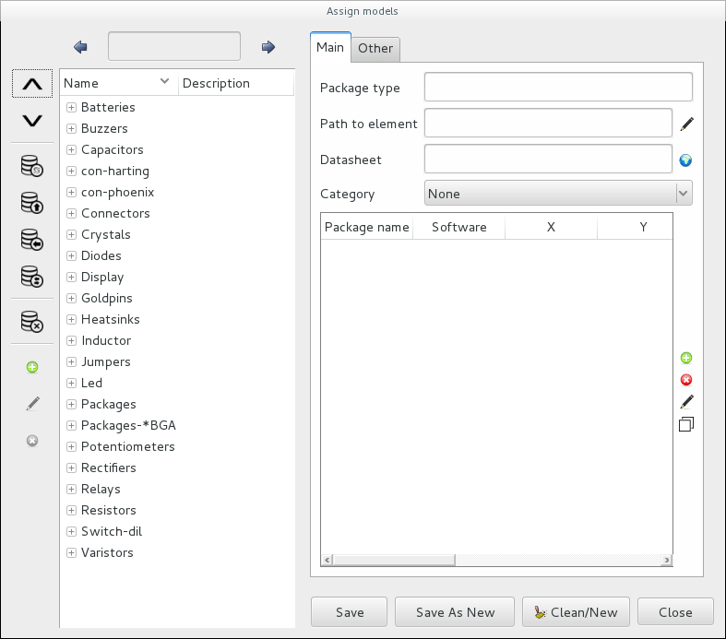

Window comprises two main columns. Left column comprises function necessary to manage parts in database. While right side comprises form where You can set (or edit) package data.

Search block contains prev/next button and entry field for search term  Package list contains categories /parts names and their description  Collapse/Expand all items from Package list  Reload database  Import new entries from different database file  Create database copy  Convert models from one software to another  Delete selected models from database  Manage Categories:  - add new category  - edit existing category  - remove selected category |  | 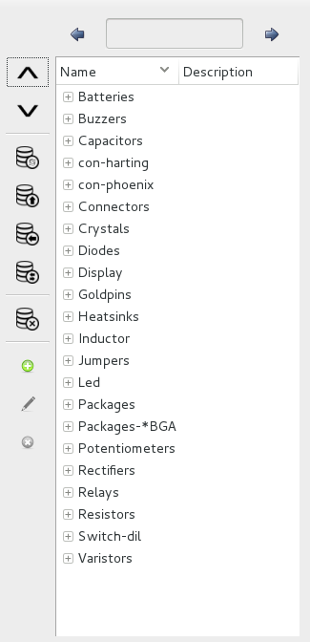

Caution!
Categories are stored directly in FreeCAD.
Tools → Edit parameters => Preferences → Mod → PCB and variable partsCategories

Caution!
After deleting model from database it is not possible to undo this operation!

Basics setting
Package type is model name (any text)  These field contains relative or absolute path to 3D model  Optional parameter: path to part datasheet (web site or local file)  Set category for model | 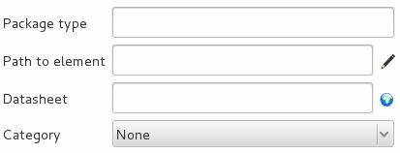

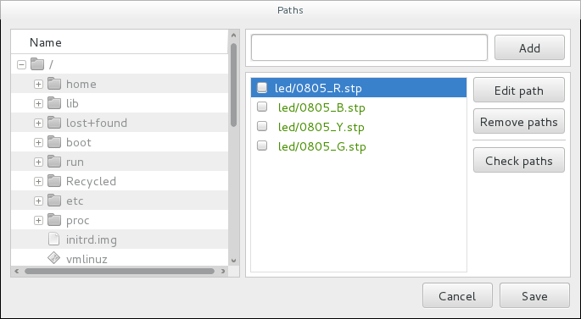
From version 3.9 it is possible to set paths in gui.

To add new 3D model (relative/absolute path) just choose model from left list or type directly in specified field and click Add button.
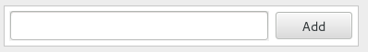
During initialization special function will check if saved before paths are still existing.  Green color means that the path is correct, while red means that something is wrong.  To check new paths you need to click button 'Check paths'. | 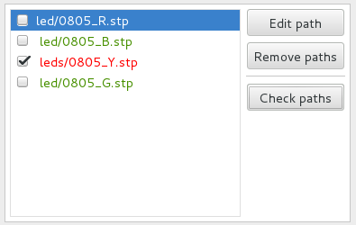

Adding equivalent package for 3D model
First sections contain all package parameters, from one of supported softwares, necessary to load specific 3D model. |  | Buttons from right side will helps You in adding new /deleting or editing entries.  After clicking button 'Add' special window will appear, that allow You to set parameters for new package.  After clicking 'Edit' button will appear window, that will contain all settings for current selected model.  Clicking 'Delete' button will delete from database selected entry.  Last button allows you to copy existing entry and save it in database under new name.
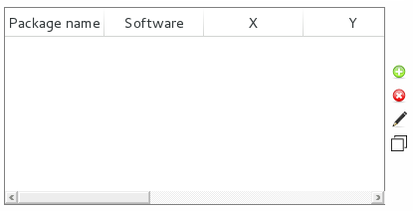

This field contains package type name taken from software used by You to create PCBboards.  From drop-down list You need to choose software name for with this entry will be connected.  X, Y, Z, RX, RY, RZ parameters are correction values used to correctly placement 3D model. | 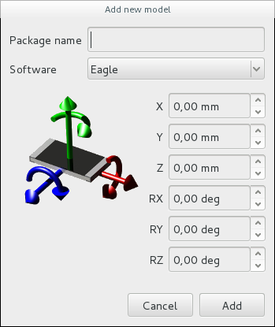

Adjust part name/value
Option 'Adjust part name/value' allows to automatic placing objects name/value in specific position.
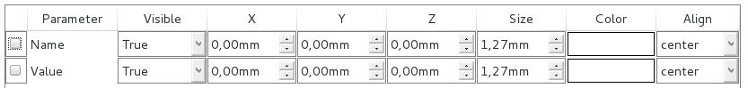
Example
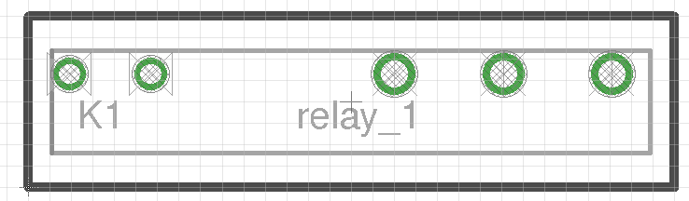
Board created in Eagle.
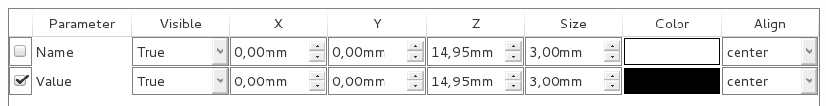
Settings

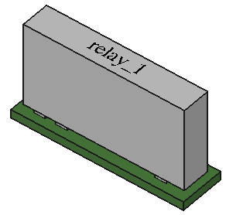
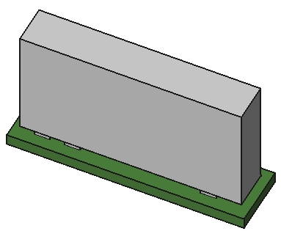
Result without option 'Adjust part name/value' | Result with option 'Adjust part name/value'

Set socket for model
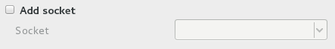
To add socket for model just mark checkbox for 'Add socket' and from drop down list choose socket 3D model name. In drop down list You will find only models marked before as sockets.

Set model as socket
To set model as socket just mark checkbox for 'Set as socket' sign. In spinbox specify socket height. | 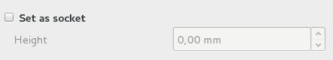

Footer from right column contain buttons to saving form entries to database

Save button will save form as new entry in database or will update package parameters (in edit mode).  'Save as new' will save existing entry in database under new package name.  'Clean/New' button clean form.  Close button will appear only for GNU/Linux users. | 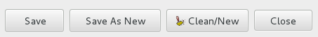

Example of adding part to database
In Eagle we prepared board containing one part: R1 SMD resistor 2k in package 1206.

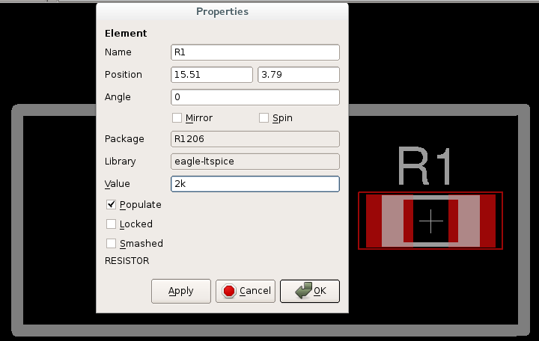
Open 'Assing models' window and:
- In 'Package type' field write resistor_smd_1206. Package name is free text.
- In 'Path to element' write resistors/R1206.

Caution!
Model extension.
resistors/R1206 mean that script will search at first file R1206.igs and then R1206.stp,
so course path to element can also ook like
resistors/R1206.igs or resistors/R1206.stp.

Caution!
resistors/R1206 – script will search model in one of relative paths set in configurations.

- Datasheet field may remain empty.
- Package category may remain as 'None'.
- Next step explains how to add new 'connection' between 3D model and part added on board.

To create board we use Eagle so in 'Package name' we should give value shown next to 'Package' field from part properties window in Eagle  Software field we set on Eagle.  That mean all parts R1206 from board, created in Eagle will be connected with 3D model R1206.igs/.stp.  Each part is placed in space (X, Y, Z, RX, RY, RZ). Parts specified in Eagle contains only X, Y and rotation around Z axis. Sometimes is necessary to set some correction values to achieve specified in board part position – these values dependence from used 3D model. | 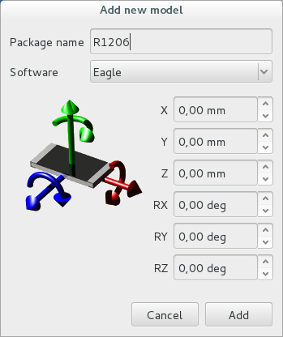

- Click add button.
- This model is not socket and doesn't contain it, so we will skip specific checkboxes.
- To save form in database click button 'Save'.
- Thats all, now just reload board or update 3D models for R1206 packages.

Multi model definition for one part
There is a possibility to set more than one 3D model for one package. To do this just split path to all models by character ';' in field 'Path to element'.
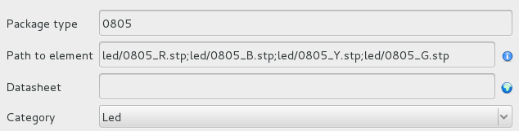

This function is useful for parts which only different is color – the same correction values are set for all models.
For packages where we set multi models, special window will appear during board loading or parts updating.
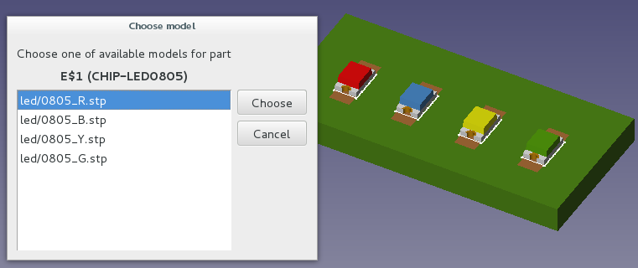

Download models
Download model window appear in Task tab. Mentioned window contains links to sites when You can
download for free 3D models.

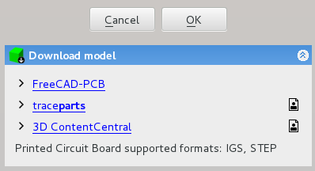
Icons definition:
Registration is necessary to download models

Printed Circuit Board workbench supported formats:
- IGS,
- STEP - at this moment colours are supported only for step files saved/created in FreeCAD. So to avoid problems with colours create part in FreeCAD or open an existing component in FC (made in another program) and save it as step with colours.

There is also possibility to search for concrete model. To do this just right click on missing model in specification tree and choose PCB model → Find model on-line.

Display modes
Display modes function can quickly and in easy way change display representation of shapes in project.

Available types:
- Shaded: border lines are hidden.

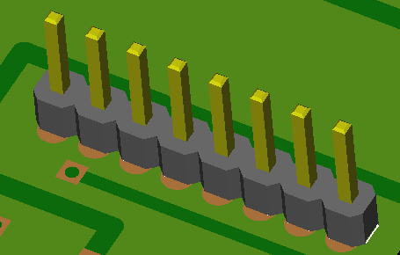
- Flat lines: surfaces and border lines are displayed in one time.

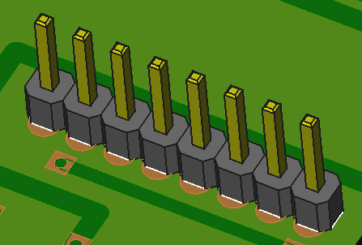
- Wireframe: only border lines are displayed.

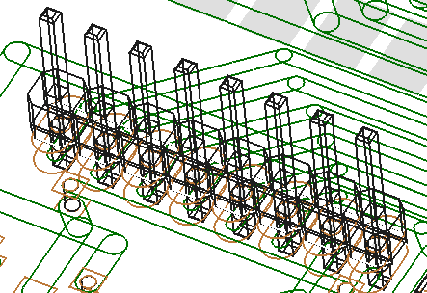
- Internal View: for board only border lines are displayed, rest is displayed in Flat lines mode

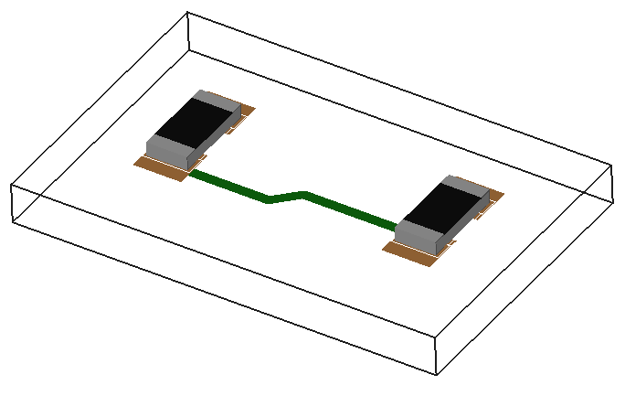

Layers
Layers settings windows help in managing of currently displayed board layers. Layers settings window
appear in Task tab.

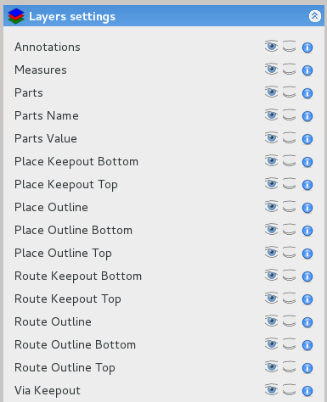

Each line consists of four parts:
- Layer name,
- Button Show All – show all objects of this type,
- Button Hide All – hide all objects of this type,
- Information button – display information about layer.

Python
To manage layers by Python You need to import PCBlayers
import PCBlayers

This module contain few functions:
- display(TypeId): display layer with a given ID
TypeId: specific list
- blank(TypeId): blank layer with a given ID
TypeId: specific list
- toggle(TypeId): toggle visibility state of layer with a given ID
TypeId: specific list
- state(TypeId): plirt state of layer with a given ID
TypeId: specific list
- list(): return list of all available layers
'layerName: {'info': 'info', 'id': TypeId}
- listTXT(): print all available layers

Example:
import PCBlayers as layer
lay = layer.list()
lay = lay["Annotations"]['id']

layer.blank(lay)
layer.state(lay) # False
layer.toggle(lay)
layer.state(lay) # True

Grouping parts
These options allow you to group/ungroup parts, according to Category they belong.

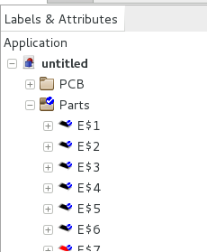 | 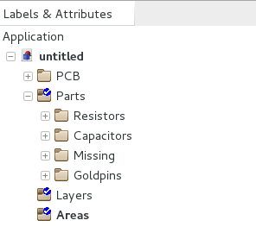
Ungrouped parts | Grouped parts

These options are also available in:
- open/import window,
- update parts window,
- add new model window.

Open/Import board
During open/import process special window will appear, in which we can set basic parameters of the board.
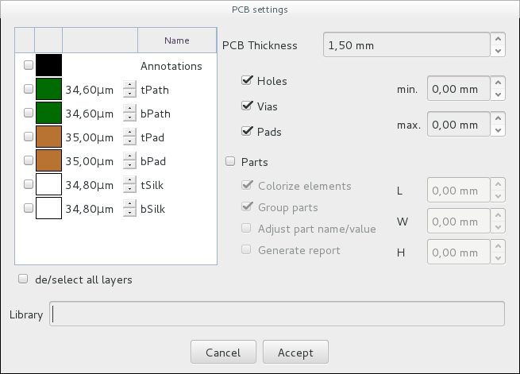
1
3
2
4
5

- In first section You can choose, which layers will be loaded. Available layers depends from loading file type.
Layer name and color are editable.
- This section allow You to set PCB thickness. If file contain board thickness this value will be displayed in this
field. Default value is 1.5[mm].
- Third section contain basic settings about importing holes.
Here You can decide what type of holes You want to import (hole/vias/pads) and set imported holes diameter range (min/max). Both parameter can be set separately.
- Fourth area contains basic settings about importing parts.
Here You can decide if You want to import parts, decide if they should contain colors, etc. Fields L/W/H allow You to decide about minimum length/width/height of 3D models which will be imported. All three parameter can be set separately.
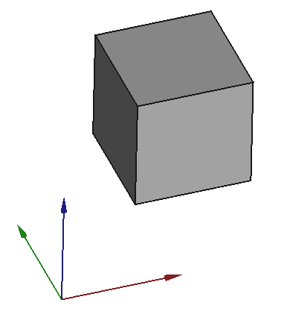
X = L
Y = W
Z = H
Option 'Adjust part name/value' allows to automatic placing objects name/value in specific position. This option is connected with functions from 'Assign window'.
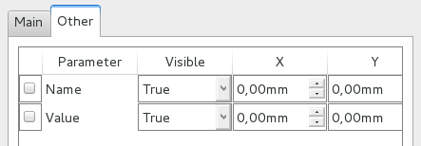
- In some cases it is necessary to define path to specific program libraries.

Unit system
During board loading process units are changed to millimeters [mm].

Below You can find information, which part of imported files are supported by Printed Circuit Board workbench.

Soft name | PCB
Soft name |  | Holes/Vias | Parts | Border | Measures | Soldermask | Keepout layers | Paths | Pads | Soldermask ARC | PCB round corners | Annotations
Eagle | brd
gEDA | pcb
FreePCB | fpc
KiCad | kicad_pcb
ZenitPCB | zpc
TARGET 3001! | t3001
FidoCadJ | fcd
SCOOTER
Razen | rzp
IDF v2 | idf
IDF v3 | idf
IDF v4
TurboPcb | apcb
DipTrace | asc
HyperLynx | HYP

Yes
No
Never
In progress
Future

Create new project
Before starting project it is recommended to press Create new project button. It will create necessary groups
in Specification Tree used later by script.

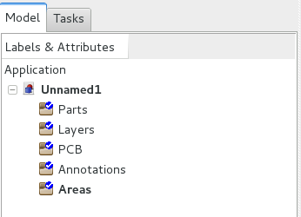
Meaning of groups:
- Areas: group will store constraint areas,
- PCB: group will store board object,
- Layers: group will store layers,
- Parts: group will store all parts used in project,
- Annotations: group will store annotations.

Caution!
It is recommended to press Create new project button before starting project, but it is not necessary – script will check if specific group exist and, if desired will create it.

Python
To manage groups by Python You need to import PCBgroups module
import PCBgroups

This module contain few functions:
- createGroup_Parts(): create Parts group.
- createGroup_Layers(): create Layers group.
- createGroup_Annotations(): create Annotations group.
- createGroup_Areas(): create Areas group.
- createGroup_PCB(): create PCB group.
- setProject(): create all available groups.

Example:

import PCBgroups as group
pcbG = group.createGroup_PCB()
pcbG.Label() # u'PCB'

Create PCB
This task explains how to create a board and design its geometry from scratch.

  - Create Sketcher with contour of fthe boaard
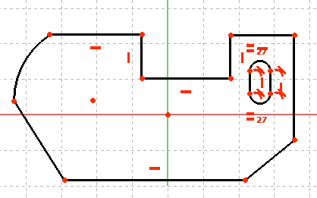
  - Create new Sketcher with holes
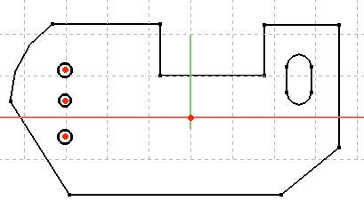
  - Click the Create PCB button

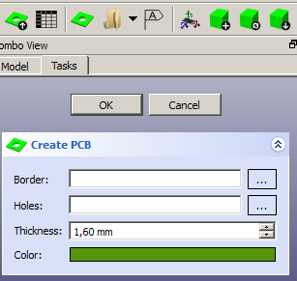
  - As Border point to Sketcher with contour of fthe boaard

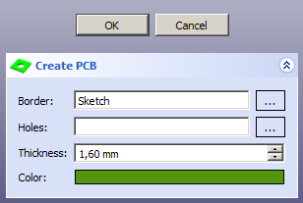

  - As Holes point to Sketcher with holes

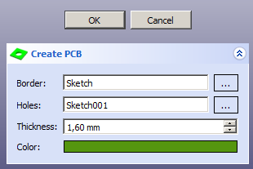

  - Set board Thickness

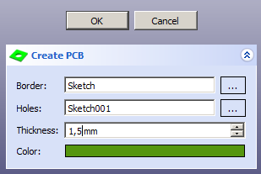

  - Set board Color

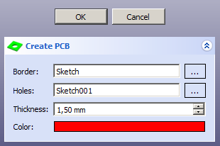

  - Click OK button to finish

The board should be generated according to settings.
The board has been created from scratch.
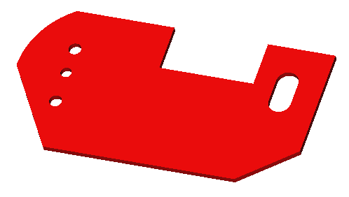

Caution!
Only one board can be generated per project

Caution!
Even if there will be no holes in board, proper Sketcher need to be done

Caution!
It is not possible to create board from a previously created part

Cut to board outline
Sometimes it is necessery to display board like it will look after manufacturing. To do this just use option
'Cut to Board Outline'. Function will automatically blank/display all layers/paths that are outside of the board.

Example

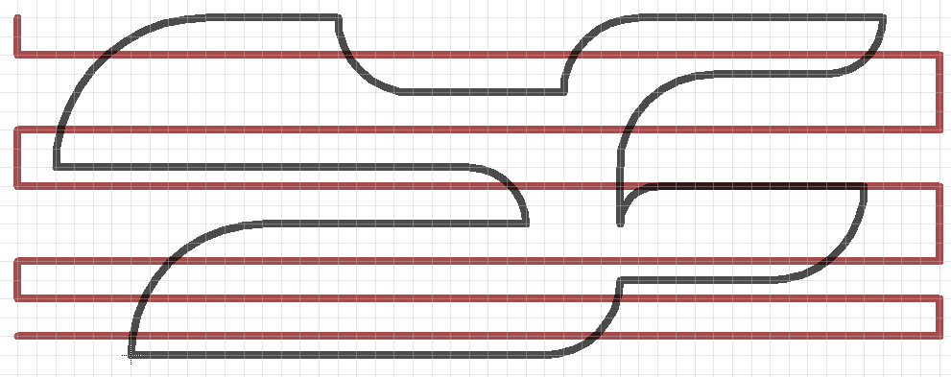
Board created in Eagle

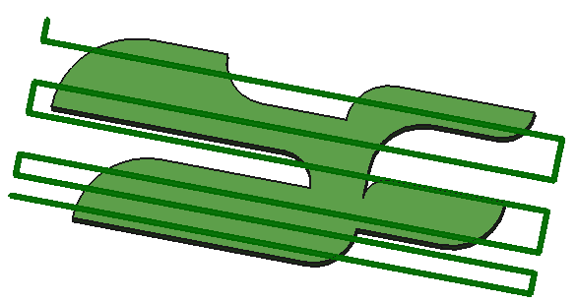
Cut to Board Outline = OFF

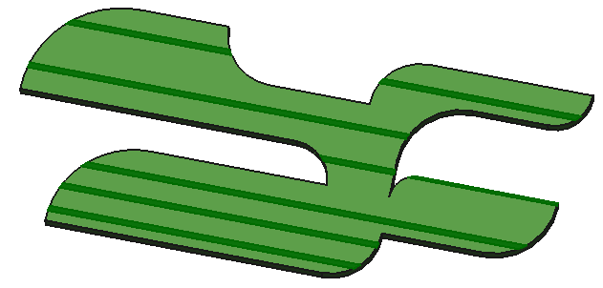
Cut to Board Outline = ON

Create glue path

Add annotation
This task shows how to add annotations to project.

  - Click button Add annotation on PCB Settings toolbar

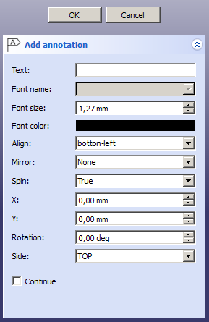
  - Set text for the annotation

  - Set font size (in mm)

  - Set font color

To change color click on colored area.

  - Set align
There is possibility to align text, according to object center.
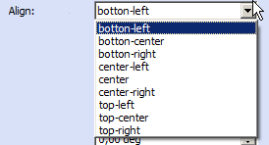
Align: bottom-left (X=0, Y=0)

Align: center (X=0, Y=0)


Caution!
Align parameter set also point around which text will be mirrored/rotated.

  - Mirror text
Available values:
    - None: do not mirror annotation,
Align: center, Rot: 45[deg]

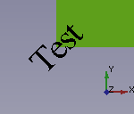
    - Global Y axis: mirror annotation according global Y axis (axis orientation is taken from 3D view space)
Align: center, Rot: 45[deg]

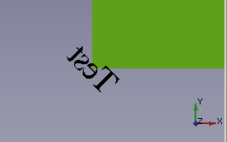
Mirror axis

    - Local Y axis: mirror annotation according local Y axis (axis orientation is taken from object)
Align: center, Rot: 45[deg], Mirror: None
Local Y axis orientation

Align: center, Rot: 45[deg], Mirror: Local Y axis
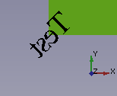
Mirror axis
  - Spin text
If spin parameter is set to True (default) the texts can be displayed in any rotation, also upside down, otherwise (Spin = False) text is displayed readable (no upside down).

Align: bottom-left, Rot: 120[deg], Mirror: None, Spin: True


Align: bottom-left, Rot: 120[deg], Mirror: None, Spin: False



  - Set values for X, Y coordinates

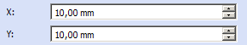
Distance is measured from 0, 0 in 3D window. Actual position (model center) is representing in 3D view by red 'arrow'

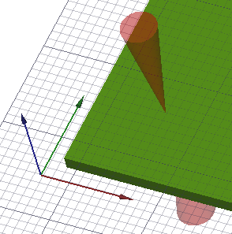
0, 0
10, 10

  - Set rotation value (rotation around Z axis)

  - Choose side for new annotation on board

Caution!
Component will not be automatically rotated according to chosen side.

  - Click Ok button to finish
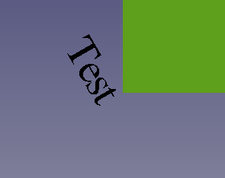 | 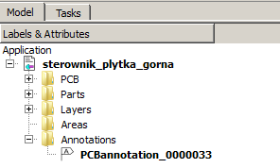

Caution!
If not existing, special group (Annotations) will be created.

Add model
This task explains how to add new component to existing board.

- Click button Add model

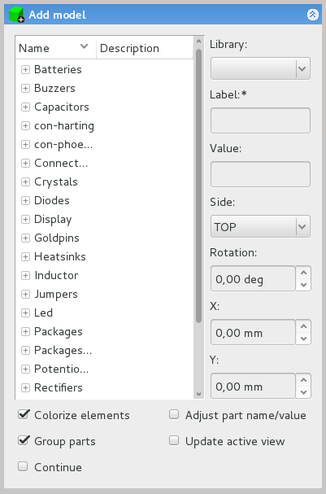

- Select package – model type

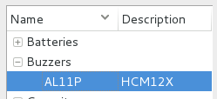

- Choose from drop-down list, from which library script should take settings

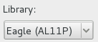

- Write component name
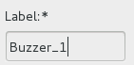

Caution!
This field is mandatory

- Add value

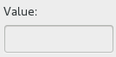
- Choose side for new component on board
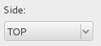

Component will be automatically rotated according to chosen side.

- Set rotation value (rotation around Z axis)

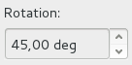
Value is in degrees.

- Set values for X, Y coordinates

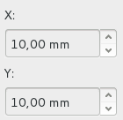
Distance is measured from 0, 0 in 3D window. Actual position (model center) is representing in 3D view by
red 'arrow'

10, 10
0, 0

- Click Ok button to finish

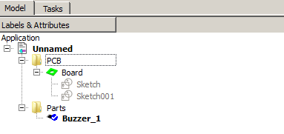
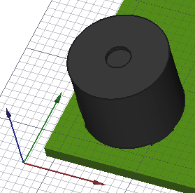

Add model tab contain five configuration options:
- Colorize elements: there is possibility to add models in two modes – with colors and without.
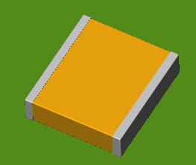  Model added with option 'Colorize elements' | 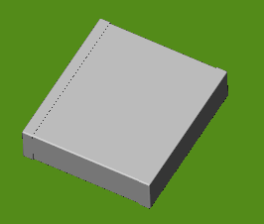  Model added without option 'Colorize elements'

- Adjust part name/value – set Name/Value annotation values according to settings set in database.
- Update active view: view in 3D window will automatically switches between TOP/BOTTOM view, dependency which side will be chosen.
- Group parts: grouping parts in tree according to Categories.
- Continue: normally after click Ok button Add modal window disappears, to avoid that (You want to add more than one object) just mark this option.

Update models
Update models window will reload/load 3D model/settings for used in project components.

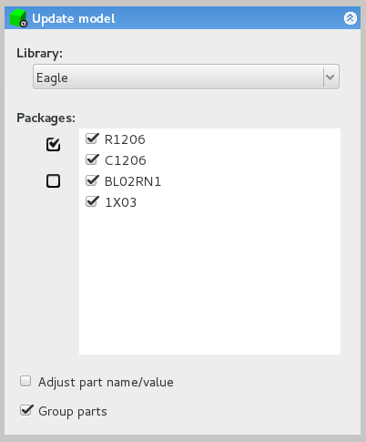
1
3
2

Update models tab contain three sections:
- Library: during update process, script will search settings (eg. X, Y, Z values) in specific library,
- Packages: contain listbox with used in project components. Checked checkbox next to model type mean that this part will be updated.
- Configuration options:
  - Adjust part name/value – set Name/Value annotation values according to settings set in database.
  - Group parts: grouping parts in tree according to Categories.

Caution!
When selected component does not appear in specified library, model will be not updated.

Create constraint area
This task shows you how to create a constraint area. A constraint area is a 'object' represent area reservation
for different purposes.

  - Create Sketcher with contour of the constraint area

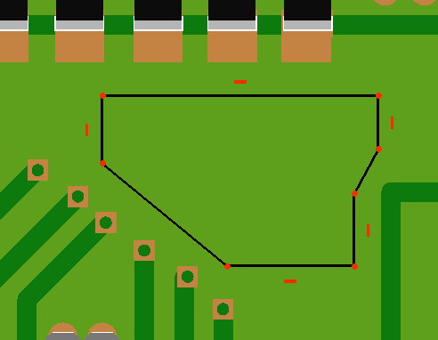

Caution!
Shape created in Sketcher need to be closed.

  - Select just created sketcher and click Create Constraint area button

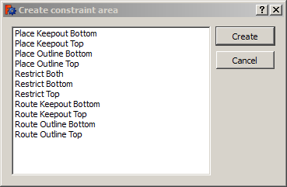
  - Choose constraint area type

Available constraint area types:
    - Place Keepout Bottom:
    - Place Keepout Top:
    - Place Outline Bottom:
    - Place Outline Top:
    - Restrict Both:
    - Restrict Top:
    - Restrict Bottom:
    - Route Keepout Bottom:
    - Route Keepout Top:
    - Route Outline Bottom:
    - Route Outline Top:

  - Click OK button to finish
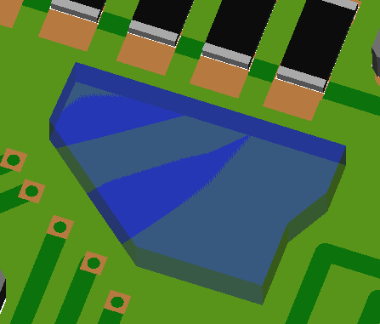
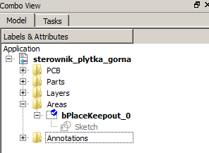

Caution!
If not existing, special group (Areas) will be created.

Explode
Explode function allows for assemblies to be quickly disassembled and shown in an exploded view.

Explode contains two similar functions:
- Fast explode: automatically explode all printed circuit board parts.
- Explode: user selects which parts and how will be relocated.

This task shows you how to manually create a explode object.

- Load PCB and click Explode button

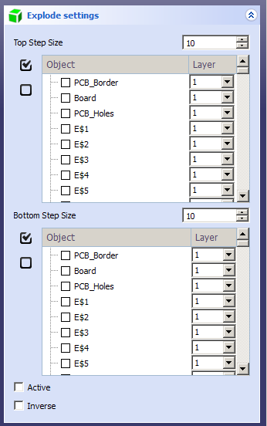

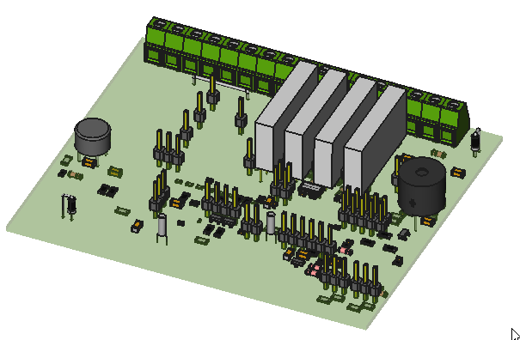
Board before exploding

- Set Top step size
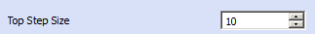

Top step size determines distance between next levels.

- Choose parts – top side
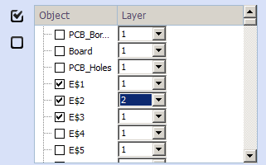
Selected parts will automatically disappear from the bottom list.
Layer parameter is a number, that will be multiplied by Top step size to determine new Z position for part after explode

- Set Bottom step size

Bottom step size determines distance between next levels.

- Choose parts – bottom side
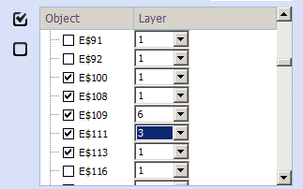
Selected parts will automatically disappear from the top list.

Layer parameter is a number, that will be multiplied by Bottom step size to determine new Z position for part after explode.

- Active

If this option will be checked explode object will be activated automatically after creation.

- Inverse

To reverse top and bottom side check this option.

- Click Ok button to finish
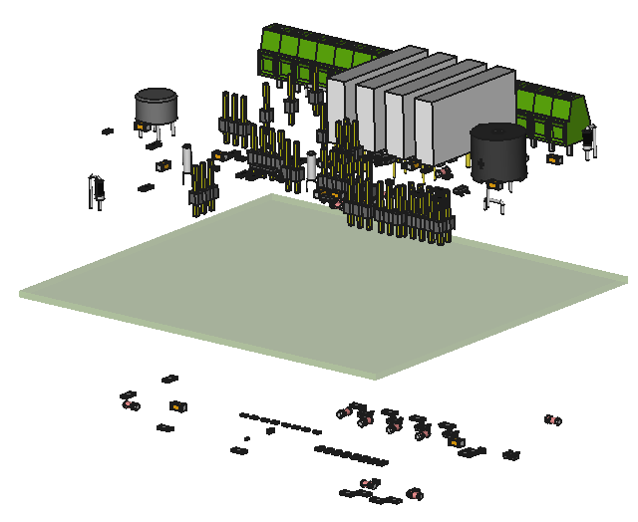  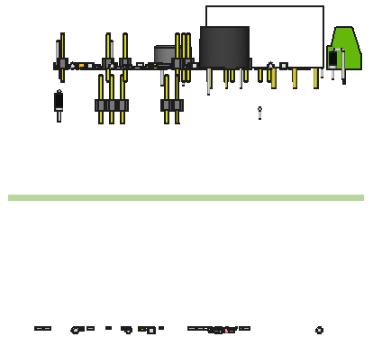 | 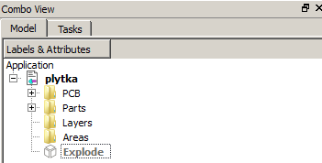

Caution!
Fast explode function automatically splits parts between top and bottom layers.

Bounding box
Bounding box is a smallest cuboid completely surrounds the object.

Printed Circuit Board workbench contain two function to generate bounding box:
- Bounding box – generate box for all board (board, parts, paths),
- Bounding box from selection – generate box for selected components.

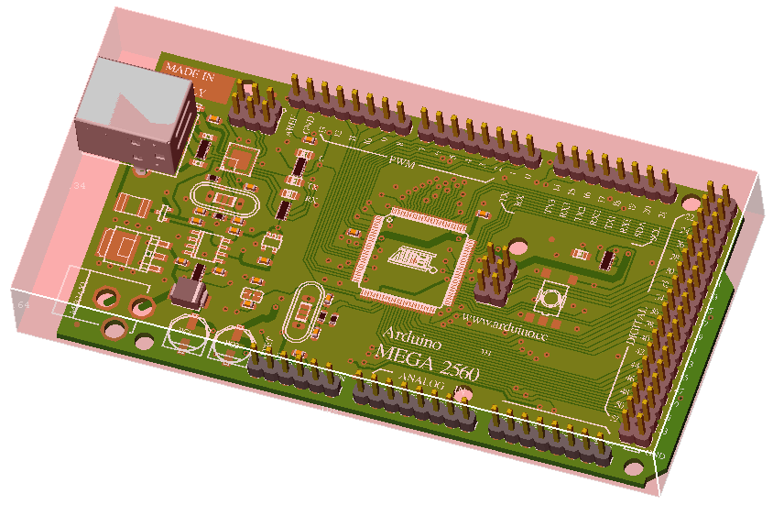
Bounding box generated for whole board

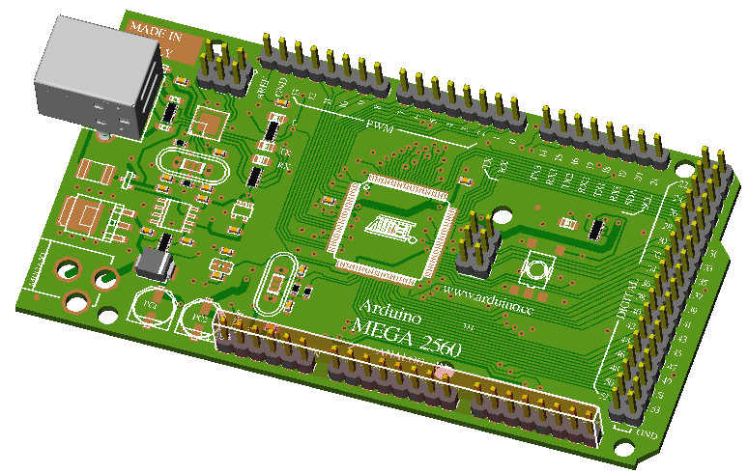
Bounding box generated for selected components

Generated boxes are normal cubes so it is possible to work on them in FreeCAD.

You can generate as many bounding boxes, as You need.

Python
To create bounding box by Python You need to import PCBboundingBox
import PCBboundingBox

This module contain few functions:
- boundingBox(): create bounding box for whole board.
- boundingBoxFromSelection(): create bounding box for selected objects.

Example:
import PCBboundingBox as box
box.boundingBox()

Example 2:
import PCBboundingBox as box
a = box.boundingBox()
a.Length # 179.546 mm
a.Width # 104.27 mm
a.Height # 2.155 mm

Export board
Export option allow You to save created/modified board in FreeCAD to one of supported file formats.

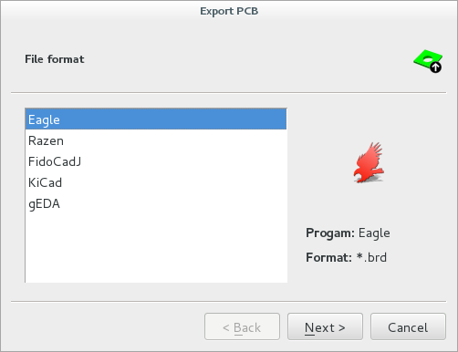

First tab in export window allow You to choose export file format.

Supported files
- Eagle (*.brd),
- FidoCadJ (*.fcd),
- KiCad (*.kicad_pcb),
- gEDA (*.pcb),
- Razen (*.rzp).

After choosing file format click Next to move to settings section where You can set which parts of PCB will be exported and where to save new file.

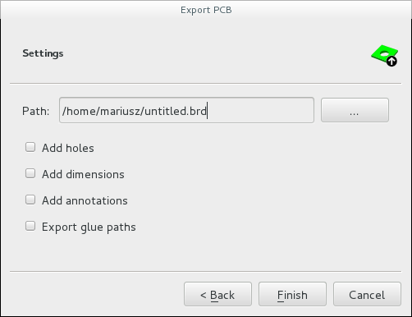

Available options depends of selected file format.
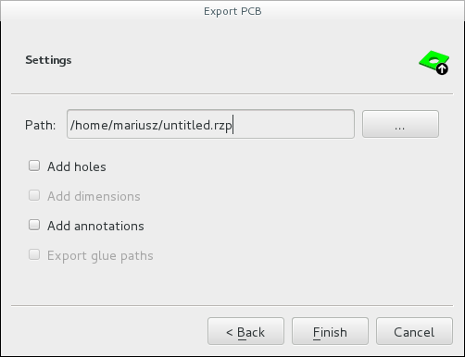
Caution!
Default settings you can set in Preferences – tab 'Customizing Workbench'.

Clicking Finish button will end Export process and script will create new file according to chosen settings.

Below You can find information, which parts of board are supported by Printed Circuit Board workbench during export process.
Soft name | PCB
Soft name |  | Border | Measures | PCB round corners | Holes | Annotations | Glue paths
Eagle | brd
KiCad | kicad_pcb
gEDA | pcb
FreePCB | fpc
FidoCadJ | fcd
Razen | rzp
IDF v2 | idf
IDF v3 | idf

Yes
No
Never
In progress
Future

Unit system
During board export process units are changed to millimeters [mm].

Python
To export board by Python You need to make few basic steps:
- Import PCBexport module.
- Choose file format, to which You want save.
Available export formats:
  - Eagle (*.brd) → eagle(),
  - FidoCadJ (*.fcd) → fidocadj(),
  - KiCad (*.kicad_pcb) → kicad(),
  - gEDA (*.pcb) → geda(),
  - Razen (*rzp) → razen().
- Set basic export parameters.
Available settings:
  - addHoles: export holes to file (if supported), default value = False,
  - addAnnotations: export annotations to file (if supported), default value = False,
  - addDimensions: export dimensions to file (if supported), default value = False.
- Call function export().

Example:
import PCBexport
export = PCBexport.eagle()
export.addHoles = True
export.addAnnotations = True
export.export("/home/mariusz/test.brd")

Where:
- /home/mariusz/test.brd: path and output file name (file extension is not required).

Export Bill Of Materials (BOM)
Option Export BOM allow You to export bill of material list to one of supported file formats.

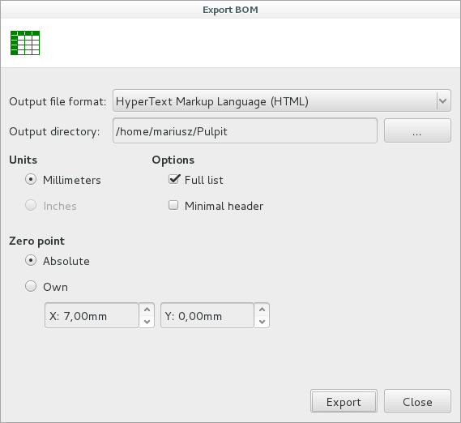

Export hole location contains a number of settings that allow you to obtain the desired output file format:
- Output file format:
  - Comma Separated Values (*.csv)
  - Text File (*.txt)
  - HyperText Markup Language (*.html)
- Output directory: set path where file will be saved
- Units:
  - Millimeters: measure Everything in Metric , default value
  - Inches: measure Everything in Inches, disabled option
- Zero point drilling
  - Absolute: base point for drilling is set in global 0, 0
  - Own: set new base point for drilling
    - X: X value for new base point for drilling
    - Y: Y value for new base point for drilling
- Extra options
  - Minimal header: set whether extra data (project name, date, format) will be saved in to output file
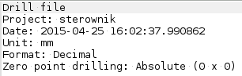
  - Option 'Full list' allow You to generate complex report for used components.

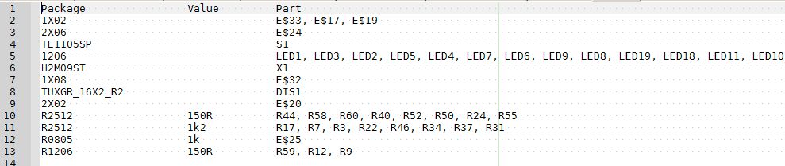
Exported list without option 'Full list'.

Exported list with option 'Full list'.

Python
To export BOM by Python You need to make few basic steps:
- Import PCBexportHoles module.
- Set basic export parameters.
Available settings:
- fileFormat:
  - Comma Separated Values → csv
  - Text File → txt
  - HyperText Markup Language →html
- filePath = def. home directory
- fileName = def. value 'untitled'
- units = mm/inch
- zeroPointDrilling:
  - -2: Absolute, def. value
  - -3: Own
    - zeroPointDrilling_X = def. value 0
    - zeroPointDrilling_Y = def. value 0
- minimalHeader = True/False, def. value False
- groupHoles = True/False, def. value False
- Call function export().
Example:
from PCBexportBOM import xportBOM
export.fileFormat = 'html'
export.filePath = /home/mariusz'
export.fileName ='test'
export.units = 'mm'
export.fullList = True
export.export()

Where:
- /home/mariusz: path foroutput file.
- test: output file name (file extension is not required).

Export hole locations
Option Export hole locations allow You to export holes list to one of supported file formats.

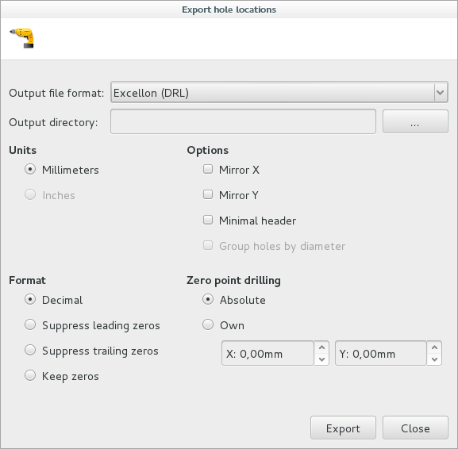

Export hole location contains a number of settings that allow you to obtain the desired output file format:
- Output file format:
  - Comma Separated Values (*.csv)
  - Text File (*.txt)
  - HyperText Markup Language (*.html)
  - Excellon (DRL)
- Output directory: set path where file will be saved
- Units:
  - Millimeters: measure Everything in Metric , default value
  - Inches: measure Everything in Inches, disabled option
- Format: choose format, in which values will be saved in file
Base value: 12.5[mm]
  - Decimal: without changes, value = 12.5
  - Suppress leading zeros: value = 12500
  - Suppress trailing zeros: value = 00125
  - Keep zeros: value = 0012500
- Zero point drilling
  - Absolute: base point for drilling is set in global 0, 0
  - Own: set new base point for drilling
    - X: X value for new base point for drilling
    - Y: Y value for new base point for drilling
- Extra options
  - Mirror X: multiply X value by -1
  - Mirror Y: multiply Y value by -1
  - Minimal header: set whether extra data (project name, date, format) will be saved in to output file
  - Group holes by diameter: some output formats support grouping for holes by diameter

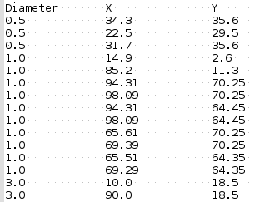
Exported list without option 'Group holes by diameter'.

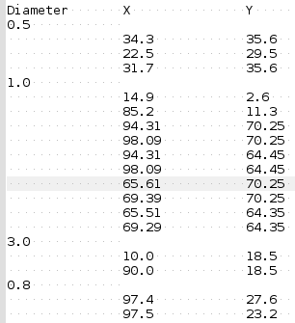
Exported list with option 'Group holes by diameter'.

Python
To export holes list by Python You need to make few basic steps:
- Import PCBexportHoles module.
- Set basic export parameters.
Available settings:
- fileFormat:
  - Comma Separated Values → csv
  - Text File → txt
  - HyperText Markup Language →html
  - Excellon →drl, def. value
- filePath = def. home directory
- fileName = def. value 'untitled'
- units = mm/inch
- saveFormat:
  - -2: Decimal, def. value
  - -3: Suppress leading zeros
  - -4: Suppress trailing zeros
  - -5: Keep zeros
- zeroPointDrilling:
  - -2: Absolute, def. value
  - -3: Own
    - zeroPointDrilling_X = def. value 0
    - zeroPointDrilling_Y = def. value 0
- mirror_X = True/False, def. value False
- mirror_Y = True/False, def. value False
- minimalHeader = True/False, def. value False
- groupHoles = True/False, def. value False
- Call function export().

Example:
from PCBexportHoles import exportHoles
export = exportHoles()
export.fileFormat = 'html'
export.filePath = '/home/mariusz'
export.fileName = 'test'
export.units = 'mm'
export.saveFormat = -2
export.zeroPointDrilling = -2
export.groupHoles= True
export.export()

Where:
- /home/mariusz: path foroutput file.
- test: output file name (file extension is not required).

Export hole locations report
Option Export hole locations report allow You to export report about needed, for drill process, tools.

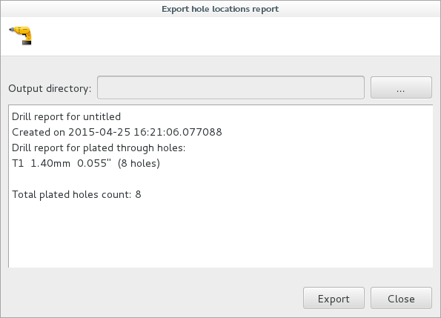

Caution!
Output file have 'rpt' extension.

Python
To export board by Python You need to make few basic steps:
- Import PCBexportHoles module.
- Set basic export parameters.
Available settings:
- filePath = def. home directory
- fileName = def. value 'untitled'
- Call function export().

Example:
from PCBexportHoles import exportHolesReport
export = exportHolesReport()
export.filePath = '/home/mariusz'
export.fileName = 'test'
export.export()

Where:
- /home/mariusz: path for output file.
- test: output file name (file extension is not required).

Create drilling map
Option 'Create drilling map' allow You to create 2D representation of board with marked drilling points.
Holes are splitted by diameter – each diameter value is represented by different symbol and color.

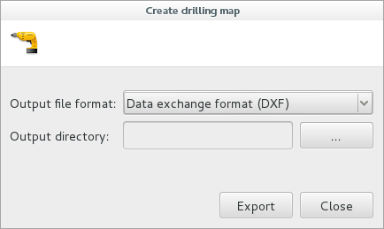

Supported formats:
- DXF: Data exchange format (*.dxf),
- SVG: Scalable Vector Graphics (*.svg).

Caution!
Output file name is the same as project in FreeCAD.
File extension depends from selected output format.

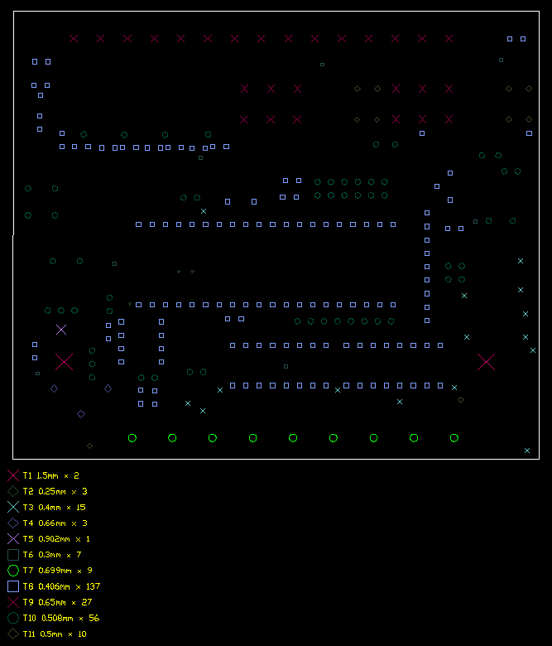
Format in the legend: T1 1.5mm x 2
- T1: tool number,
- 1.5mm: hole dimater in [mm],
- 2: number of holes with same diameter.

Python
To create drilling map by Python You need to make few basic steps:
- Import PCBexportDrillingMap module.
- Set basic export parameters.
Available settings:
  - fileFormat
    - Comma Separated Values → csv,
    - Data exchange format → dxf,
  - filePath = def. home directory
- Call function export().

Example:
from PCBexportDrillingMap import exportDrillingMap
export = exportDrillingMap()
export.filePath = '/home/mariusz'
export.fileFormat = 'dxf'
export.export()

Where:
- /home/mariusz: path foroutput file,
- dxf: output file format.

Create drill center
Option 'Create drill center' is useful for persons which will drill holes in PCB manually. This function
allow to decrease holes sizes for better drill position during work.

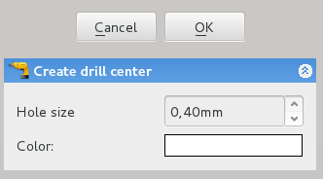

Caution!
To update/change drill size, use same function. Script will automatically update layer.

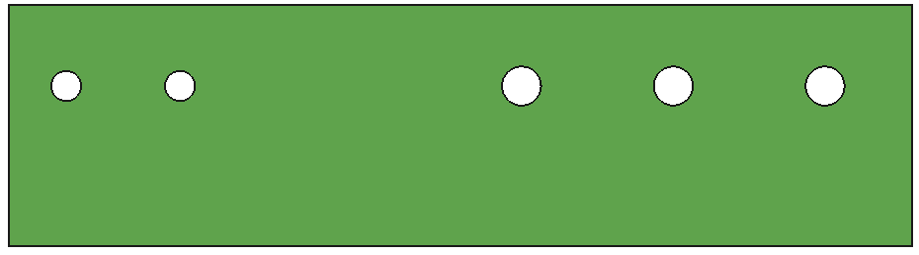
Before:

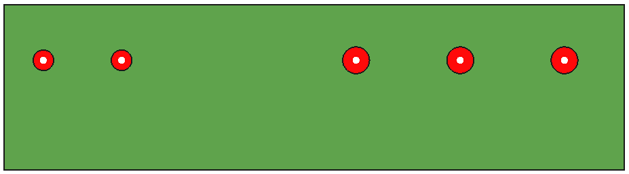
After:

Python
To create drill center by Python You need to make only two steps:
- Import PCBdrill module.
- Call function createDrillcenter(size, color).
Where:
  - size: new hole size in [mm],
  - color: (R / 255, G / 255, b / 255).

Example:
from PCBdrill import createDrillcenter
createDrillcenter(0.4, (1, 0.5, 0))

Add assembly
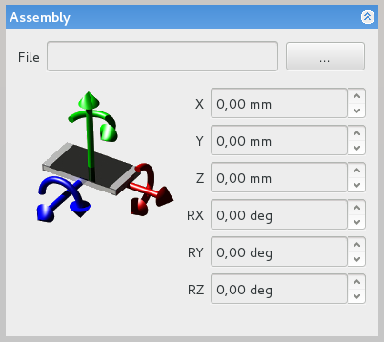

Python
To add assembly object by Python You need to import PCBassembly:
- Import PCBassembly module.
- Set basic export parameters.
Available settings:
- fileName = full path: destination path + filename,
- x = position in X direction,
- y = position in Y direction,
- z = position in Z direction,
- rx = rotation value around X axis,
- ry = rotation value around Y axis,
- rz = rotation value around Z axis,
- Call function create().

Example:
from PCBassembly import createAssembly
asm = createAssembly()
asm.fileName = '/home/mariusz/dol.fcstd'
asm.create()

Where:
- /home/mariusz/dol.fcstd: path and file.

Update assembly
These option allow you to update loaded assemblies. Script can recognize if selected to update assembly is
currently opened in FreeCAD or not.

Caution!
Auto update after file loaded does not work at the moment.

Caution!
During update process, script will keep only main assembly placement in 3D space – all deleted previously objects are reloaded.

Caution!
At one time you can select and update more than one assembly.

Python
To update assembly object by Python You need to import PCBassembly:
- Import PCBassembly module.
- Select assemblies to update.
- Call function updateAssembly().

Example:
from PCBassembly import updateAssembly
asm1 = FreeCAD.ActiveDocument.dol
FreeCADGui.Selection.addSelection(asm1)
updateAssembly()

Where:
- asm1: assembly to update.

Export to Kerkythea

Objects properties
Each object created in PCB workbench has unique parameters that can be set in Property View (View or Data tab). This task explains meaning each parameter.

Annotation/Object Name/Object Value
Text: text displayed by annotation object  Align: text position according to X, Y values  Mirror: mirror text  Spin: if parameter set to True text will keep rotation, parameter works for angle value >= 90deg  Font: font name, parameter disabled  Size: font size  Rot: rotation value around Z axis  Side: text position on board (top/bottom side)  X: text position in X direction  Y: text position in Y direction | 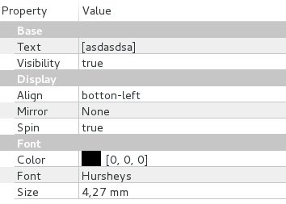  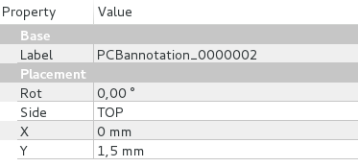

Board
Display Holes: turn on/off holes  Holes: reference to sketch that containing holes  Border: reference to sketch that containing board outline  Thickness: board thickness | 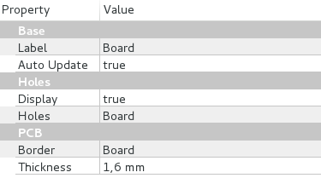

Part model not found in database
Part Name: reference to part name object  Part Value: reference to part value object  Keep Position: part will ignore changes in correction values if this value will be set to True  Package: 3D model name, parameter disabled for editing  Rot: rotation value around Z axis, parameter disabled for editing  Side: part position on board (top/bottom side), parameter disabled for editing  X: model position in X direction, parameter disabled for editing  Y: model position in Y direction, parameter disabled for editing | 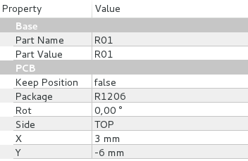

Context menu PCB model:
- Assign model: assign 3D model to part,
- Update model: implement new model/correction values for selected part,
- Find model on-line: find 3D model in internet.

Explode
Active: turn of/off explode effect  Bottom Step Size: distance between parts placed on bottom side of board  Inverse: switch exploded parts from top to bottom and conversely  Top Step Size: distance between parts placed on top side of board | 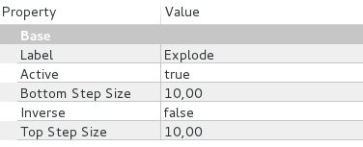

Context menu Explode:
- Edit: edit list of models which will be exploded.

Part model found in database
Part Name: reference to part name object

Part Value: reference to part value object

Keep Position: part will ignore changes in correction values if this value will be set to True

Package: 3D model name, parameter disabled for editing

Rot: rotation value around Z axis

Side: part position on board (top/bottom side)

X: model position in X direction

Y: model position in Y direction

Context menu PCB model:
- Placement model: change correction values for model in 'real time',
- Update model: implement new model/correction values for selected part.

Constraint area
Height: area height, parameter available only for some constraints areas type  Base: reference to sketch that containing area outline | 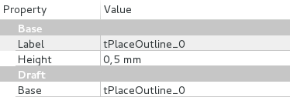

Glue path
Base: reference to sketch that containing glue path shape  Flat: if this parameter is set to True, object will ignore Width/Height parameters  Height: glue path height  Width: glue path width | 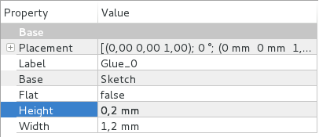

Main assembly object
File: path to *.fcstd file  Placement: position of whole assembly in 3D space | 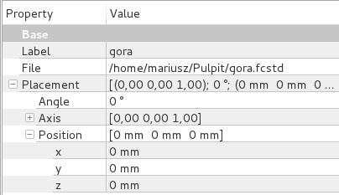

File format
This task explains database.cfg file format.
Each connection between 3D model and component used in ECAD software is stored in mentioned database.cfg file. All parameters can be set by Assign model window and manualy by editing database.cfg file (not recomendet).

Example 3D model setting:
[hibhb_8788937480]
socket = [False, 0.0]
description =
add_socket = [False, None]
datasheet =
path = connectors/goldpin/1x08
soft = [[u'1X08', u'Eagle', 0.0, 0.0, 2.77, 90.0, 0.0, 0.0]]
name = 1X08
category = 10

Where:
[unique ID]
unique ID = String
socket = [modelIsSocket, socketHeight]
modelIsSocket = True / False
socketHeight = Float
description = modelDescription
modelDescription = String
add_socket = [addSocket, socketID]
addSocket = True / False
socketID = ID / None
datasheet = pathToDatasheet
pathToDatasheet = String

path = pathTo3DModel
pathTo3DModel = String
soft = [[componentName, softName, X, Y, Z, RX, RY, RZ]]
componentName = String
softName = String
X = Float
Y = Float
Z = Float
RX = Float
RY = Float
RZ = Float
name = modelName
modelName = String
category = categoryID
categoryID = Integer

Scripts
There are available few scripts which are helping exporting the boards to FreeCAD.

Eagle
Directly exporting boards from Eagle to FreeCAD [path: scripts/eagle]

- scripts/eagle/ulp/freecad.ulp – copy file to $EAGLEDIR/ulp/
- scripts/eagle/scr/freecad.scr – copy file to $EAGLEDIR/scr/
- scripts/eagle/bin/freecad.png – copy file to $EAGLEDIR/bin/

In Eagle choose File → Execute Script → freecad.

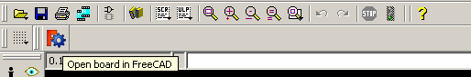
On Linux to set path to FreeCAD change value of var 'programPath_LIN' in file freecad.ulp.
On Windows to set path to FreeCAD change value of var 'programPath_WIN' in file freecad.ulp.

Razen
Directly exporting boards from Razen to FreeCAD [path: scripts/razen]
- scripts/razen/freecad – copy folder `freecad` to $RAZENDIR/plugin/export/

In Razen choose File → Export → FreeCAD.

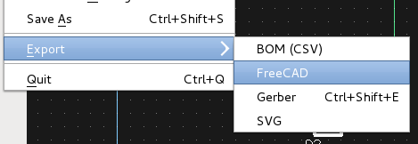

On Linux to set path to FreeCAD change value of var 'programPath_LIN' in file conf.cfg.
On Windows to set path to FreeCAD change value of var 'programPath_WIN' in file conf.cfg.

Errors code
Code | Description | File
1 | Function getColorFromIGS() | PCBpartManaging
2 | Function partExist() | PCBpartManaging
3 | Function reloadList() | PCBaddModel
4 | Function deletePackage() | PCBassignModel
5 | Function convertDatabase() | PCBassignModel
6 | Function reloadList() | PCBassignModel

Licence

#****************************************************************************
#*
#* This program is free software; you can redistribute it and/or modify
#* it under the terms of the GNU Lesser General Public License (LGPL)
#* as published by the Free Software Foundation; either version 2 of
#* the License, or (at your option) any later version.
#* for detail see the LICENCE text file.
#*
#* This program is distributed in the hope that it will be useful,
#* but WITHOUT ANY WARRANTY; without even the implied warranty of
#* MERCHANTABILITY or FITNESS FOR A PARTICULAR PURPOSE. See the
#* GNU Library General Public License for more details.
#*
#* You should have received a copy of the GNU Library General Public
#* License along with this program; if not, write to the Free Software
#* Foundation, Inc., 59 Temple Place, Suite 330, Boston, MA 02111-1307
#* USA
#*
#****************************************************************************

Changelog

- Version: 3.2 (beta)
  - Path layer: add support for arcs,
  - Added support for arcs width,
  - Multi model definition for one part,
  - Added support for lines/circles/arcs width,
  - Export hole locations/annotations
  - Preference tab for PCB mod.

- Version: 3.1 (beta)
  - Rewrite placement object function,
  - STEP format support for library parts,
  - Added categories to window ('Asssingn models')

- Version: 3.0 (beta)
  - Support for new pads type: oval, round rectangle,
  - New database format,
  - Add function: Layers settings,
  - New Icon Set.

- Version: 2.9 (beta)
  - Changes in script code,
  - KiCad: improvement of errors associated with the PCB import. Many thanks go to
Giovanni Di Trapani
  - Round corners for PCB,
  - Added new object: PCB board,
  - FidoCadJ - import object name/value from file.

- Version: 2.8 (beta)
  - Changes in script code,
  - Add option: Create Bounding Box for PCB,
  - Add option: Update parts directly from FreeCAD ,
  - Export bill of materials (BOM),
  - Export PCB layers to one of supported file formats,
  - Rewrite placement object function.

- Version: 2.7 (beta)
  - changes in script code,
  - Add option: Create constraint area,
  - Added ability to edit some layers,
  - Use layer names from brd file,
  - Initialize PCB thickness control from DRC settings in brd file.

- Version: 2.6 (beta)
  - rewrite FreePCB importer,
  - changes in script code,
  - add layer: path,
  - add support for:
    - IDF v2/v3,
    - FidoCadJ (.fcd),
    - KiCad (.kicad_pcb).

- Version: 2.5 (beta)
  - changes in script code,
  - fix bug in rotation of layers 21, 22, 51, 52,
  - fix bug in directly exporting boards from Eagle to FreeCAD on Linux,
  - add pad/via layer,
  - add support for:
    - FreePCB file format (*.fpc),
    - gEDA file format (*.pcb),
    - Razen file format (*.rzp).

- Version: 2.4 (beta)
  - changes in script code,
  - new command -> Assign models,
  - remove file param.py → replaced by dane.cfg,
  - new command → Convert old database to a new format,
  - directly exporting boards from Eagle to FreeCAD.

- Version: 2.3 (beta)
  - changes in script code,
  - add layerObject for layers 39, 40, 41, 42, 43,
  - split layer 39, 40, 41, 42, 43 into separately objects,
  - add Height property for layer 39, 40,
  - REMOVE var 'socketHeight' FROM 'CONF' => ADDED NEW ELEMENT IN 'bibliotekaDane' FROM 'PARAM' FILE.

- Version: 2.2 (beta)
  - changes in importing iges files,
  - changes in script code.

- Version: 2.1 (beta)
  - import IGES models with colours,
  - add possible to generate report with unknown parts,
  - add/cancel socket for all elements.

- Version: 2.0 (beta)
  - layer types supported: 20, 21, 22, 39, 40, 41, 42, 43, 47, 51, 52,
  - possible to show holes/vias independent,
  - possible to choose colours, transparency and names for each layer.

ToDo list
If you have any further queries, requests or suggestions post a detailed information on project site
http://sourceforge.net/p/eaglepcb2freecad/feat-req/ or on forum https://sourceforge.net/p/eaglepcb2freecad/forum/.

To create post click Create Topic button.
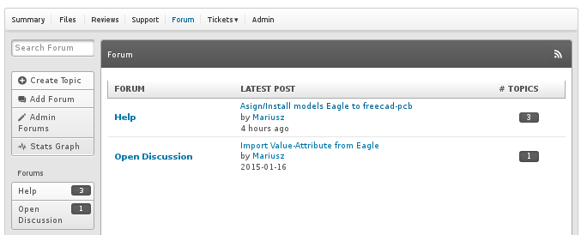

To create post click Create Ticket button.
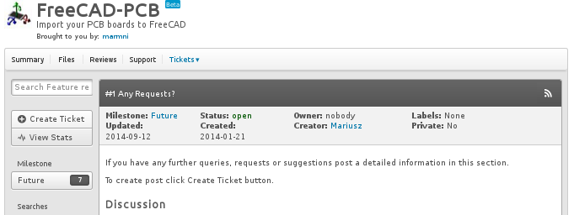

Errors
Found a bug? Post a detailed information on project page http://sourceforge.net/p/eaglepcb2freecad/bugs/. To create post click Create Ticket button.

