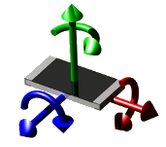 | Printed Circuit Board Workbench for FreeCAD (PCB)  Flexible Printed Circuit Board Workbench for FreeCAD (FPCB)
marmni (marmni@onet.eu)
Copyright 2013 - 2016
http://sourceforge.net/projects/eaglepcb2freecad/

Index
Introduction 4
Supported files 5
Requirements 5
Installation 6
GNU/Linux 6
Windows 6
Configuration 8
STP file format colors definition 8
Accessing the workbench 10
Set PCB module as main workbench 11
Menu bars 12
Toolbars 13
PCB View toolbar 13
PCB Settings toolbar 15
Displaying toolbars 17
Specification tree 18
Customizing workbench 20
Download models 24
Assign models 26
Basics setting 28
Adding equivalent package for 3D model 29
Adjust part name/value 30
Multi model definition for one part 34
Open/Import board 35
Unit system 36
Grouping parts 38
Display modes 39
Layers 41
Update models 43
Cut to board outline 45
Explode 47
Bounding box 51
Create new project 54
Create PCB 56
Add models 60
Add annotations 64
Create glue paths 65
Create constraints areas 66
Export board 67
Export bill of materials (BOM) 68
Export hole locations 69
Export hole locations report 70
Create drilling map 71
Create drill center 72
Add assembly 73
Update assembly 74
Collision detection 75
Export to Kerkythea 76
Export object to POV-Ray 77
Objects properties 78
File format 79
Scripts 80
Errors code 81
Licence 82
Changelog 83
ToDo list 84
Errors 85

Introduction
[ENG]

Mod allow you to import/create PCB boards in FreeCAD. Scope of mod:
- support for many different layers,
- possible to choose colours, transparency and names for each layer,
- mod allows you to import IGES/STP models with colours,
- possible to show holes/vias independent.

[PL]

Moduł pozwala na importowanie/tworzenie płytek PCB w programie FreeCAD. Możliwości modułu:
- wsparcie dla wielu różnych warstw,
- wyświetlanie otworów, przelotek niezależnie od siebie,
- możliwość wyboru koloru, przeźroczystości oraz nazwy dla poszczególnych warstw,
- importowanie modeli zapisanych w formacie IGS/STP wraz z kolorami.

Supported files
- Eagle (*.brd),
- Razen (*.rzp),
- FreePCB (*.fpc),
- gEDA (*.pcb),
- FidoCadJ (*.fcd),
- KiCad (*.kicad_pcb),
- IDF v2/v3,
- HyperLynx (*.HYP).

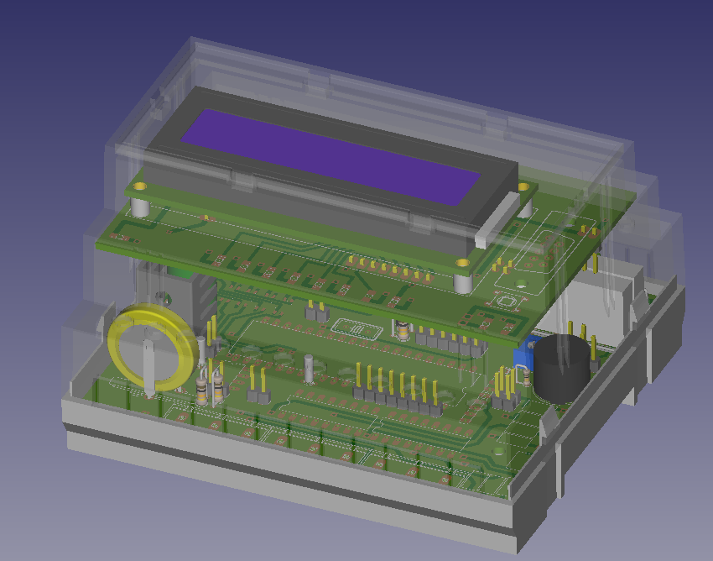
Requirements
FreeCAD-PCB require FreeCAD in version 14.0 or never. Module was tested on Windows and GNU/Linux.

Installation
Unpack downloaded zip file and copy extracted folder to direction where FreeCAD is installed (subfolder Mod).

GNU/Linux
Example:
FreeCAD path:
~/Programs/FreeCAD
So copy mod to folder
~/Programs/FreeCAD/Mod
You can also copy files to folder ~/.FreeCAD/Mod .

Next change read/write permission to 777. Please don't forget about parameter -R!
Example:
chmod 777 -R PCB

Windows
Example:
FreeCAD path:
C:/Program Files/FreeCAD-0.14
So copy mod to folder
C:/Program Files/FreeCAD-0.14/Mod

Next change read/write permission for all users. Click right button on folder PCB and choose Properties → Security → Edit → Users and mark all checkboxes under 'Allow' option.

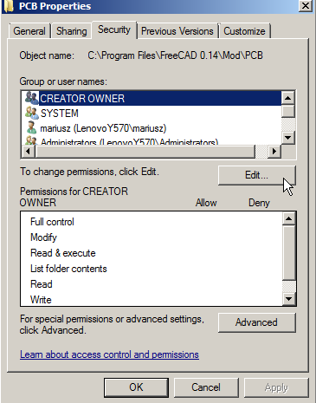
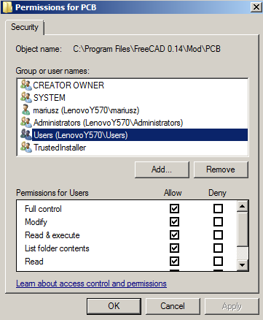

Configuration
At this moment some settings need to be configured in file PCBconf.py. You can open this file in any text editor (please avoid Notepad).

STP file format colors definition
During loading board, You can meet with error connected with missing STP color definition. To fix that problem just add new color definition in PCBconf.py file in spisKolorowSTP variable.

Example:
Missing color name:
red
Actual situation:
spisKolorowSTP = {
"white": (1.0, 1.0, 1.0),
"black": (0.0, 0.0 ,0.0)
}
Write to file:
spisKolorowSTP = {
"red": (1.0, 0.0 ,0.0),
"white": (1.0, 1.0, 1.0),
"black": (0.0, 0.0 ,0.0)
}

Where:
"red": (1.0, 0.0 ,0.0), => „colorName”: (R / 255, G / 255, B / 255)

 |  | Please do not change anything else in the PCBconf.py file! More configuration options You can find in Customizing Workbench section.

Accessing the workbench
There are two methods to access to the PCB workbench:
- In toolbar 'File' locate drop down list and choose 'Printed Circuit Board'.
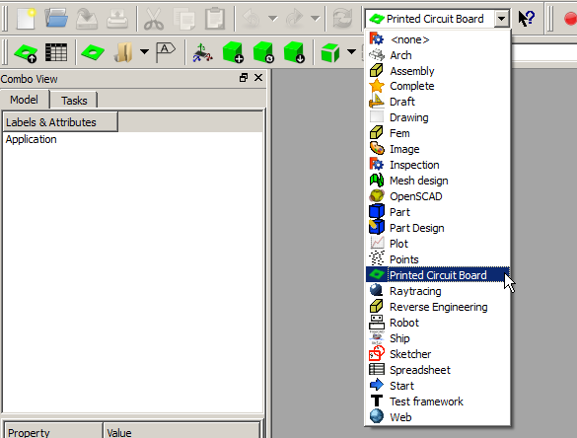
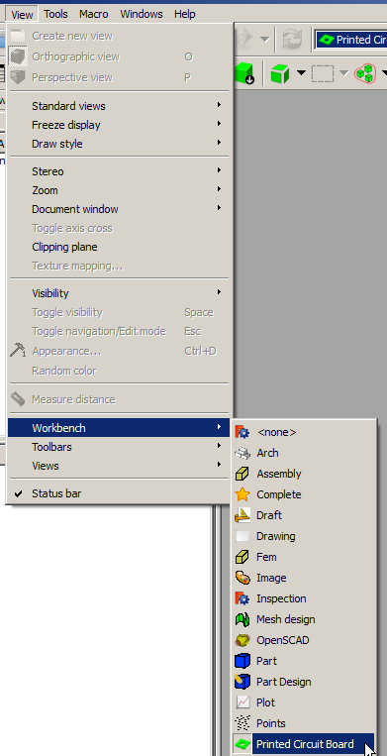
- From top menu bar choose View → Workbench → Printed Circuit Board.

Set PCB module as main workbench
There is possibility to set PCB module as main workbench. To do this choose from top menu bar Edit → Preferences, in settings window choose General and tab General. In displayed tab You should find 'Start up' section, where You can set which workbench should be loaded after FreeCAD start.

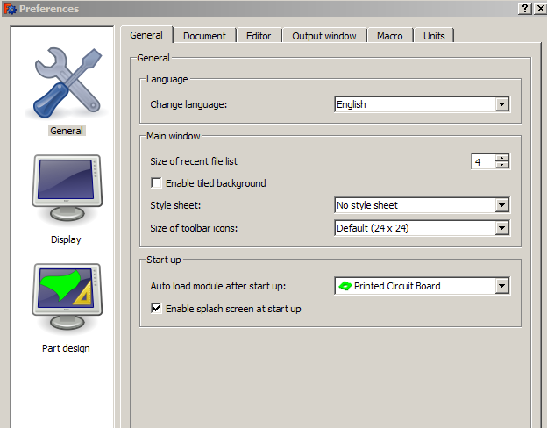

Menu bars
Menu bars are not available.

Toolbars
Three toolbars are available in PCB workbench:
- PCB View.
- PCB Settings.
- Sketcher.

PCB View toolbar
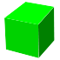 | Change display mode to Shaded | See Display modes section
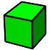 | Change display mode to Flat Lines | See Display modes section
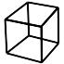 | Change display mode to Wireframe | See Display modes section
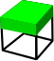 | Change display mode to Internal View | See Display modes section
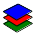 | Layers settings | See Layers section
 | Cut to board outline | See Cut to board outline section
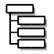 | Ungroup models in 'Parts' folder | See Grouping parts section
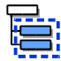 | Group models in 'Parts' folder | See Grouping parts section
 | 3D rendering: export to Kerkythea | See Kerkythea section
 | Export object to POV-ray | See Export object to POV-Ray section
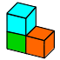 | Load file as assembly | See Add assembly section
 | Update selected assemblies | See Update assembly section
 | Collision detection | See Collision detection section

PCB Settings toolbar
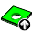 | Export PCB | See Export board section
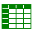 | Export BOM | See Export Bill Of Materials (BOM) section
 | Export hole locations | See Export hole locations section
 | Export hole locations report | See Export hole locations report section
 | Create drilling map | See Create drilling map section
 | Create drill center | See Create drill center section
 | Create new project | See Create new project section
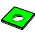 | Create PCB | See Create PCB section
 | Create glue path | See Create glue path section
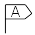 | Add annotation | See Add annotation section
 | Assign models | See Assign models section
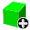 | Add model | See Add model section
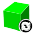 | Update models | See Update models section
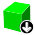 | Download models | See Download models section
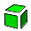 | Explode | See Explode section
 | Create constraint area | See Create constraint area section
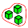 | Bounding box | See Bounding box section

Displaying toolbars
When mentioned toolbars are not displaying after choosing PCB workbench in main FreeCAD window, You need to do it manually. From top menu bar choose View → Toolbars and mark toolbars from Printed Circuit Board workbench.

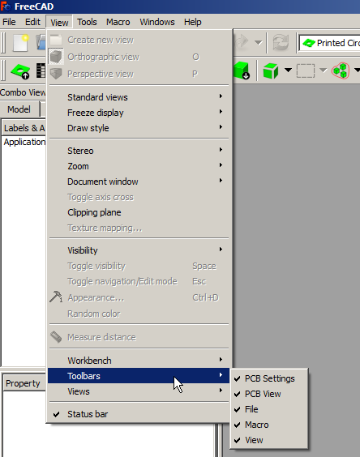

Specification tree
There are few object types directly connected with PCB workbench. They can be identified in the 'Combo view' by the specific icons.

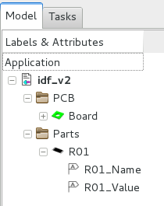 | Board
 | Constraint area
 | Explode
 | Layer
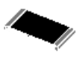 | Part model found in database
 | Part model not found in database
 | Annotation/Object Name/Object Value
 | Glue path
 | Main assembly object
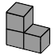 | Main assembly subcomponent

More info about mentioned objects You can find in Objects properties section.

Customizing workbench
To access to the PCB workbench settings You need to choose from top menu Edit → Preferences: section PCB.
Preference tab for module contain three groups:
- General

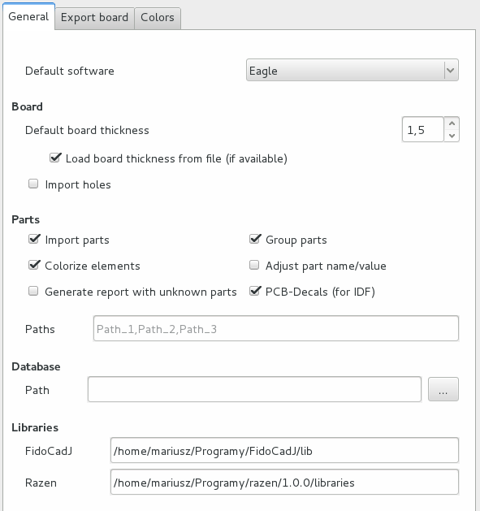

This section contains default settings for import process:
- Default software: this field allow You to set default used by you software,
- Board thickness: default value is 1.5mm,
- Paths to: database, 3D models, extra libraries,
- Checkboxes associated with importing parts/colors/holes
- Checkbox associated with generating report with unknown parts.

If checkbox 'Group parts' is checked, imported parts will be splitted to groups according to Category they belong.

It is recommended to keep parts and database.cfg file outside PCB folder.

 |  | For more information about grouping parts see ’Grouping parts’ section.

To set libraries for FidoCadJ you can indicate folder or main jar file.

- Export board

Default settings associated with exporting board to one of supported formats can be set in this tab.
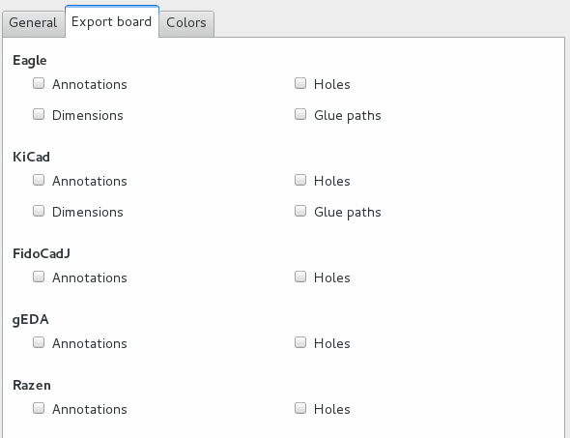

- Colors

All default color can be set in 'Colors' section.
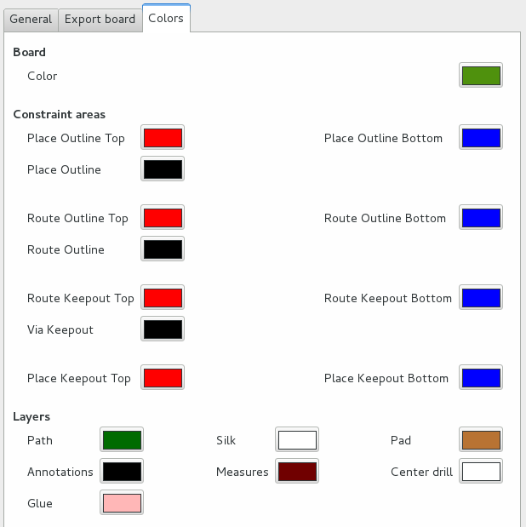

Download models
Download model window appear in Task tab. Mentioned window contains links to sites when You can
download for free 3D models.

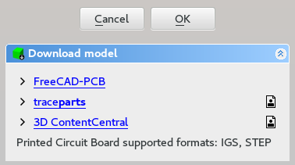
Icons definition:
Registration is necessary to download models

Printed Circuit Board workbench supported formats:
- IGS,
- STEP - at this moment colours are supported only for step files saved/created in FreeCAD. So to avoid
problems with colours create part in FreeCAD or open an existing component in FC (made in another
program) and save it as step with colours.

There is also possibility to search for concrete model. To do this just right click on missing model in specification tree and choose PCB model → Find model on-line.

It is recommended to keep parts outside PCB folder - to avoid data lost.

Default path is set on folder ‘/parts’, which is placed in main PCB workbench folder.

To add/remove paths you need to open Preferences window. More info you can find in section Customizing workbench.

Assign models
Window 'Assign models' allow for assigning 3D models to corresponding part from one of supported
software.

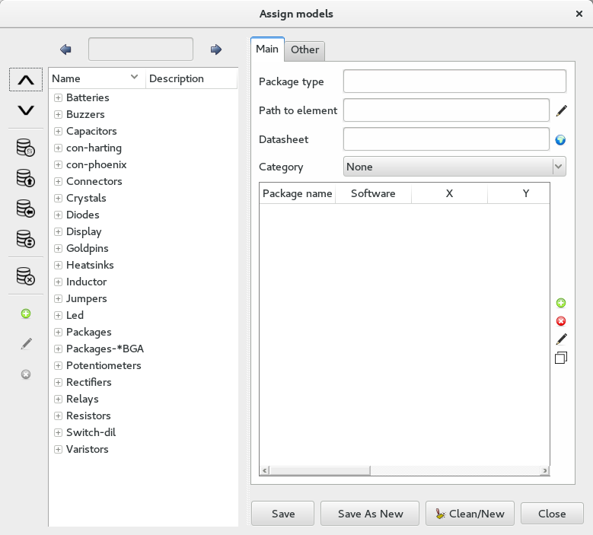
Window comprises two main columns. Left column comprises function necessary to manage parts in database. While right side comprises form where you can set (or edit) package data.

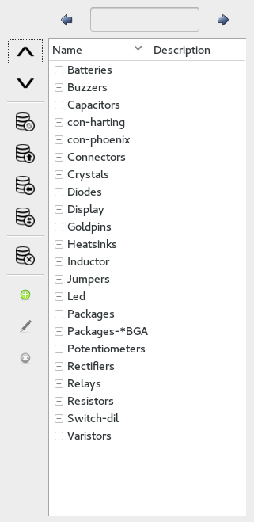
Search block contains prev/next button and entry field for search term

Collapse/Expand all items from Package list

Reload database

Import new entries from different database file

Create database copy

Convert models from one software to another

Delete selected models from database

Manage Categories:
- add new category
- edit existing category
- remove selected category

Package list contains categories /parts names and their description

Categories are stored directly in FreeCAD. Tools → Edit parameters => Preferences → Mod → PCB and variable partsCategories

After deleting model from database it is not possible to undo this operation!

Basics setting

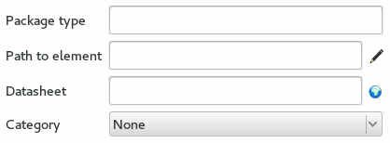
Package type is model name (any text)

These field contains relative or absolute path to 3D model

Optional parameter: path to part datasheet (web site or local file)

Set category for model

From version 3.9 it is possible to set paths in gui.
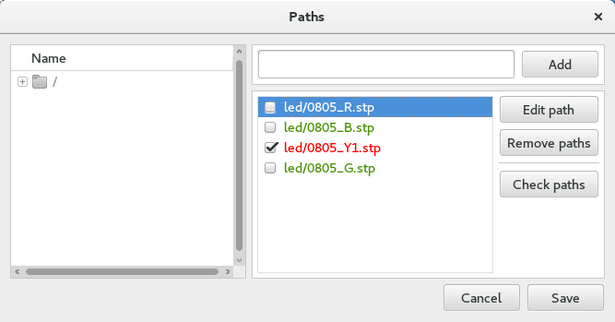

To add new 3D model (relative/absolute path) just choose model from left list or type directly in specified field and click Add button.

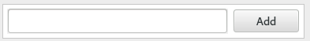

During initialization special function will check if saved before paths are still existing.  Green color means that the path is correct, while red means that something is wrong.  To check new paths you need to click button 'Check paths'. | 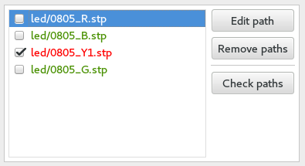

Adding equivalent package for 3D model

First sections contain all package parameters, from one of supported softwares, necessary to load specific 3D model. | Buttons from right side will helps You in adding new /deleting or editing  entries.  After clicking button 'Add' special window will appear, that allow You to set parameters for new package.  After clicking 'Edit' button will appear window, that will contain all settings for current selected model.  Clicking 'Delete' button will delete from database selected entry.  Last button allows you to copy existing entry and save it in database under new name.
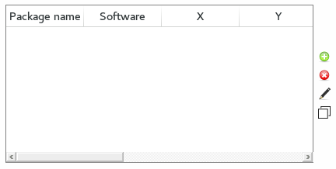

Adding new package.

This field contains package type name taken from software used by You to create PCBboards.  From drop-down list You need to choose software name for with this entry will be connected.  X, Y, Z, RX, RY, RZ parameters are correction values used to correctly placement 3D model. | 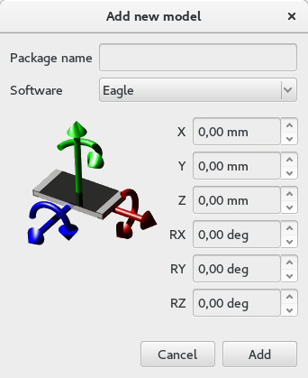

Adjust part name/value
Option 'Adjust part name/value' allows to automatic placing objects name/value in specific position.

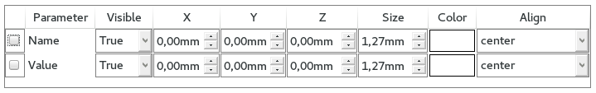
Example:
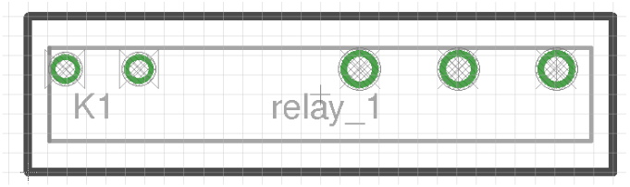
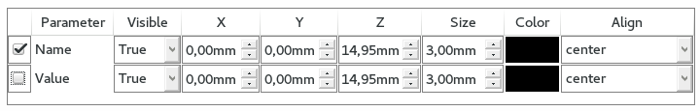
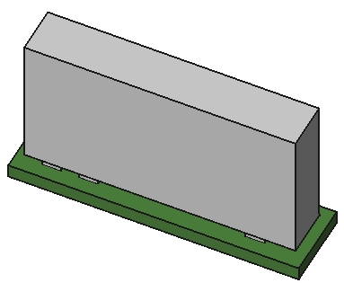 | 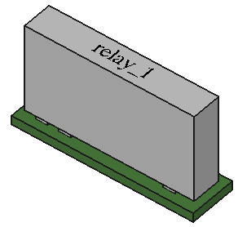
Result without option 'Adjust part name/value' | Result with option 'Adjust part name/value'

Set socket for model
To add socket for model just mark checkbox for 'Add socket' and from drop down list choose socket 3D model name. In drop down list You will find only models marked before as sockets. | 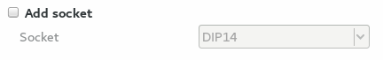

Set model as socket
To set model as socket just mark checkbox for 'Set as socket' sign. In spinbox specify socket height. | 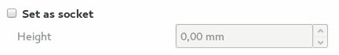

Footer from right column contain buttons to saving form entries to database.
Save button will save form as new entry in database or will update package parameters (in edit mode).  'Save as new' will save existing entry in database under new package name.  'Clean/New' button clean form.  Close button will appear only for GNU/Linux users. | 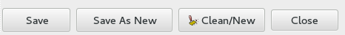

Example of adding part to database
In Eagle we prepared board containing one part: R1 SMD resistor 2k in package 1206.

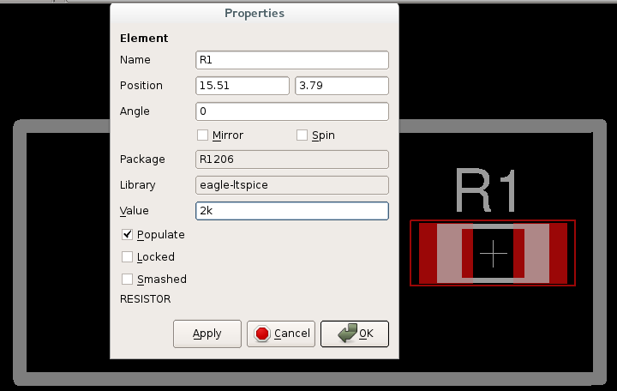
Open 'Assing models' window and:
- In 'Package type' field write resistor_smd_1206. Package name is free text.
- In 'Path to element' write resistors/R1206.
Model extension. resistors/R1206 mean that script will search at first file R1206.igs and then R1206.stp, so course path to element can also ook like resistors/R1206.igs or resistors/R1206.stp.
resistors/R1206 – script will search model in one of relative paths set in configurations.
- Datasheet field may remain empty.
- Package category may remain as 'None'.
- Next step explains how to add new 'connection' between 3D model and part added on board.

To create board we use Eagle so in 'Package name' we should give value shown next to 'Package' field from part properties window in Eagle  Software field we set on Eagle.  That mean all parts R1206 from board, created in Eagle will be connected with 3D model R1206.igs/.stp.  Each part is placed in space  (X, Y, Z, RX, RY, RZ). Parts specified in Eagle contains only X, Y and rotation around Z axis. Sometimes is necessary to set some correction values to achieve specified in board part position – these values dependence from used 3D model. | 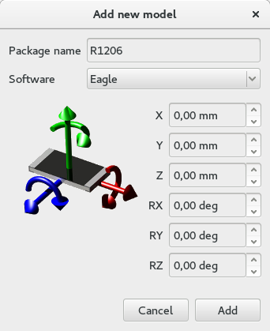

- Click add button.
- This model is not socket and doesn't contain it, so we will skip specific checkboxes.
- To save form in database click button 'Save'.
- Thats all, now just reload board or update 3D models for R1206 packages.

Multi model definition for one part
There is a possibility to set more than one 3D model for one package. To do this just split path to all models by
character ';' in field 'Path to element'.

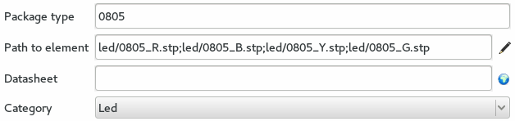

This function is useful for parts which only different is color – the same correction values are set for all models. For packages where we set multi models, special window will appear during board loading or parts updating.

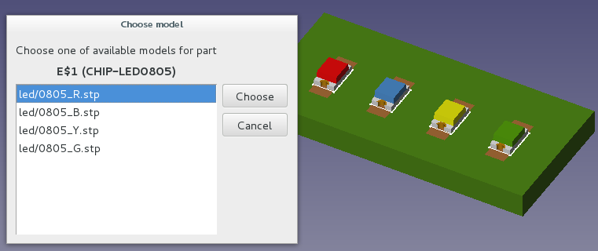

Open/Import board
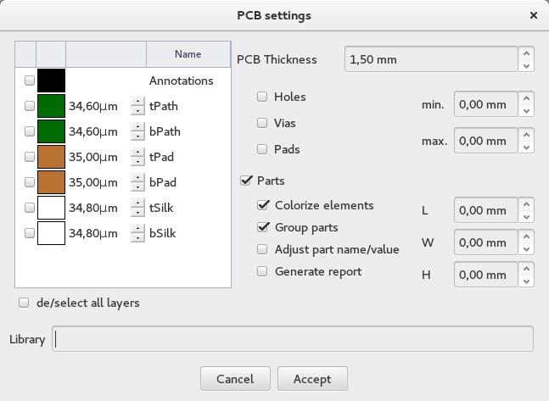
During open/import process special window will appear, in which we can set basic parameters of the board.
1
2
3
4
5

- In first section You can choose, which layers will be loaded. Available layers depends from loading file type. Layer name and color are editable.
- This section allow You to set PCB thickness. If file contain board thickness this value will be displayed in this field. Default value is 1.5[mm].
- Third section contain basic settings about importing holes. Here You can decide what type of holes You want to import (hole/vias/pads) and set imported holes diameter range (min/max). Both parameter can be set separately.
- Fourth area contains basic settings about importing parts. Here You can decide if You want to import parts, decide if they should contain colors, etc. Fields L/W/H allow You to decide about minimum length/width/height of 3D models which will be imported. All three parameter can be set separately.

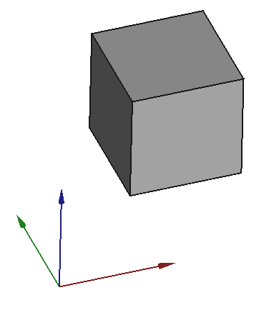

Option 'Adjust part name/value' allows to automatic placing objects name/value in specific position. This option is connected with functions from 'Assign window'.

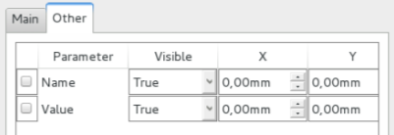
- In some cases it is necessary to define path to specific program libraries.

Unit system
During board loading process units are changed to millimeters [mm].
Below You can find information, which part of imported files are supported by Printed Circuit Board workbench.

Soft name | PCB
Soft name |  | Holes/Vias | Parts | Border | Measures | Soldermask | Keepout layers | Paths | Pads | Soldermask ARC | PCB round corners | Annotations
Eagle | brd
gEDA | pcb
FreePCB | fpc
KiCad | kicad_pcb
ZenitPCB | zpc
TARGET 3001! | t3001
FidoCadJ | fcd
SCOOTER
Razen | rzp
IDF v2 | idf
IDF v3 | idf
IDF v4
TurboPcb | apcb
DipTrace | asc
HyperLynx | HYP

Yes
No
Never
In progress
Future

Grouping parts
These options allow you to group/ungroup parts, according to Category they belong.

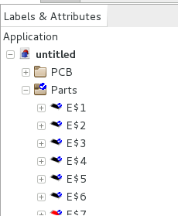 | 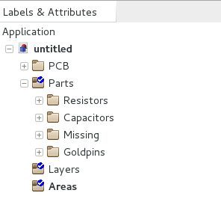
Ungrouped parts | Grouped parts

These options are also available in:
- open/import window,
- update parts window,
- add new model window.

Display modes
Display modes function can quickly and in easy way change display representation of shapes in project.

Available types:
- Shaded: border lines are hidden.

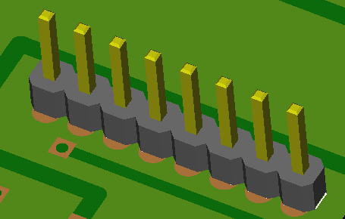
- Flat lines: surfaces and border lines are displayed in one time.

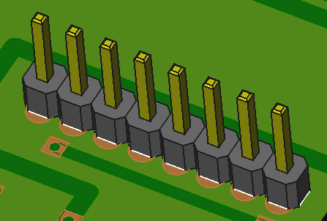
- Wireframe: only border lines are displayed.

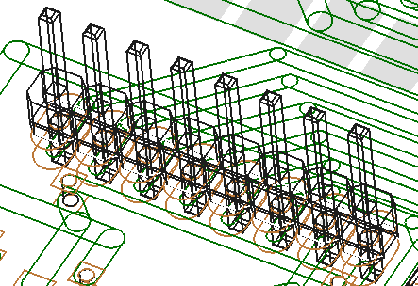
- Internal View: for board only border lines are displayed, rest is displayed in Flat lines mode

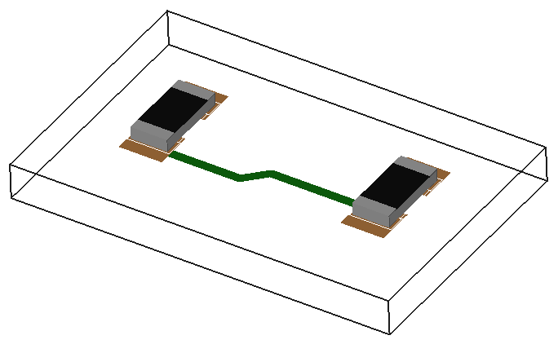

Layers
Layers settings windows help in managing of currently displayed board layers. Layers settings window appear in Task tab.

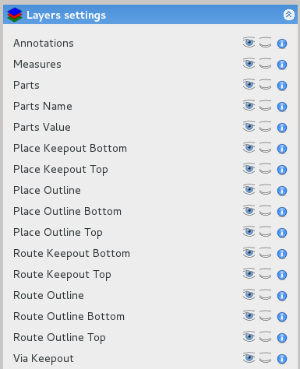
Each line consists of four parts:
- Layer name,
- Button Show All – show all objects of this type,
- Button Hide All – hide all objects of this type,
- Information button – display information about layer.

Python
To manage layers by Python You need to import PCBlayers.
This module contain few functions:
- display(TypeId): display layer with a given ID
TypeId: specific list
- blank(TypeId): blank layer with a given ID
TypeId: specific list
- toggle(TypeId): toggle visibility state of layer with a given ID
TypeId: specific list
- state(TypeId): plirt state of layer with a given ID
TypeId: specific list
- list(): return list of all available layers
'layerName: {'info': 'info', 'id': TypeId}
- listTXT(): print all available layers
Example:
import PCBlayers as layer
lay = layer.list()
lay = lay["Annotations"]['id']

layer.blank(lay)
layer.state(lay) # False
layer.toggle(lay)
layer.state(lay) # True

Update models
Update models window will reload/load 3D model/settings for used in project components.

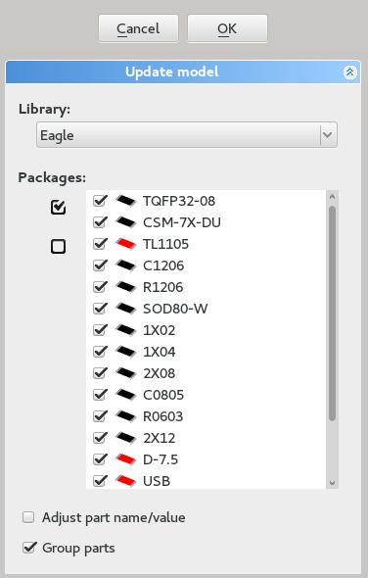
1
2
3
Update models tab contain three sections:
- Library: during update process, script will search settings (eg. X, Y, Z values) in specific library,
- Packages: contain listbox with used in project components. Checked checkbox next to model type mean that this part will be updated.
- Configuration options:
  - Adjust part name/value – set Name/Value annotation values according to settings set in database.
  - Group parts: grouping parts in tree according to Categories.
When selected component does not appear in specified library, model will be not updated.

Cut to board outline

Sometimes it is necessery to display board like it will look after manufacturing. To do this just use option 'Cut to Board Outline'. Function will automatically blank/display all layers/paths that are outside of the board.

Example

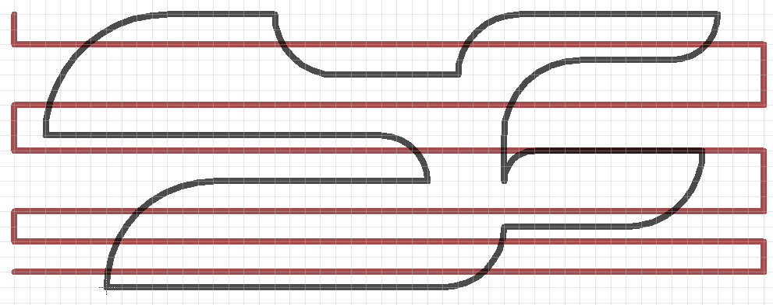
Board created in Eagle
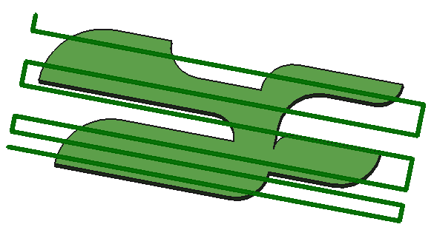
Cut to Board Outline = OFF

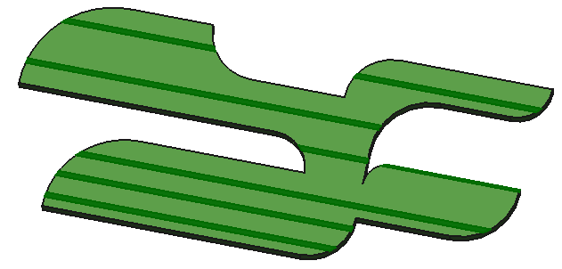
Cut to Board Outline = ON

Explode
Explode function allows for assemblies to be quickly disassembled and shown in an exploded view.

Explode contains two similar functions:
- Fast explode: automatically explode all printed circuit board parts.
- Explode: user selects which parts and how will be relocated.

This task shows you how to manually create a explode object.
- Load PCB and click Explode button

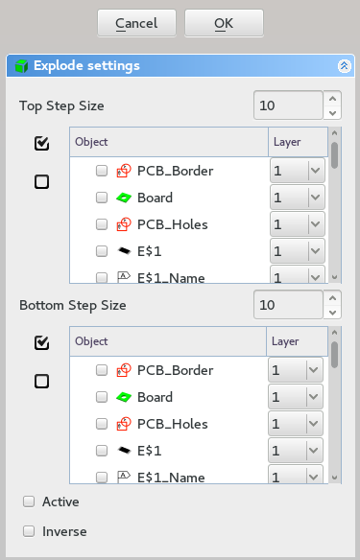
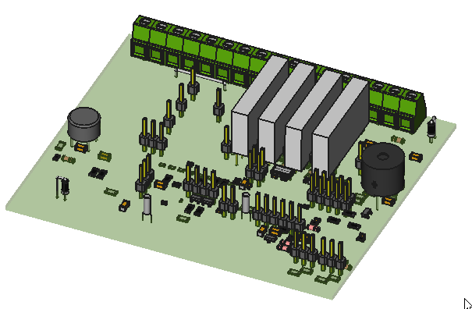
Board before exploding

- Set Top step size

Top step size determines distance between next levels.

- Choose parts – top side

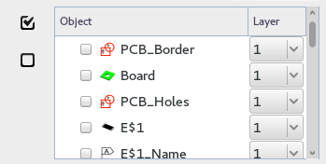
Selected parts will automatically disappear from the bottom list.

Layer parameter is a number, that will be multiplied by Top step size to determine new Z position for part after explode

- Set Bottom step size

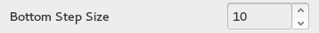

Bottom step size determines distance between next levels.

- Choose parts – bottom side

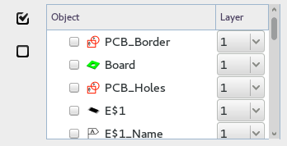
Selected parts will automatically disappear from the top list.

Layer parameter is a number, that will be multiplied by Bottom step size to determine new Z position for part after explode.

- Active
If this option will be checked explode object will be activated automatically after creation.

- Inverse
To reverse top and bottom side check this option.

- Click Ok button to finish

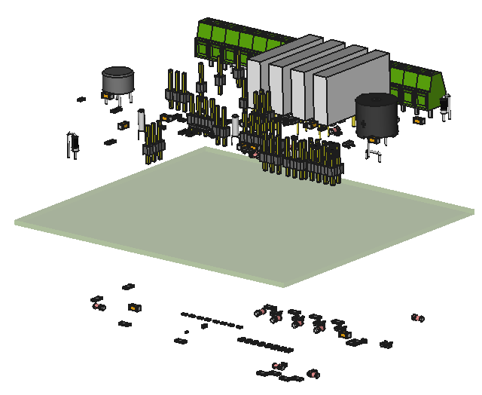  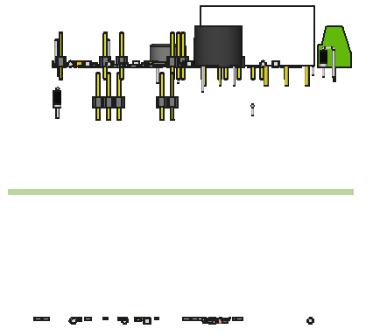 | 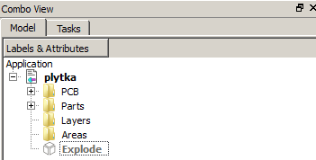

Fast explode function automatically splits parts between top and bottom layers.

Bounding box
Bounding box is a smallest cuboid completely surrounds the object.

Printed Circuit Board workbench contain two function to generate bounding box:
- Bounding box – generate box for all board (board, parts, paths),
- Bounding box from selection – generate box for selected components.

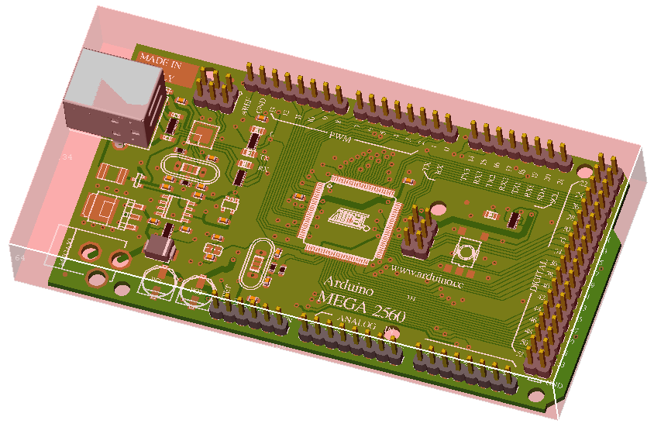
Bounding box generated for whole board

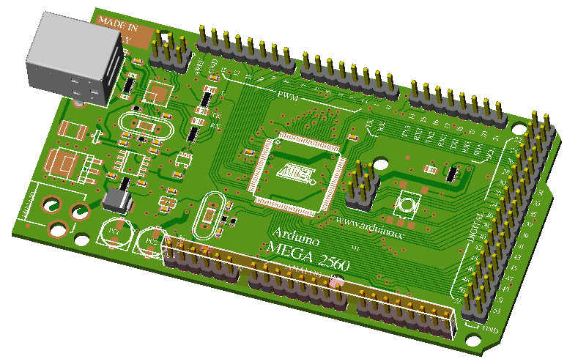
Bounding box generated for selected components

Generated boxes are normal cubes so it is possible to work on them in FreeCAD.

You can generate as many bounding boxes, as You need.

Python
To create bounding box by Python You need to import PCBboundingBox

This module contain few functions:
- boundingBox(): create bounding box for whole board.
- boundingBoxFromSelection(): create bounding box for selected objects.

Example 1:
import PCBboundingBox as box
box.boundingBox()

Example 2:
import PCBboundingBox as box
a = box.boundingBox()
a.Length # 179.546 mm
a.Width # 104.27 mm
a.Height # 2.155 mm

Create new project
Before starting project it is recommended to press Create new project button. It will create necessary groups in Specification Tree used later by script.

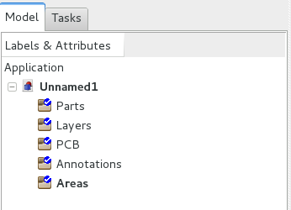

Meaning of groups:
- Areas: group will store constraint areas,
- PCB: group will store board object,
- Layers: group will store layers,
- Parts: group will store all parts used in project,
- Annotations: group will store annotations.

It is recommended to press Create new project button before starting project, but it is not necessary – script will check if specific group exist and, if desired will create it.

Python

To manage groups by Python You need to import PCBgroups module.

This module contain few functions:
- createGroup_Parts(): create Parts group.
- createGroup_Layers(): create Layers group.
- createGroup_Annotations(): create Annotations group.
- createGroup_Areas(): create Areas group.
- createGroup_PCB(): create PCB group.
- setProject(): create all available groups.

Example:
import PCBgroups as group
pcbG = group.createGroup_PCB()
pcbG.Label() # u'PCB'

Create PCB
This task explains how to create a board and design its geometry from scratch.

  - Create Sketcher with contour of fthe boaard

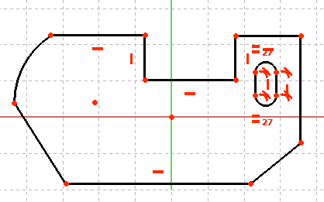

  - Create new Sketcher with holes

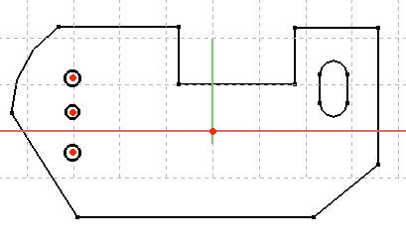

  - Click the Create PCB button
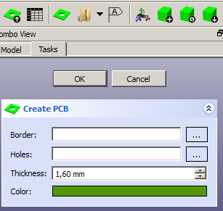

  - As Border point to Sketcher with contour of fthe boaard

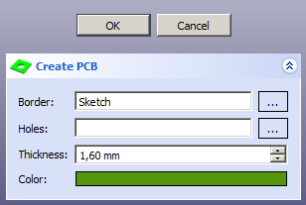
  - As Holes point to Sketcher with holes

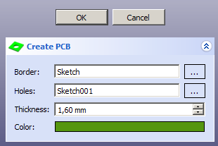

  - Set board Thickness
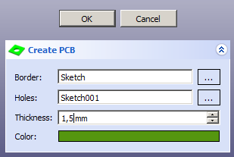

  - Set board Color
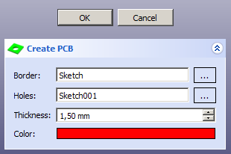

  - Click OK button to finish

The board should be generated according to settings. The board has been created from scratch.
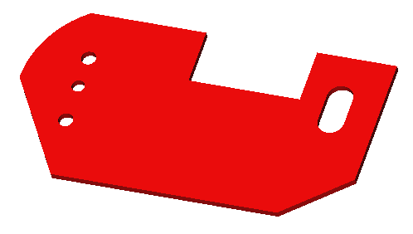
Only one board can be generated per project

Even if there will be no holes in board, proper Sketcher need to be done

It is not possible to create board from a previously created part

Add models
This task explains how to add new component to existing board.

- Click button Add model

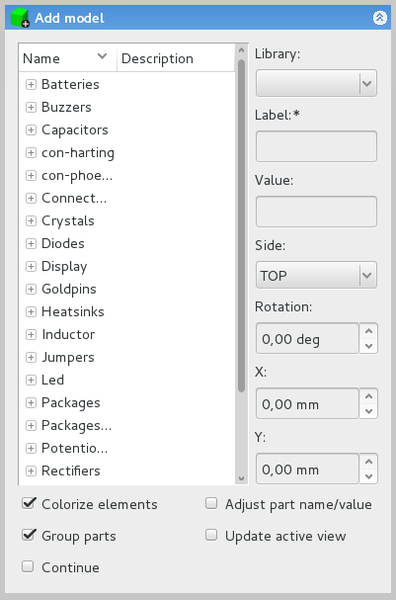

- Select package – model type

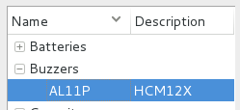

- Choose from drop-down list, from which library script should take settings

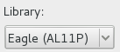

- Write component name
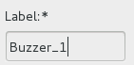

This field is mandatory

- Add value

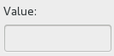
- Choose side for new component on board
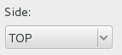

Component will be automatically rotated according to chosen side.

- Set rotation value (rotation around Z axis)

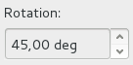
Value is in degrees.

- Set values for X, Y coordinates

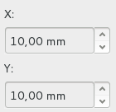

Distance is measured from 0, 0 in 3D window. Actual position (model center) is representing in 3D view by red 'arrow'

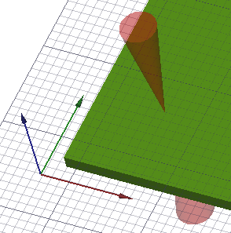
10, 10
0, 0

- Click Ok button to finish

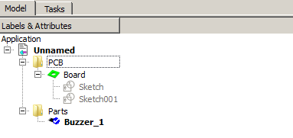
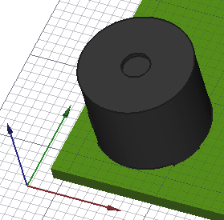

Add model tab contain five configuration options:
- Colorize elements: there is possibility to add models in two modes – with colors and without.
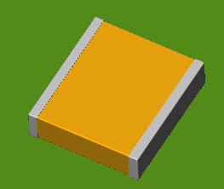  Model added with option 'Colorize elements' | 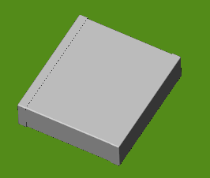  Model added without option 'Colorize elements'

- Adjust part name/value – set Name/Value annotation values according to settings set in database.
- Update active view: view in 3D window will automatically switches between TOP/BOTTOM view, dependency which side will be chosen.
- Group parts: grouping parts in tree according to Categories.
- Continue: normally after click Ok button Add modal window disappears, to avoid that (You want to add more than one object) just mark this option.

Add annotations

Create glue paths

Create constraints areas

Export board

Export bill of materials (BOM)

Export hole locations

Export hole locations report

Create drilling map

Create drill center

Add assembly

Update assembly

Collision detection

Export to Kerkythea

Export object to POV-Ray

Objects properties

File format

Scripts

Errors code

Licence

Changelog

ToDo list

Errors

