 | Printed Circuit Board Workbench for FreeCAD (PCB)  marmni (marmni@onet.eu)  Copyright 2013-2019
- https://github.com/marmni/FreeCAD-PCB
- https://sourceforge.net/projects/eaglepcb2freecad/

INTRODUCTION

Printed Circuit Board Workbench for FreeCAD. Workbench allows you to:
- Importing boards created in various dedicated PCB softwares. Layers/colors are supported. Supported softwares:
  - Eagle (*.brd),
  - FreePCB (*.fpc),
  - gEDA (*.pcb),
  - KiCad (*.kicad_pcb),
  - IDF v2/v3.

- Creating and exporting boards to various formats. Supported formats:
  - Eagle (*.brd),
  - FreePCB (*.fpc),
  - gEDA (*.pcb),
  - KiCad (*.kicad_pcb),
  - IDF v2/v3.

Workbench supports 3D models saved in one of the following formats:
- IGS
- STP/STEP

Supported software (importing)

Soft name | PCB
Soft name |  | Holes/Vias | Parts | Border | Measures | Soldermask | Keepout layers | Paths | Pads | Soldermask ARC | PCB round corners | Annotations
Eagle | brd
gEDA | pcb
FreePCB | fpc
KiCad | kicad_pcb
FidoCadJ | fcd
Razen | rzp
IDF v2 | idf
IDF v3 | idf
IDF v4
HyperLynx | HYP

Yes
No
Never
In progress
Future

Requirements

FreeCAD-PCB require FreeCAD in version 0.18 (or newer) and Python 3.6 (or newer). Module was tested on Windows and GNU/Linux.

INSTALLATION

There are two method to install workbench: manually and by FreeCAD-addons manager. Second solution is recommended.

Manually
Unpack downloaded zip file from github/sourceforge and copy extracted folder to direction where FreeCAD is installed (subfolder Mod).

- GNU/Linux
On GNU/Linux distributions better do not keep PCB workbench folder under standard FreeCAD installation path (often under /sys path). This is connected with root permissions. Better idea is to keep it under /home directory.
Go to your user directory ‘/home/userName’ and display all hidden folders. Search for .FreeCAD. Under this directory you should find subfolder ‘Mod’

/home/userName/.FreeCAD/Mod

So move PCB main folder to ‘home/userName/.FreeCAD/Mod/’.

Next change read/write permissions to 777 (also for subfolers).
chmod 777 -R PCB

- Windows

For example.
FreeCAD is installed under path:
C:/Program Files/FreeCAD-0.18

So move PCB folder to:
C:/Program Files/FreeCAD-0.18/Mod

Next change read/write permission for all users. Click right button on folder PCB and
choose Properties ➝ Security ➝ Edit ➝ Users and mark all checkboxes under ’Allow’ option.
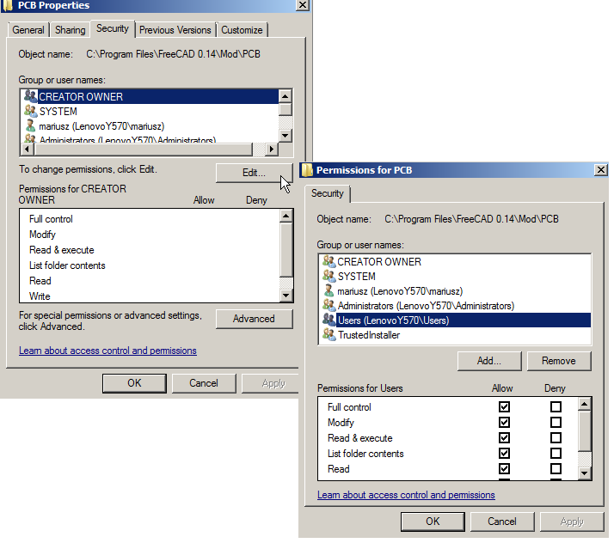

FreeCAD-addons
FreeCAD-addons is a standard part of FreeCAD which allows you to automatically implementing new workbenches/macros for FreeCAD. You will find it in main menu.

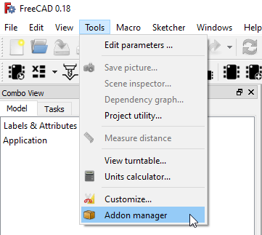

Next search for 'pcb' and click Install/update - that's all.

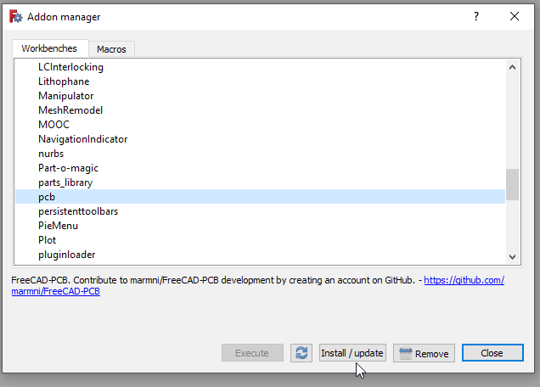

CONFIGURATION

Most of variables/parameters are stored in FreeCAD configure files. You can find a parameter editor in main menu
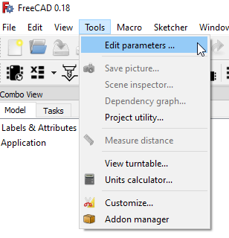

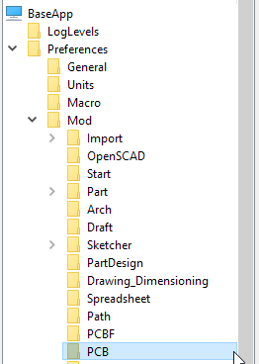

 |  | 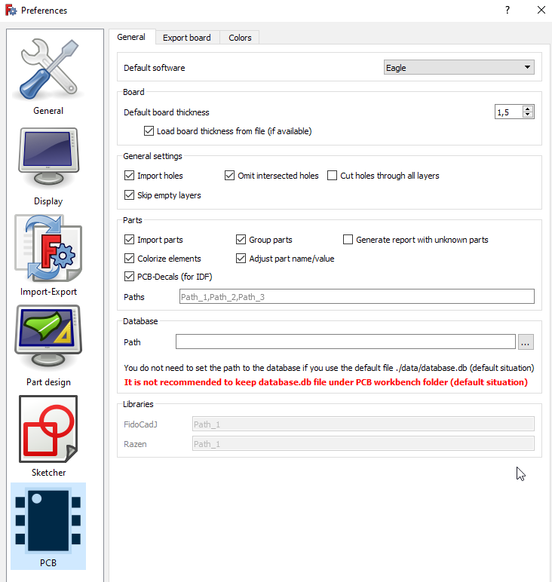  It is not recommended to change them by parameters editor. All entries are available under Preferences window – more user friendly solution.

You can easily import/export them by ‘Parameters editor’ or in window ‘Assign models’.

 |  | Do not change anything in file ‘PCBconf.py’.

PREFERENCES SECTION
Workbench is fully configurable - you can set various variables which are directly connected with importing/exporting PCB boards. All setting are automatically stored in FreeCAD so you need to set them only once (of course you can change them also whenever you want).

In main menu choose Edit → Preferences.

Set PCB module as main workbench
There is a possibility to set PCB module as main workbench. To do this choose General. Under tab ‘General’ you should find 'Start up' section, where you can set which workbench should be loaded after FreeCAD start.

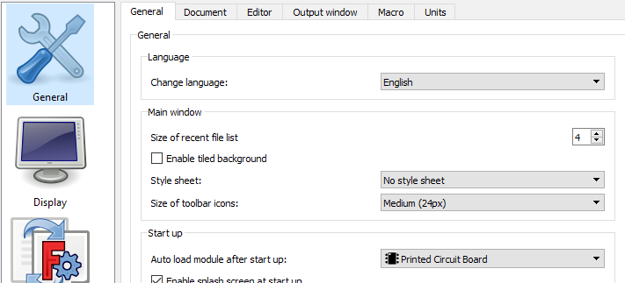
Click ‘Apply’.

PCB workbench settings
In section PCB you can find variables which are directly connected with importing/exporting PCB boards. They are arranged under three tabs:
- General
- Export board
- Colors

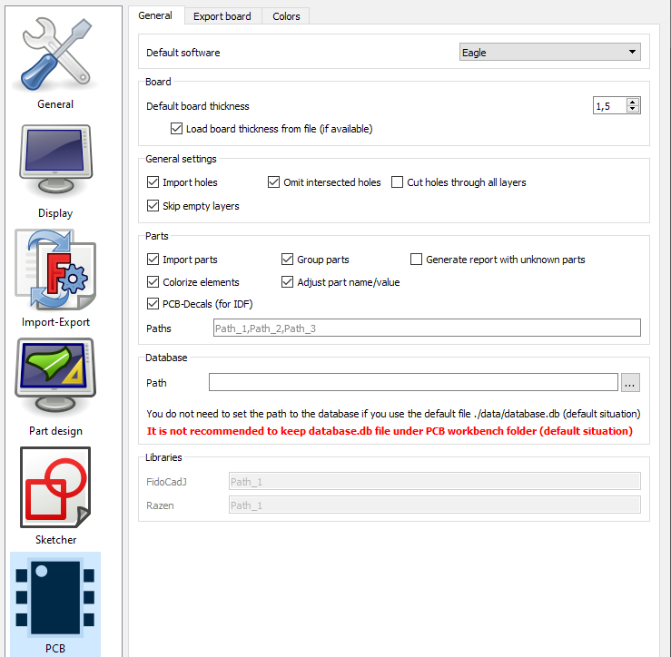

General
In this tab all settings are arranged under six sections.

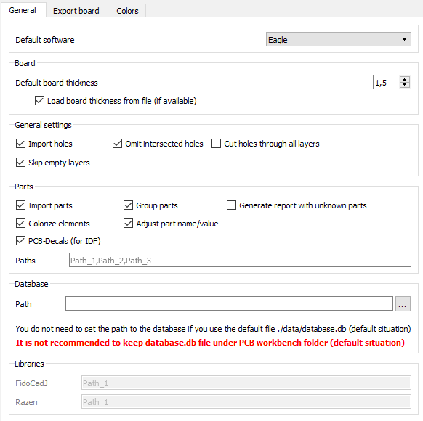
1
4
3
2
5
6
1 | Set default software which you are using.
2 | Set def. boart thickness (parameter can be changed even after importing the board)
3 | Import holes – import holes from file (if checked)  Omit intersected holes - to avoid problems during loading PCB board option should be always checked  Cut holes through all layers – it is possible to show/hide holes in layers (for example paths/pads, parameter can be changed even after importing the board)  Skip empty layers – this option decrease time necessary to generate 3D representation of the PCB board – empty layers will not be generated
4 | Import parts – import or skip 3D models of the parts  Group parts – group imported 3D models in categories  Generate report with unknown parts – if 3D representation for imported package will not be recognize yoy can generate report (txt file) which will contain missing 3D models  Colorize elements – import also color from IGS/STP files  Adjust part name/value -  PCB-Decals – check this option if you will import IDF files  Paths – add here a path under which you are storing 3D models. Do not change anything (leave empty) if you are using standard localization (PCB/parts) . Separate paths by comma
5 | Path – path to database.db file (only one). Do not change anything (leave empty) if you are using standard localization (PCB/data/atabase.db)
  It is not recommended to keep database.db file under PCB workbench folder (default situation)
6 | Libraries – for future

Export board
Here you can set default layers that will be exported to a specific format
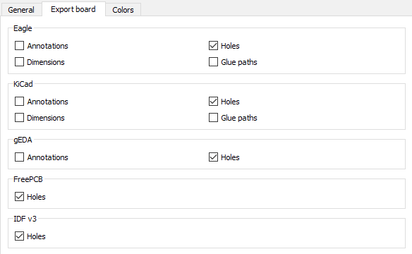

Colors
Default colors for imported layer.
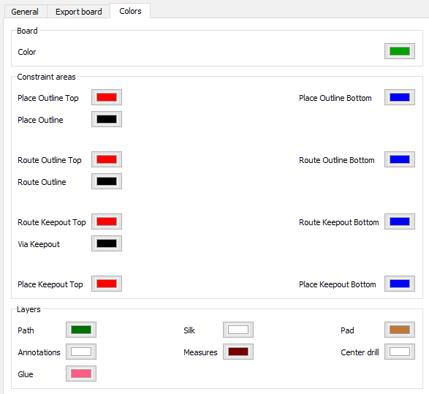

ACCESSING THE WORKBENCH
There are two methods to access to the PCB workbench:

- On toolbar ’File’ locate drop down list and choose ’Printed Circuit Board’.

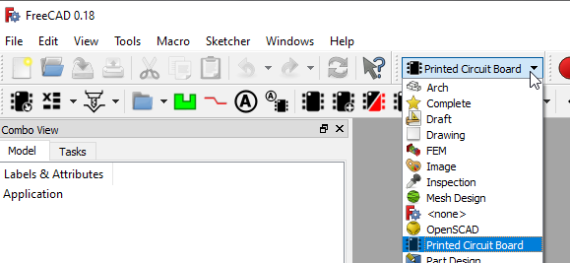

- From top menu bar choose View ➝ Workbench ➝ Printed Circuit Board.

MENU BAR
There are no menu bars dedicated for PCB workbench.

TOOLBARS
Two special toolbars for PCB workbench are available:
- PCB View.
- PCB Settings.

This section describes the various icons available in mentioned toolbars.

PCB View toolbar
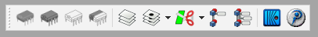

PCB Settings toolbar

Displaying toolbars
When mentioned toolbars are not displaying after choosing PCB workbench in main FreeCAD
window, you need to do it manually. From top menu bar choose View ➝ Toolbars and mark
toolbars from Printed Circuit Board workbench.

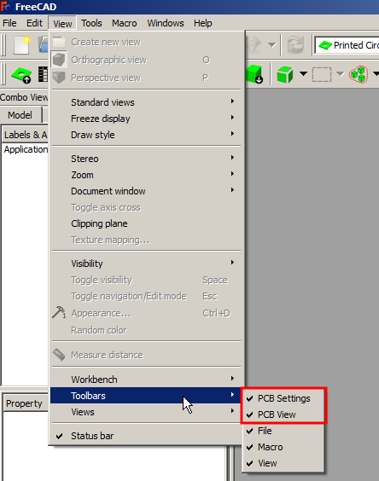

SPECIFICATION TREE
There are few object types directly connected with PCB workbench. They can be identified
in the ’Combo view’ by the specific icons.

For some object context menu is available.
 | Explode objects | - Edit
 | 3D representation founded in database | - Update model  - Placement model
 | 3D representation not founded in database | - Assign model  - Update model  - Find model on-line

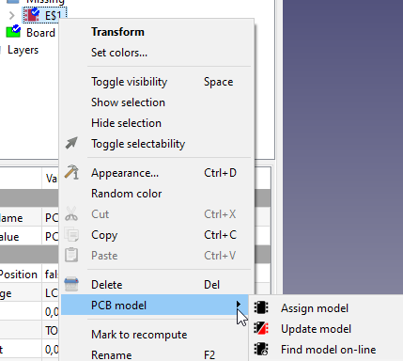

 | 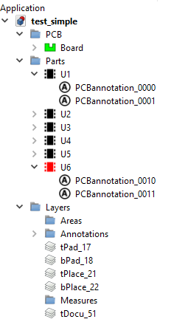  Board
 | Constraint area
 | Explode objects
 | Layer
 | 3D representation founded in database
 | 3D representation not founded in database
 | Annotation/Object Name/Object Value
 | Glue path

OBJECTS PROPERTIES
Each object created in PCB workbench has unique parameters that can be set in Property
View (View or Data tab).

Board
Group: all objects which are directly connected with board  Display Holes: show/blank holes  Holes: reference to sketch that containing holes  Border: reference to sketch that containing board outline  Thickness: board thickness | 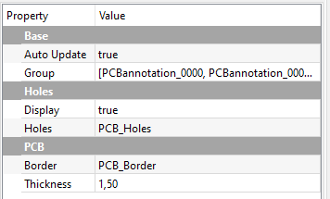

Constraint area
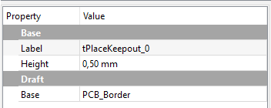
Height: area height, parameter available
only for some constraints areas type (on TOP/BOTTOM side)

Base: reference to sketch that containing area outline

Explode objects
Active: turn of/off explode effect  Bottom Step Size: distance between  parts placed on bottom side of board  Inverse: switch exploded parts from  top to bottom and conversely  Top Step Size: distance between parts  placed on top side of board. | 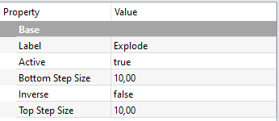

Layer
Cut: show/blank holes  Cut To Board: cut shape to board outline | 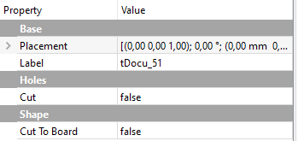

Glue path
Base: reference to sketch that containing  glue path shape  Flat: if this parameter is set to True,  object will ignore Width/Height parameters  Height: glue path height  Width: glue path width  Length: glue seam lenght (for specific W/H)  Volume: for specific W/H | 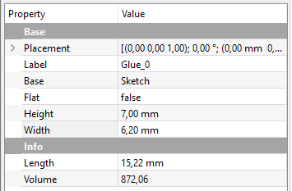

Part model founded in database
Part Name: reference to part name object  Part Value: reference to part value  object  Keep Position: part will ignore changes in  correction values if this value will be set to  True  Package: 3D model name, parameter  disabled for editing  Rot: rotation value around Z axis  Side: part position on board (top/bottom side)  Socket: socket height / model position in Z direction  X: model position in X direction  Y: model position in Y direction | 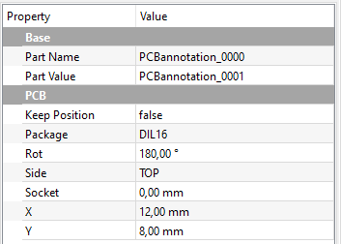

Part model not founded in database
Part Name: reference to part name object  Part Value: reference to part value  object  Keep Position: part will ignore changes in  correction values if this value will be set to  True  Package: 3D model name, parameter  disabled for editing  Rot: rotation value around Z axis  Side: part position on board (top/bottom side)  Socket: socket height / model position in Z direction  X: model position in X direction  Y: model position in Y direction | 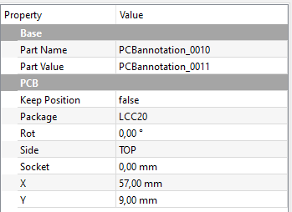

Annotation/Object Name/Object Value
Font: font name  Font file: it is possible to use own font  Justification: text position according to X, Y  values  Line distance: distance between lines (in % according to fonf size)  Size: font size  Spin: if parameter set to True text  will keep rotation, parameter works for  angle value >= 90deg  Text: text displayed by annotation object  Tracking: distance between letters  Rot: rotation value around Z axis  Side: text position on board (top/bottom side)  X: text position in X direction  Y: text position in Y direction | 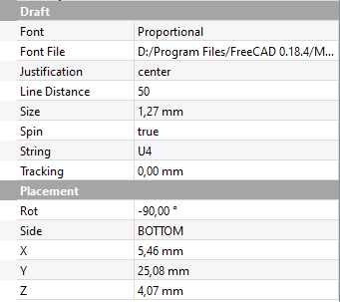

3D MODELS
Workbench comes without 3D model so it is necessery to dowload them separatelly. You can bring up the ‘Download models’ window from the PCB Settings toolbar. Mentioned window contains links to sites when you can find free 3D models.

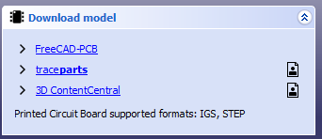


Registration is necessary to download models

There is also possibility to search for concrete model. To do this just right click on missing model in specification tree and choose PCB model → Find model on-line

Models from FreeCAD-PCB (github site) are directly connected with default database.db file.
To add/remove paths you need to open Preferences window. More info you can find in section Customizing workbench.
Workbench supports 3D models saved in one of the following formats: STP/IGS
Default path is set on folder ‘/parts’, which is placed under main PCB workbench folder.
It is recommended to keep parts outside PCB folder - to avoid data lost durimg workbench update.

ASSIGN MODELS
It is necessery to assign 3D models and specific packages after downloading new components (not applicable for models downloaded from FreeCAD-PCB site).

You can bring up the ‘Assign models’ window from the PCB Settings toolbar.
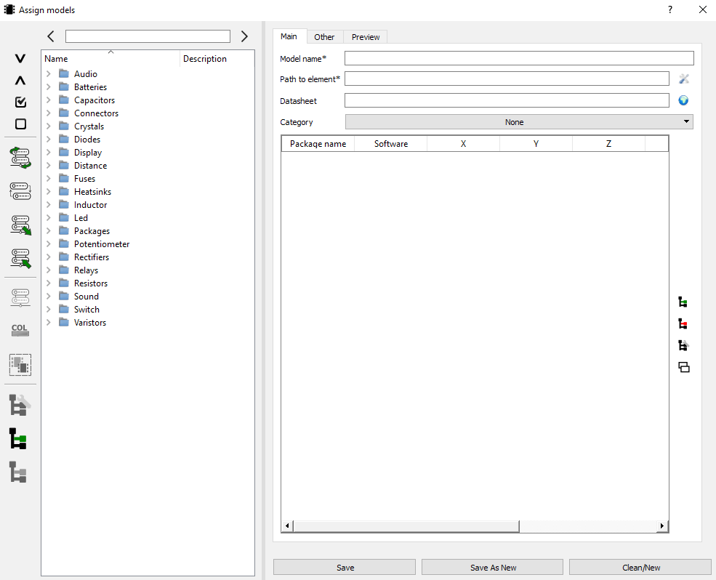
Window comprises three main columns.
- left column contains functions necessary to manage parts in database

Collapse/Expand all items from Package list

Check/uncheck all items from Package list

Reload database

Convert packages between softwares

Export database copy

Import database copy

Delete all selected packages from database

Delete *.col files for selected packages

Set one category for selected models

Add/edit/delete category

- middle colum contains list of all categories/packages saved in the database
Search block contains prev/next button  and entry field for searching specified package  All models are grouped under categories (blue folder). | 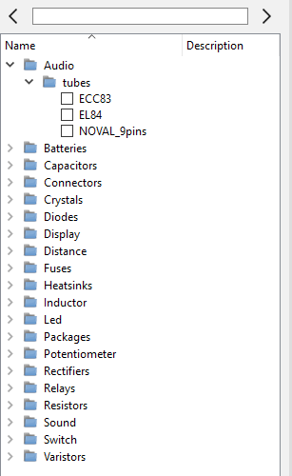

- right columns allows to view/edit parameters for selected package. Area is splitted to three main blocks:
  - Main parameters
  - Other parameters
  - 3D model preview

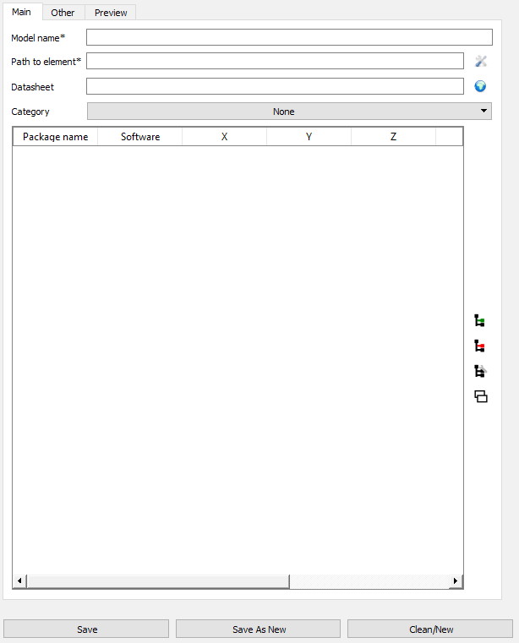

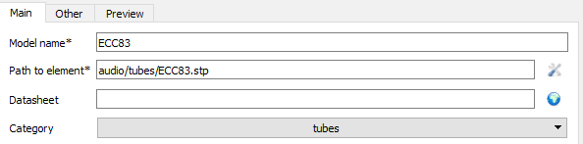

- Model name: any name for model
- Datasheet: you can specific path to datasheet for package (url or path to pdf file)
- Category: define under what category model will be placed. To keep it withoud category select ‘None’
- Path to element: path to assignet 3D models – it is available to assign more then one 3D representation for one model. To add/edit/delete path click button on the right – new window will appear
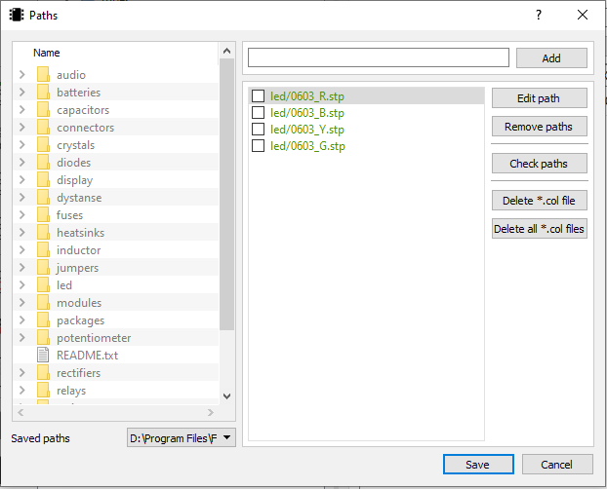
To add new 3D model just select it in the list on the left and click ‘Add’.
Option ‘Check paths’ will check if previously picked paths still exist (green color → YES, red color → NO).

If 3D model is under one of pre definied paths (in PCB Workbench preferences) you will see only relative path (no absolute).
If something will be not ok with model after loading board (for example no colors) or model will not automatically update despite the new 3D file use function ‘Delete *.col file’.
Workbench supports 3D models saved in one of the following formats: STP/IGS

Multi model definition for one part
This function is useful for parts which only different is color – the same correction values are set for all models.
For packages where we set multi models, special window will appear during board loading or parts updating.

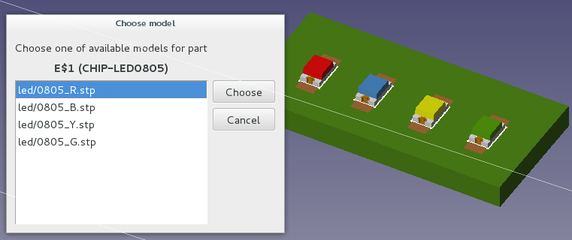

For each model you can define as many packages as you need (there are no limits).
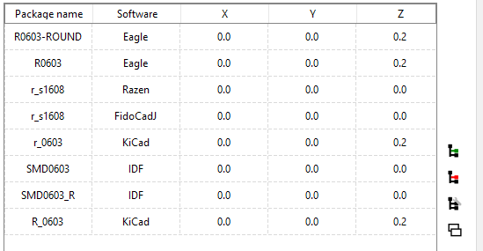

Buttons from right side will helps you in managing packages:
- 'Add' special window will appear, that allow you to set parameters for new package.
- 'Edit' button will appear window, that will contain all settings for current selected model.
- 'Delete' button will delete from database selected entry.
- Last button allows you to copy existing entry and save it in database under new name.

Package name is strictle connected with software wich from PCB files comes

This field contains package type name taken from software used by you to create PCB boards.  From drop-down list You need to choose software name for with this entry will be connected.  X , Y, Z, RX, RY, RZ parameters are correction values used to correctly placement 3D model | 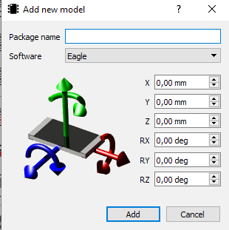

For example:
Package name = DIL16
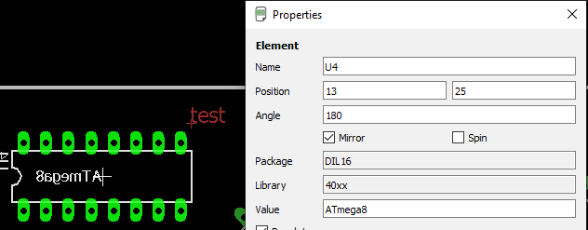

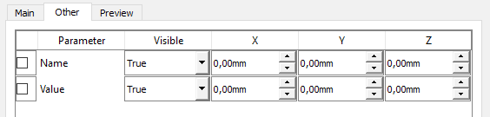

Option 'Adjust part name/value' allows to automatic placing objects name/value in specific position.

Example for DIL16:

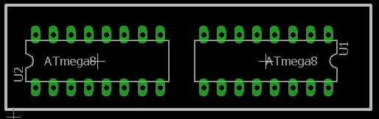

Board created in external software.

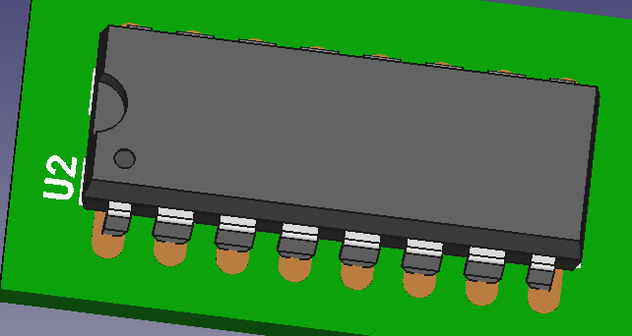 | 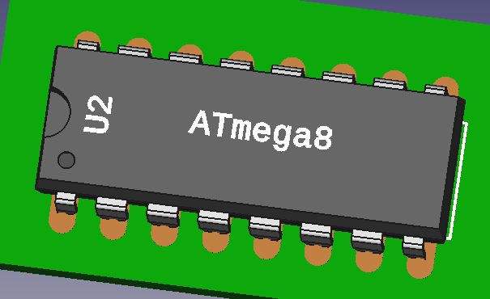
'Adjust part name/value' = OFF | 'Adjust part name/value' = ON

Board view after importing to FreeCAD.
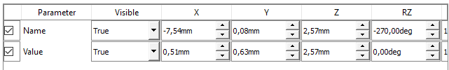
Parameter activation

Set socket for model
To add socket for model just mark checkbox for 'Add socket' and from drop down list choose socket 3D model name. In drop down list you will find only models marked before as sockets | 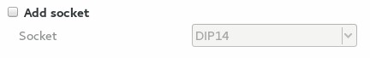

For model where socket was specified special window will appear.
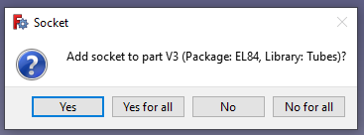

Set model as socket
To set model as socket just mark checkbox  for 'Set as socket' sign. In spinbox specify  socket height. | 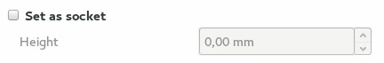

It is possible to see 3D model in last tab - ‘Preview’.
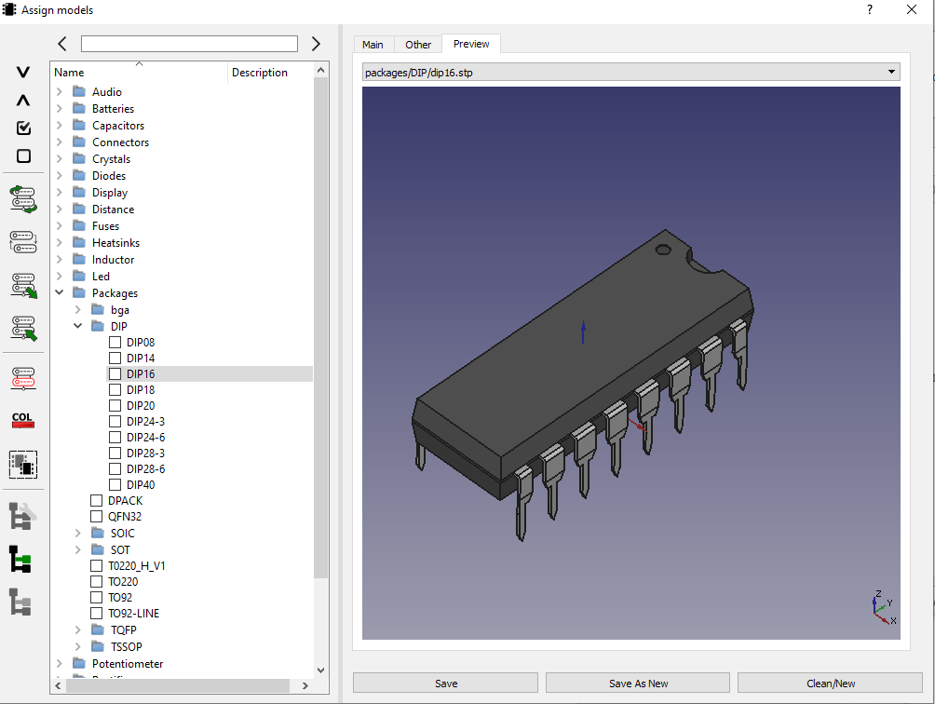

To save specified model in database you need to use one of the available on the bottom buttons.

Save button will save form as new entry in database or will update existing model.
'Save as new' will save existing entry in database under new package name.
'Clean/New' button clean form.
Close button will appear only for GNU/Linux users.

